Stereotaxic Injection by Iontophoresis

- Scope and Applicability: This protocol describes the delivery of a neuronal tracer using the iontophoretic method. The surgery uses a stereotaxic system to target specific brain coordinates in the mouse.

- Materials:
  - Anesthesia and related:
    - Isoflurane (Piramal Critical Care Inc. 330250; purchased as Patterson Veterinary 07-890-8115 or equivalent)
    - See CM_S_04_A/B or CM_S_04_C/D for proper drug preparation and administration for this procedure
  - Tool Kit:
    - Black handle scissors, ToughCut (Fine Science Tools 14058-11 or equivalent)
    - Scalpel handle (Fine Science Tools 10003-12 or equivalent)
    - Iris forceps (Fine Science Tools 11064-07 or equivalent)
    - Dumont #5 45° forceps (Fine Science Tools 11251-35 or equivalent)
    - 45° Vanna scissors, 8 cm (World Precision Instruments 500260 or equivalent)
    - Plastic sterilization container (Fine Science Tools 20810-02 or equivalent)
    - Hemostats (Fisher Scientific 12004-16 or equivalent)
    - large iris forceps (Fisher Scientific 13-820-073 or equivalent)
    - Bulldog clamp (Fisher Scientific 18053-28 or equivalent)
  - Consumable Supplies
    - PREempt Disinfectant spray (Contecinc 21101 or equivalent)
    - 70% Ethanol spray bottle (RP0032 or equivalent)
    - Alcohol Wipes (BD326895 or equivalent)
    - Sterile Surgical Drape, 18x26” (Fisher Scientific NC9517505 or equivalent)
    - Sterile Multi-well plate, 24 well (VWR 29443-952 or equivalent)
    - Nair Hair Removal Cream (Amazon B00R4HWYNI or equivalent)
    - Betadine solution (McKesson Medical-Surgical 77911 or equivalent)
    - Artificial Cerebrospinal Fluid.V (RP0205 or equivalent)
    - Surgifoam Absorb Gelatin Sponge Size 100 (McKesson Medical-Surgical 403360 or equivalent)
    - Sterile Gauze, 3x3” squares, autoclave sterilized (Patterson Veterinary 07-893-8587 or equivalent)
    - Cotton swabs, double ended, autoclave sterilized (VWR 89133-810 or equivalent)
    - Cotton swabs, double ended, non-sterile (VWR 89133-810 or equivalent)
    - Kimwipes, autoclave sterilized (VWR 21905-026 or equivalent)
    - Kimwipes, non-sterile (VWR 21905-026 or equivalent)
    - Sugi pointed sterile swabs (Fine Science Tools 18105-01or equivalent)
    - Insulin syringes, U-100, 0.3 ml, 31G (VWR BD328438 or equivalent)
    - Insulin syringes, U-100, 1 ml, 31G (VWR BD328418 or equivalent)
    - Luer-Lock Syringe, 20 ml (VWR 53548-025 or equivalent)
    - Luer-Lock Syringe, 10ml (VWR 75846-756 or equivalent)
    - 25G 5/8-inch needle (VWR 89134-134 or equivalent)
    - 32 mm Syringe Filter 0.2 µm Supor Membrane (VWR 28143-350 or equivalent)
    - Press ‘n’ Seal (Medline CLO70441 or equivalent)
    - Saran Wrap (Amazon B015FCLAVU or equivalent)
    - Sterile Drill Bits, 0.5/0.4 (NeoBurr FG1/4 or equivalent)
    - Sterile Drill Bits, 1.4/1.1 (NeoBurr FG4 or equivalent)
    - Sterile Drill Bits 1.0/4.2 (NeoBurr EF4 or equivalent)
    - Sterile Scalpel blades, #10 (VWR 21909-378 or equivalent)
    - Sterile Scalpel blades, #11 (VWR 21909-380 or equivalent)
    - Systane Eye Ointment (ALCON293787 or equivalent)
    - Silicone Sealant
      - Kwik-Cast Sealant (World Precision Instruments KWIK-CAST or equivalent)
      - Dura Gel (Dura Gel or equivalent)
      - Sorta Clear (SORTA-ClearTM 18 or equivalent)
    - Heat-sterilized Glass pipettes (Drummond Scientific 3-000-203-G/X, World Precision Instruments 1B120F-4 or equivalent)
    - “Marker” glass pipette, pulled, broken, and Sharpie for measuring coordinates (World Precision Instruments 1B120F-4 or equivalent)
    - Microcapillary Pipette tips (Eppendorf 89009-310 or equivalent)
    - Sterile Bone Wax (Lukens 901)
    - 5-0 Monofilament suture with 17 mm 1/2C taper needle attached (Stoelting™ 50499 or equivalent)
    - Sterilization pouches (VWR 89140-804 or equivalent)

- Equipment:
  - Small Animal Stereotaxic Instrument (Kopf 1900 or equivalent)
  - Adjustable Stage Platform (Kopf 901 or equivalent)
  - Stereo Microscope (Leica M80 or equivalent)
  - Gooseneck Illumination (AM LED-6WA or equivalent)
  - On-axis Illumination (Leica KL2500 LED or equivalent)
  - Bead sterilizer (Germinator 500 or equivalent)
  - Small Animal Temperature Control System (CWE Inc. TC-1000 or equivalent)
  - Heat plate/pad (Lectro Kennel Outdoor Heating Pad or equivalent)
  - Dental Drill (NSKPana or equivalent)
  - Oxygen Concentrator (Puraline or equivalent)
  - Isoflurane with oxygen delivery system (Patterson Scientific 07-8914722 or equivalent)
  - Isoflurane induction chamber (Patterson Scientific 078917853 or equivalent)
  - Ear bars (Kopf 1922 or equivalent)
  - Lambda Stylus (0111-300-01 or equivalent)
  - Dovetail Clamp (0111-200-00 or equivalent)
  - Electrode Holder (Kopf 1970 or equivalent)
  - Galaxy Mini Centrifuge (VWRC1413V-230 EU or equivalent)
  - P20 Pipettor (Gilson Inc F123600 or equivalent)
  - Silver wire (Stoelting 50880 or equivalent)
  - Midgard Precision Current Source (Stoelting 51595 or equivalent)

- Safety:
  - Non-Sterile Gloves
  - Disposable lab coat
  - Face mask; 0.6-micron filter (optional)
  - Shoe covers or designated surgery shoes
  - Scrubs
  - Surgical Cap (or hair secured away from face)
  - Biohazard sharps disposal container
  - Biohazard waste disposal container

Warning: Personal Protective Equipment (PPE) should be used at all times while operating this protocol. If you are unsure what PPE you should be using, see your immediate supervisor.

Isoflurane Warning: Acute over-exposure to waste anesthetic gases (WAG) may cause eye irritation, headache, nausea, drowsiness, or dizziness. Repeated exposure may cause damage to cardiovascular system and central nervous system. Refer to MSDS for additional information. Consult the surgical workstation guide to ensure all parts of the dispensation rig are functioning properly. Employee exposure monitoring is periodically conducted by EHS and may be requested at any time from EHS.

Only IACUC approved and appropriately trained personnel may perform this procedure. Refer to Section 10.2 for detailed information on IACUC guidelines.

- Output:
  - Adult mouse with tracer(s) injected into the brain.

- Reference Documents:
  - CM_S_04_A/B or CM_S_04_C/D: IACUC Care Modules
  - AF0098: Preparation of Sterile Consumables Packets
    - To be Published
  - RP0032: Ethanol Dilutions
    - To be Published
  - RP0205: Artificial Cerebrospinal Fluid V (ACSF.V)
    - dx.doi.org/10.17504/protocols.io.besjjecn
  - NSBWI-0012 Suture Training
  - NSBWI-0022 Preparation and take down for NSB surgical procedures
  - NSBWI-0041 Pulling Pipettes for Injections
  - NSBWI-0054 Identifying Bregma and Lambda

- Setup
  - Please reference NSB Work Instruction NSBWI-0022 for preoperative setup procedures.

Note: This procedure can be combined with cranial window surgeries by following the skin and muscle removal steps outlined in the cranial window protocol and omitting the suturing step.

- Methodology/Procedures:
  - Expose and prepare the skull surface. Throughout the procedure, spray surgical gloves with ethanol to keep them as clean as possible after touching non-sterile surfaces such as the Metabond trays, freezer/refrigerator doors, or tables/equipment that were not disinfected before the procedure
    - While looking through microscope, pull the skin between the eyes taut with blunt iris forceps and make a clean incision with the scalpel down the middle of the skull, exposing both Bregma and Lambda. The exact extent of the incision may vary by surgeon and can be extended using the Vanna scissors.
    - Using two sterile cotton swabs, gently tear the periosteum and ensure that it is pushed away from the area where the bur hole will be drilled.
  - Align the skull.
    - Ensure ear bars are snug and the skull is stable.
    - Place the Marker pipette in the electrode holder and attach to the Kopf 1900.

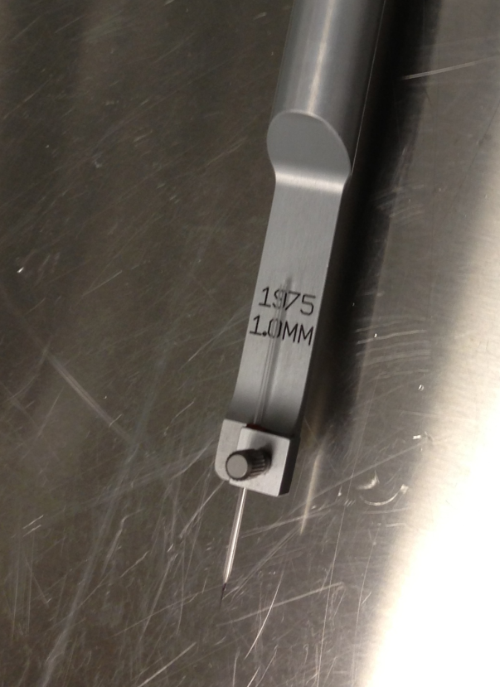
Figure 1: Marker glass pipette in the electrode holder.

    - Locate the landmarks Lambda and Bregma.
      - Locate the best fit intersection between the midline suture and the coronal suture (Bregma) or lambdoid suture (Lambda). Use the best fit, not necessarily the exact intersection.

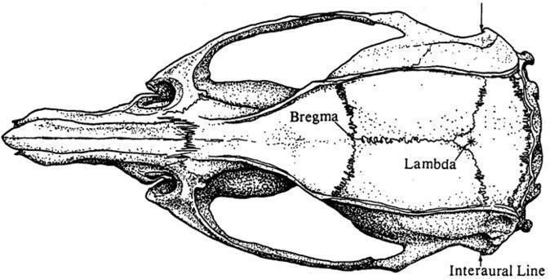
Figure 2: Lambda and Bregma landmarks.

    - Anterior-Posterior Leveling:
      - Using the X, Y, and Z knobs, and the microscope to visualize, lower the point of the marker pipette until it is just touching the skull surface on Bregma.
      - Zero the coordinates on the digital display.
      - Raise the marker pipette and move it to Lambda. Lower the marker pipette again until it is just touching the skull surface.
      - If the Lambda – Bregma Z-offset is greater than 0.1 mm, fix it by adjusting the pitch adjustment knob or by moving the ear bars. Repeat this process until the Z coordinates at Bregma and Lambda are within 0.1 mm of each other.
      - Yaw Adjustment: if the Lambda – Bregma X-offset is greater than 0.1 mm, release the yaw lock and use the yaw adjustment knob to adjust the yaw to within 0.1 mm. Reapply the yaw lock once aligned.
    - Lateral Leveling:
      - Move the marker pipette to approximately midway on the suture line between Bregma and Lambda and zero X, Y, and Z.
      - Move the marker pipette 2 mm laterally to the left and slowly lower the marker pipette down to the skull. Zero the Y and Z digital display.
      - Raise the marker pipette and move the marker pipette 2mm to the right of the suture and slowly lower the marker pipette down to the skull.
      - If the Left – Right Z-offset is greater than 0.15 mm, fix it by adjusting the roll or by moving the ear bars. Repeat this process until the Z coordinates are within 0.15 mm of each other.
    - Mark the Injection site
      - Move the marker pipette tip back to hover over Bregma and zero the coordinates of the digital display.
      - Using the X and Y controls, find the desired A/P (Y) and M/L (X) coordinates from Bregma.
      - Mark the spot on the skull to be drilled with a felt tip marker or by cross hatching with the scalpel.
  - Burr hole
    - A Burr hole is: a small craniotomy used for stereotaxic injections generally sealed with either bone wax or a silicone sealant. It should have a maximum diameter of 1mm for a single target or if two targets are center to center 1.5 mm or less apart they can be combined into a single oblong burr hole not to exceed a width of 1.0 mm and length of 2.0 mm. any larger and Craniotomy would be more appropriate.
    - Maximum number of burr holes per mouse is currently dependent on the procedure and the time limitations of a surgical slot.
      - CM_S_04 – Stereotaxic suture injection – 6 burr holes
      - CM_S_03 – HP only w/ Injection – 4 burr holes
      - CM_S_01 – Fiber implants – 4 burr holes
      - CM_S_01 – Craniotomy or Spinal w/ Burr holes – 2 burr holes
    - Drilling the Burr hole:
      - Using the drill with the FG ¼ or EF4 bit, create a burr hole over the mark.
      - If necessary, stop bleeding by using a Sugi Absorption Spear.
      - If there are multiple injection locations complete the first injection before drilling the second burr hole.
  - Fill the pipettes with tracer.
    - Place a Microcapillary pipette tip on a P20 pipette set to the correct volume.
    - Depress the plunger to the first stop and place the pipette tip into the viral solution.
    - Slowly and gently release pressure from the plunger to aspirate proper volume of virus.
    - Insert the pipette tip all the way to the shoulder of the pulled pipette and slowly depress the plunger to the first stop to expel the virus.
      - Pull the pipette out of the virus and gently apply pressure again to the second stop to expel any remaining virus into pipette. If the pipette is left in the viral solution, it will create bubbles.
    - Remove the marker pipette and place the viral pipette into the electrode holder and affix to the Kopf 1900.
      - Check the pipette tip under the microscope to ensure that the viral solution reaches the tip. If it does not, or if there are air bubbles, gently touch or flick the tip with a Sugi Absorption spear or forceps, being careful not to break the pipette.

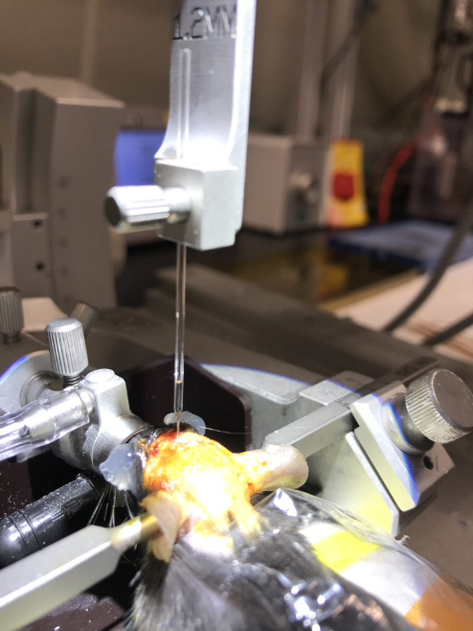
Figure 3: Viral solution in the tip of the pipette.

  - Inject Virus with Iontophoresis
    - Insert the silver wire into the base of the glass pipette to the point where it is just below the meniscus of the viral solution without reaching the narrowing of the shoulder. Bend the wire at the base of the pipette to secure it in place.
    - Bring the viral pipette tip to the injection coordinates. If necessary, drill a larger hole to correctly access coordinates.
    - Ground the circuit by affixing a bulldog clamp to the skin or tail, then clip the black terminal to the bulldog clamp. Clip the red terminal to the silver wire and ensure it is not touching any metal surface.

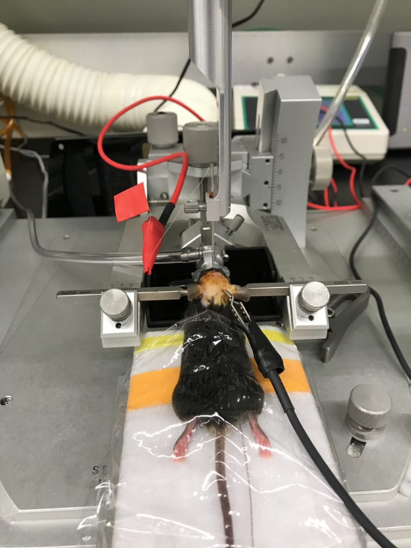
Figure 4: Electrode setup of a complete circuit.

    - Check the surgical work request and the injection settings on the current source.
        - Ionto Ret Current
        - Current
        - Alternating Time
    - Lower the pipette tip to the brain surface while visualizing under the microscope, then zero the Z coordinate on the digital display
    - Lower the viral pipette to the designated D/V coordinate and allow 5 minutes for the tissue to adjust to the pipette.
      - Note if doing multiple depths always start with the deepest.
    - Press “GO” to start the current. Start a timer to designated length of time described on the Surgical Work Request for delivering the virus.
      - The current will alternate on and off. Check that the voltage is steady at 0.3-0.5 volts. If the voltage fluctuates there may be a problem with the equipment. Take note of this on the Surgical work request. If there is significant fluctuation, the pipette tip may need to be re-broken.
    - If injecting at an additional depth within the same burr hole raise the pipette to the second designated D/V coordinate and immediately start a new timer for the designated length of time described on the surgical work request.
      - The current source can be left on while raising the pipette to the next depth.
    - After the injection is complete press “Stop”, leave the pipette in place for 5 more minutes. This is to allow the virus to diffuse away from the injection site and reduce the likely hood of a viral tract along the injection site.
    - Leaving the current source on and everything connected, slowly remove the pipette from the brain. This helps to avoid a viral tract at the injection site.
  - Suturing
    - Remove the electrode holder from the Kopf 1900.
    - Using the broken end of a cotton swab, smear bone wax or silicone sealant over the drilled burr holes to seal them level with the skull.
      - Some injections do not require bone wax or silicone sealant and will be noted in the requestor comments section of the Surgical Work Request
    - Close the scalp incision with a surgeon’s knot (3 throws) followed by a square knot (2 throws) for a total of 5 throws using the monofilament suture pack.
  - Turn off Isoflurane and remove the mouse from the surgical rig.
  - ATTENTION: Before proceeding, please reference care module CM_S_04_A/B or CM_S_04_C/D for complete list of drugs and drug preparations required by this procedure.
  - Obtain the mouse’s post-operative weight.
  - Place the mouse back in a recovery cage and put the cage on the 37ºC heat plate.
  - Write the following on the cage card: date of procedure, surgeon’s three letter initials, name and volume of any drugs or fluids administered, route of administration, procedure that was performed, post-operative weight of the animal, and the time the surgery was completed.
    - If a surgical injection was done please include the BSL level and material injected ex (BSL 1 AAV STX INJ)
  - Return mouse to the surgical recovery cart in the vivarium when the mouse is fully conscious.

- Take Down: Please reference NSB Work Instruction NSBWI-0022 for take down procedures.

- Technical Information:
  - Anesthesia and pain control agents:
Drug | Dose | Route | Frequency | Indication
Isoflurane | 1-5% | Inhalation | Continuous | Used to induce anesthesia

  - If the surgeon anticipates the procured will exceed 1 hour, at their discretion they may administer Atropine in addition to other drugs listed in the care module.
Drug | Dose | Route | Frequency | Indication
Atropine | 0.02-0.05mg/kg | SC | Once, after induction of anesthesia | Suppress bronchial secretions

