Stereotaxic Injection by Nanoject

- Scope and Applicability: This protocol describes the delivery of a neuronal tracer using the Nanoject. The surgery uses a stereotaxic system to target specific brain coordinates in the mouse.

- Materials:
  - Anesthesia and related:
    - Isoflurane (Piramal Critical Care Inc. 330250; purchased as Patterson Veterinary 07-890-8115 or equivalent)
    - See CM_S_04_A/B or CM_S_04_C/D for proper drug preparation and administration for this procedure
  - Tool Kit:
    - Black handle scissors, ToughCut (Fine Science Tools 14058-11 or equivalent)
    - Scalpel handle (Fine Science Tools 10003-12 or equivalent)
    - Iris forceps (Fine Science Tools 11064-07 or equivalent)
    - Dumont #5 45° forceps (Fine Science Tools 11251-35 or equivalent)
    - 45° Vanna scissors, 8 cm (World Precision Instruments 500260 or equivalent)
    - Plastic sterilization container (Fine Science Tools 20810-02 or equivalent)
    - Hemostats (Fisher Scientific 12004-16 or equivalent)
    - large iris forceps (Fisher Scientific 13-820-073 or equivalent)
  - Consumable Supplies
    - PREempt Disinfectant spray (Contec Inc 21101 or equivalent)
    - 70% Ethanol in spray bottle (RP0032 or equivalent)
    - Alcohol Wipes (BD326895 or equivalent)
    - Sterile Surgical Drape, 18x26” (Fisher Scientific NC9517505 or equivalent
    - Sterile Multi-well plate, 24 well (VWR 29443-952 or equivalent)
    - Nair Hair Removal Cream (Amazon B00R4HWYNI or equivalent)
    - Betadine solution (McKesson Medical-Surgical 77911 or equivalent)
    - Artificial Cerebrospinal Fluid.V (RP0205 or equivalent)
    - Surgifoam Absorb Gelatin Sponge Size 100 (McKesson Medical-Surgical 403360 or equivalent)
    - Sterile Gauze, 3x3” squares, autoclave sterilized (Patterson Veterinary 07-847-3539 or equivalent)
    - Cotton swabs, double ended, autoclave sterilized (VWR 89133-810 or equivalent)
    - Cotton swabs, double ended, non-sterile (VWR 89133-810 or equivalent)
    - Kimwipes, autoclave sterilized (VWR 21905-026 or equivalent)
    - Kimwipes, non-sterile (VWR 21905-026 or equivalent)
    - Sugi pointed sterile swabs (Fine Science Tools 18105-01 or equivalent)
    - Insulin syringes, U-100, 0.3 ml, 31G (VWR BD328438 or equivalent)
    - Insulin syringes, U-100, 1 ml, 31G (VWR BDBD328418 or equivalent)
    - Luer-Lock Syringe, 20 ml (VWRBD 309661 or equivalent)
    - Luer-Lock Syringe, 10 ml (VWR BD309604 or equivalent)
    - 25G 5/8-inch needle (VWR BD305122 or equivalent)
    - 32 mm Syringe Filter 0.2 µm Supor Membrane (VWR 28143-350 or equivalent)
    - Press ‘n’ Seal (Medline CLO70441 or equivalent)
    - Saran Wrap (Amazon B015FCLAVU or equivalent)
    - Systane Eye Ointment (ALCON293787 or equivalent)
    - Sterilization pouches (Chex-All 082411 or equivalent)
    - Sterile Drill Bits, 0.5/0.4 (NeoBurr FG1/4 or equivalent)
    - Sterile Drill Bits, 1.4/1.1 (NeoBurr FG4 or equivalent)
    - Sterile Drill Bits 1.0/4.2 (NeoBurr EF4 or equivalent)
    - Sterile Scalpel blades, #10 (World Precision Instruments 500239 or equivalent)
    - Sterile Scalpel blades, #11 (World Precision Instruments 500240 or equivalent)
    - Silicone Sealant
      - Kwik-Cast Sealant (World Precision Instruments KWIK-CAST or equivalent)
      - Dura Gel (Dura Gel or equivalent)
      - Sorta Clear (SORTA-ClearTM 18 or equivalent)
    - “Marker” glass pipette, pulled, broken, and Sharpie for measuring coordinates (World Precision Instruments 1B120F-4 or equivalent)
    - Heat-sterilized Glass pipettes (Drummond Scientific 3-000-203-G/X, World Precision Instruments 1B120F-4 or equivalent)
    - Microcapillary Pipette tips (Eppendorf 89009-310 or equivalent)
    - Parafilm (VWR 52858-000 or equivalent)
    - 30 gauge, 2" Backfilling Needle (Amazon B00EOAI5HC or equivalent)
    - Lightweight Mineral Oil (Sigma Aldrich M8410 or equivalent)
    - Sterile Bone Wax (Lukens 901)
    - 5-0 Monofilament suture with 17 mm 1/2C taper needle attached (Stoelting™ 50499 or equivalent)

- Equipment:
  - Small Animal Stereotaxic Instrument (Kopf 1900 or equivalent)
  - Stereo Microscope (Leica M80 or equivalent)
  - Fiber optic illuminator (Dolan Jenner MI-152 or equivalent)
  - Bead sterilizer (Germinator 500 or equivalent)
  - Small Animal Temperature Control System (CWE Inc. TC-1000 or equivalent)
  - Heat plate/pad (Lectro Kennel Outdoor Heating Pad or equivalent)
  - Dental Drill (NSKPana or equivalent)
  - Oxygen Concentrator (Puraline or equivalent)
  - Isoflurane with oxygen delivery system (Patterson Scientific 07-8914722 or equivalent)
  - Isoflurane induction chamber (Patterson Scientific 078917853 or equivalent)
  - Ear bars (Kopf 1922 or equivalent)
  - Lambda Stylus (0111-300-01 or equivalent)
  - Electrode Holder (Kopf 1970 or equivalent)
  - Galaxy Mini Centrifuge (VWRC1413V-230 EU or equivalent)
  - P20 Pipettor (Gilson Inc F123600 or equivalent)
  - Nanoject II Variable Volume (2.3 to 69 nl) Automatic Injector (VWR 490007-164 or equivalent)
  - Nanoject III (Drummond Scientific 3-000-207 or equivalent)

- Safety:
  - Non-Sterile Gloves
  - Disposable lab coat
  - Face mask; 0.6-micron filter (optional)
  - Shoe covers or designated surgery shoes
  - Scrubs
  - Surgical Cap (or hair secured away from face)
  - Biohazard sharps disposal container
  - Biohazard waste disposal container

Warning: Personal Protective Equipment (PPE) should be used at all times while operating this protocol. If you are unsure what PPE you should be using, see your immediate supervisor.

Isoflurane Warning: Acute over-exposure to waste anesthetic gases (WAG) may cause eye irritation, headache, nausea, drowsiness or dizziness. Repeated exposure may cause damage to cardiovascular system and central nervous system. Refer to MSDS for additional information. Consult the surgical workstation guide to ensure all parts of the dispensation rig are functioning properly. Employee exposure monitoring is periodically conducted by EHS and may be requested at any time from EHS.

Only IACUC approved and appropriately trained personnel may perform this procedure. Refer to Section 10.2 for detailed information on IACUC guidelines.

- Output:
  - Adult mouse with tracer(s) injected into the brain.

- Reference Documents:
  - CM_S_04_A/B, CM_S_04_C/D: IACUC Care Modules
  - AF0098: Preparation of Sterile Consumables Packets
    - To be Published
  - RP0032: Ethanol Dilutions
    - To be Published
  - RP0205: Artificial Cerebrospinal Fluid V (ACSF.V)
    - dx.doi.org/10.17504/protocols.io.besjjecn
  - NSBWI-0012 Suture Training
  - NSBWI-0022 Preparation and take down for NSB surgical procedures
  - NSBWI-0041 Pulling Pipettes for Injections
  - NSBWI-0054 Identifying Bregma and Lambda

- Setup
  - Please reference NSB Work Instruction NSBWI-0022 for preoperative setup procedures.

Note: This procedure can be combined with cranial window surgeries by following the skin and muscle removal steps outlined in the cranial window protocol and omitting the suturing step.

- Methodology/Procedures:
  - Expose and prepare the skull surface. Throughout the procedure, spray surgical gloves with ethanol to keep them as clean as possible after touching non-sterile surfaces such as the Metabond trays, freezer/refrigerator doors, or tables/equipment that we’re not disinfected before the procedure.
    - While looking through microscope, pull the skin between the eyes taut with blunt iris forceps and make a clean incision with the scalpel down the middle of the skull, exposing both Bregma and Lambda. The exact extent of the incision may vary by surgeon and can be extended using the Vanna scissors.
    - Using two sterile cotton swabs, gently tear the periosteum and ensure that it is pushed away from the area where the burr hole will be drilled.
  - Align the skull.
    - Ensure ear bars are snug and the skull is stable.
    - Place the Marker pipette in the electrode holder and attach to the Kopf 1900.
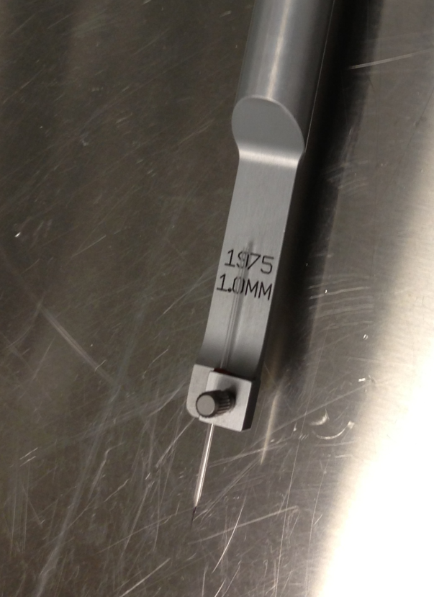
Figure 1: Marker glass pipette in the electrode holder.

    - Locate the landmarks Lambda and Bregma.
      - Locate the best fit intersection between the midline suture and the coronal suture (Bregma) or lambdoid suture (Lambda). Use the best fit, not necessarily the exact intersection.
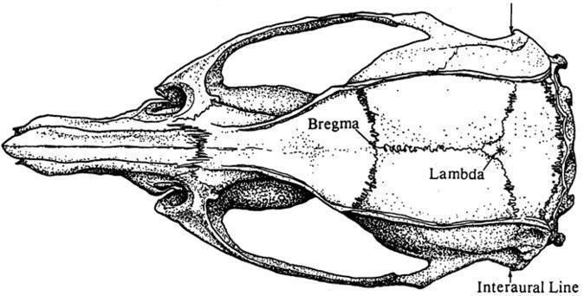
Figure 2: Lambda and Bregma landmarks.

    - Anterior-Posterior Leveling:
      - Using the X, Y, and Z knobs, and the stereomicroscope to visualize, lower the point of the marker pipette until it is just touching the skull surface on Bregma.
      - Zero the coordinates on the digital display.
      - Raise the marker pipette and move it to Lambda. Lower the marker pipette again until it is just touching the skull surface.
      - If the Lambda – Bregma Z-offset is greater than 0.1 mm, fix it by adjusting the pitch adjustment knob or by moving the ear bars. Repeat this process until the Z coordinates at Bregma and Lambda are within 0.1 mm of each other.
      - Yaw Adjustment: if the Lambda – Bregma X-offset is greater than 0.1 mm, release the yaw lock and use the yaw adjustment knob to adjust the yaw to within 0.1 mm. Reapply the yaw lock once aligned.
    - Lateral Leveling:
      - Move the marker pipette to approximately midway on the suture line between Bregma and Lambda and zero X, Y, and Z.
      - Move the marker pipette 2mm laterally to the left and slowly lower the marker pipette down to the skull. Zero the Y and Z digital display.
      - Raise the marker pipette and move the marker pipette 2 mm to the right of the suture and slowly lower the marker pipette down to the skull.
      - If the Left – Right Z-offset is greater than 0.15 mm, fix it by adjusting the roll or by moving the ear bars. Repeat this process until the Z coordinates at are within 0.15 mm of each other.
    - Mark the Injection site
      - Move the marker pipette tip back to hover over Bregma and zero the coordinates of the digital display.
      - Using the X and Y controls, find the desired A/P (Y) and M/L (X) coordinates from Bregma.
      - Mark the spot on the skull to be drilled with a felt tip marker or by cross hatching with the scalpel.
  - Burr hole
    - A Burr hole is: a small craniotomy used for stereotaxic injections generally sealed with either bone wax or a silicone sealant. It should have a maximum diameter of 1 mm for a single target or if two targets are center to center 1.5 mm or less apart they can be combined into a single oblong burr hole not to exceed a width of 1.0 mm and length of 2.0 mm, any larger and Craniotomy would be more appropriate.
    - Maximum number of burr holes per mouse is currently dependent on the procedure and the time limitations of a surgical slot.
      - CM_S_04 – Stereotaxic suture injection – 6 burr holes
      - CM_S_03 – HP only w/ Injection – 4 burr holes
      - CM_S_01 – Fiber implants – 4 burr holes
      - CM_S_01 – Craniotomy or Spinal w/ Burr holes – 2 burr holes
    - Drilling the Burr hole
      - Using the drill with the FG ¼ or EF4 bit, create a burr hole over the mark.
      - If necessary, stop bleeding by using a Sugi Absorption Spear.
      - If there are multiple injection locations complete the first injection before drilling the second burr hole.
  - If Inject Virus with Nanoject II
    - Attach the Nanoject injector with loaded pipette onto the Kopf 1900 stereotaxic arm
    - Bring the viral pipette tip to the injection coordinates. If necessary, drill a larger hole to correctly access coordinates.
    - Lower the tip of the pipette to the brain surface carefully while visualizing under the microscope, then zero the Z-coordinate on the digital display
    - Lower the tip to the designated D/V coordinate and allow 5 minutes for the tissue to adjust to the pipette.
      - Note if doing multiple depths always start with the deepest.
    - Verify that the volume and injection rate specified by the switches on the Nanoject control box are correct.
      - Once the volume has been selected, each time the "inject" button is depressed an audible beep will be heard and the selected volume will be dispensed at the designated rate.
      - Multiple injections can be made in one location by simply pressing the "inject" again. Pressing "inject" again before the first injection is complete will not produce a second injection.
    - Inject the specified volume of virus, waiting 30 seconds in between each depression of the “Inject” button (for example, a 200 nl injection at 50 nl requires four depressions of the “Injection” button).
      - Injection parameters vary, please double check Surgical Work Request for injection details.
    - Once the injection is complete, leave the pipette in place for 5 minutes. This is to allow for the virus to diffuse away from the injection site and reduce the likely hood of a viral tract along the injection site.
    - Raise the pipette tip slowly until clear of the brain surface. If no more injections are being performed press and hold the “Fill” button until the plunger has returned to the home position, then remove and discard the viral pipette.
    - If doing multiple injection locations in the same mouse, go back to step 8.2.6.
  - If Injecting with Nanoject III
    - Attach the Nanoject injector with loaded pipette onto the Kopf 1900 stereotaxic arm
    - Bring the viral pipette tip to the injection coordinates. If necessary, drill a larger hole to correctly access coordinates.
    - Lower the tip of the pipette to the brain surface carefully while visualizing under the microscope, then zero the Z-coordinate on the digital display
    - Lower the tip to the designated D/V coordinate and allow 5 minutes for the tissue to adjust to the pipette.
      - Note if doing multiple depths always start with the deepest.
    - On the Inject Screen of the Nanoject III ensure volume and flow rate are correct
      - The default flow rate should be 2 nl/sec.
    - Press the INJECT button and ensure the Injection counter went up by 1 then wait until you hear the beep indicating that the injection is done.
      - It is recommended that you set a timer and you can find the length of the injection by dividing the volume by the flow rate. Example 600 nl injection with a flow rate of 2 nl/sec would finish in 300 seconds or 5 min.
    - Once the injection is complete, leave the pipette in place for 5 minutes. This is to allow for the virus to diffuse away from the injection site and reduce the likely hood of a viral tract along the injection site.
    - Raise the pipette tip slowly until clear of the brain surface. If no more injections are being performed return the plunger to the home position by navigating to the Manual screen and pressing the HOME button, then remove and discard the viral pipette.
    - If doing multiple injection locations in the same mouse, go back to step 8.2.6.
  - Suturing
    - Remove the Nanoject from the stereotaxic holder to clear the surgical area.
    - Using the broken end of a cotton swab, smear bone wax or silicone sealant over the drilled burr holes to seal them level with the skull.
      - Some injections do not require bone wax or silicone sealant and will be noted in the requestor comments section of the Surgical Work Request
    - Close the scalp incision with a surgeon’s knot (3 throws) followed by a square knot (2 throws) for a total of 5 throws using a monofilament suture pack.
  - Turn off Isoflurane and remove the mouse from the surgical rig.
  - ATTENTION: Before proceeding, please reference care module CM_S_04_A/B or CM_S_04_C/D for complete list of drugs and drug preparations required by this procedure.
  - Obtain the mouse’s post-operative weight.
  - Place the mouse back in a recovery cage and put the cage on the 37ºC heat plate.
  - Write the following on the cage card: date of procedure, surgeon’s three letter initials, name and volume of any drugs or fluids administered, route of administration, procedure that was performed, post-operative weight of the animal, and the time the surgery was completed.
    - If a surgical injection was done, please include the BSL level and material injected ex (BSL 1 AAV STX INJ)
  - Return mouse to the surgical recovery cart in the vivarium when the mouse is fully conscious.

- Take Down: Please reference NSB Work Instruction NSBWI-0022 for take down procedures

- Technical Information:
  - Anesthesia and pain control agents:
Drug | Dose | Route | Frequency | Indication
Isoflurane | 1-5% | Inhalation | Continuous | Used to induce anesthesia
  - If the surgeon anticipates the procured will exceed 1 hour, at their discretion they may administer Atropine in addition to other drugs listed in the care module.
Drug | Dose | Route | Frequency | Indication
Atropine | 0.02-0.05 mg/kg | SC | Once, after induction of anesthesia | Suppress bronchial secretions

