Cell type distribution - data processing and structure
Osten Lab, CSHL

Table of contents
Table of contents 2
Table of Figures 3
Abstract 4
Introduction 4
Metadata 4
STP Image Reconstruction 6
Method 6
Implementation 6
Setting up the raw data 6
Processing scripts setup 6
Level 0 Data desciption 7
Image Reconstruction - Quality Control 8
Cell Type detection & Registration to CCF space 9
Method 9
Cell detection 9
Registration to CCF space 9
Implementation 10
Level 1 data description 11
Cell detection & Registration Quality Control 11
CCF Region Wise Cell counts 12
Method 12
Implementation 12
Level 2 data description 12
Data Compression for Archival 12
File Size overview 13

Table of Figures
Figure 1: Reconstruction script showing ch1 and ch2 file path entries along with section start and end numbers 7
Figure 2: Reconstruction script showing advanced stitching parameters including image correction and stitching blending method. 7
Figure 3: Processed data folder containing reconstruction script along with high-resolution channel 1 and 2 folders along with downsized p05 files in the warping folder. 8
Figure 4: Examples of imaging artifacts detected after image reconstruction 9
Figure 5: Shows coronal reference view of anterior commissure 10
Figure 6: Processed folder showing the location of transformix Output folder contents generated after prediction. 11
Figure 7: Script showing the file path and directory information for microscope raw data compression 13

Abstract
Even though scientists have been captivated by the diversity of brain cells for well over a century, since the initial anatomical descriptions by Santiago Ramn y Cajal, it is only recently that the developments in new technologies allowed us to truly appreciate the astonishing complexity of cell types in the mammalian brain. Yet, even today, our knowledge of cell type anatomy and function is largely limited to a few brain areas, such as the sensory cortex or the hippocampus. This lack of whole-brain data has led to generalizations from one brain area to other regions with similar architecture. However, our preliminary studies applying quantitative whole brain analyses have revealed unexpected region specific differences in cell type ratios and uncovered new gender-based differences in cellular anatomy that can inform our understanding of brain development, wiring and function. We thus believe that closing the gaps in our knowledge of the cellular architecture of the brain will be a major contribution to enable a modern quantitative understanding of the brain as a system. Here we propose to establish an Anatomical Collaboratory for Systematic Atlasing of Cell-Type Distribution and Morphology in female and male brain. This Collaboratory will apply standardized, unbiased and largely automated methods developed in our laboratories to atlas the distribution and morphology of >80 molecularly defined cell classes and cell type across all regions of the female and male brain. This work will yield the most comprehensive characterization of cell type anatomy in the mammalian brain to date, establishing a structural basis for building an integrated Cell Type Brain Atlas.
Specific Aim 1: Quantify and atlas the brain wide distribution of molecularly defined cell types. This work will generate a quantitative brain atlas of the distributions of molecularly defined cell classes and cell types within the Common Coordinated Framework (CCF) of the adult brain.

Introduction
This document describes the materials and methods used to process data generated from a Serial 2-photon microscope to quantify the molecular cell types

Metadata
For the cell-type CELL NUMBER atlasing project the brains are imaged using serial two-photon tomography (STPT) and the serial section datasets are acquired at x-y resolution = 1 micron and z resolution = 50 microns for 270-280 sections depending upon the rostro-caudal axial length of the brain.
The total size of uncompressed raw data is ~145 GB, after compression it is ~65 GB (LZW Lossless compression). Each high-resolution section is composed of 12 x 16 = 192 tiles, with each tile saved in 16-bit tif format.
Each dataset is associated with the following METADATA:
- Cell type specific cre mouse line (e.g Parvalbumin-Cre, Chat-Cre etc)
- Cre-reporter (e.g Ai75, H2BGFP etc)
- Mice derivate strain (e.g. C57BL/6 etc.)
- Mice Origin (JAX etc)
- Mice Room ID
- Mice Cage ID
- Sex (male or female)
- Date of Birth
- AGE (in weeks)
- Date of perfusion
- Date of imaging
- Imaging machine id (e.g. Godzilla)
- Laser wavelength
- PMT value for channel1
- PMT value for channel 2
- Voltage under objective
- Surface measured on piezo
- Imaging plane measured on piezo
- Total number of sections
- Data processing server (e.g. brain2, brain5 etc.)
- Raw and processed data storage server location (brainstore 4, 5 etc.)

STP Image Reconstruction

Method
The reconstruction part is specific to Serial two-photon tomography (Ragan et al. 2012). Initial part involves image reconstruction of an image tile from the Photomultiplier tube data. The data from PMT is read in a binary/TIFF format files and cropped along the edges where there is saturation artifacts from turning of the galvo mirrors. During this step, the average of all the image tiles is also calculated to determine the illumination field of the setup. [Supplementary Fig. 1]. The images can be stitched together by either specifying a predetermined overlap or using position information from the linear X and Y stages. With meta-information from the microscope, the image series data is converted grid image data and finally a sequence of stitched mosaic files. When mosaicking, the user has the option to blend the tiles at the overlap, or use a simple overlap. When stitching without blending, the stitching can also be done in the reverse order of imaging so as to avoid regions that have been photo bleached previously while imaging the previous tile. This also features generation of XML files for generation of input files for terastitcher and TrakEM2 tile configuration files (Fiji Plugin) based stitching. This process also creates a volume thumbnail for a quick inspection of the imaging quality and downstream process of image registration with reference atlas. Fiji Module to view full resolution data set

Implementation

Setting up the raw data
- Check if all sections (.tiff) are saved in both ch1 (red channel) and ch2 (green channel).
- Remove ch3 (blank channel) tiffs acquisition data - by using the script - move_test.bat
- Following the ch3 channel data deletion, transfer ch1 raw data and ch2 raw data to the IBM SONAS server.

Processing scripts setup
- Create a process folder with project ID in the processing server (e.g. brain2, brain3 or brain5)
  - /data/<user>/STP_processed_data/<cell_type>/<group1_male>/
  - /data/<user>/STP_processed_data/<cell_type>/<group2_female>/
- Copy the reconstruction script in the process folder and input relevant data path and edit the runReconstruction_part1.sh script in gedit editor
- Update Mosaic text file is located in ch1 raw data folder (fig.1)
- Update the CH2_TIF_DIR and CH3_TIF_DIR (Ch2 tif directory path can be directly copied by right click copy command from the file browser nautilus)
- Update the SECTION_STARTNUMBER and (fig.1) and SECTION_ENDNUMBER (e.g. 270) from the imaging.
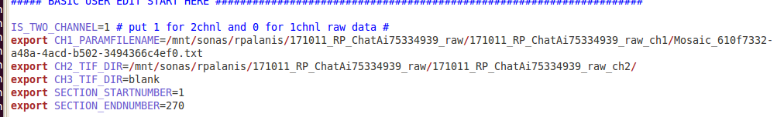
Figure 1: Reconstruction script showing ch1 and ch2 file path entries along with section start and end numbers

Verify the correctness of the advanced parameters i. Rest of the values are set to default as show in the Figure 2.
  - IMAGE_CORRECTION=1
  - FUSION_METHOD=4 (no blending)

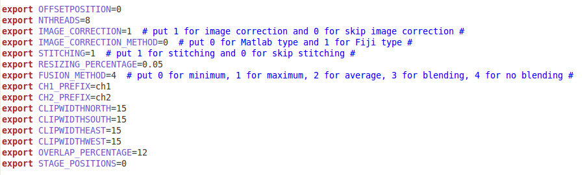
Figure 2: Reconstruction script showing advanced stitching parameters including image correction and stitching blending method.
- Open terminal application. Change directory to the processed data directory . Run the script from terminal command.

Level 0 Data desciption
The output of the reconstruction are the following files
- Stitched image directories of each of the imaged channels (Typically Red and Green) in stitchedImage_ch1 and stitchedImage_ch2. This contains the coronal section files at 1 micron resolution and 50 micron spacing in between sections. The stitched images are saved in lossless LZW compressed 16-bit tif images.
- The warping folder that contains the 5% downsized image stack that can be opened ImageJ
The intermediate data are the following:
- The average tile used for illumination correction for the each channels of the dataset is stored as averageTile_ch1.tif and averageTile_ch2.tif
- In Log/Mosaic_*.mat file contains all the meta information about the imaging parameters stored by the TissueCyte Scope
  - It has the raw tile file names
  - Their stage positions in each section
  - Imaging parameters like laser power etc.
  - Processing parameters, intermediate processing file names
  - Missing tiles during imaging

Image Reconstruction - Quality Control

- Visualize the stitched images in Fiji for checking the overall quality of the acquisition
- Obtained data folder structure should appear as shown below (fig. 3).

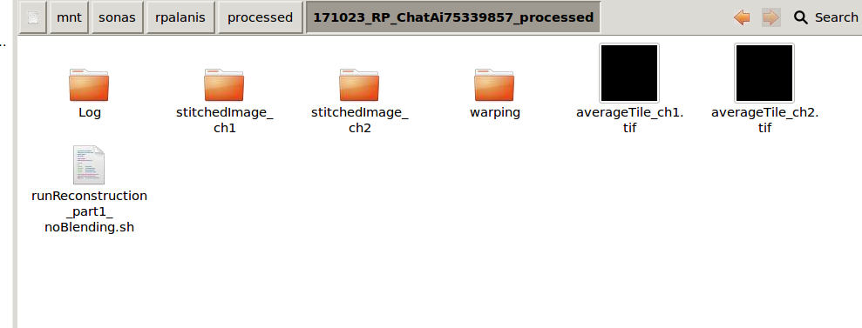
Figure 3: Processed data folder containing reconstruction script along with high-resolution channel 1 and 2 folders along with downsized p05 files in the warping folder.

  - Stitchedimage_ch1 and stitchedimage_ch2 folder contains high resolution acquired images.
  - The warping folder contains 5% downsized images and these images can be visualized for checking the overall quality of the imaging acquisitions.
  - Log folder has missing tiles info
- Few examples of the troubleshooting are below (fig.4)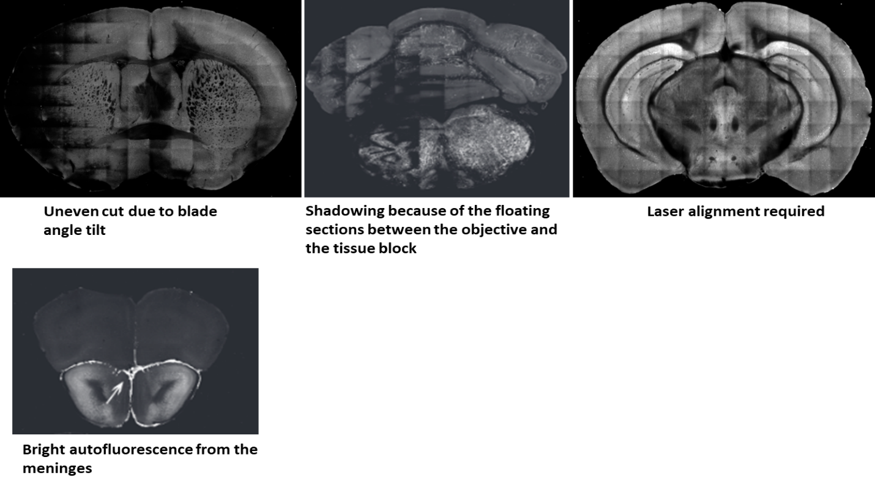
Figure 4: Examples of imaging artifacts detected after image reconstruction

Cell Type detection & Registration to CCF space

Method

Cell detection
Convolutional neural networks (CNN) (Lecun et al. 1998) are used to detection of cells and other structures. Our segmentation tool has capability to detect nuclear, cytoplasmic and axonal signals imaged using fluorescent light microscopes. The cell detection CNN is built over CNS (Mutch et al. 2010) and CNPKG uses an older CUDA framework. These tools require a nvidia CUDA-enabled GPU to process these detections. The networks have both variable hidden layers and field of view depending on the feature that is being detected.

Registration to CCF space
This module registers the downsampled sample brain to CCF space. It is executed in 2 steps, first the affine and then followed by b-spline registration. The registration uses Mattes mutual information as similarity measure (Mattes et al. 2003). We use a toolbox for image registration call elastix (Klein et al. 2010). It is based on ITK (Ibáñez 2003). (Niedworok et al. 2016)

Implementation
As described above there are multiple cell signal that can be identified. Cell detections networks ID and their applications are listed below:

- 164 – single channel quantification of c-fos positive cells and any nuclear based signals
- 10 – Mecp2-GFP or intra-nuclearly distributed signal based dataset quantification
- 313 – subtraction channel based quantification of c-fos and any nuclear based signals
- 320 – Rabies/Somatic labeling quantification
- Identify anterior commissure region in the stitched images (fig.5)

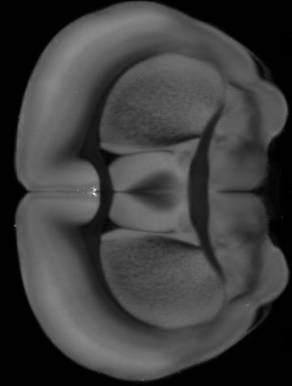
Figure 5: Shows coronal reference view of anterior commissure

- Calculate image intensity mean and standard deviation of the anterior commissure region using matlab for both the channels.
- Find the warpable range of the stitched brain by comparing the start and end coordinates with respect to the 25 micron Allen reference atlas.
- Input all the relevant values in the prediction script, change channel directories and run predictions.

Level 1 data description
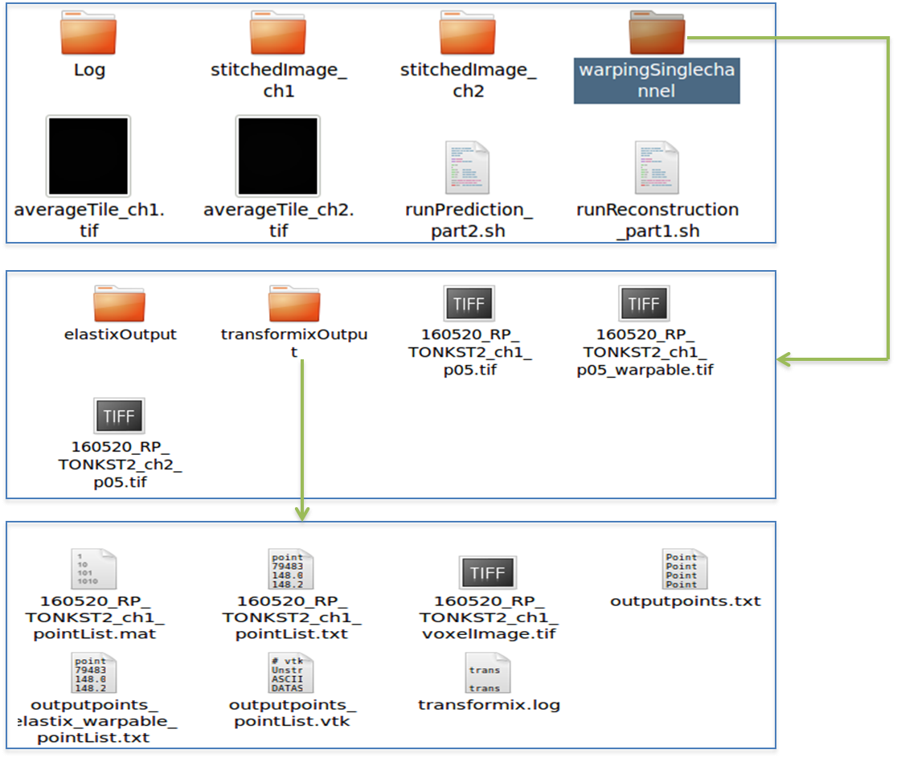
Figure 6: Processed folder showing the location of transformix Output folder contents generated after prediction.
- The detected cell masks can be found under the directory expressing the signal followed by network ID directory (e.g. statichedImage_ch1/164)
- The cleanup directory has the mask of the cells detected
- Cell count for the predicted channel is contained in the transformix output as displayed in figure 6 which can be then directly used as an input file for the ROI based statistics analysis.

Cell detection & Registration Quality Control
- The cell mask images can be opened alongside the corresponding reconstructed sections and with synchronized mouse pointer the quality of cell detections can be qualitatively assessed
- For registration, open the result file of registration in the elastixOutput folder in warping with the fixed image (the downsized warpable image) and synchronize the stack slices and mouse pointers and look for congruous edges and corners in each of the image stacks.

CCF Region Wise Cell counts

Method
With the registration parameters the cells detected are transformed to CCF space and with the CCF labels the region wise counts are determined.

Implementation
It is done as combination of C++ and R code
- For ROI statistics create a Project folder in the processing server.
- The Project folder should contain at least designated groups for brains and the matlab script.
- Put all the point list text file in the appropriate groups, for example Group 1 can contain all the point list files from female brain and the same for male brains in Group 2.
- Run the matlab script – runROI_all in the processing server.
- Extract all (right and left hemisphere) summary text file from the output folder and copy it in spreadsheet (*.csv) format to visualize region wise cell count.

Level 2 data description
The spreadsheet has the sample ID rows and the regions listed as columns. It also computed the mean and standard deviation for groups of animals

Data Compression for Archival
After the steps of reconstruction and cell detections the corresponding raw folders (the files containing the tiles from STPT computer) should be compressed using the script shown below in figure 7. This script can be run on the processing servers without assigning the GPU since its CPU-intensive processing.
Document the size of the raw data before compression which is approximately 145 GB and after compression it is approximately 65-75GB.
The script is run from matlab and is run as follows:
>> homeDirectory = <dataDirHome>
>> compressionRatio = 16;
>> archivalHome = /mnt/ostenmitragrid/batchx
>> createArchivalDataForSTP (homeDirectory, compressionRatio, archivalHome)
There is provision for converting the Data Level 1: reconstructed images (R and G channels) to JP2 file format . The L2 cell masks are compressed binary tif images.

Figure 7: Script showing the file path and directory information for microscope raw data compression

Data set size
Data type | Data description | Usage Per Brain before compression | Usage Per Brain after compression | Usage per month with compression (20 brains)
Level 0 data | Stitched coronal section 1µx1µ resolution spaced 50µ | ~70GB | ~25GB | ~500GB
Level 1 data | Cell detection masks | <1GB | <1GB | ~5GB
Level 2 data | Registration | <1GB | <1GB | ~5GB
Total Data | Raw & processed | ~75GB | ~25GB | ~500GB

STPT raw data: Every month we expect to produce ~3 TB of raw, uncompressed STPT data (5 brains per week). After LZW compression, the data size will be reduced to 1.5 TB.
Level 0,1,2: The typical size of a processed data folder which contains image reconstruction, cell detection and registration is about 75 GB per brain, which amounts to 1.5 TB per month for 20 brains with OME-TIFF supported LZW compression. If JP2 is used then we can go down to 500GB

