Sonographic B-lines, fluid resuscitation, and hypoxemia in Malawian patients with suspected sepsis

Richard J Wang, Grace Katha, Miriam Phiri, Philip Delbridge, Stephen B Gordon, Carolyn S Calfee, Laurence Huang, Jamie Rylance

Supplemental Methods

Contents

Section 1. Lung ultrasonography methods …..…………………………….…. p 3
Image acquisition…………………………………………...…………………. p 3
Image interpretation………………………………………...…………………. p 4
Section 2. Additional statistical analysis …………………………………….. p 6
Intra-rater agreement………………………………………...……………….. p 6
Section 3. Figure E1…………………………………………...…………………….. p 7
References ………………………………………………………...………………….. p 8

Section 1. Lung ultrasonography methods

Eight-point lung ultrasonography was performed using an S4-1 Lumify phased array transducer (Phillips NV, Amsterdam, Netherlands) at enrollment, and then again at 3, 6, 24, 48, and 72 hours. All images were obtained by an experienced sonographer, either an intensivist or an emergency physician.

Image acquisition
The S4-1 Lumify phased array transducer was paired with a Samsung Galaxy Tab S3 SM-T820NZKA (Samsung Electronics, Seoul, Korea). The manufacturer’s “Lung” preset was used. Image depth was set to 12.0 cm. Gain was set to 49. No other settings were changed.
Each participant was positioned in supine position with arms abducted. The chest wall was partitioned into 8 zones in the method described in consensus guidelines by Volpicelli et al. (1, 2). The anterior chest wall was delineated from the sternum to the anterior axillary line and was subdivided into superior and inferior zones at the level of the third or fourth inter-costal space. The lateral chest wall was delineated from the anterior to the posterior axillary line, and was similarly subdivided into superior and inferior zones at the level of the fourth or fifth inter-costal space (see Figure E1). This method, which omits imaging of the posterior chest, was chosen to avoid repositioning patients multiple times for every exam, which would have increased the time required for image collection and decreased this technique’s potential clinical utility.
The transducer was applied in the sagittal orientation for anterior zones and coronal orientation for the lateral zones. The transducer was positioned overlying an inter-costal space such that both ribs were visible simultaneously. Four-second clips were recorded at each quadrant of the hemi-thorax, for a total of eight clips per exam.

Image interpretation
Ultrasound exams were analyzed offline by an expert reader (RJW), a board certified pulmonologist and intensivist, to generate a B-line score. B-lines are hyperechoic sonographic artifacts that arise from the pleura, extend the entire depth of the ultrasound image, move with respiration, and obliterate A-line artifacts (3). Each clip was reviewed, and the maximal number of discrete B-lines visualized in a single frame for each clip was counted. The distance between discrete B-lines was not measured to ascertain whether two or more B-lines were contiguous or coalescent. While other studies have assigned an arbitrary distance (typically 7 mm) as the minimum distance between two B-lines for them to be counted as separate, measuring the distance between B-lines substantially increases the complexity of image interpretation, and reduces its potential real-time utility in the emergency and critical care setting. The approach employed in this study has been used successfully in other studies. (4, 5) When a pleural effusion was observed, the number of B-lines recorded for that clip was zero. When a consolidation was observed, the number of B-lines recorded was zero. In the event that B-line artifacts appear confluent throughout the duration of the clip and separate, discrete B-lines cannot be distinguished in any frame, the number of B-lines recorded was 1. The number of B-lines for each clip was summed to generate a B-line score for each exam.

Section 2. Additional statistical analysis

Intra-rater agreement
Intra-rater agreement was assessed in 30 exams using the Bland-Altman method. The mean difference was 0.17 B-lines (95% limits of agreement: -1.6, 1.9).
Section 3. Figure E1

4 zones of the right hemithorax for a participant of the study. Line A indicates the right border of the sternum. Line B indicates the anterior axillary line. Line C indicates the posterior axillary line.

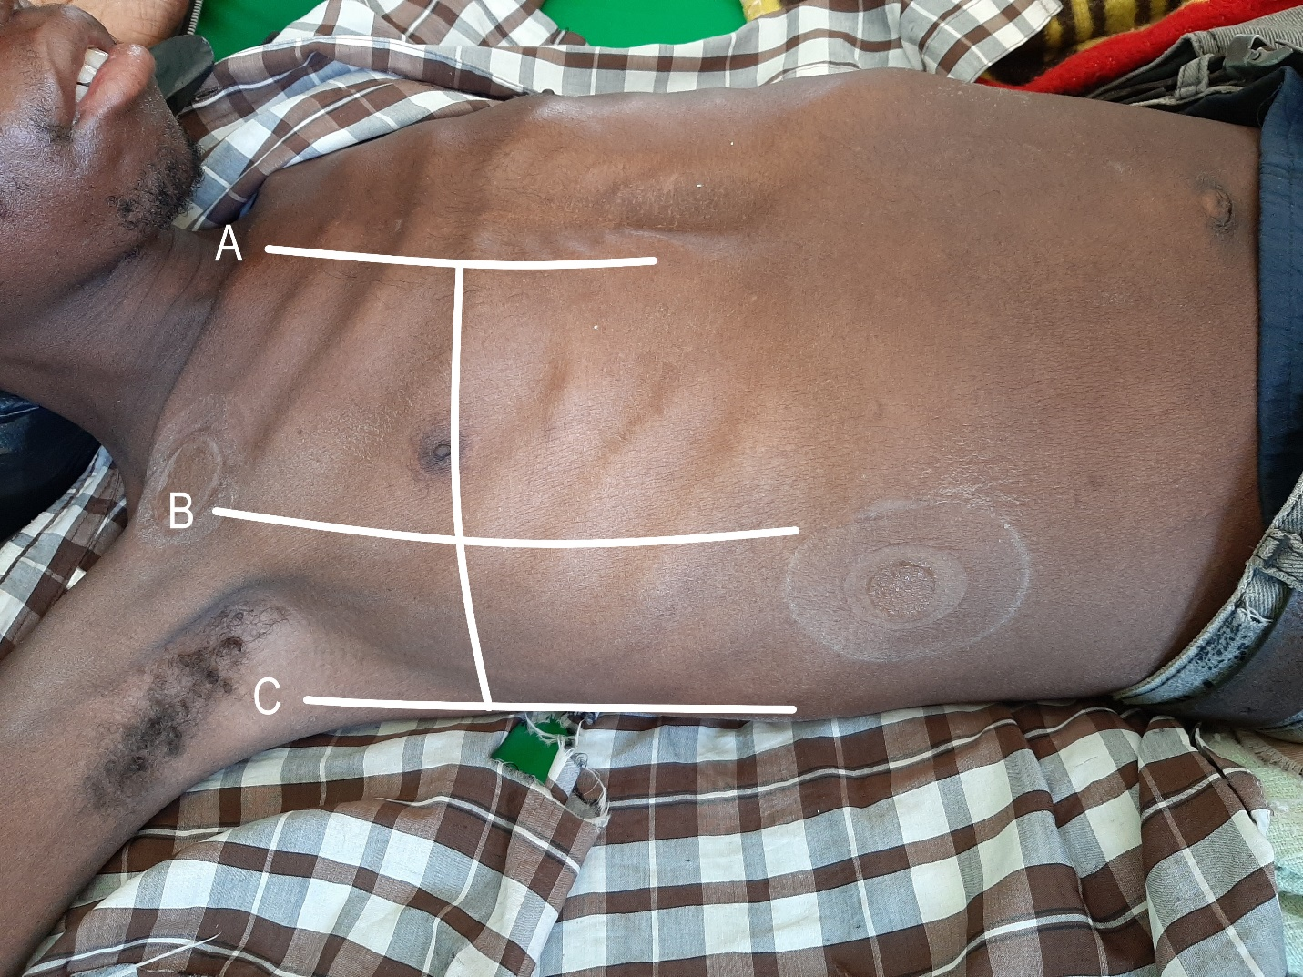
References

1. Volpicelli G, Mussa A, Garofalo G, Cardinale L, Casoli G, Perotto F, Fava C, Frascisco M. Bedside lung ultrasound in the assessment of alveolar-interstitial syndrome. Am J Emerg Med 2006;24:689–696.
2. Volpicelli G, Elbarbary M, Blaivas M, Lichtenstein DA, Mathis G, Kirkpatrick AW, Melniker L, Gargani L, Noble VE, Via G, Dean A, Tsung JW, Soldati G, Copetti R, Bouhemad B, Reissig A, Agricola E, Rouby JJ, Arbelot C, Liteplo A, Sargsyan A, Silva F, Hoppmann R, Breitkreutz R, Seibel A, Neri L, Storti E, Petrovic T. International evidence-based recommendations for point-of-care lung ultrasound. Intensive Care Med 2012;38:577–591.
3. Lichtenstein DA. Lung ultrasound in the critically ill. Ann Intensive Care 2014;4:.
4. Platz E, Lewis EF, Uno H, Peck J, Pivetta E, Merz AA, Hempel D, Wilson C, Frasure SE, Jhund PS, Cheng S, Solomon SD. Detection and prognostic value of pulmonary congestion by lung ultrasound in ambulatory heart failure patients. Eur Heart J 2016;37:1244–1251.
5. Noble VE, Murray AF, Capp R, Sylvia-Reardon MH, Steele DJR, Liteplo A. Ultrasound assessment for extravascular lung water in patients undergoing hemodialysis: Time course for resolution. Chest 2009;135:1433–1439.

