Supplementary information I

Historical background
It was not the characteristic of clustering that had been discovered firstly, but the phenomenon that some accidents are accompanied with earthquakes. On Nov 14th , 2001, a severe earthquake measured 8.1 on the Richter scale hitted Kunlun Mt, West China(E90. 53, N35. 92). During the following week, five fatal gas explosions successively occurred in coal mines of ShanXi Province, making 94 deaths. The coincidence drew attentions of several Chinese geologists. The five gas explosions were presumably caused by the fatal earthquake. Seismological Bureau of Shanxi investigated on the affection between 8.2-magnitude earthquake and the five gas explosions¹, which ultimately got an inconclusive result because of multiple factors, such as incompleted gas monitoring records. A hypothesis put forward² that the fatal magnitude-8.1 earthquake brought about fractures deep in crust, by which the hydrogen from the deep crust moves upward on a large scope, finally found its way into mining space and caused gas accidents.
Not confined to these five gas explosions, the author turned to all the historical accident records of and found more gas accidents accompanied by earthquakes (magnitude 0-5) nearby. Then the author³ analyzed the processes of stress perturbation, it seems that the increasing stress may produce crannies around the mining space through which gas of coal bed is released in advance and the distending stress increases the penetrability of the coal bed which permits more gas to release from coal walls or coal pillars over a larger scope. Both the increasing and decreasing stress can lead to higher gas content.
As early as 2002, I noticed an obvious phenomena: In historical records, for some areas, either no accidents occur or several accidents occur together over several days. Limited by the insufficient accident records accumulated at that time, the further research was put off until Sep, 2006 and the types of accidents were extended from gas accidents alone to all kinds of accidents.
In 1990s, mine quakes in some Chinese coal mines were first found to tend to response with natural earthquakes^{4,5}. Regarded as stress window of tectonic field, mine quakes were expected to be capable to predict some fatal earthquakes or to discover the deeper geological principle of the coal mine accidents, which was the earliest, but not so obvious evidence that local stress fluctuates with tectonic stress.

References
- Y. Q. Chuai et al. A study on relation between gas explosion at coal mines of Shanxi Province and west Kunlun Mountain coal earthquake of m8. 1. Eearthquake Research In Shanxi. 115(4). 6-13 (Oct. 2003)
- H. D. Liang. Are gas explosions in coalmines in Shanxi linked to the earthquake at Kunlun Mountain?. Science Technology and Engineering. 2, 197-200( 2002).
- B. Chen, W. T. Zheng, H. D. Liang, Mechanism on interaction of earthquake activity into gas accident in coal mining underground. Journal of China Coal Society 30(4). 447-450(Sep, 2005).
- G. M. Zhang, Z. J. Ma, Y. Z. Zhang, Progress of research on the “window” of regional stress field[J]. Chinese Seismic. (Mar, 1985)
- H P Xiao. Coal mine quakes for tectonic mechanism. Hunan Geology. 18(213), 141-146(1999).

Data source
- Meteorological Data: The Chinese National Meteorological Data Share Service System
Website:http://cdc.cma.gov.cn
- Coal mine accident records :The State Administration of Coal Mine Safety Supervision Bureau.
Website: http://media.chinasafety.gov.cn:8090/iSystem/shigumain.jsp
- Earthquake Records: Chinese Earthquake Network Directory(E70-145°,N10-55°)
Website:http://www.csndmc.ac.cn/newweb/data.htm
- The number and the structure of Chinese coalmines
Website: Government website: http://www.chinasafety.gov.cn/file/2004-01/kjgh-3.doc

Methods
Once the readers agree on the clustering feature, the following questions may come up: How many accidents are involved in clustering series? How many are accompanied by earthquakes nearby ? How long do the series generally last (which potentially is the time for stress to transmit)? These questions are well resolved by the following simple methods.
Euclidean distance has been widely used in geological, meteorological and demographic researches. By some simple processes, the spatial clustering degree can be acquired easily. For example, if there are n objects in a 2D space, each possesses n-1 distances between it and the rest n-1 objects (Fig.1).
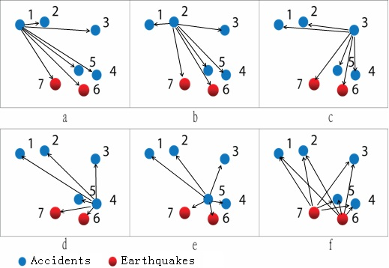
Figure 1 | Each object possesses n-1 distances of between it and the rest n-1 neighboring objects.
Calculating all the objects one by one, in mathematics, this kind of calculation belongs to the complete arrangement.

Method Illustration
For a given object, all the n-1 distances between it and the rest n-1 objects are compared with certain distance threshold. If some are shorter or longer than the distance threshold, the related objects will be included into or excluded from series. The object newly included into series will be selected as the next central object, through which new neighbors within the scope of threshold will be picked out. The whole process is accomplished by recursive functions in programming (Fig.2).
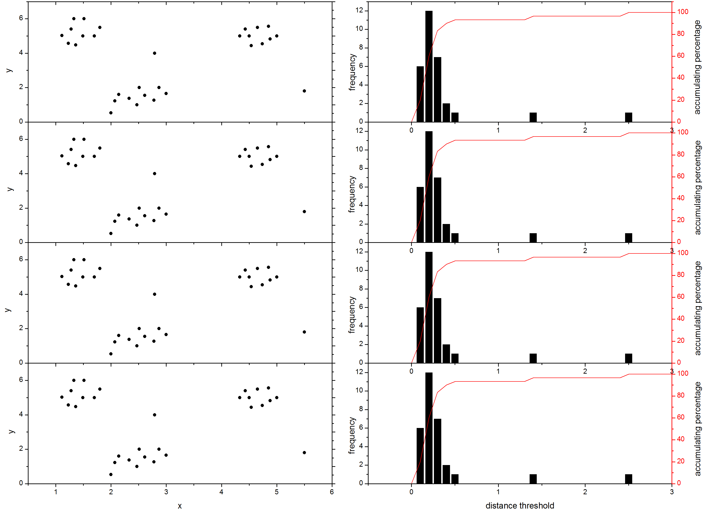
threshold of 0.3
threshold of 0.4

threshold of 0.1
threshold of 0.2

Figure 2| The mechanism of spatial clustering degree: Under different distance threshold, the percentage of objects involved in clustering series is different. Continuous increased distance thresholds can get frequency distribution curve and the accumulation curve, according to which the ratio of accidents presents clustering feature can be acquired. For example, under distance threshold of 0.1(blue lines) the ratio is 20%; under distance threshold of 0.2, the ratio is 60%; under distance threshold of 0.3, the ratio is 83.33%; under distance threshold of 0.4, the ratio is 90%.

Comparision of clustering feature among different distributions
In space, there exist three types of distributions: regular distribution, discrete distribution and clustering distribution(Fig.3.a,b,c),. By the above method, spatial clustering degree calculation can be made on all the distribution types. For example, at the distance threshold of 0.4, for the three types of distributions, under distance threshold of 0.4, the ratio of objects involved in clustering series for regular distribution is 0% (Fig.3.d), for discrete distribution is 30% (Fig.3.e) and for clustering distribution is 83.33% (Fig.3.f). Under certain distance threshold, different distribution types will get different ratio of objects involved in clustering series.
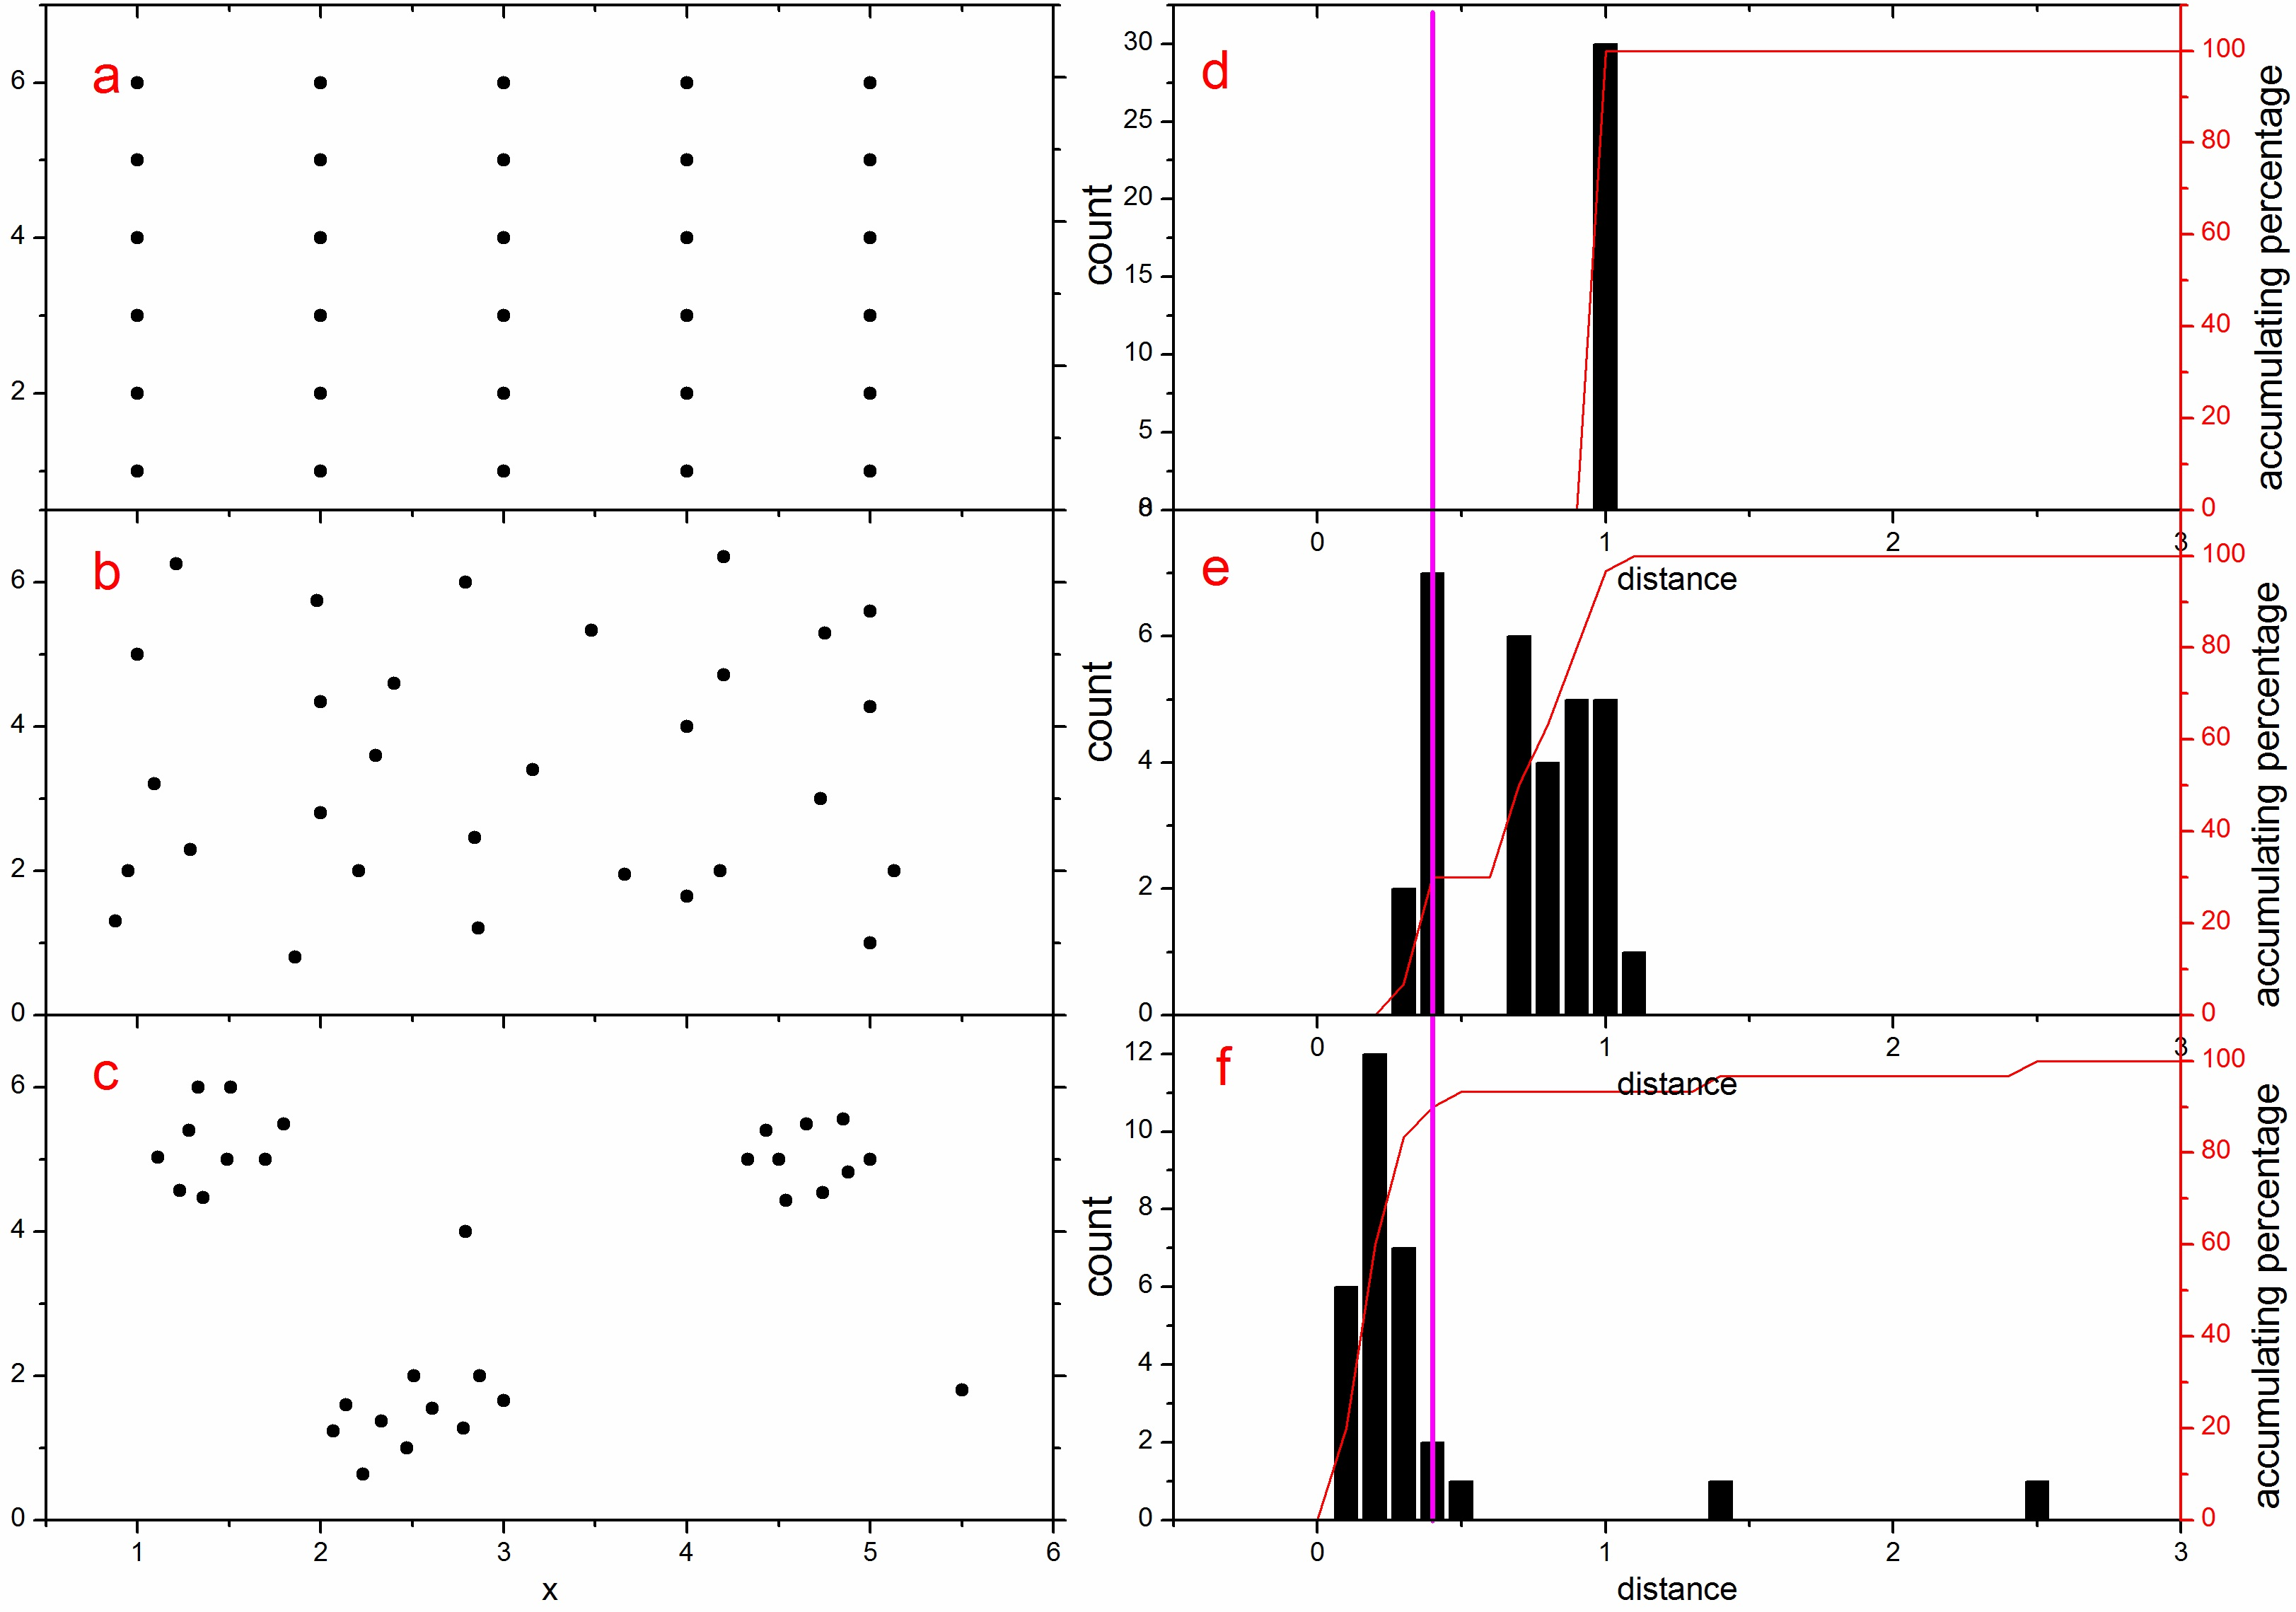
Figure 3 |Different distribution types on 2D space, the frequency distribution and the accumulation of the accidents involved in clustering series under different distance thresholds. Under certain distance threshold, different distribution types will get different ratio of objects involved in clustering series.
By this method, on the one hand, all the accidents associated in clustering series can be picked out, on the other hand, different distance thresholds will get different ratios of accidents involved in clustering series. Then the frequency distribution curves along distance axis can be acquired, on which the ratio of accidents involved in clustering series and the number of earthquakes accompanied with accidents can be acquired.

The ratio of accidents associated in series and the number of earthquakes accompanied with accidents
At threshold of 0~3 kilometers, as many as 157 accidents occurred in coal mines of the same town which were presumably caused by the neighboring coal mine accidents directly (Fig.4 left). At threshold of 50±3 kilometers, 25.98% are involved in series. Others, at 100±3 kilometers, 47.45% involved, at 170±3 kilometers, 65.2% involved. Similarly, the number of earthquakes accompanied with accidents is also acquired(Fig.4 right), at threshold of 50±3 kilometers, 82 accidents are accompanied by earthquakes, at 100±3 kilometers, 372 accidents are accompanied by earthquakes, at threshold of 170±3 kilometers, 696 accidents are accompanied by earthquakes.

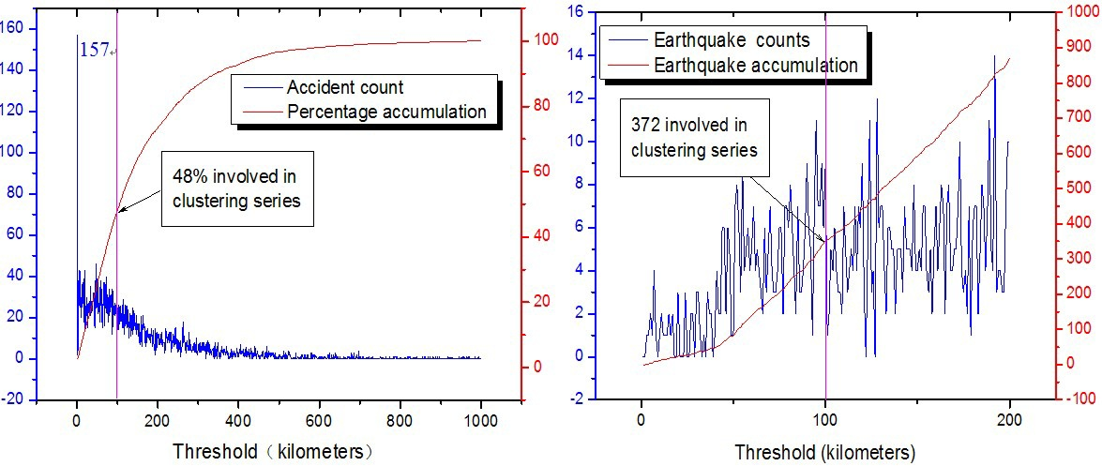
Figure 4 | The left is accumulative percentage (right y-axis) and counts (left y-axis) of accident associated in clustering series (earthquakes accompanied are excluded), x-axis is the distance among accident mines. The right is frequency (right y-axis) and accumulations of earthquakes accompanied with accidents (left y-axis) x-axis is the distance between epicenters and accident mines.

The duration of series
To a given clustering series, the date of the latest accident minus that of the earliest accident equals the duration of the series. Frequency distribution of series along x-axis is presented on curves (Fig 5). As is shown, most series lasted for 2 days, quite a few lasted for 1 day and 3 days. Those lasting for longer than 4 days decrease sharply, but which coincided with fatal earthquakes intensively.

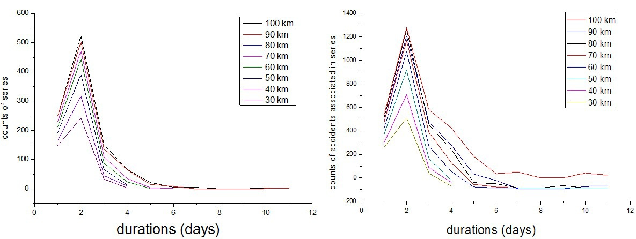
Figure 5 | The duration distribution of series durations at different thresholds (left), The duration distribution of associated accidents under different thresholds (right).

The relationship between threshold and clustering series
The longer thresholds get the more series and the more associated accidents, but the maximum number of series(1134 series) is acquired at threshold of 170 km, in which 4688 events are involved(3848 are accidents, accounting for 65.2%, another 840 accidents accompanied by earthquakes). Under thresholds longer than 170 km, more small series will be merged into a larger one and the number of series will begin to decrease (Fig6). The author failed to obtain the optimal threshold on mathematics, just acquire the frequency of the clustering series under thresholds ranging from 0~600km. The distance thresholds ranging from 10~90 km can get more obvious series, while the thresholds longer than 170 km get ambiguous series. A conservative threshold is recommended as 100~130 kilometers.
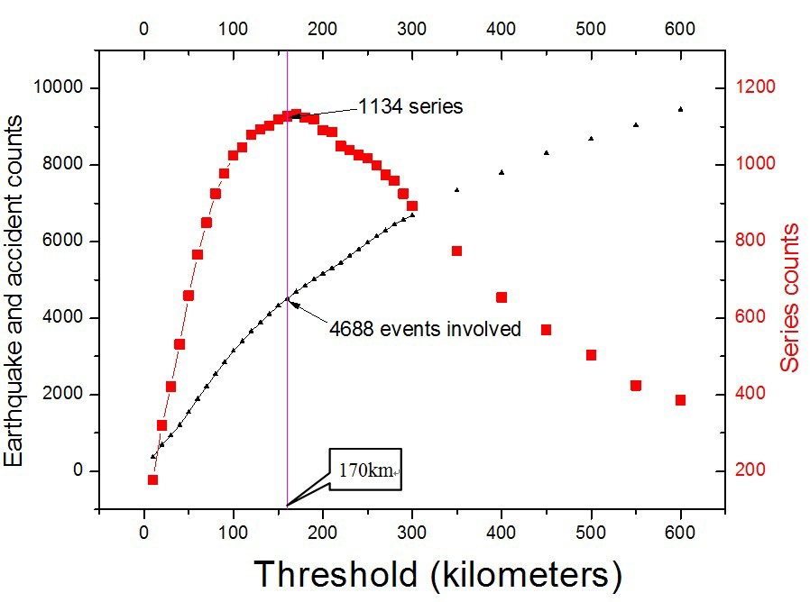
Figure 6 | The frequency distribution of series and accidents associated, with distance threshold increasing. Left y-axis is the accumulation of accidents and earthquakes associated in series. Right y-axis is frequency of series, x-axis is the length of distance threshold, under which the amount of series are calculated. Threshold of 170-kilometer corresponds to the 1134 series, in which 3848 accidents and 840 earthquakes were involved.

Clustering samples
Nearly every day, there exist clustering series. All kinds of accidents, such as roof accident, gas accident, water accident, even transporting accident can occur on adjacent areas successively.
Case 1: All kinds of accidents are involved.
On May 20th, 2004, there occurred 6 accidents all over the Chinese coalmines, but 3 occurred in the coalmines of Panzhihua City Sichuan Province which include a transporting accident in Yaojiaping Coalmine (1 death), a roof accident Wangjiawan Coalmine( 2 deaths ) and a transporting accident in Dabaoding Coalmine(2 deaths). The three coalmines are 0~7.9±3 km far away (Series 454, in Fig.3) .

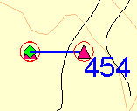
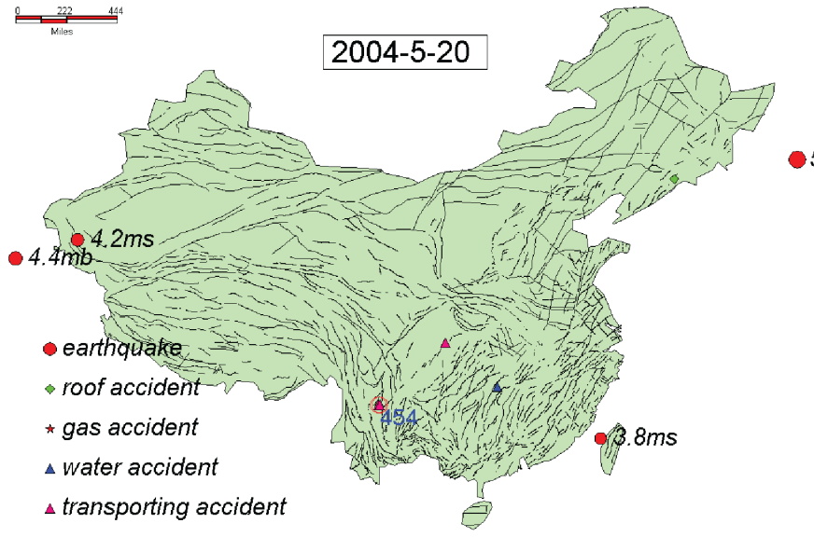
Figure 3 | All the earthquakes and coalmine accidents occurred on 20th May,2004.

Case 2: Roof accidents involved
On May 24th, 2004, there occurred 6 accidents all over the Chinese coalmines. On May 24th , 2004, there occurred 3 roof accidents respectively Tiaoshuijing Coalmine (1 death), Taiping Coalmine(1 death ) and Dabaoding Coalmine(1 death) of west of Panzhihua. The three coalmines are 0~7.9±3 km far away ( Series 456, in Fig.4).
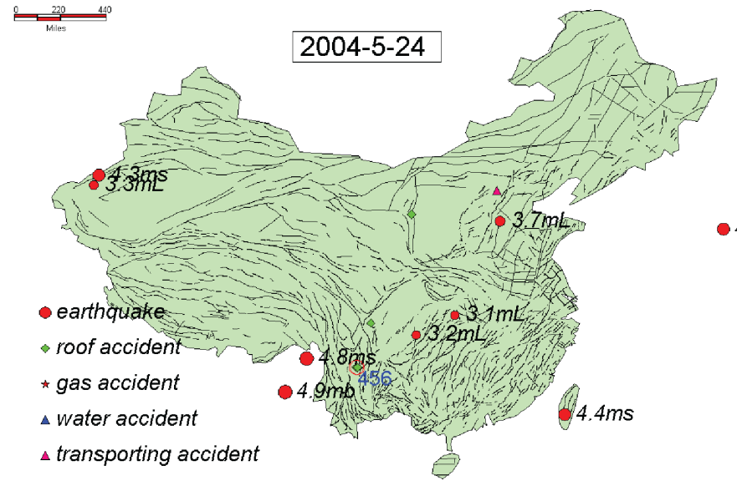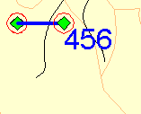
Figure 4 | All the earthquakes and coalmine accidents occurred on 24th May,2004.

It is purely a coincidence or there are some elements that control two transporting accidents and one roof accidents occurring successively together. The stress fluctuation is the only element that can cause accidents over a large scope. The fast fluctuation, like pressure bump, destroys railway or throw the couch out of railway; the slowly process(deformations) destroys the railway in some special sector. (Fig.3.1-7)
Of all the coalmine accidents, there were only two cases that three accidents successively occurred in single area within a week, causing 7 deaths, of which 4 accdients occurred in Taiping Coalmine, causing 5 deaths. On a larger scope, these accidents are companied by five earthquakes(ms 3~4.9) in adjacent areas during May 23 th -24th on which the stress fluctuation is doubted to play a role.

Case 2：Roof accidents involved
On Dec 23th 2003, a roof accident occurred at Fengsheng Coalmine at Baohua Town Liupanshui City Guizhou Province, causing 1 death. In the same day, another roof accident attacked Damawo Coalmine of Zongling Town Nayong County Guizhou Province which are 18±3 km far away,causing 1 death ( Series 401, in Fig.5).
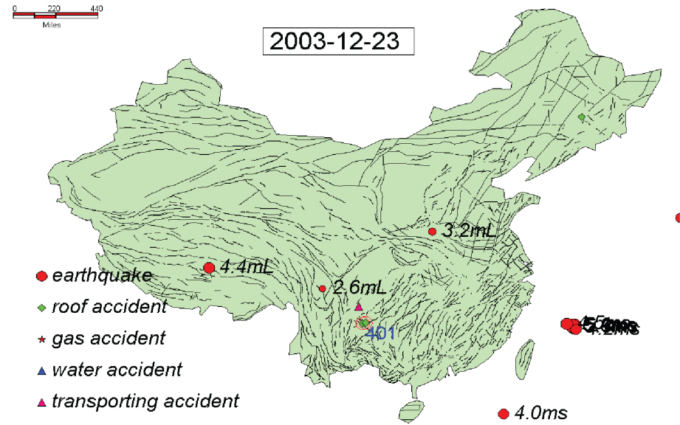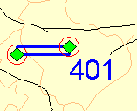
Figure 5 | All the earthquakes and coalmine accidents occurred on 23th Dec,2003.

Case 3：Gas explosions involved
On Sep 12th 2000, at 14:50 o’clock, a gas explosion occurred at Tenglong Coalmine at Xinhua Town Jinsha County Guizhou Province, causing 5 deaths and 2 seriously wounded. On Sep 13th 2000, at 3:00,another gas explosion occurred at Malinwan Coalmine of Anliu Town Qingzhen City Guizhou Province, causing 21 deaths. The two mines are 43±3 km far away ( Series 0, in Fig.6).

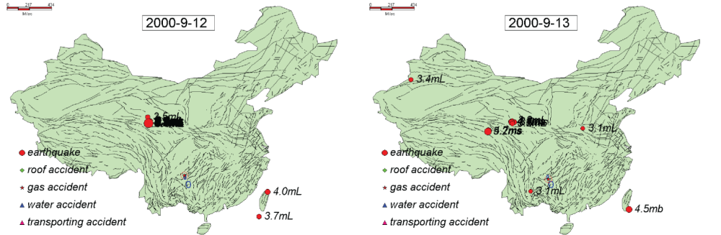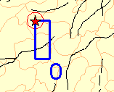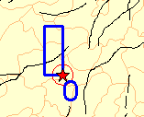
Figure 6 | All the earthquakes and coalmine accidents occurred during the period of 12th and 13th Sep,2000.

Case 4:Not only gas explosion, even gas asphyxia can occur successively in adjacent areas
On Jan 16th 2002, two gas asphyxia occurred in Guizhou Province, one in Biye Coalmine Panshui Town in Zunyi County at 1:00 o’clock, causing 2 deaths and 3 severe wounded. At about 4:00 o’clock, another gas asphyxia occurred in Kuayan Coalmine in Qingzhen City, causing 3 deaths which are 49±3 km away from each other. What’s more, at about 8:00 o’clock, a transporting accident occurred in TongChun Coalmine in Qingzhen City causing 1 death ( Series 70, in Fig.7) .
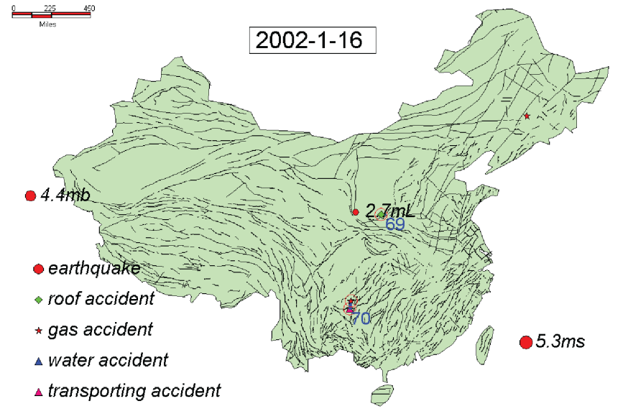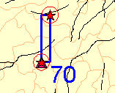
Figure 7 | All the earthquakes and coalmine accidents occurred on 16th Jan,2002.
Other gas asphyxia occurring in adjacent areas, see the dates of 2002-1-16 2003-2-10~13 2003-3-11~13 2003-6-18~19 2003-7-8~9 2003-8-21 2003-9-9~10 2003-9-25~26 29~30 2003-10-8~10 2003-12-20~21 2004-4-16 2005-1-13~14 2005-4-14 2005-4-25~26 28~29 2005-6-1~2 2005-8-2~3 6~9 18~19 2005-10-24~25.

Earthquakes accompanied with accidents
As mentioned, there are many accidents accompanied by earthquakes nearby.
Case 1：
On 11th Oct 2001,8:04，there occurred an earthquake(with magnititude of 3.9mL）in southeast of Chongqing Fengjie County Rural Tianchi(E110.45,N30.94), earthquake depth is 17km. On 12th Oct 2001,at 10:20, Jiangouwan Coalmine in Chongqing Fengjie County Rural Tianchi occurred a roof accidents, 54.4±3 km away. As is show in fig，there were no earthquakes and accidents within 15 days before 11th Oct, 2001 ( Series 31, in Fig.8) .
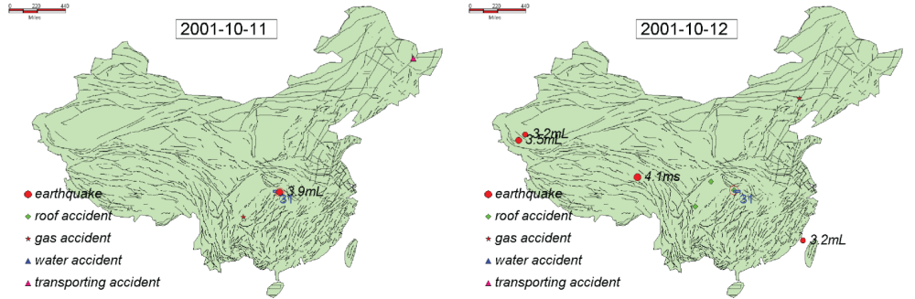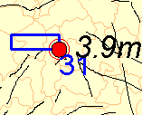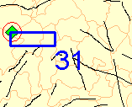
Figure 8 | All the earthquakes and coalmine accidents occurred during the period of 11th and 12th Oct,2001.
Case 2:
On Apr 20th, 2005, 52.7±3 kilometers far away to northeast of Yunjialing Coalmine of Xitushan Town Wu’an City Hebei Province（E114.67,N37.41）,a ms4.7 earthquake occurred. In the next day, at 11:45 o’clock , a roof accident occurred in Yunjialing Coalmine, causing 1 death.(Series 113, in Fig.9)

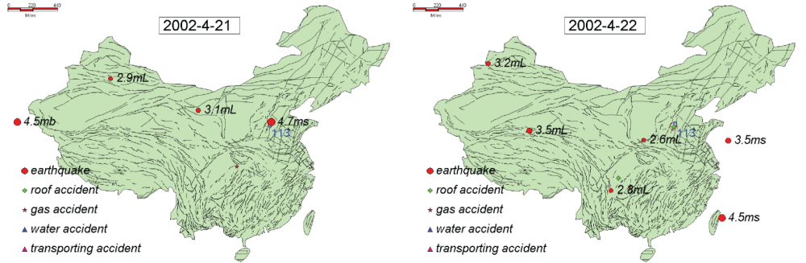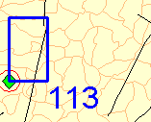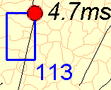
Figure 9 | All the earthquakes and coalmine accidents occurred during the period of 21th and 22th April, 2002.
Case 3：
On Sep 23th, 2003,two accidents are companied by earthquake.
Location 1:
On Sep 23th,2003, at 14:30 o’clock, there occurred a roof accident in Lvhuan Coalmine in Panzhihua City Sichuan Province, In the same day, at 22:59 and 23:15，two earthquake occurred to southwest of the coalmine（E101.22, N26.06; E101.14,N25.94）which were 54.2km，44.7km away from coalmine, the earthquake depth are 17±3 km and 14±3 km. ( Series 346, in Fig.10)
Location 2:
On 23th Sep,2003, at 20:59, there occurred an earthquake with magnitude of 3.3mL (E113.14,N40.2）which is 5.7 km away from New Shangshenjian Coalmine Datong City, Shanxi Province. The earthquake depth is 25±3 km. On 24th Sep,2003, at 8:00, gas gush out informally beyond control in New Shangshenjian Coalmine, causing five deaths and three injured. ( Series 347, in Fig.10)

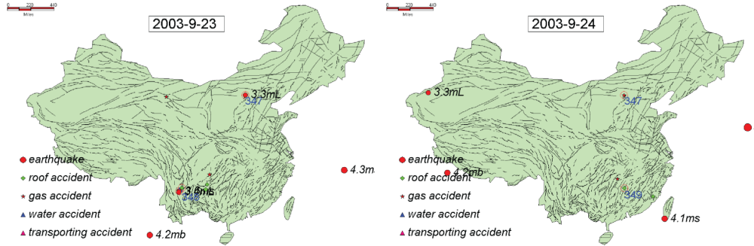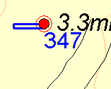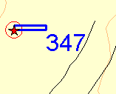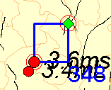
Figure 10 | All the earthquakes and coalmine accidents occurred during the period of 23th and 24th Sep, 2003.

Case 3:
Location 1:
On Oct 25th 2005, 14.1±3 km to northeast of Ximing Town Taiyuan City Shanxi Province（E112.69,N37.
91）,a 3.4(mL)earthquake occurred and earthquake depth is 11km. In the same day,at 17 o’clock , a gas explosion occurred in Jiuyuan Coalmine causing 2 deaths, 3 missing.(Series 634, in Fig.11)
Location 2:
On Oct 25th 2005, at 23:35, there occurred a 2.9(Ml) earthquake to 29.6±3 km away from Hongcun Town Wushan County Chongqing City（E110.13, N31.09, the depth of hypocenter was 20km.On Oct 26th 2005, a transport accident occurred in Qiaomawan Coalmine, causing 1 death. (Series 635, in Fig.11)
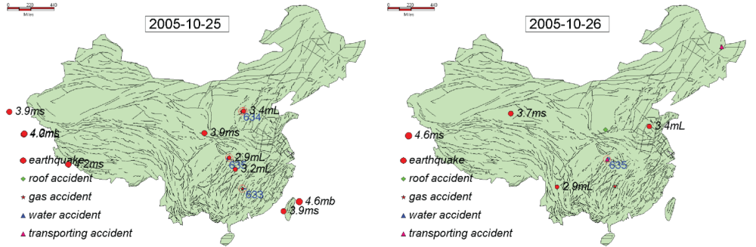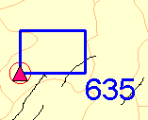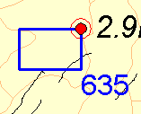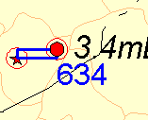
Figure 11 | All the earthquakes and coalmine accidents occurred during the period of 25th and 26th Oct, 2005.

Water accident accompanied by earthquakes
Case 1: Water accidents involved
On Jul 8th 2002, a water accident occurred in Gaokeng Coalmine Gaokeng Town Pingxiang Ctiy Jiangxi Province,causing 1 death. In the next day. on Jul 9th, an earthquake（E114.62，N28）with magnitude of 3.8mL occurred to northeast of coalmine, 47.7±3 kilometers away. ( Series 95, in Fig.12)

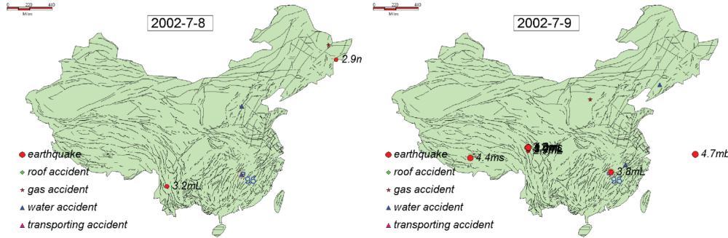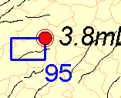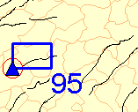
Figure 12 | All the earthquakes and coalmine accidents occurred during the period of 8th and 9th Jul, 2002.

Case 2：Water accidents involved
On Jul 23th 2002, at 00:31:38.5 a 3.4 mL earthquake occurred in Miquan Ctiy Xinjiang(E87.06,N43.79), at 2:40, 30.83±3 kilometers far away, a water accident occurred in Shagou Coalmine of Gumudi Town Miquan Ctiy Xinjiang, causing 3 deaths. (Series 101, in Fig.13)
Case 3：
On Jan 20th 2003, at 10:0, a water accident occurred in Pingan Coalmine of Cihua Town Yichun Ctiy Jiangxi province, causing 2 deaths. At 10:50, a water accident occurred in Wuzipo Coalmine of Huangfengqiao Town You County Zhuzhou Ctiy Hunan Province,causing 2 deaths. They are 55±3 kilometers far away(Fig.13).
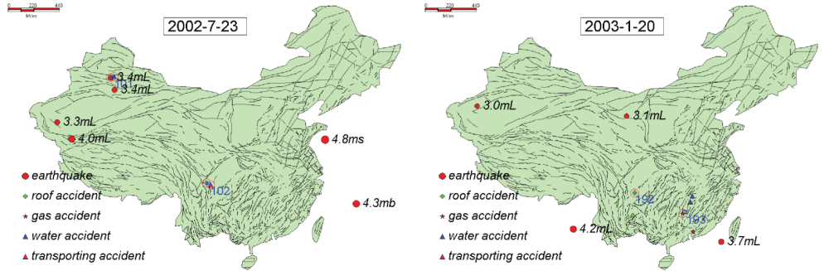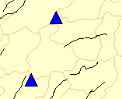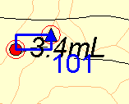
Figure 13 | All the earthquakes and coalmine accidents occurred on 23th Jul, 2002 and on 20th Jan, 2003

Under threshold of 100 km, 372 coalmine accidents are accompanied by earthquakes nearby. Under threshold of 80 km, 234 coalmine accidents are accompanied by earthquakes nearby.

More clustered samples
I provide three months of clustering series(under threshold of 80km). To access all the clustering series and all the accidents, please download software which can display all the series.
Demonstration:
All the accidents and earthquakes of each day are mapped to a map . The figures on the map, such as 424,426 stand for the ID of clustering series. The blue rectangle is the scope of series. Of all the series, some last for one day, like series 424, 426, those lasting for more than one day are connected by red arrow line(series 423,425).
If printed, the paper size is recommended to be A3 at least. The maps is of high resolution that can be zoomed in for 300% the size of A3

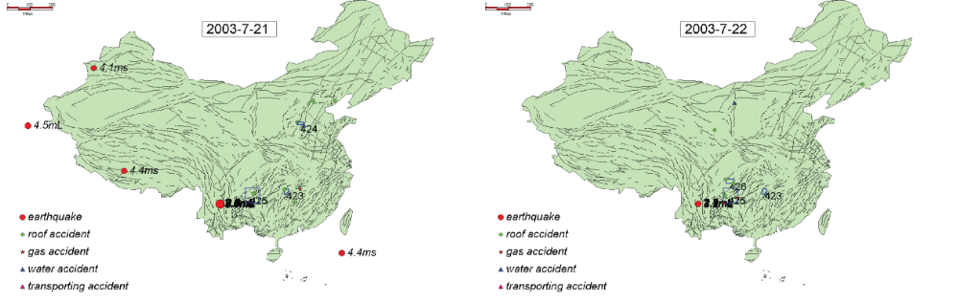
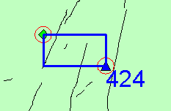
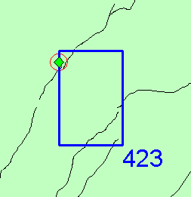
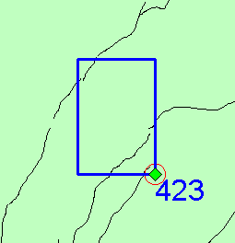
Series lasting for 1 day
Accident involved
Rectangle scope of Series
Series lasting for 2 days

