Tissue Quality Evaluation for Brain Perfusion/Dissection Specimens

- Scope and Applicability: This SOP provides guidance in the assessment of quality of tissues post perfusion and dissection and applies to all such procedures. Perfusion and dissection quality will be categorized on the following scale: perfect, good, fair, and poor. This SOP also presents written descriptions, and images, of specific category attributes.
- Equipment
  - Computer with network access.
- Safety:
  - See Vivarium Entry Procedures and Movement Between Rooms
Warning: Personal Protective Equipment (PPE) should always be used while operating this protocol. If you are unsure what PPE you should be using, see your immediate supervisor.
- Output:
  - Brains that have been dissected, or perfused and dissected, and have been visualized and assessed for quality information for use by project leads.
- Reference Documents:
  - AF0061 Brain Dissection of Post-natal mice
    - https://www.protocols.io/view/brain-dissection-of-post-natal-mice-besnjede
  - AF0075 Mouse Cardiac Perfusion Fixation and Brain Collection
    - https://www.protocols.io/view/mouse-cardiac-perfusion-fixation-and-brain-collect-bg5vjy66

- Methodology/Procedures:
  - Perfusion quality assessment:
    - During perfusion, there is a sequence of events to look for:
      - After the right atrium is clipped and saline is pumped into the left ventricle the liver should start to clear, turning an ashen grey color.
      - As soon as the animal starts receiving PFA a reaction will begin:
        - The tail will flick, and the muscles will begin to twitch, sometimes quite violently.
        - There can be intestinal expansion, where the internal organs expand slightly in size and start to protrude from the body.
        - After the perfusion, the animal should be stiff all over, including all the internal organs and the extremities. The lungs should stay pink and not have inflated. No solutions dripped out of the nose or mouth. If the lungs inflated or solution dripped out of the nose or mouth, make sure to note this on the task.
  - Perfused brain dissection quality assessment:
    - After the brain has been harvested it should have an all-around dull cream color, with the brain stem being white. Veins should no longer be visible on the surface of the brain.
    - The perfused brain must also be observed for damage (from tools, dura or bones). The main things to look for are:
      - Slices/grazing into the tissue (where no tissue has been removed).
      - Damaged or missing olfactory bulbs and/or paraflocculi.
      - Tissue has been nicked or removed.
  - Fresh brain dissection quality assessment:
    - After a brain has been dissected, damage to the tissue will be assessed. Care must be taken to look at all sides and structures of the brain; because fresh collections have not been fixed/perfused the tissue will be softer and easier to damage. Main things to look for are:
      - Slices into the tissue (from tools, dura or bone).
      - Nicks into the tissue that can be visible as chunks of tissue that have been removed.
      - Missing paraflocculi and/or olfactory bulbs.
      - Olfactory bulbs or cerebellum have been stretched or disrupted and no longer match up with the cortex.
  - Some transgenic lines will have expression on the brain, the location of the expression should be noted on the task. Expression looks different from an improperly perfused brain that is showing blushiness (red/pink spots). Expression is usually uniform and/or symmetrical. If expression cannot be determined, note “possible expression”.
  - Assign quality assessment using Table 1 in the Appendix (Section 8.1) which defines the scale for the quality assessment classifications.
- Appendix:
  - Quality assessment classifications
    - Assessment table defining classifications
Scale | Perfusion | Perfused Brain Dissection | Fresh Frozen Brain Dissection
Perfect | - Liver cleared well and is no longer red  - Lungs retain normal color (pinkish–red) and did not inflate  - There was a strong visible reaction to PFA throughout the whole body (muscle twitching, intestinal expansion and tail flexing)  - Body is stiff everywhere after perfusion | - Brain tissue is firm with no red/pink spots and vessels are cleared  - No dissection damage at all to the brain*  - No damage to brain stem, leaving 1-2 mm of brain stem intact. | - There is no damage* to the brain at all  - No damage to brain stem, leaving 1-2 mm of brain stem intact
Good | - Liver cleared well, but one of the lobes may be slightly red at the tips  - Lungs are still normal color, but slightly inflated; no solution out of the mouth or nose  - There is a visible reaction to PFA throughout the body (muscle twitching, tail flexing and little to no intestinal expansion)  - Body is stiff after perfusion | - Brain tissue is firm with no red/pink spots and vessels are cleared  - There may be a missing paraflocculus  - Slight bone fragment disruption to the olfactory bulbs  - Brain stem may be shorter than 1-2 mm, but no dissection damage present | - One paraflocculi might be missing  - Slight bone fragment disruption to the olfactory bulbs  Brain stem may be shorter than 1-2 mm, one area of slight grazing on the cortex or cerebellum
Fair | - Very little visible reaction to PFA (limited to tail flexing, little to no muscle twitching and no intestinal expansion)  - The liver cleared, but some lobes are still red/splotchy  - The body is slightly stiff after perfusion  - The lungs are slightly inflated; solution came out of the nose at a very slow rate toward the last half of the perfusion | - Slight pink area on cerebellum, but no vessels showing  - Tissue grazed during dissection, but no tissue has been removed  - Both paraflocculi may be missing  - Possible damage to brain stem or brains stem left shorter than 1-2 mm | - Tissue grazed during dissection, but no tissue has been removed  - Both paraflocculi may be missing  - Possible damage to brain stem or brain stem left shorter than 1-2 mm
Poor | - Liver did not clear well or at all  - There was no reaction to PFA, or it was very slight  - The body is not stiff after the perfusion  - Lungs inflated and are bright white with solution coming out of the nose and mouth | - Brain is not firm  - You can see vessels in the brain and/or pink spots  - Dissection damage where tissue has been removed or slices into the tissue by dura or tools  - Both paraflocculi missing and/or both olfactory bulbs missing  - Severe damage to brain stem or brain stem missing | - Cerebellum is separated from the cortex  - Tissue loss in the cortex, cerebellum or brain stem  - Very deep damage caused by dura removal or tools
*Damage could be present from experimental procedures
Table 1: Assessment chart to follow when looking at tissues
    - Example Images
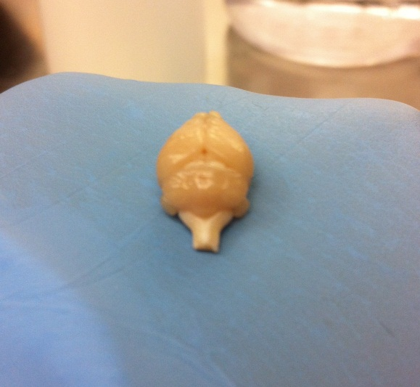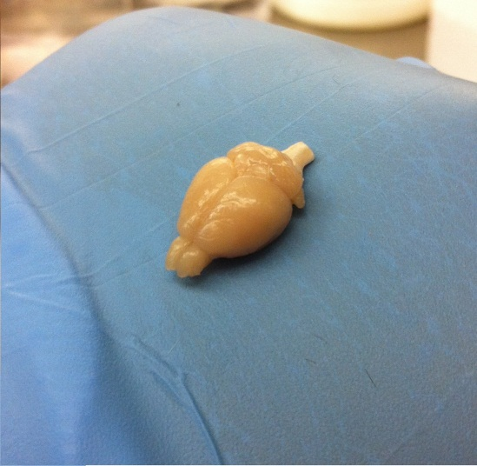
Figure 1: Pictures of perfectly perfused and dissected brains.

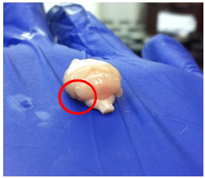
Figure 2: The left paraflocculus is missing in this picture (circled in red); this brain would still be considered ‘Good’ with only one paraflocculus missing.

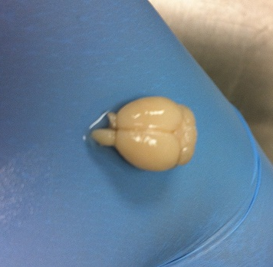
Figure 3: A large portion of the right olfactory bulb has been removed from this specimen. This can happen from tool, bone or dura damage.

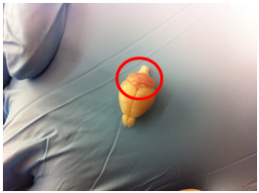
Figure 4: The cerebellum (circled in red) is more pinkish red than the washed-out color of the cortex and the white of the spinal cord. Classified as ‘Fair’.

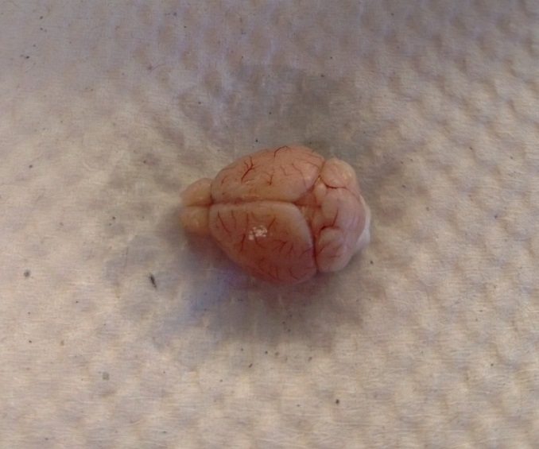
Figure 5: An example of a poorly perfused brain, as indicated by the blood vessels that are visible on the surface of the cortex and cerebellum. Classified as ‘Poor’.

