TissueCyte Image QC

- Scope and Applicability: This QC step occurs after the week of TissueCyte runs, and prior to analysis by the Data Annotation group. It is useful in determining issues that may occur with the equipment or data pipeline, that can then be addressed immediately in order to limit workflow interruptions.

- Materials:
  - Laboratory Information Management System
  - Excel Tracking Sheet (see below for necessary columns).
- Equipment:
  - Computer with access to the network.
- Output: QC passed or failed TissueCyte runplans as well as information on system functions and potential problem areas.
- Reference Documents:
  - PF0262 Core Protocol for Serial Imaging of Fluorescently-Labeled Mouse Brain on the TissueCyte 1000 System
    - https://www.protocols.io/view/core-protocol-for-serial-imaging-of-fluorescently-bdvmi646/abstract

- Setup:
  - Open your Laboratory Information Management System.
Methodology/Procedures:
  - Check out and open the Excel Tracking Sheet.
  - Find the most recent runs on the bottom of the sheet to determine what needs to be examined.
  - In your Laboratory Information Management System, search for the image series of the runplan that is to be examined.
  - Open “contact sheet”.
  - Review this overview of all the images. Click on a particular image to view it more closely when necessary.
  - Pass or fail the run using the QC column of the Excel Tracking Sheet.
    - If run passes: select “Pass” from the dropdown in the “QC” column.
    - If run fails: select “Fail” from the dropdown, and specify reasons in the “QC Comments” column. Then search your Laboratory Information Management System for the failed runplan, select “Edit”, and change the “Runplan state” to “fail”.
  - Images will then be analyzed by the Data Annotation group. Annotation personnel may pass or fail data if it meets or fails to meet their criteria.
    - TissueCyte QC personnel will periodically go through the recently annotated runplans to see what has passed/failed, and will update the Excel Tracking Sheet noting Pass/Fail in the “QA” column and entering any comments made by the Data Annotation group.
    - TissueCyte QC personnel will also update the “Runplan state” in the Laboratory Information Management System: For those runplans that Annotation has failed, ensure the “Runplan state” reads “fail”. For those runplans that Annotations has passed, change the “Runplan” state to “pass”.
- Take Down:
  - Save and check in the Excel Tracking Sheet so it can be edited by others.
- Appendix:
  - Example images and terminology definitions
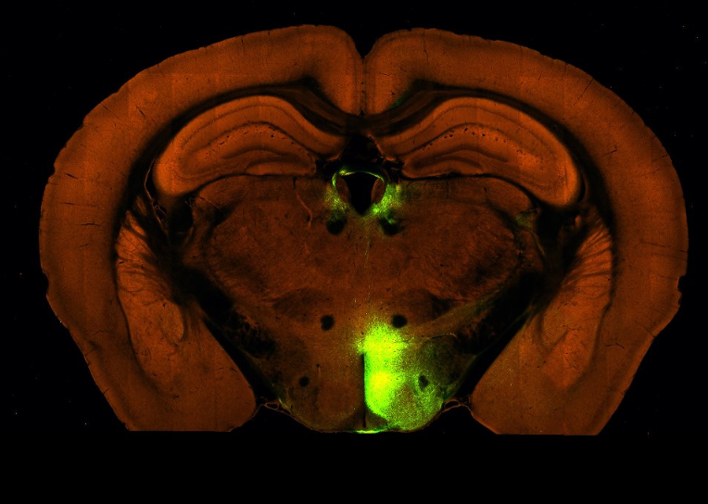
Figure 1. An example of an image with the bottom cut off.
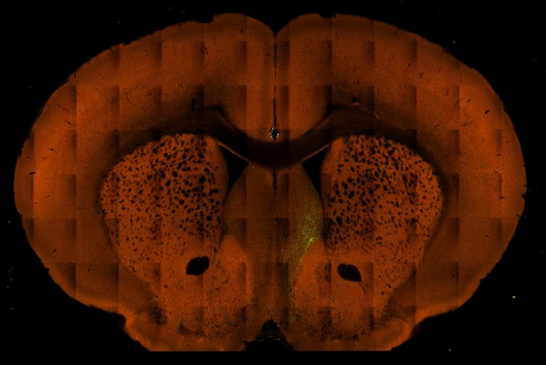
Figure 2. An example of an image showing a “Bounding Box Error”.
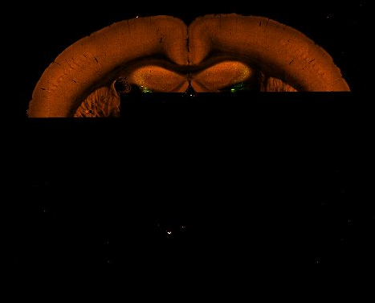
Figure 3. An example of “Modelock” error.
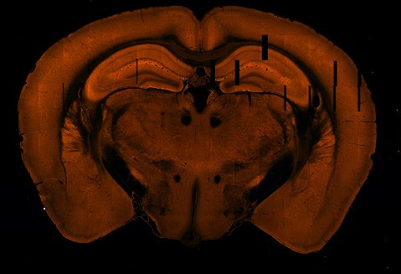
Figure 4. An example of “Tile Aberration” error.
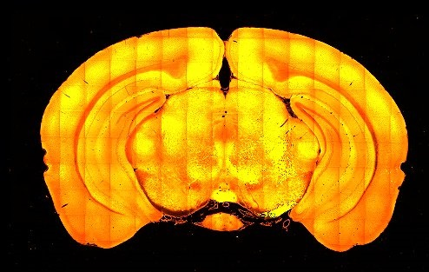
Figure 5. An example of “Intensity Issue” error.

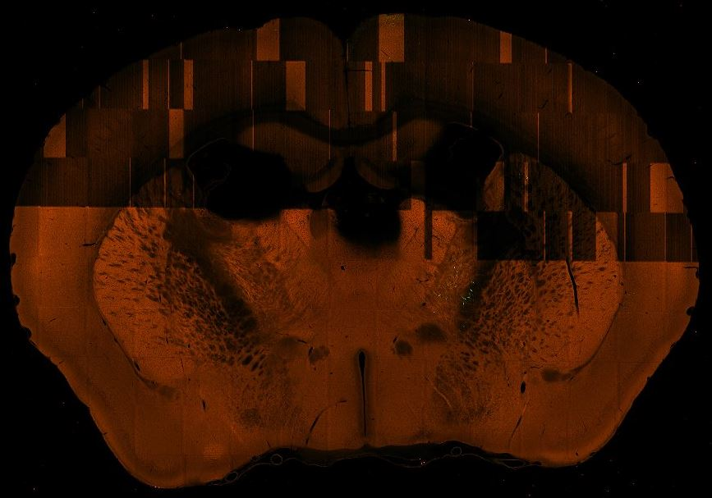
Figure 6. An example of a “pseudo modelock” error.
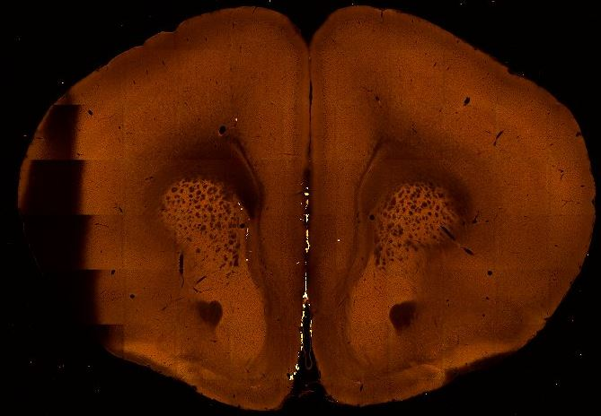
Figure 7. An example of an “obstruction” error.
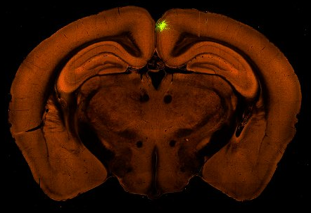
Figure 8. Example of a high quality, passing image.

  - Workflow diagram
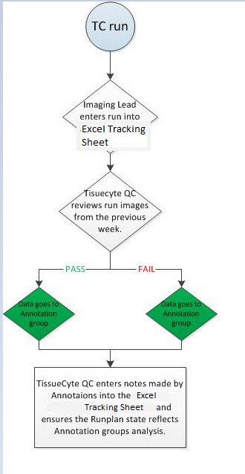
Figure 9. Workflow flowchart

