TissueCyte Installation and Alignment Guide

- Scope: This document outlines some of the steps that are required to align a TissueCyte 1000 serial two-photon imaging system and install commonly replaced parts.

- Materials:
  - Air blower
  - 70% Ethanol
  - Screwdriver set
  - Hex key set
  - Flashlight

- Equipment
  - TissueCyte scanning system
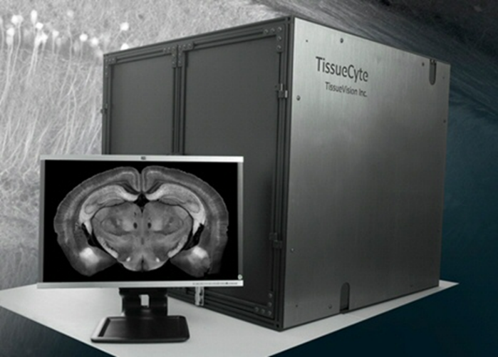

  - Newport IRV1-1700 Infrared viewer
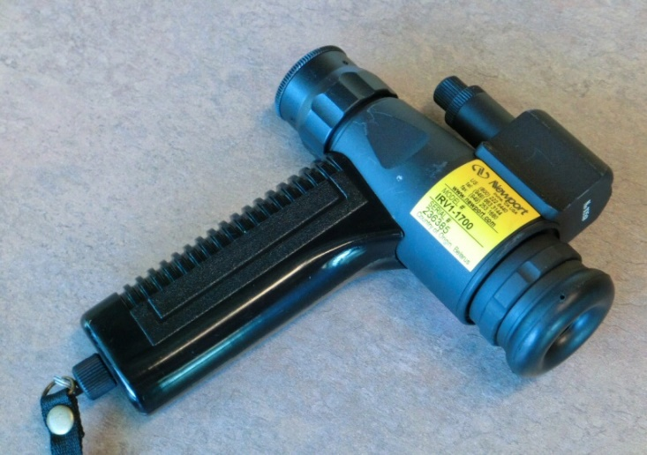
  - Newport Power Meter 1918-R
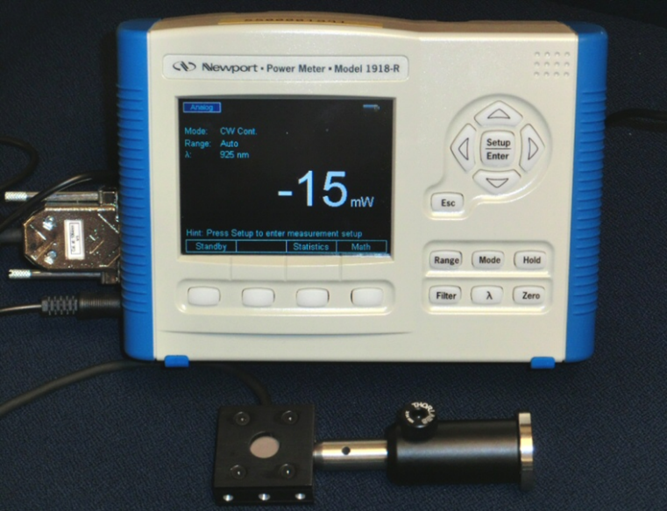

  - Newport F-IRC2 Infrared Sensor Card
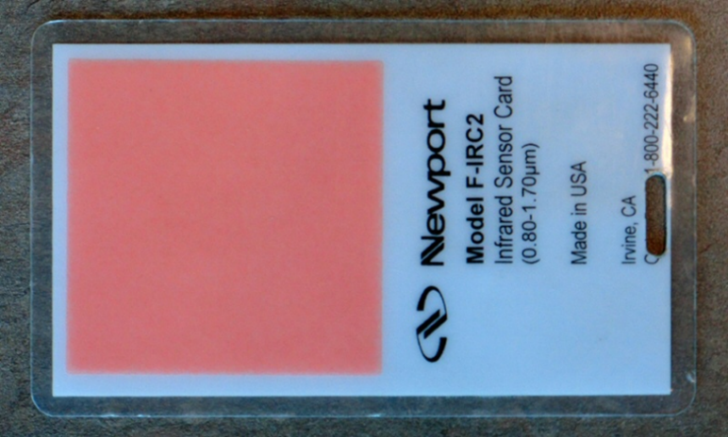

- Safety
  - Do not have any body parts in the enclosure box while the machine is running.
  - Always wear PPE when using the system.
  - The enclosure door should be closed during normal operations.
  - Follow standard laser safety protocols including the use of laser safety glasses. The laser used in this system is a class IV laser and can be dangerous if proper safety precautions are not followed.

Warning: Personal Protective Equipment (PPE) should be used at all times while operating this protocol. If you are unsure what PPE you should be using, see your immediate supervisor or the Institute laser safety officer.

- Reference Documents (Include all that apply)
  - PF0262 Core Protocol for Serial Imaging of Fluorescently-Labeled Mouse Brain on the TissueCyte 1000 System
    - https://www.protocols.io/view/core-protocol-for-serial-imaging-of-fluorescently-bdvmi646/abstract
  - EQ0063 Maintenance of TissueCyte System
    - https://www.protocols.io/view/maintenance-of-tissuecyte-system-bdpui5nw/abstract
  - EQ0068 TissueCyte Troubleshooting Guide
    - https://www.protocols.io/view/tissuecyte-troubleshooting-guide-beryjd7w/abstract

- Laser Alignment on the Table
  - Make sure that the laser is on. If it is not on, open the Spectra Physics Mai Tai software, and turn the laser on by clicking and holding down on the “ON” button for 3 seconds. It will take about 30 minutes for the laser power to be steady. Click and hold down on the Shutter button for 3 seconds to open the shutter.
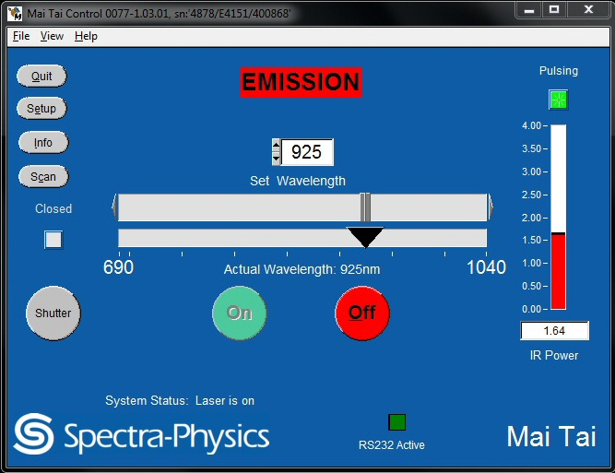
  - Turn the laser power to a lower level.
  - It is advisable to do the alignment first using the visible (red) laser (~ 700 um), and do the final alignment using IR laser (~950 um).
  - Type 700 in the wavelength window. The slider will gradually adjust to that value.
  - Most sections of the laser path incorporates two pinholes (P1, P2) followed by two 45 degree mirrors (M1, M2), or, the reverse. (See the two diagrams below). For the path to be aligned, P1, P2 and M1 should fall along a straight line, and M1, M2 on another straight line perpendicular to that.
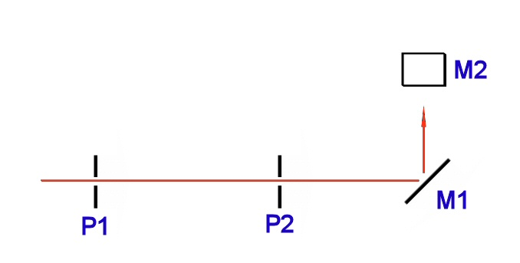
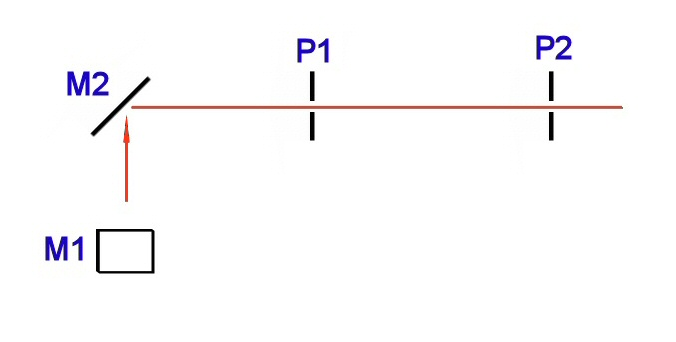
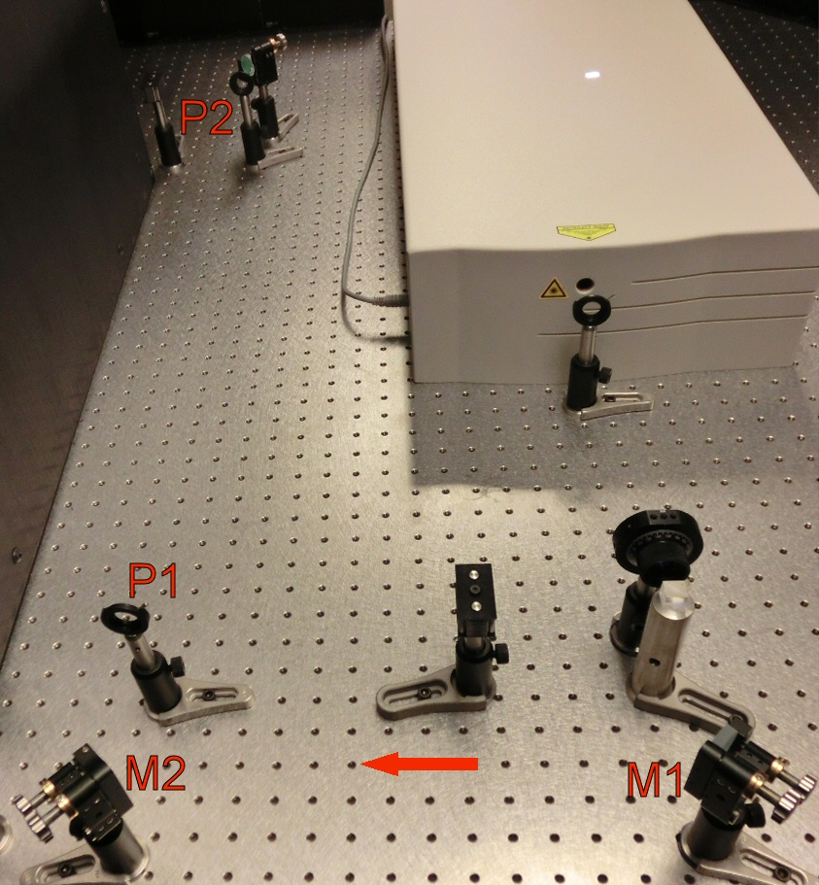
  - Start working on the section that is closest to the laser source, and work towards the other end, one section at a time.
  - Adjust the pinholes P1 and P2 to be very small. Do not move the location of P1 and P2 unless necessary.
  - Adjust the angle of mirror M1 as needed until the light path is aligned for P1 (determined by visual inspection since you are using visible light at this point).
  - Open up pinhole P1. Now adjust the angle of mirror M2 as needed until the light path is aligned for P2 (determined by visual inspection since you are using visible light at this point).
  - Iterate the above two steps, until perfect alignment is achieved.
  - Now change the wavelength to 925-950 um (invisible IR), and repeat the above alignment procedure with the best possible accuracy. At this stage you should use the IR viewer and the IR sensor card to find the location of the beam while adjusting the pinholes and mirrors.
  - At the end, make sure that all the pinhole apertures are open all the way, before you continue on to the next section of the laser path.

- Laser Alignment Inside the TissueCyte
  - Before beginning, reset the scanning mirror positions by performing the following sequence of events
    - Turn OFF scanner box and wait 30 seconds
    - Unplug X-CMD and Y-CMD cables from scanner box
    - Turn ON scanner box (when scanner box is turned ON without any input signal the mirror position is reset to where it’s supposed to be).
  - Make sure that the laser is on. If it is not on, open the Spectra Physics Mai Tai software, and turn the laser on by clicking and holding down on the “ON” button for 3 seconds. It will take about 30 minutes for the laser power to be steady. Click and hold down on the Shutter button for 3 seconds to open the shutter.
  - Turn the laser power to a lower level (<50mW) using the half wave plates.
  - Do the alignment first using the visible (red) laser ~700 um. Type 700 in the wavelength window of the laser control window. The slider will gradually adjust to that value.
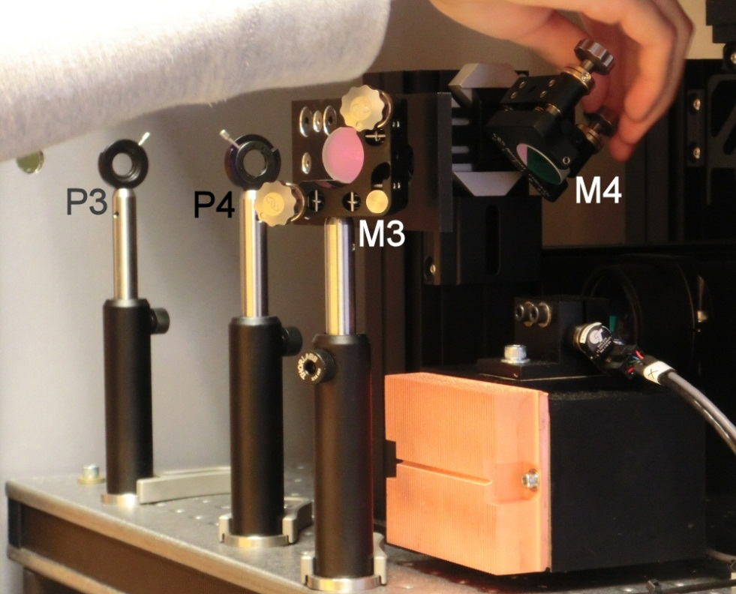
  - “Walk” laser into alignment with near/far pinholes and near/far lasers
    - Remove down mirror (M4) just upstream of X-scanner
    - Close irises on pinholes and examine alignment on far pinhole (beyond down mirror)
    - If misaligned:
    - Use far mirror (top of periscope) to increase the misalignment vector (magnitude and direction) on the far pinhole
    - Adjust near mirror (M3) to bring beam back into the center of the near pinhole
    - Repeat until aligned
  - Reinstall down mirror (M4)
  - The light path incorporates two pinholes (P3, P4) followed by two 45 degree mirrors (M3, M4). For the path to be aligned, P3, P4 and M3 should fall along a straight line, and M3, M4 on another straight line perpendicular to that.
  - Put partially transparent sheet with bulls-eye behind objective and examine for beam centering
  - Put sheet of paper behind objective and examine for beam aberrations. Anything ordered or patterned indicates need for:
    - Lens alignment
    - Dichroic alignment
    - Scanner repair
  - Put mirror behind objective
  - Place opaque card with hole punched in it where laser enters the TC system and look for reflected beam
  - Two beams indicate need for dichroic alignment
  - Single beam indicates that system is well aligned and laser is going through the hole in the card in both directions
  - If dichroic is misaligned adjust screws on the front and side of the plate upstream of the objective to bring reflected beam in alignment with incident beam
  - Turn scanner box OFF, wait 30 sec
  - Plug X-CMD, Y-CMD cables back in
  - Turn scanner box ON
  - Make sure down mirror is installed and pinholes are fully open
  - Reset laser to appropriate wavelength and power
- Emission Path Alignment
  - Alignment of the emission path should be done by the TissueVision personnel only.
- Beam Expander Installation and Focusing
  - The Beam Expander (BE) is placed as the last element on the laser path on the table. It is placed just before the deflecting mirror (M) that guides the laser beam towards the TissueCyte enclosure.
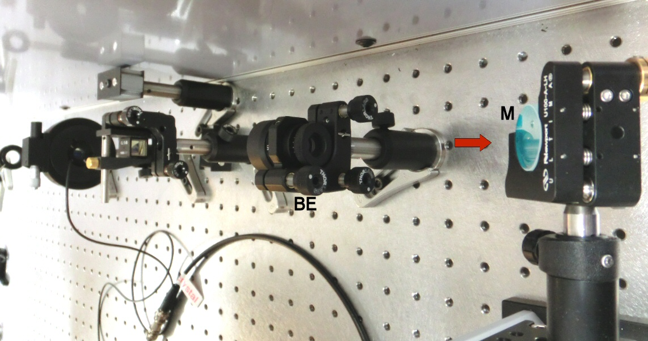
  - The beam expander is mounted on a reverse way, (the arrowhead in the picture shows the direction of the laser) and its mounting angle can be fine-adjusted using the set of three screws (S) on the mounting hardware.
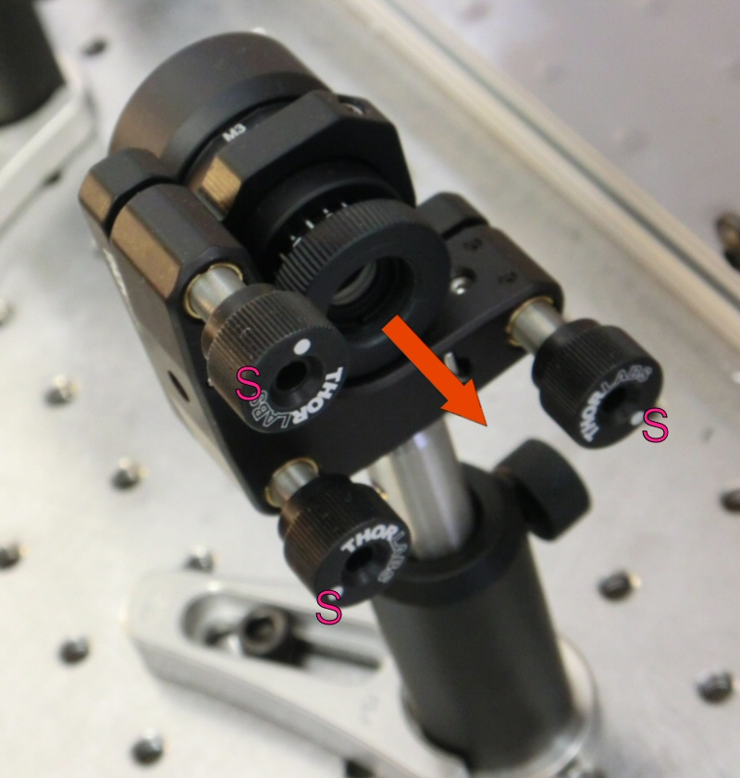
  - After adjusting the mounting angle using screws S, slowly turn the adjusting ring to adjust the width of the beam.
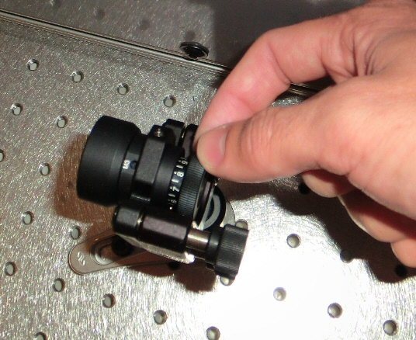

- LCVR Calibration
  - The purpose of this procedure is to set Liquid Crystal Retarder into the optical path allowing 250mW of the laser power to reach the sample. Ideally we would want to leave a little bit of heads up, allowing ~ 270mW power to go through.
    - Mount LCR on the table perpendicularly to the optical axis. Beam should hit approximately center of crystal.
    - Place power meter sensor at the objective output. Monitor power meter readout while rotating LCR’s mount to find such position where the power is maximized. Note that maximum value.
  - Power the LCR up by hitting OPEN at LC Shutter State tab of Vivace window
  - Change the V2 voltage (either at Vivace software (ref. Fig. above) or at the LCR controller (Ref. Figure below)) to maximize power again. Note the V2 value that gives you maximum.
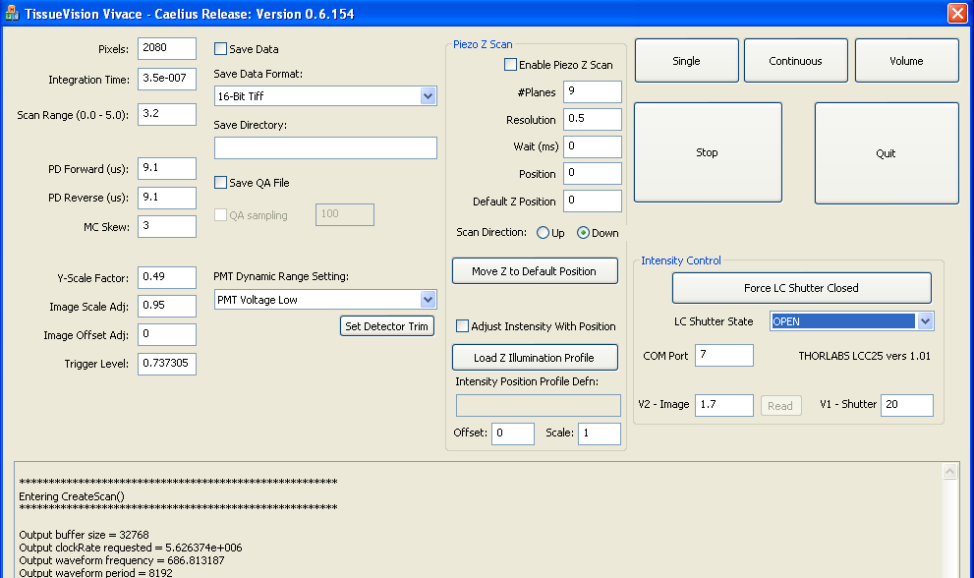

  - Set the V2 to allow 250+/-10mW at the objective out.

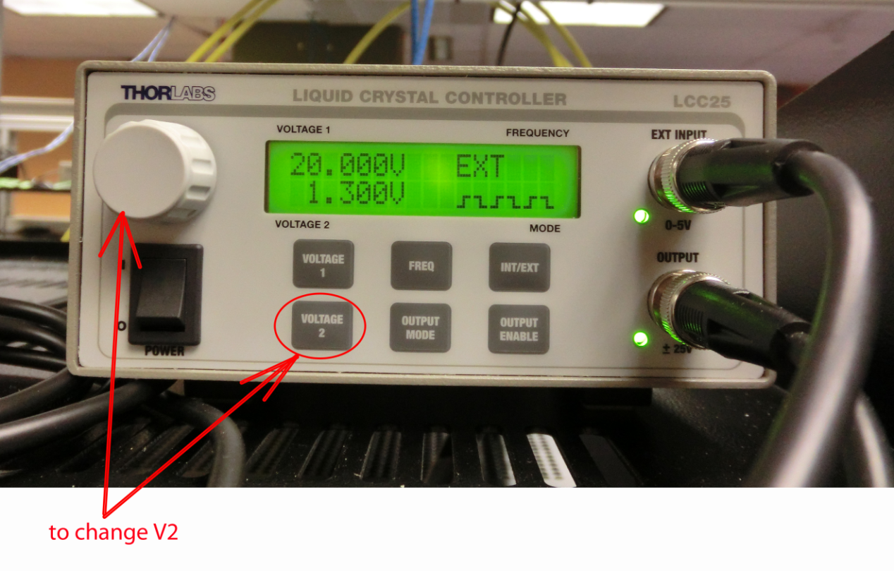
- Phase Adjustment to Align Left/Right Scans
  - This procedure is to be performed through Orchestrator
- Cable Installation and Replacement
  - Power down the component on which you will install the new cable.
  - Shut down both the Master and Slave computers and power down all electronics of the TissueCyte system.
  - If necessary, take down the side(s) of the TissueCyte box (for example, left side of the box for changing the piezo controller cable.
  - During installation, use extreme care when you handle the cables, making sure that they are not subjected to any mechanical stress at any point.
  - Make sure to take up any slack to keep cables from accidentally drooping into the optical path.
  - After installation, power up the system and test the system thoroughly, paying particular attention to the component on which the new cable has been installed.
  - Discard the old cable or mark it clearly as defective.

- Swapping Component Cards in PCs
  - Swapping component cards in PCs should only be done with the approval and under the guidance of Tissue Vision.
  - Shut down Windows and power off the PC.
  - Remove all of the cables from the back of the computer making sure to identify which cable is connected to which connector on the computer using tape labels or any other reliable means of identification.
  - Remove the PC from the rack
  - Place the PC onto a grounded anti-static matt before opening it up. Use a wrist strap while working on the PC to keep yourself grounded.
  - Carefully open up the PC. Remove any cables internal to the PC that are connected from the card that needs to be replaced.
  - Unscrew the capture screw and remove the card. Place it on the anti-static matt until it can be placed into an anti-static bag for safe keeping.
  - Place the new card carefully into the slot where the old one was located and lock it tight using the capture screw.
  - Replace any internal cables that were disconnected when removing the card from the PC and then close the PC enclosure.
  - Replace the PC in the rack.
  - Reconnect the cables that were removed from the PC.
  - Power the PC on and run tests to make sure that the cables have all been reconnected properly and that the new card works correctly.

- Stage Calibration Using Microspheres
  - Find the microsphere slide located in the TissueCyte refrigerator. The slide is in a tube, as shown in this picture.
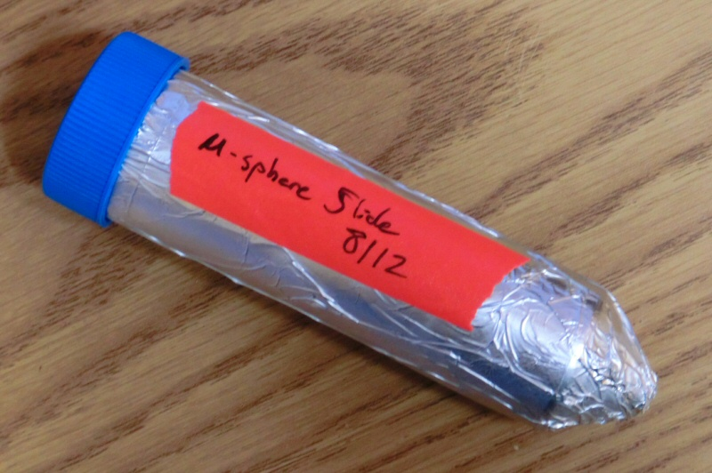
  - Find the tip-tilt stage, which is about 5x5 inches in size. Put it on a level surface and make it horizontal using two small spirit levels and dialing the two micrometer screws located at the two corners.
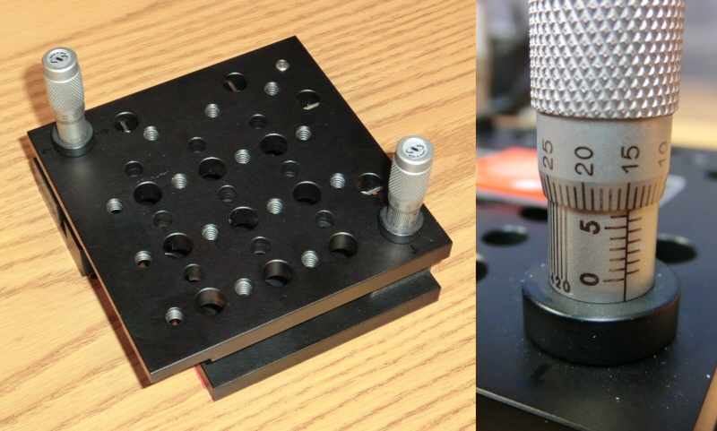
  - Put the slide on the tip-tilt stage, and tape the two ends of the slide onto the stage so that it does not move.
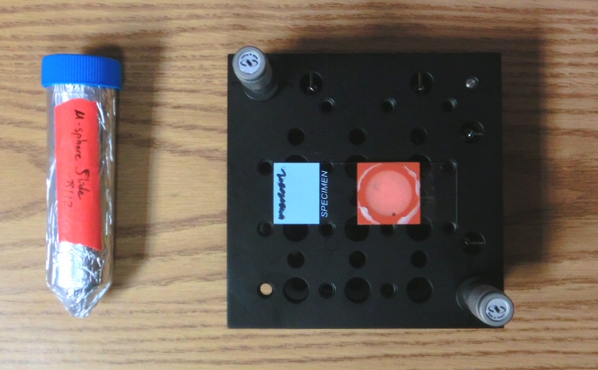
  - Taking a bottle of distilled water, put water on the center of the slide, to form a nice meniscus.
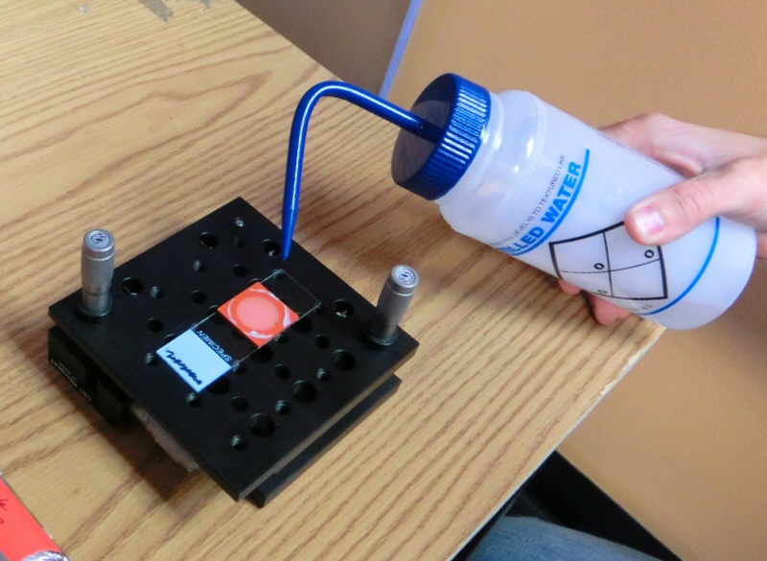
  - The water should form a nice meniscus, as shown here.
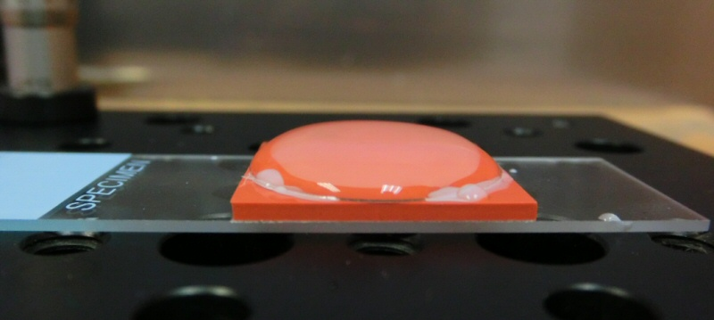
  - Place the stage carefully on the XY platform of the system. Bring the sample area right below the objective, and bring up the stage so that the objective lens just touches the water meniscus.
  - Start imaging the usual way (turn the lights off, turn on the PMT voltage, click on the 2D in the Imaging tab of the Orchestrator window to do a 2D image acquisition.
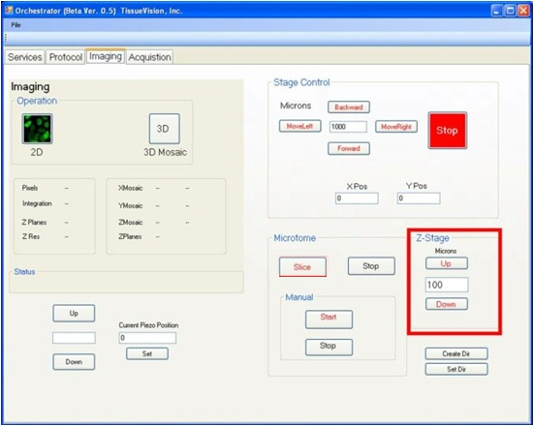
  - Adjust the Z-stage height until you get a fairly focused image of the microspheres.
  - Click on 2D box to grab an image. If properly focused, the image will show hundreds of randomly scattered microspheres, about 8 pixels in diameter.
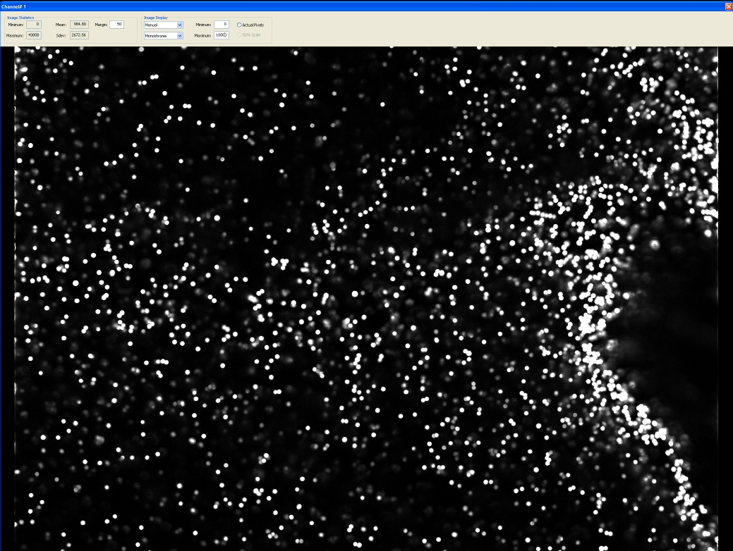
  - Find a small group of spheres that can be easily followed around when you move across the field. Using Orchestrator Imaging Stage Control (Move Left – Right – Backward – Forward), move that group of spheres across the image area from one end to the other (say, left to right), and see if their intensity is staying the same.
  - If the intensity of the group (and the relative intensities of the group members) is changing across the field, then the stage tilt needs to be adjusted in that direction. Adjust the corresponding micrometer knob very finely (1 graduation mark or less), and repeat the procedure until the intensity stays fairly constant.
  - Repeat the same procedure along the other (perpendicular) axis, and iterate the process if needed.
  - Now, move one of the microspheres from one edge to the other (while keeping track of the distance travelled in Orchestrator) to find out the total distance (in microns) between the two edges (i.e. the width of the captures area). Repeat it in perpendicular direction.
  - The area of the captured image should be approximately 750 to 780 microns square. It is expected to differ from one system to the other.
  - In order to find the image overlap, in Orchestrator, capture a mosaic for a single layer, with the following settings in Protocol tab and then clicking 3D Mosaic in the Imaging tab:
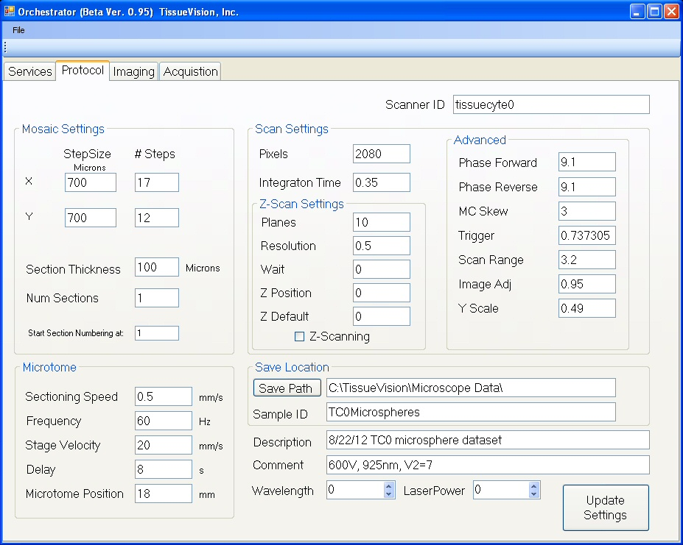
  - Once the set of image tiles is captured, you can determine the x-overlap and y-overlap by inspecting the adjacent tiles of the set.

- Flat Field Calibration
  - Standard flat field calibration, using microsphere slides with Fluorescein and Rhodamine dyes has been attempted on TissueCyte, but did not yield acceptable results. The standard background tile generated this way did not work well to produce smooth boundaries for the mosaic. Moreover, the background was found to be changing frequently and from run to run, thus making it difficult to use the same correction to consecutive runs.
  - The flat field correction that is used now is generated by software during the processing of the image files. It is generated from taking an average of all the tiles of any given image set.

- Detector Trim Settings
  - The trim setting on the PMT detectors is a way to control the noise threshold level of the photomultiplier tubes. This should be adjusted such as to allow maximum signal, while cutting off as much low level noise as possible.
  - The trim setting dial is located inside the casing of the PMT assembly.
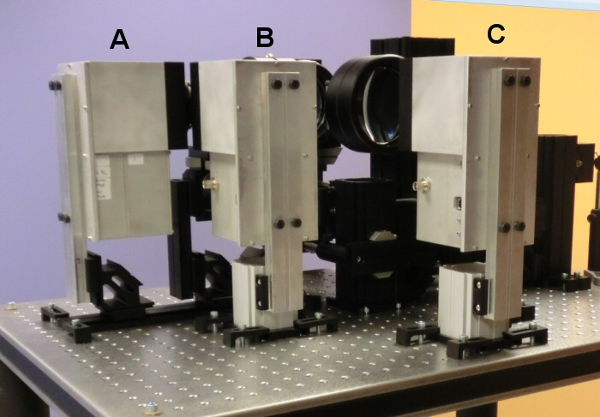
  - We found that the best signal-to-noise ratio is achieved when the Trim dial is set at 9. This is true for all the 18 (3 each in 6 systems) detectors that we have operational at this moment.
  - The trim setting should not be re-adjusted unless really necessary, that is, unless the noise level is found to be excessively high over a significant period of time. All the other possibilities (for example, external noise source, interference from other parts, software generated artifacts etc.) should be checked before adjusting the trim setting.

- Software Updates
  - Before updating any software, get a set of release notes from Tissue Vision about what has changed with the new software release. Circulate this release note amongst the stakeholders for the TissueCyte systems, including representatives from the Imaging team, Analysis team, and the IT team.
  - Based on feedback from those teams, create a validation test plan that will validate that the changes made to the software address whatever problem(s) they were intended to address and that the resulting data is collected and analyzed well within the expected bounds of data collected with the instrument.
  - When the validation plan is ready, work with the lead imaging research associate to schedule any test runs. These will typically be performed on test brains rather than production brains, but the specific details are to be specified by the test plan.
  - Software updates may be performed by Tissue Vision remotely using WebEx or they may send a set of software along with installation instructions which can be installed by a member of the engineering team.
  - With the schedule approved, execute the test plan and make certain that the data gathered has been flagged for proper analysis to show that the data is acceptable for production. In some cases there may be an unrelated problem that causes the analysis to fail in which case the test plan will need to be run again.
  - Check with the stakeholders to see that the test data passes before either placing the system into production with the new software or before rolling out the updates to any other systems (which will also need to be validated using similar test plans).

