TissueCyte Specimen Embedding –
Acrylamide Co-Embedding

- Scope: This protocol describes the preparation of a fixed mouse brain specimen bonded to an agarose block for blockface imaging and sectioning using the TissueCyte 1000 system.

- Materials:
  - Perfusion-fixed adult mouse brain specimen in PBS with 0.1% Sodium Azide (perfused according to SOP AF0075)
  - Agarose Type IA, (Sigma A0169)
  - Sodium periodate (NaIO₄), (Sigma S1878)
  - 0.2 µm filter and 1 liter waste bottle (VWR 28199-317 or equivalent)
  - Weigh boat (large, small)
  - Magnetic stir bars
  - Magnetic stir bar remover
  - 50 mM phosphate buffer (SOP RP0197)
  - Glass beakers, various sizes
  - Erlenmeyer flasks, 500 ml, 1 liter, 2 liter (for stirring agarose).
  - 4 oz. glass jar with lid (to store daily portions of oxidized agarose), (Uline M-1058R)
  - Peel-A-Way Disposable Embedding Molds, Square 22x22x20 mm (VWR 15160-215 or equivalent)
  - Freezing chamber used for embedding mouse brains (See Sect 8.3, Figure 1)
  - Starrett Satin-chrome steel precision rulers (McMaster-Carr 2285A65 or equivalent)
  - Razor blades
  - 3 ml transfer pipettes
  - Fine tip dissecting forceps
  - 1x3 TissueCyte barcoded slide (SOP PF0260)
  - Loctite 404 Quick Set Instant Adhesive
  - Aluminum foil
  - Parafilm
  - Kimwipes
  - Thin-point Sharpie marker
  - Surecast (Acrylamide:Bis-acrylamide ratio of 29:1, ThermoFisher HC2040)
  - VA-044 activator
- Equipment:
  - Calibrated balance
  - Microwave
  - Hot/stir plate
  - pH meter
  - Oven
  - Shaker

- Safety:
  - Nitrile Gloves
  - Lab coat
  - Eye protection
  - Thermal gloves for handling hot glass beaker
  - Fume hood

NOTE: Acrylamide, bis-acrylamide, and solutions containing these chemicals are toxic. Work with these solutions in a fume hood and while wearing gloves and eye protection.

- Output: A fixed mouse brain embedded in an agarose block, mounted on a 1x3 slide with barcode, ready for sectioning and imaging on TissueCyte 1000.

- Reference Documents:
  - AF0075 Mouse Cardiac Perfusion and Brain Collection
    - https://www.protocols.io/view/mouse-cardiac-perfusion-fixation-and-brain-collect-bd8vi9w6/abstract
  - PF0260 Slide Preparation for Mounting Samples for TissueCyte 1000 Sectioning and Imaging
    - https://www.protocols.io/view/slide-preparation-for-mounting-samples-for-tissuec-bdvni65e/abstract
  - RP0068 PBS with 0.01% Sodium Azide
    - https://www.protocols.io/view/pbs-with-0-1-sodium-azide-bfzsjp6e
  - RP0197 50 mM Phosphate Buffer (with 0.02% sodium azide option)
    - https://www.protocols.io/view/50-mm-phosphate-buffer-with-0-02-sodium-azide-opti-bezjjf4n/abstract

- Setup:
  - Prepare 4.0% Oxidized Agarose Solution: For full production mode, prepare 500 ml/week.
    - Combine Agarose, Sodium Periodate and 50 mM Phosphate Buffer in flask as indicated in Table 3. Note: the volume of Phosphate Buffer added at this step is larger than the final volume of the solution. Make sure the size of the container used is at least 2.5 times the volume of agarose solution to avoid spilling. Stir for 2-3 hours at room temperature, with light protection.
Final Volume of Agarose Solution | 100 ml | 250 ml | 500 ml
Agarose | 4.0 g | 10 g | 20 g
Sodium Periodate | 0.42 g | 1.05 g | 2.10 g
50 mM Phosphate Buffer  (initial suspension) | 200 ml | 500 ml | 1 L
50 mM Phosphate Buffer  (wash buffer x3) | 50 ml | 125 ml | 250 ml
50 mM Phosphate Buffer  (final suspension) | 100 ml | 250 ml | 500 ml

Table 1: Oxidized Agarose Solution

    - Place the solution in a 0.2 µm bottle top filter with a waste bottle attached. Apply suction with the vacuum pump and pull the liquid through the filter.
    - Once most of the Phosphate Buffer has been removed, apply the wash volume of Phosphate Buffer 3 times, pulling the liquid through the filter between each application.
    - Turn off the vacuum pump.
    - Resuspend the solution caught in the filter by adding half of the “final suspension” volume of Phosphate Buffer. Pour the suspension into a bottle. Rinse the filter with the remaining volume of the “final suspension” buffer and transfer the suspension to the bottle.
    - Stir the suspension with a stir bar on a stir plate until the mixture is homogeneous.
    - Aliquot the agarose into light protected glass containers as needed (~12.5 ml/brain).

  - Embed brain in 4.5% Oxidized Agarose solution
    - In a glass beaker, add the total amount of agarose needed for embedding all of the brains for the day (~12.5 ml/brain). Make sure to stir/shake the solution prior to measuring to ensure proper concentrations.
    - Heat the glass beaker containing agarose in the microwave at 10 seconds intervals on low power (3-4), swirl intermittently to prevent overheating and “bumping” solution. The solution should become clear and watery. Use a glass laboratory thermometer to check temperature/stir.
    - Once the agarose solution reaches 75ºC, stop heating and place on the laboratory bench to cool. Use the solution to embed the brains once the temperature reaches 60ºC.

  - Embedding set-up
    - Prepare the embedding mold
      - Using a straight edge ruler, mark 2 adjacent sides of the embedding mold with 2 straight, vertical lines.
      - Label the embedding mold with the specimen and block number.
      - Alternatively, grid lines can be printed on transparent sheets with adhesive backing and attached to the embedding mold. See Appendix 14.2
    - Cut off approximately 2 cm of the tip a of 3 ml transfer pipette with a straight razor for transferring agarose solution.

- Methodology/ Procedures: Embed Brain
  - Obtain the previously perfused brain stored in PBS with 0.1% Sodium Azide.
  - Remove the brain from the plastic conical tube and dry the brain on a Kimwipe. Gently dab the brain with Kimwipe if necessary (note that agarose will not adhere well to the surface of the brain if the surface remains wet).
  - Place the embedding mold on the metal plate. See Figure 1.
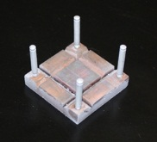
Figure 1. Metal plate with grid lines for embedding

  - Fill up the embedding mold to the top edge of the mold with agarose, using transfer pipettes with the tips cut off. Avoid introducing air bubbles when adding agarose to the mold. Top off the mold with 3-4 drops of agarose (the agarose may go over the top).
  - Using a pair of fine tip dissecting forceps, transfer the brain into the agarose solution and submerge the brain to the bottom of the embedding mold. Position the brain so that the anterior-posterior axis is vertical, with the posterior end at the bottom. See Figure 2.

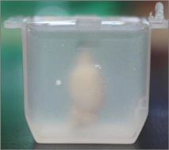
Figure 2. Brain with posterior end (cerebellum) at the base of the embedding mold
  - Align the mid-line of the brain with the grid line on the metal plates and the lines that were drawn on the sides of the embedding mold. See Figure 3.

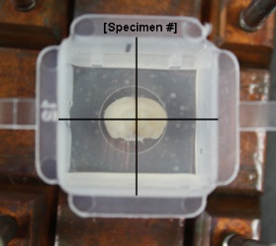
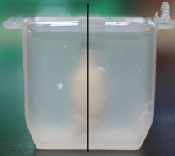 | 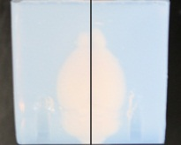
Figure 3. Alignment of the brain during embedding

  - Gently hold the brain upright with the forceps until the agarose solidifies enough for the brain to stand upright by itself.
  - Allow the agarose to completely solidify at room temperature for 20 minutes. Place the block in a jar labeled with the corresponding ID at 4°C to harden for an additional 20 minutes.
  - Soak the agarose-embedded tissue overnight at 4°C in a solution of Surecast (Acrylamide:Bis-acrylamide ratio of 29:1), with a total concentration of 4.5% Surecast and 0.5% VA-044 activator, with excess volume (>20mL for a brain), diluted in PBS: (22mL PBS; 3mL Surecast; 0.13g activator per 1 brain). First prepare the 22ml PBS mixed with 0.13g activator (per brain) and place the solution in the fridge until ready to use. Add 22ml of the PBS /activator solution and 3ml Surecast per jar. All components should be kept cold at all times to avoid spontaneous polymerization. Mix well the solutions within the jars and place in the fridge overnight.
  - After the overnight soak, remove the brains in solution from the refrigerator, and place on a shaker for 2 hours.
  - Prepare a mold with the brain ID and place small amount of the acrylamide solution. Use fume hood as Acrylamide and VA-044 are hazardous materials.
  - Transfer the tissue using forceps from the jar to the disposable mold (carefully matching the IDs from the jar to the mold) and let the acrylamide solution fill in the empty space. Make sure to gently push the agarose block all the way to the mold.
  - Excess oxygen inhibits polymerization. To prevent this from occurring, cover the mold securely with parafilm and place it in an oven at 40°C for a minimum of two hours.
  - After the 2 hour bake, remove the brains from the oven and place back into the corresponding jars by cutting the four edges of the mold with a razor blade and filling the jars with ~25ml PBS. Place the jars into 4C fridge until ready to use.

- Removing Mis-Aligned Tissue from an Agarose Block
  - Allow the block to cool and solidify before removing the misaligned tissue from the block. The agarose will be opaque.
  - Slice down the sides of the plastic well using a razor blade.
  - Remove the agarose block from the well.
  - Cut a 5 mm slit diagonally into each corner of the block using a razor blade (Figure 4). Extend the slits lengthwise to the base of the block.
  - Cut a 5 mm slit on each side of the block using a razor blade (Figure 4). Extend the slits lengthwise to the base of the block.
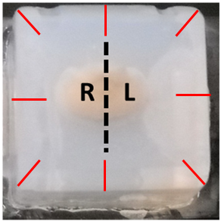
Figure 4: Slit Placement

  - Using gloved fingers, peel the agarose block apart at the slits. The brain should come out of the agarose cleanly and in one piece if it has just been embedded. If the brain has been embedded overnight or longer, use extreme care as the agarose tends to adhere tightly to the brain stem and olfactory bulbs. There is a risk that these parts of the brain may become detached during the agarose removal process.
  - Remove any remaining agarose pieces from the surface of the tissue using forceps taking care not to damage the brain.
  - Proceed to re-embed the tissue following the protocol in Section 8.0.

- Methodology/ Procedures:
  - Retrieve the embedded brain from the 40°C oven. Carefully remove the agarose block containing tissue from the embedding mold in the fume hood.
    - Place the mold on a clean, dust-free surface.
    - Gently run a razor blade over the top of the mold to remove excess agarose and create a flat surface. Then gently run a razor blade through the four vertical edges of the embedding mold. Peel the embedding mold from each side of the block, taking care to not damage the agarose block.
  - Place the agarose block containing a brain in fresh Phosphate Buffer in an amber specimen container. Add enough buffer to the container to cover the mounted brain (~25 ml). Cap the container, write specimen number on cap, and place in 4ºC fridge overnight. Use the next day. For weekend embedding, do not leave the brains in borohydride solution more than 48 hours.

- Methodology/ Procedures: Mount Brain on Slide
  - Attach the agarose block to a 1x3 glass slide for TissueCyte imaging; see PF0260 Slide Preparation for Mounting Samples for TissueCyte 1000 Sectioning and Imaging.
    - Put the agarose block on the slide with the olfactory bulb facing down. Make sure the brain is straight vertically. If the brain is not straight, trim the base of the agarose block to correct the angle. Remove the agarose block and apply a small amount of Loctite 404 adhesive to the roughened surface of the slide.

    - Carefully place the agarose block between the 2 magnets, with the right side of the brain facing the barcode and the olfactory bulb at the bottom (see Figure 5).
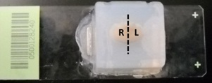
Figure 5. Alignment of the brain during mounting

  - Enter specimen information into your Laboratory Information Management System.

- Takedown:
  - Clean work area
  - Dispose of excess and used items appropriately

NOTE: Non-polymerized acrylamide, bis-acrylamide, and solutions containing these chemicals are toxic. Dispose of these chemicals and items containing these chemicals in the proper waste stream.

- Technical Information:
  - Storage: Ideally, embedded specimens should be imaged within 2 days of preparation.

- Appendix:
  - The overall workflow for 2P Serial Imaging and specimen block use is shown below. Steps covered in this protocol are highlighted in yellow:
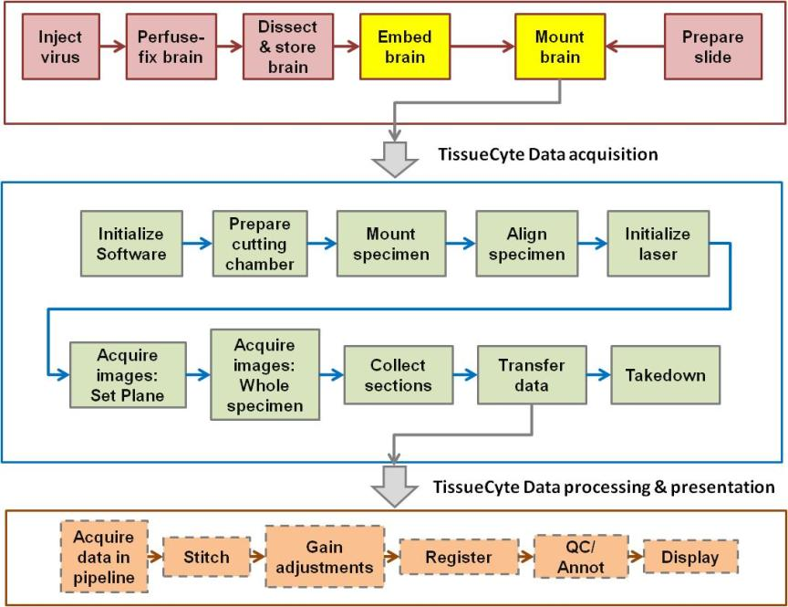

  - Grid lines for embedding

