TissueCyte Troubleshooting Guide

- Scope and Applicability: This document outlines strategies to solve common problems that occur when setting up the TissueCyte 1000 system for normal operation.

- Materials:
  - Air blower
  - Ethanol
  - Screwdriver set
  - Hex key set
  - Flashlight
  - Transfer pipette
- Equipment:
  - TissueCyte scanning system
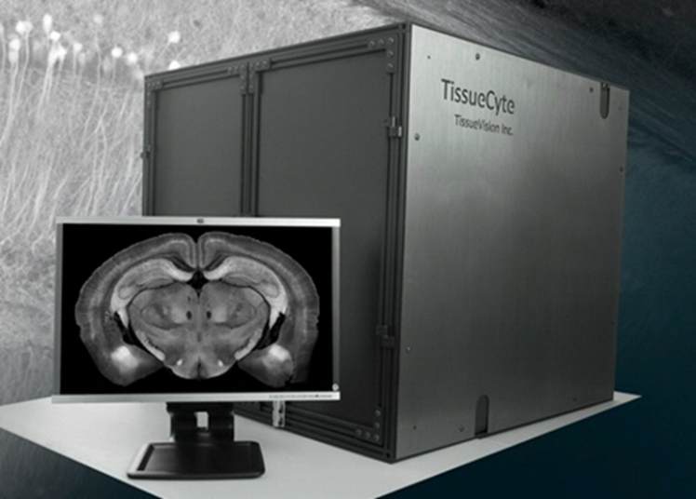

  - Newport IRV1-1700 Infrared viewer
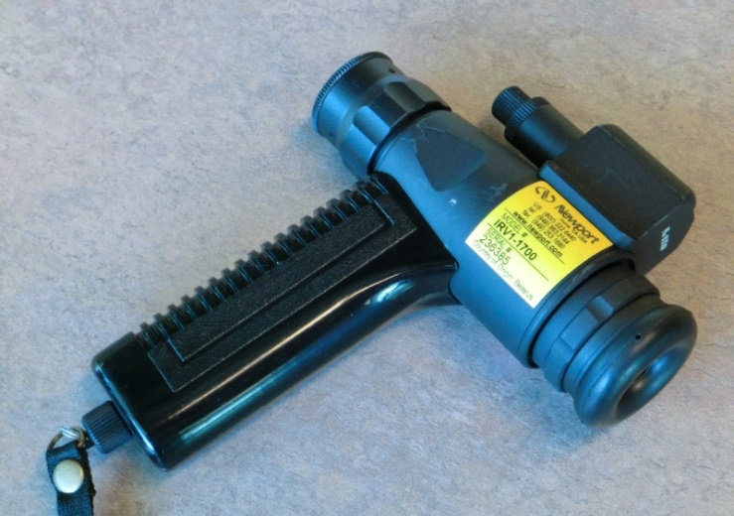
  - Newport Power Meter 1918-R
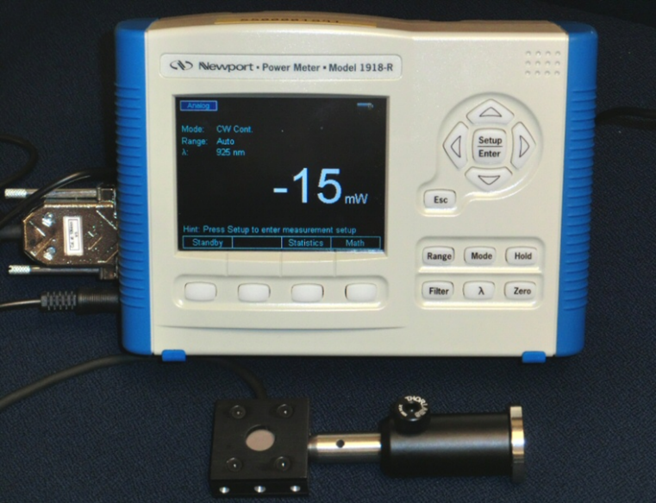

  - Newport F-IRC2 Infrared Sensor Card
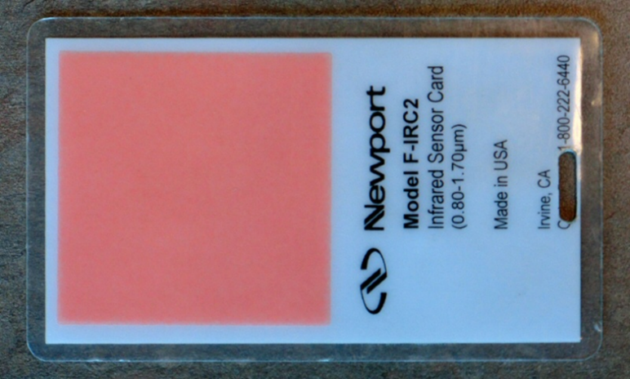
- Output: A well-maintained TissueCyte 1000 system.
- Reference Documents:
  - PF0262 Core Protocol for Serial Imaging of Fluorescently-Labeled Mouse Brain on the TissueCyte 1000 System
    - https://www.protocols.io/view/core-protocol-for-serial-imaging-of-fluorescently-bdvmi646/abstract
  - EQ0063 Maintenance of TissueCyte System
    - https://www.protocols.io/view/maintenance-of-tissuecyte-system-bdpui5nw/abstract
  - EQ0067 TissueCyte Installation and Alignment Guide
    - https://www.protocols.io/view/tissuecyte-installation-and-alignment-guide-bdpti5nn/abstract

Warning: Personal Protective Equipment (PPE) should be used at all times while operating this protocol. If you are unsure what PPE you should be using, see your immediate supervisor.

- Issue: Cannot Find Tissue
  - Make sure that the Laser is on, and it is not shuttered.
  - Make sure that the LCDR on the laser path is not shuttered, and there are no beam-blocks on the laser path.
  - Make sure that the PMT is on, and the set voltage is between 600 and 650 volts.
  - Cut sections by clicking on “Slice” button in Orchestrator. Repeat sectioning until some part of the tissue (usually brain stem) is exposed.
  - Make sure that the tissue lies directly beneath the objective. This can be done either by visual inspection, or by turning on the laser, and moving the stage using Orchestrator Imaging Stage Control (Move Left – Right – Backward – Forward) while watching the brightness of the IR reflection off the tissue using the Newport IRV1-1700 Infrared viewer. The brightness will maximize at the desired point.
  - Set the Piezo control at 200. In Orchestrator, move the Z-stage Up/Down in 50 micron steps, while capturing a 2D image at each step. An image of the tissue should be visible at some point.
  - Cut a section by clicking on “Slice” in Orchestrator. After slicing if the image is lost again, then first try by adjusting the Piezo control (which goes from 0 to 400).
  - One of the reasons of tissue being not visible during the scanning can be the wrong angle of the cutting blade. If this is the case, the imaging plane will be above/below of the plane where the tissue is located because the blade cuts below or above of the objective focal plane. To fix this issue, follow the procedure “Changing the vibratome blade angle” or “Adjusting the Height of the Objective Assembly”.
- Issue: Software Crashes
  - If possible (depending on the state of Windows) capture the screen and save it to a JPEG image.
  - Write down all of the information that seems like it might possibly be relevant to the error on the screen. This would include any history of this system, what state the system was in when it crashed, the state of the hardware, etc.
  - If the cause of the error is not apparent, contact Tissue Vision and let them know of the software crash and send them the information and screen capture so that they know what happened.
  - There is no a priori method to determine whether or not a given software error should take the system out of production. In many cases an error may happen only once and a simple reboot may be enough to clear the error and allow the system to be placed back into production. In other cases, there may be something more serious that is wrong and the system will have to be taken out of production to be repaired.
  - If the errors repeat and affect data quality, then the system will need to be taken out of production until a fix can be identified and implemented. If unsure, work with stakeholders in order to get their sense of whether or not data generated with a software bug will be acceptable or not.
- Issue: Sine Wave Signals (Noise)
  - Sine wave noise is usually associated with issues with the motion controllers (X/Y). It shows up as a cross hatched pattern in a captured image, as shown in Figure 1
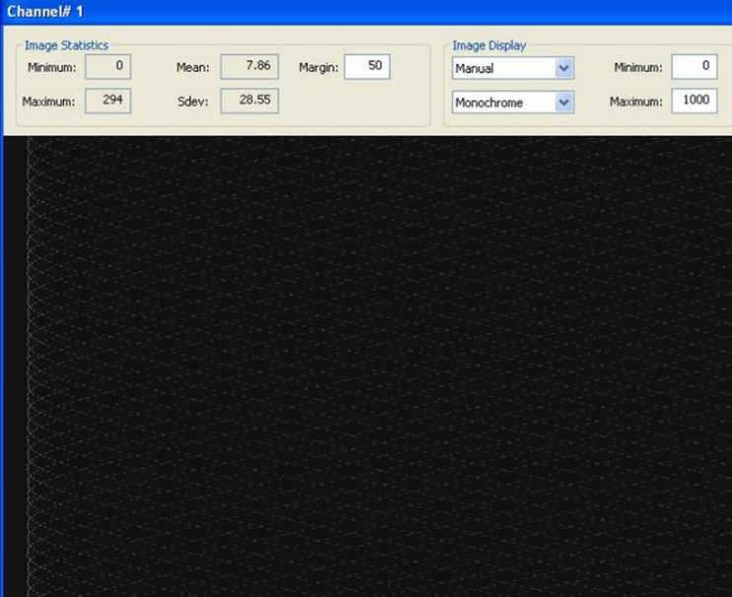
Figure 1: Sine Wave Noise
  - If the tissue is in the view, distortion in the tissue image will also be visible, as shown in Figure 2.
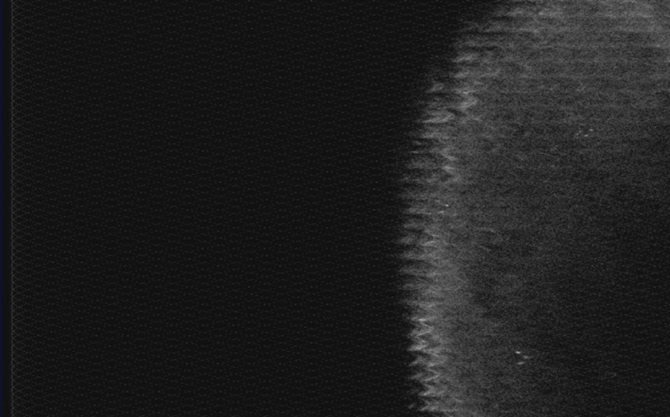
Figure 2: Distorted image caused by sine wave noise

  - To fix the problem, first make sure that the tissue surface in the bath is not close to the objective. If necessary, either drop the stage by 1000 micrometers, or remove the bath altogether.
  - Close all the programs running on master and slave, including Orchestrator, Vivace, and PMT control.
  - Turn off the power switch on the back of the black Motion Control box on the rack.
  - Disconnect the power connectors from the back of the X and Y stage controllers (Mercury C-863 DC Motor Controllers) located on the controller board on the equipment rack.
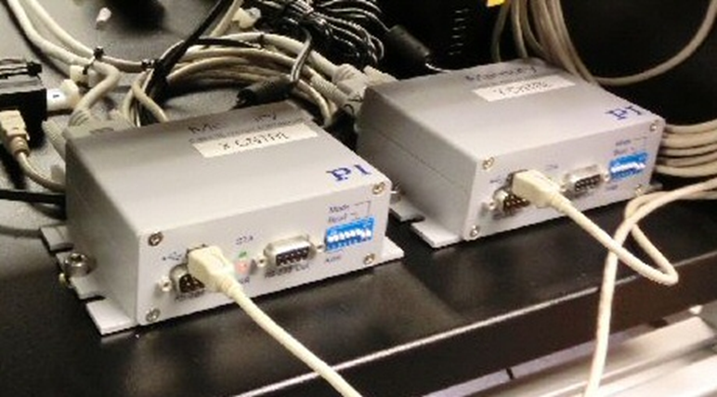
Figure 3: Stage controller power connectors
  - Wait for 10 seconds and reconnect the power to the X and Y stage controllers.
  - Turn on the power on the Motion Control box.
  - Restart Orchestrator software on master and client as the usual start-up procedure.
  - Click “Connect all” from the Services tab in Orchestrator. DO NOT click the “Reference Stage” button at this point.
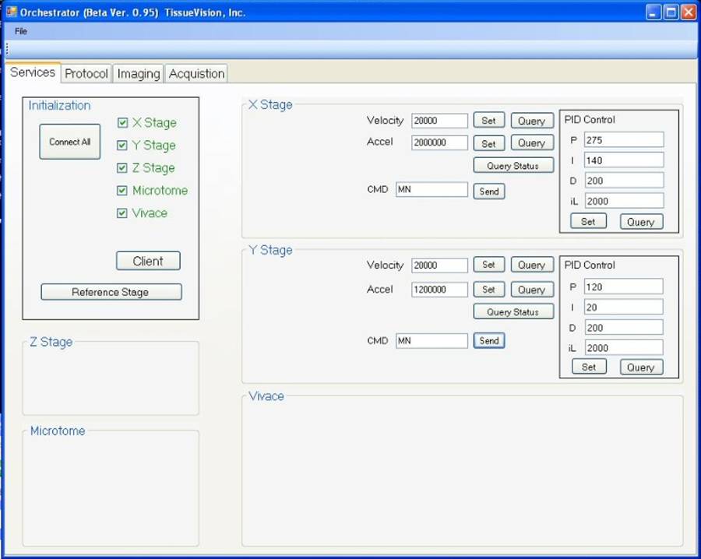
Figure 4: Orchestrator

  - Type “MN” (Motor oN) in the CMD command boxes in X and Y stage as shown and click on Send button. That will turn on the motors.
  - Verify that the X and Y stage controllers both have green lights on, and no red lights. In case any of the red lights are on, re-initialize the controllers with the following procedure.
    - If the top LED is red (which happens every time power is lost), reinitialize the controller through Orchestrator following the same procedure as above.
    - If both top and bottom LEDs are red, disconnect the power cable from the controller, wait for 10 seconds, and connect it back again. Then it will come up only the top LED red, which can be fixed by reinitializing through Orchestrator again.
  - Initialize the stage by clicking on the “Reference Stage” button in the Services tab.
  - Click on “Slice” in the Protocol tab. This mimics the process of cutting a section. It is necessary to do it as the final step of clearing the noise.
  - Capture an image by clicking on the 2D box in the Imaging tab and verify that the image is clean and noise free.

- Issue: Moiré (Crosshatch) Pattern Noise
  - Moiré pattern issue is associated with the malfunction of the Laser system. It shows up in the image when the laser pulse width becomes unstable. An example of Moiré pattern is shown in Figure 5.
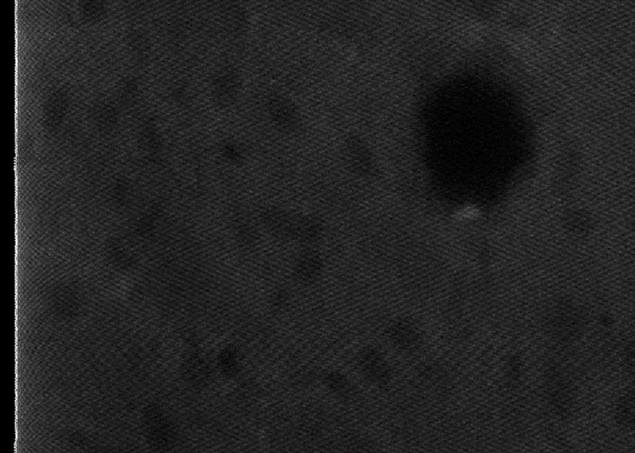
Figure 5: Moiré (Crosshatch) Pattern
  - This pulse competency problem may not have any obvious indication on the laser computer, though the Green Adjust may show a higher value during this issue.
  - To fix this issue, try re-starting the laser.
- Issue: Quasi-periodic Pattern
  - This type of noise shows up in the image as quasi-periodic bright patches in horizontal direction. It shows repeating features within a short time span but no long-time correlation, as shown below.
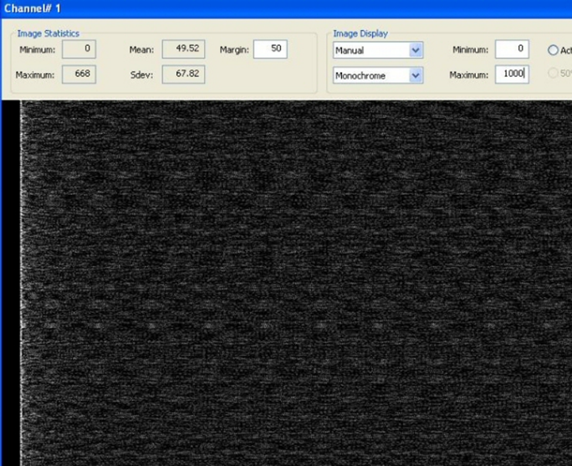
Figure 6: Quasi-periodic Pattern
  - The source of this noise is not yet identified, but probably it is originated in either the main CPU or the Slave. It shows up even with the PMT off.
  - In order to fix the noise, restart the computers. The preferred sequence is: first shut down the Slave, then restart the Master, and then restart the Slave.
  - Restart the software following the normal startup procedure. Capture an image within Orchestrator (2D capture) to make sure that the noise is gone

- Issue: Changing the Vibratome Blade Angle
  - The blade angle on the vibratome is set during initial construction/alignment of the TissueCyte system and it is unlikely that it will need to be changed. If necessary, this should be done with the arm of the vibratome removed from the system and secured to the alignment tool, as in figure below.
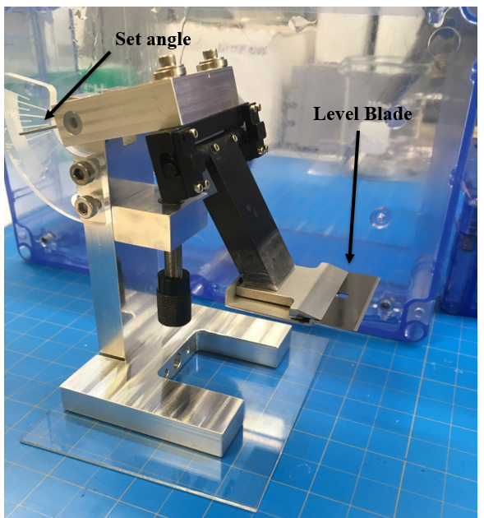
Figure 7: Blade Alignment Tool

  - Use the adjustment screw to set the desired angle of attack.
  - Adjust set screws on vibratome arm until the razor blade is horizontal and level. It can be useful to place a dial indicator on the blade surface and then move the whole assembly back and forth to observe small displacements from level.

- Issue: Adjusting the Height of the Objective Assembly
  - The objective assembly consists of the objective lens, the piezo, and the lens holder mounted on the main rail.
  - It may be necessary to adjust the height of the objective assembly if the tissue surface (after cutting a slice) falls below the range of the piezo (that is, the block surface falls below the focusing plane of the lens when the piezo is set at 400 microns).
  - (This step is rarely necessary and should be performed only if needed). Loosen the two screws (S) with 2.5mm hex drivers, while supporting the assembly from the bottom. Drop the assembly by about 1mm and tighten the screws (S) again.

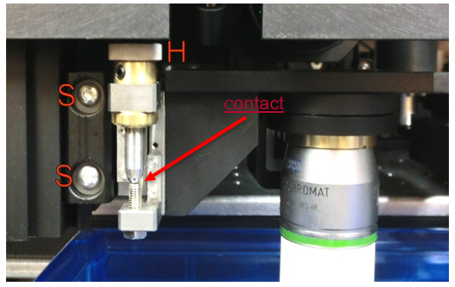
Figure 8: Object alignment

  - Adjust the height of the objective holder by turning the head of the fine-pitch adjustment screw (H). It is spring-loaded with high damping. The pitch of the screw is 4/mm. When the screw is turned one turn to the right (left), it raises (drops) the assembly by 0.25 mm or 250 microns.
  - After adjusting, ensure that the fine-pitch adjustment screw is in contact with the reference point.

- Issue: Components Can’t Communicate with the Software
  - Make sure that the power cable and the signal cable of the component in question are connected properly.
  - Exit the software, open it again, and retry.
  - If that does not fix it, exit the software, power cycle the component, and retry.
  - If that does not work, restart the computer, power cycle the component, and retry.

- Issue: Setting Up WebEx For External Access
  - Make certain that the computer that will be remoted into is actively on the internet. If not, work with End User Support to get this system online.
  - Contact Tissue Vision to get a WebEx session ID and the login path.
  - Use an internet browser (either Firefox or IE will work) and connect to the WebEx session ID using the URL and the session login information from Tissue Vision.
  - When asked if you wish to give control of the desktop to the remote party, answer yes.
  - It is often instructive to watch the screen as the Tissue Vision support staff navigates through the system trying to identify a problem. You can also talk to them on the phone simultaneously to ask questions or give the engineer other information about the system that wouldn’t be apparent from just looking at the computer state or log files.
  - When the session is done, close the connection and terminate the browser.

- Issue: Low Signal Intensity
  - Low signal intensity may be caused by a number of factors related to laser operation, alignment, specimen age and type, sample obstruction, etc.
  - Ensure that there is no air bubble trapped on the front element of the objective (see section 16.0).
  - Check that the laser is operating normally, and that the alignment is good (especially if intensity is uneven across the image). Increase laser power through the quarter-wave plate if necessary.

- Issue: Bubbles in the Bath
  - Periodically bubbles may be seen in the bath, floating on the surface, or sticking to the lens body underneath the surface.
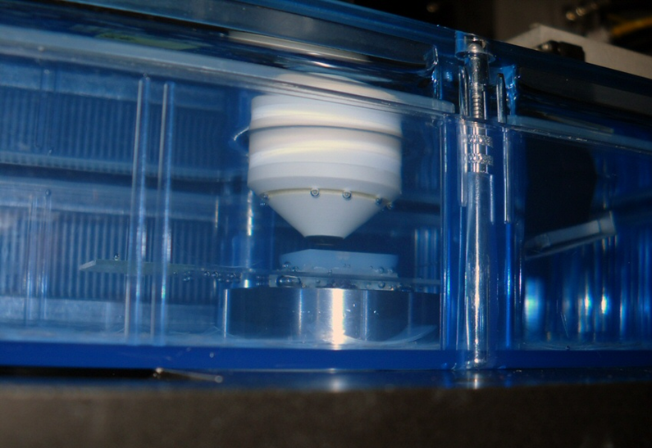
Figure 9: Bubbles in bath
  - Use a small transfer pipet (each TS system should have one) to carefully suck in the bubble carefully.
  - If a bubble sits on the glass of the lens, it may cause severe image artifacts.

- Issue: Scanning Mirrors Not Working
  - Verify that the cables are properly connected to the scanning control box and to the scanning mirrors themselves.
  - If that doesn’t solve the problem, power off the scanning control box for ten seconds and power it back on.
  - If that doesn’t solve the problem, reboot the PC.
  - If that also does not solve the problem, then contact Tissue Vision for assistance.

