Using FACS to sort fluorescent Bodo cells

Introduction: Fluorescence-activated cell sorting (FACS) is a powerful method to isolate cells expressing fluorescent proteins. It is a routine technique in our lab to enrich, and subclone cells that express exogenously introduced fluorescent reporter proteins. We developed this protocol to isolate Bodo saltans that express a fluorescent protein.

Unlike our previous work to isolate T. gondii, or T cruzi, there are two major obstacles to the application of this technology to B. saltans. The first obstacle is that B. saltans needs bacteria as food in the culture so there are multiple organisms in the medium. We have to determine which cells are B. saltans, and which are feeder bacteria. The second problem is that the osmolarity of the solution used for standard FACS is not appropriate for B. saltans. B. saltans lives in low osmolarity solutions. We needed to determine a proper solution in which B. saltans can survive, and if it works with the FACS system.

Step 1. Determine a FACS solution appropriate for B. saltans.
The solution that runs in a flow cytometer is called sheath fluid. Our FACS facility has its standard sheath fluid. In order to choose a proper sheath fluid for B. saltans we needed to make sure that: 1) the cells can survive in this sheath fluid for a significant time, 2) the sheath fluid can still support FACS since there is a requirement for the presence of ions for FACS to work. We tested serial dilutions of the standard sheath fluid. We found that B. saltans dies almost instantly in standard sheath fluid, but can live for at least 20 minutes in 50% sheath fluid. We also determined that the minimal sheath fluid needed for FACS is 40% of the standard sheath fluid. So we decided to use this diluted sheath fluid.

Step 2. Determine which is the population of B. saltans. Wild type cultures are passed through a 10 nm Nylon filter to remove big residues in the culture medium, and filtered cells are collected by centrifugation at 1,200 x g for 5 minutes. The cells are further washed three times by centrifugation at 1,200 x g for 5 minutes, and twice at 1,200 x g for 5 minutes. The washing step is to get rid of most bacteria in the culture medium.

After the last wash, the cells are resuspended in culture medium. We sort the cells by size and shape. There are usually two major distinct populations. We sort each of the populations into a collection tube. After the sorting, the cells are checked by microscopy. We confirm that the population 1 is B. saltans, and that the cells can survive the FACS sorting when we use 40% of standard sheath fluid as our sorting solution.

Fig 1: R1 is B. saltans population. We previously used MoFlo XDP Sorter From Beckman Coulter, now we are upgrading to Beckman Coulter MoFlo Astrios EQ version. In the SSC Vs FSC dot plot, R1 represents B. saltans cells.

Step 3. Sorting of B. saltans transfected with a reporter gene.

1, 24 hours after electroporation, B. saltans (wild type and transfected) are filtered through a 10 nm Nylon membrane. The cells are collected by centrifugation at 1,000 x g for 5 minutes.
2, Cells are washed twice with autoclaved distilled water.
3, After the final wash, cells are resuspended in ~1-1.5 ml medium. We also prepare a collection tube with 2 ml fresh culture medium.
4, After the sorter has been set up, we first run the wild type control cells to set up the parameters for sorting. In the SSC Vc FSC dot plot, the B. saltans population is chosen. Then in the fluorescence plot, we use DsRed Vs GFP dot plot to set the gate. There are no cells in the gated area for wild type cells.
5, After the parameters are set, we run the transfected B. saltans. A small population of fluorescent cells should appear in the fluorescence plot. This is the population we want to sort into a collection tube.
6, After the sorting is done, cells are transferred to the collection tube and then to a T25 flask, adding 4 ml culture medium and a small colony of bacteria taken from a plate.
7, Cells are cultured for further analysis.

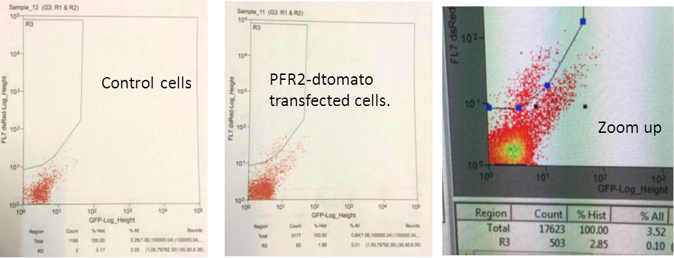Fig. 2. Representative sorting of B. saltans
Control cells
PFR2-dtomato transfected cells.
Zoom up

