Zeiss AxioImager 63X Z-Stack Image Capture

- Scope and Applicability: The Zeiss AxioImager Z2 is an upright bright-field microscope. This SOP describes the capture of 63X brightfield z-stack images using mouse, human, and macaque tissue.

- Materials:
  - Immersion Oil (Zeiss Immersol 518F)
  - Pre-moistened lens cleaning wipes (Zeiss 170597)
- Equipment:
  - Zeiss AxioImager Z2 upright microscope
    - Oil condenser
    - 63X Oil immersion objective lens (Zeiss Plan-APOCHROMAT 63X/1.2 oil)
    - Heidenhain closed loop Z linear encoder
    - TFT display
  - Zeiss Axiocam 506 monochrome camera
  - Model 232 microscope power supply
  - WSB Piezo Drive 08 power supply
  - Automated Stage (PI Line; Wienecke and Sinske M666K011)
  - Stage controller with joystick (Wienecke and Sinske JoyMach4)
  - Barcode scanner (Honeywell 3800g)
  - Computer with Zeiss Efficient Navigation (ZEN) software
  - Monitor
- Safety:
  - Nitrile Gloves
  - Eye protection
  - Lab coat
  - Caution: Immersol 518F immersion oil causes skin irritation; avoid contact with skin and eyes.
Warning: Personal Protective Equipment (PPE) should be used at all times while operating this protocol. If you are unsure what PPE you should be using, see your immediate supervisor.

- Output:
  - CZI file (Zeiss proprietary format)
- Reference Documents:
  - ZEN Pro Software Guide: https://applications.zeiss.com/C125792900358A3F/0/3F21E9A00C34C477C1258283004BB960/$FILE/ZEN2_3-First_steps.pdf

- Setup:
  - Turn on the hardware.
    - Turn on the light source power supply (A in Figure 1).
    - Turn on the stage controller power supply (B in Figure 1).
    - Turn on the microscope (C in Figure 1).

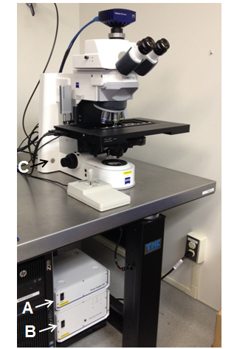
Figure 1: Power switches for Light Source (A), Stage Controller (B) and Microscope (C)

  - Start up the Zeiss Efficient Navigation (ZEN) software by double clicking the  desktop icon. Note: Always start the software after the hardware is fully powered and the TFT screen is displaying the Home menu.
  - Upon startup, Zen software will allow you to choose between the Image Processing environment and Zen Pro. Select Zen Pro for image acquisition.
  - Next, a window prompt will appear requiring stage/focus calibration. Proceed with the calibration (Figure 2). Warning: Be sure the stage is free of any obstacles and can move to its limits without obstructions.

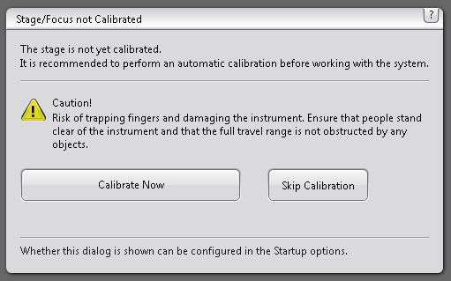
Figure 2: Stage/Focus calibration software prompt.

- Methodology/Procedures:
  - Setting Kohler Illumination:
    - Switch to the 63X objective lens by selecting the objective on the TFT display (Microscope tab - Turret tab – 63X) or rotating the turret.
    - Use the 1.2 NA objective for all mouse, human, and macaque tissue.
    - Position the slide on the stage.
    - Turn on the light by selecting TL Illumination On on the TFT display.
    - Set the beam splitter so that all the light is directed to the eyepieces.
    - Apply immersion oil to the condenser and slide.
      - Move the slide so that the condenser is accessible.
      - Turn the turret to move the objective lens out of the way (if needed).
      - Apply one or two drops of Zeiss Immersol 518F immersion oil to the condenser. Allow the oil to drip off the applicator rather than touching the condenser.
      - Apply one or two drops of immersion oil to the top of the slide.
      - Click Done on the oil addition instruction pop-up to move the stage back up.
      - Move the slide back into position for imaging.
      - Turn the turret to bring the objective lens back into position (if needed).
    - Use the joystick to bring the tissue into the field of view.
    - Focus the image using the focusing knobs on either side of the microscope body.
    - Adjust the lamp intensity so that the specimen is evenly illuminated.
    - Close down the field diaphragm (Figure 3A).
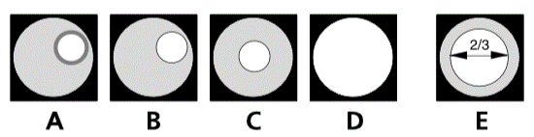
      - Use the two buttons located behind the focusing knob. Push the lower one to close the diaphragm and the upper one to open it.
Figure 3: Diaphragm control for Kohler
    - Use the condenser vertical adjustment knob to bring the edges of the iris into sharp focus (Figure 3B). When the system is set properly, both the tissue and the iris diaphragm will be in focus.
    - While looking through the oculars, center the iris in the field using the silver screws on the condenser (Figure 3C).
    - Open the field diaphragm until the edges of the iris are just outside the field of view (Figure 3D).
    - Remove one eyepiece from the binoculars and look through the tube with your naked eye and adjust the aperture diaphragm to approximately 2/3 of the diameter of the exit pupils of the objectives (Figure 3E). Replace the binoculars to the tube.
      - Alternatively, the field diaphragm can be opened in Zen software. Select Locate tab and set TL Motorized Fieldstop to 75% (Figure 4).
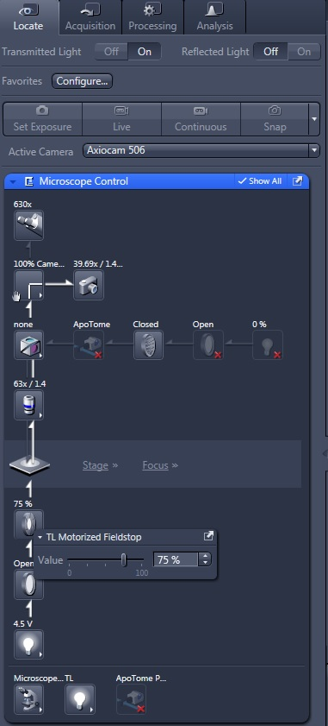
Figure 4: TL Motorized Fieldstop

  - Setting the shading correction:
    - Focus on the specimen.
    - Move off the tissue and navigate to a clear area of the slide without visible debris or defects.
    - Adjust the lamp intensity using the TFT display.
    - Set the beam splitter to direct light only to the camera.
    - Open the Acquisition tab in the software (A in Figure 5).

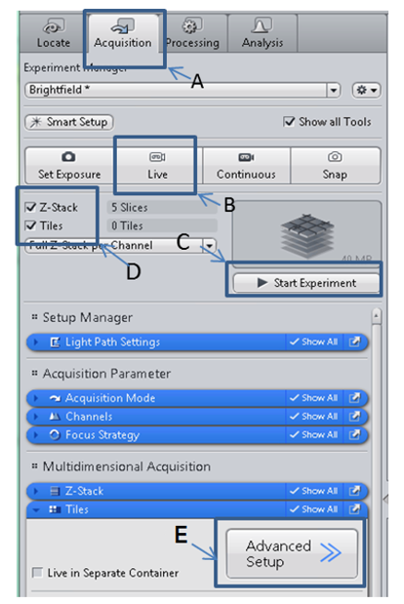
Figure 5: Image Acquisition Setup

    - Click on the Live button (B in Figure 5).
    - Open the Channels drop-down menu.
    - Uncheck Shading Correction (A in Figure 6).
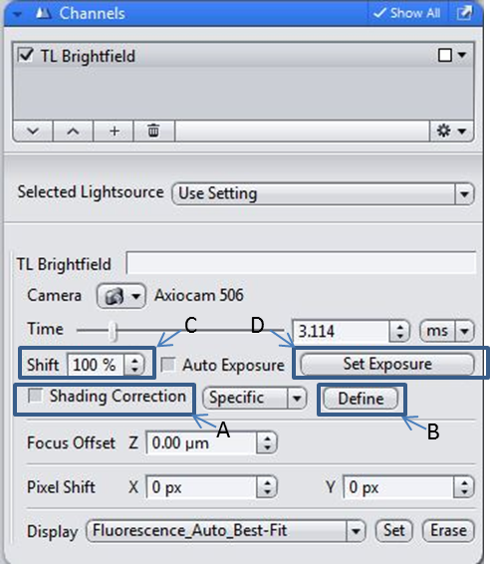
Figure 6: Shading correction

    - Turn on the Range Indicator in the Dimension menu (Figure 7). Oversaturated areas will be indicated in red.
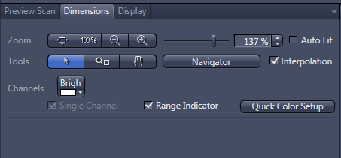
Figure 7: Range Indicator

    - Open the histogram in the Display menu.
      - Select Set Exposure (D in Figure 6). If the exposure time is less than 10 ms, adjust the light intensity manually and click Set Exposure again. Repeat this process until the exposure time is 10-20 ms. This will create stability in the light source and create a flat field illumination within a field of view.
      - Click Define to capture and apply the shading correction (B in Figure 6). The box for Shading Correction should now be checked.
    - Set Shift to 100% to maximize the dynamic range (C in Figure 6).
    - Locate a stained cell in the tissue.
    - Use the joystick to navigate to a location on the slide that is just outside of the field of view of the cell but where tissue is still visible.
    - Select Set Exposure while on tissue (D in Figure 6). Make sure that the exposure time is greater than 20 ms. If it is less than 20 ms, adjust the lamp intensity manually and click set exposure again. Repeat this procedure until you can obtain a value between 20-50 ms.
  - Z-Stack Image Capture
    - Select Z-Stack and Tiles in the Experiment Manager (D in Figure 5).
    - Click Advance Setup (E in Figure 5).
    - Define the region to be imaged.
      - Locate the cell or cluster of cells being imaged.
      - Follow each dendritic and axonal projections of the cell or cluster of cells of interest and acquire a snapshot at each ending.
        - hMPATCH tissue requires all dendrites to be imaged, but axons can be cropped after 2 tiles.
      - In the Tile Region Setup tab below the live window, select the draw tile region tool as shown in Figure 8.
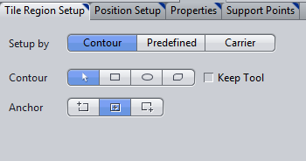
Figure 8: Tile Region Setup

      - Navigate to your area of interest, then click and drag the yellow rectangle until it covers the entire area. Release and adjust so that the tile region best fits the area of interest.
      - Confirm that the region has been saved by deselecting and selecting the tile region in the Tiles drop-down menu.
    - Set the Z Stack range.
      - When imaging mouse tissue, use a 0.28 µm step Z-step intervals. When imaging human or macaque tissue, use a 0.44 µm Z-step intervals.
      - Under the Focus Strategy pull-down menu and select None.
      - Open the Z Stack pull-down menu.
      - Focus on the cell body or another well-defined structure. The blue plane in the dialog box will indicate the current Z position.
      - Drive the focus up in the tissue to the desired upper extent of the range by turning the focus knob forward. Define the top of the Z stack by clicking on the Set First (A in Figure 9).
      - Focus deeper into the tissue to reach the desired lower extent of the range by turning the focus knob back. Define the bottom of the Z stack by clicking on the Set Last (B in Figure 9).

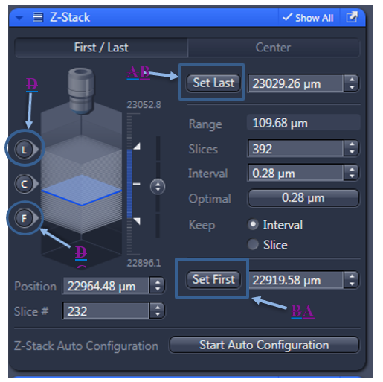
Figure 9: Z stack parameters

      - Click on the “F” in the graphic to move the focus to the top of the Z stack (C in Figure 9).
      - Acquire a preview scan of the top plane. If biocytin staining is found in the top plane, focus further up in the tissue until the staining is no longer visible. Click Set First to redefine the top of the Z-stack. If necessary, expand the borders of the tile region to include additional features of the specimen within the imaged z-stack.
      - Click on the “L” in the graphic to move the focus to the bottom of the Z stack (D in Figure 9).
      - Acquire a preview scan of the bottom plane. If biocytin staining is found in the bottom plane, focus further down in the tissue until the staining is no longer visible. Click Set Last to redefine the bottom of the Z stack. If necessary, expand the borders of the tile region to include additional features of the specimen within the imaged z-stack.
        - If there is still staining visible on the bottom plane, but the free working distance of the objective has been reached, set that position to Last and record “Z-limit reached”.
    - Acquire the Z-stack image series
      - Acquire a preview scan of the specimen in focus.
      - Once the preview scan has been completed, check for image quality. The image should be free of any tiling artifacts (tessellation). If necessary, redefine shading correction (Section 8.2), adjust the lamp intensity, or exposure time to optimize the final image output.
      - Click the Start Experiment button at the top of the Acquisition tab.
      - An experiment progress pop-up box will appear at the bottom of the screen once the acquisition is running.
      - A new window will appear when the scan is finished.
      - Rename the image to match the slide barcode.
- Batch Image Stitching
  - The stitching function allows you to align the individual tiles of a tile image with one another automatically and correctly. This step is only performed if there is a stitch error in the scanned image. If the image does not have a stitch error, skip this step and proceed directly to section 10.0 Image Export.
  - Navigate to the Processing tab.
  - Select the Batch option under Function: Stitching (Figure 10).
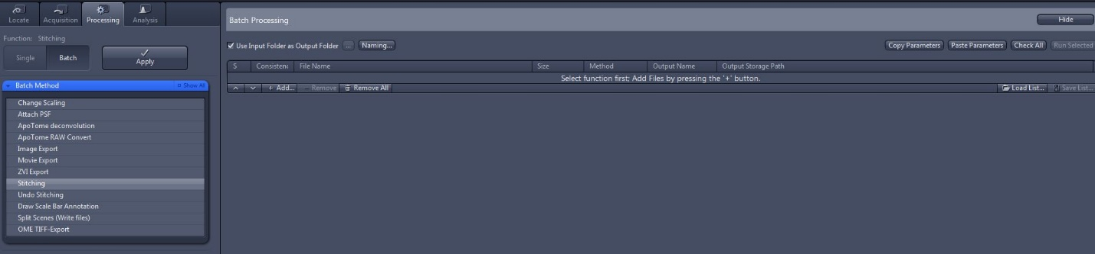
Figure 10: Batch Method Selection

  - Drag and drop the image .czi file to be stitched into the field that says ‘Select function first: Add files by pressing the ‘+’ button.’ under the Batch Processing section.
    - Files can be added using the ‘+’ button. They may also be dragged and dropped.
  - While the file is highlighted, open the Batch Method drop-down menu and select Stitching (Highlighted Figure 11). Toggle between stitching and another method if stitching is auto-selected to ensure parameters are correctly applied.
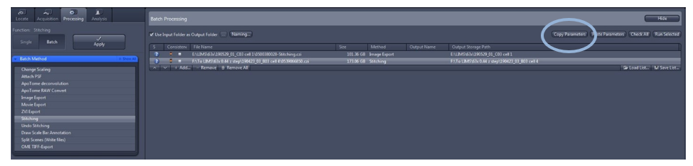
Figure 11: Stitching Method Selection

  - Under Method Parameters open the Parameters drop-down menu (Figure 12).
    - Under ‘Settings’, toggle between ‘63x Stitching’ and ‘63x Optimized.’ Choose ‘63x Stitching’.
    - Under ‘Settings’, select Inplace.
      - Open the ‘Select dimension references for stitching’ tab and under ‘Z-Position’ select ‘All by reference.’
      - Enter the desired stitch plane into the window (circled in Figure 12).
    - Open the ‘Parameters’ drop down menu.
      - Set Edge Detector to No.
      - Set Minimal Overlap to 5%.
      - Set Max shift to 10%.
      - Set Comparer to ‘Best’.
      - Set Global Optimizer to ‘Best’.
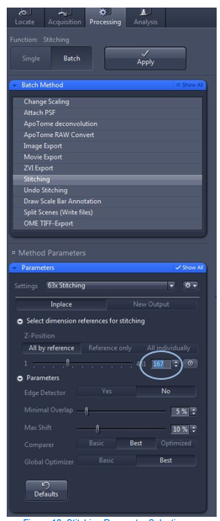
Figure 12: Stitching Parameter Selection

  - Click Copy Parameters (circled in Figure 11).
  - Add the rest of the files that need to be stitched by dragging and dropping them into the window.
  - Highlight all files and click Paste Parameters. Enter the correct stitch plane for each image.
  - Ensure that ‘Use Input Folder as Output Folder’ is checked (A in Figure 13).
  - Click Check All on the far-right side of the screen (B in Figure 13)
    - Make sure the stoplight icon next to each file turns from yellow to green.
  - Click Apply on the left side of the screen (C in Figure 13).
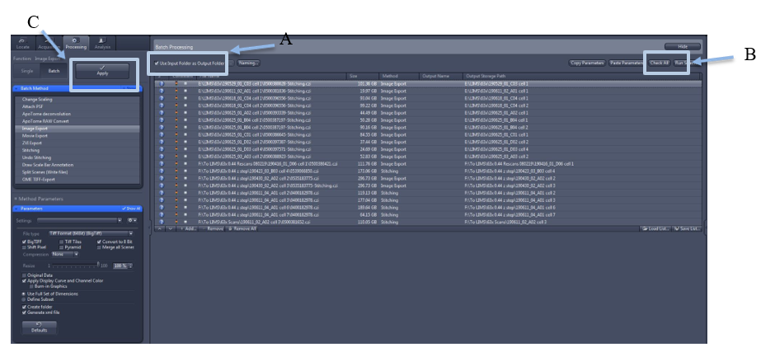
Figure 13: Batch Processing

- Image Export
  - The Image Export method allows export of single images into various file types. Multidimensional images are exported as individual images.
  - Open a file that has already been stitched and drag it into the Batch Processing window.
  - Highlight the file in the window and select Image Export under the Batch Method drop down menu (highlighted in Figure 14). Toggle between stitching and another method if Image Export is auto-selected to ensure parameters are correctly applied.
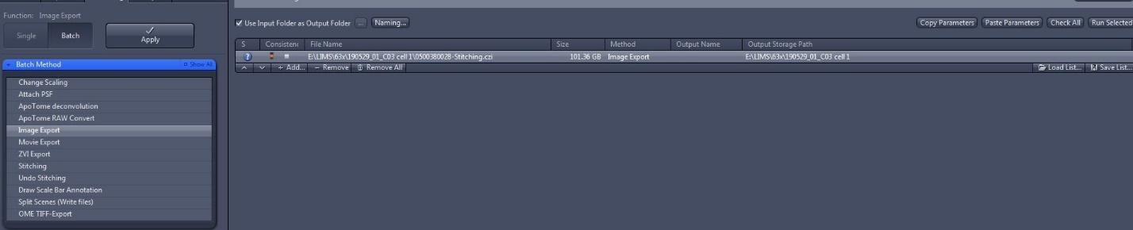
Figure 14: Image Export Parameter Selection

  - Under Method Parameters open the Parameters tab (Figure 15).
    - Under ‘File type’ toggle between ‘Tiff’ and ‘Tiff Format (64Bit) (BigTiff.)’ Choose ‘Tiff Format (64Bit) (BigTiff)’
      - ‘BigTIFF’ and ‘Convert to 8 Bit’ should be checked.
      - Set ‘Compression’ to None.
      - Set ‘Resize’ to 100%.
      - ‘Apply Display Curve and Channel Color’ should be checked.
      - Select ‘Use Full Set of Dimensions’.
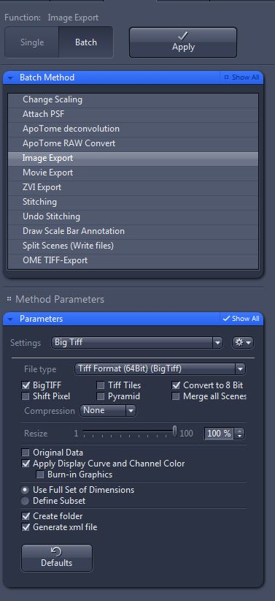
      - ‘Create folder’ and ‘Generate .xml file’ should be checked.
Figure 15: Image Export Parameter Selection

      - Click Copy Parameters (circled in Figure 11). Add the rest of the files that need to be exported by dragging and dropping them into the window. Highlight all files that need to be exported and click Paste Parameters.
      - Stitching and image export files can be combined in the Batch Processing window (Figure 13). Please ensure that correct Batch Method and Method Parameters are defined for each file.
      - Ensure that ‘Use Input Folder as Output Folder’ is checked (A in Figure 13).
      - Click Check All on the far-right side of the screen (B in Figure 13).
      - Make sure the stoplight icon next to each file turns from yellow to green.
      - Click Apply on the left side of the screen (C in Figure 13).
- Take Down:
  - Clean immersion oil off of condenser and objective lens.
    - Only use Zeiss pre-moistened lens cleaning wipes on the optics.
    - Swipe lightly across the lens once with the moist wipe. Turn or fold the wipe so an unused surface is available. Never touch the lens twice with the same area of the wipe.
  - Close the ZEN software. Note: if there are unsaved files, a save/keep documents dialog box will open. Deselect the box next to the file name of any snaps that can be deleted.
- Appendix:
  - Light Path Settings
    - Light path settings should by default be set correctly in the Brightfield under Experiment Manager in the Acquisition Tab, (Figures 16 a-d).

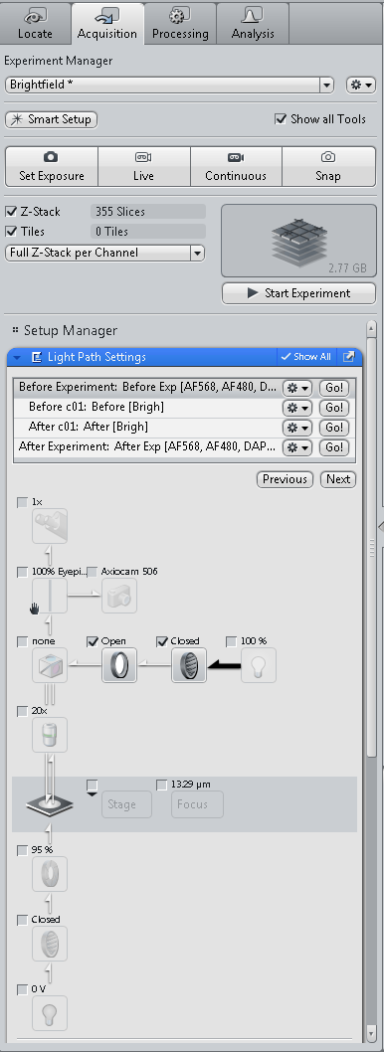 | 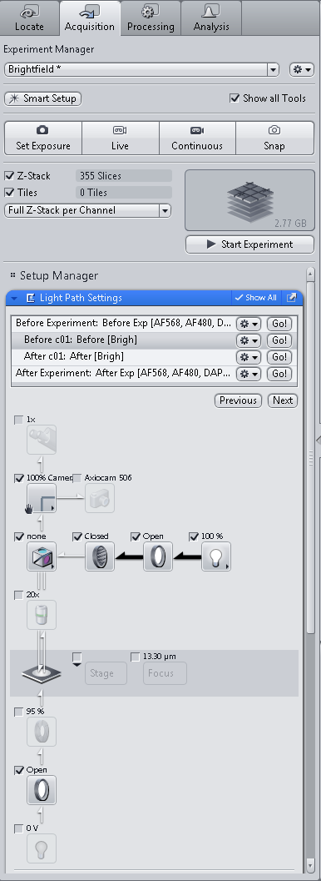
Figure 16a. BF Before Experiment | Figure 16b. BF Before c01

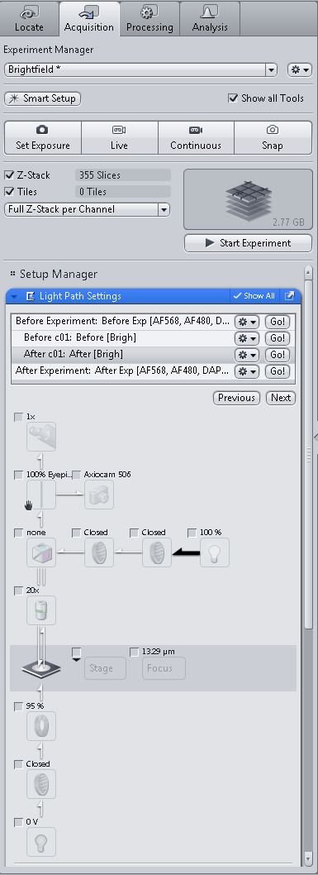 | 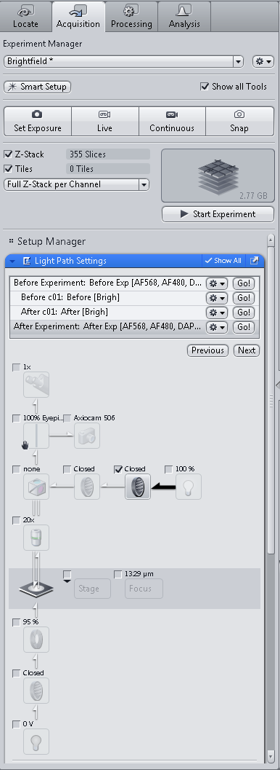
Figure 16c. BF After c01 | Figure 16d. BF After Experiment

  - Proper Alignment of the Camera
    - Locate the stage micrometer slide (slide with an embedded ruler) and place it on the stage of the microscope.
    - Under the “Locate” menu, select “Live.”
    - Under “Graphics” select “Grid” (Figure 17).

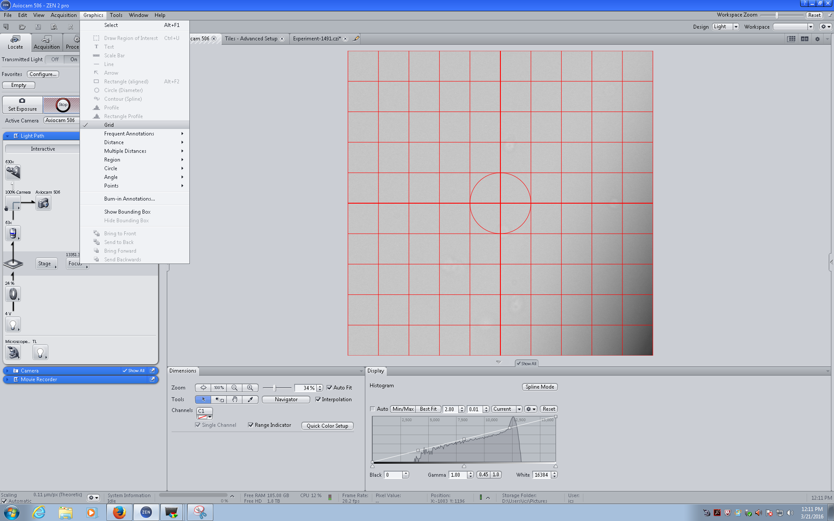
Figure 17: Graphics Menu

    - A grid should appear on the screen (Figure 18).

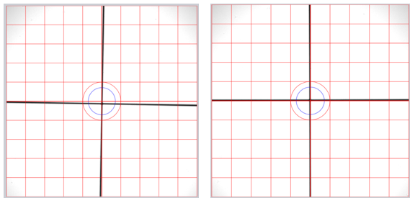
Figure 18: Alignment Grid showing unaligned (left) and aligned (right) ruler and grid

    - Navigate to the slide and locate the ruler on the slide. Both axes on the ruler should align with the grid. Make sure the slide is properly secured and positioned within the slide holder. If the ruler and grid don’t align, the camera will need to be adjusted.
    - Carefully twist the holding ring between the c-mount of the camera and microscope port hole (show picture). Rotate the camera until the ruler of the stage micrometer aligns with the grid.
    - Once aligned, carefully tighten the ring back in place without moving the camera (continue observing the live image as you tighten the ring in place.
    - The camera is now aligned.
  - Workflow flowchart: processes captured in this SOP are indicated in yellow.
