Zeiss AxioImager Multi-Channel 20X Image Capture

- Scope and Applicability: The Zeiss AxioImager Z2 is an upright bright-field microscope that can be configured with fluorescent illumination and 3 emission spectrum filter cubes and used to acquire 2D overview or z-stack images. This SOP describes the capture of 20X multi-channel images using human and mouse tissue.

- Materials:
  - Pre-moistened lens cleaning wipes (Zeiss 170597)
  - Set of autofluorescent plastic slides (Chroma 92001)
- Equipment:
  - Zeiss AxioImager Z2 upright microscope
    - 20X Objective lens (Zeiss Plan-NEOFLUAR 20X/0.5)
    - Oil condenser
    - Heidenhain closed loop Z linear encoder
    - TFT Display Screen
  - Monochrome Camera (Zeiss Axiocam 506)
  - Camera Adapter (60N-C 2/3” 0.63x)
  - Microscope Power Supply (Model 232)
  - WSB Piezo Drive 08 power supply
  - Automated Stage (PI Line; Wienecke and Sinske M666K011)
  - Reflector turret (FL Filter Set 49 DAPI EX G365 S free, FL Filter Set 43 HE Cy3 shift free, FL Filter Set 38 HE GFP shift free)
  - LED Light Source (Lumen Dynamics X-Cite 120 LED or Excelitas X-Cite 120 LED Boost)
  - Stage controller with joystick (Wienecke and Sinske JoyMach4)
  - Barcode scanner (Honeywell 3800g)
  - Computer with Zeiss Efficient Navigation (ZEN) software
  - Monitor
- Safety:
  - Nitrile Gloves
  - Eye protection
  - Lab coat

- Output:
  - CZI file (Zeiss proprietary format), multi-acquisition file format
- Reference Documents:
  - ZEN Pro Software Guide

Warning: Personal Protective Equipment (PPE) should be used at all times while operating this protocol. If you are unsure what PPE you should be using, see your immediate supervisor.

- Setup:
  - Turn on the hardware.
    - Turn on the microscope power supply (A in Figure 1)
    - Turn on the stage controller power supply (B in Figure 1)
    - Turn on Zeiss AxioImager Z2 Microscope (C in Figure 1)
    - Turn on the X-Cite 120 LED (D in Figure 1)
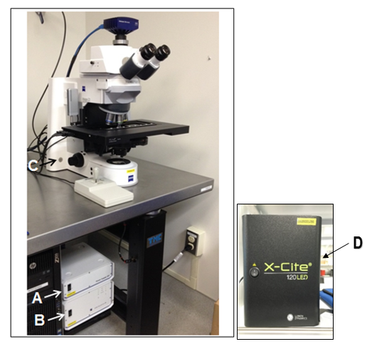
Figure 1: Power switches for Micrcoscope Power Supply (A), Stage Controller Power Supply (B),
Zeiss AxioImager Z2 Microscope (C), X-Cite 120 LED (D)

  - Start up the Zeiss Efficient Navigation (ZEN) software by double clicking the  desktop icon. Note: Always start the software after the hardware is fully powered and the TFT screen is displaying the Home menu.
  - Upon startup, the Zen software will allow you to choose between the Image Processing environment and Zen Pro. Select Zen Pro for image acquisition.
  - Next, a window prompt will appear requiring stage/focus calibration. Proceed with the calibration by selecting Calibrate Now (Figure 2). Warning: Be sure the stage is free of any obstacles and can move to its limits without obstructions.
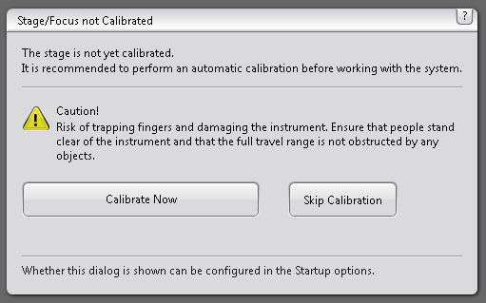
Figure 2: Stage/Focus calibration software prompt
- Methodology/Procedures:
  - In the Locate Tab (top left), under Light Path, click on focus and drag the focus box out to the right side of the screen.
    - In the Acquisition Tab, under Experiment Manager, select Brightfield + DAPI Production Scanning 2020 from the dropdown menu. This option contains all of the correct software settings needed to acquire a 20X image in Brightfield and Fluorescence.
    - Under the Channels Tab, make sure the Red (c03), Blue (c04), White (c01), and Green (c02) channels are shown. If they do not appear add them by selecting the (+) sign (Figure 3). Note: the Red and Green Channels will not be used for production purposes, but are still added as placeholders in case future work requires the addition of these channels.
    - It is important to make sure that the channels appear in the correct order with red first (c03), blue second (c04), brightfield third (c01), and green last (c02). If they are not ordered correctly, press up arrow or down arrow to change the order.
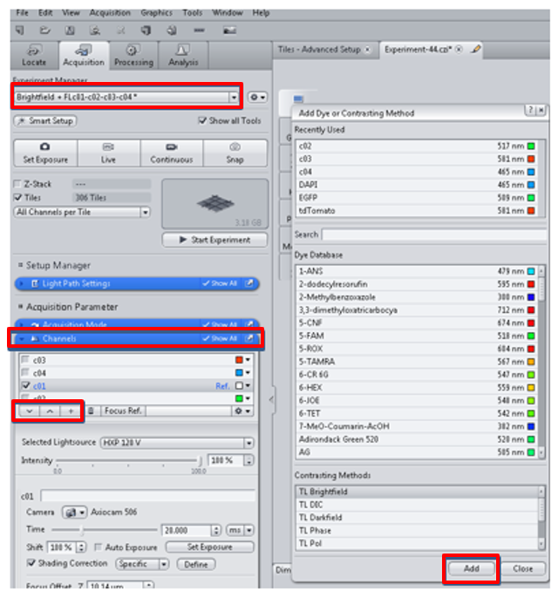
Figure 3: Adding the Td Tomato, DAPI and TL Brightfield Channels
    - Once you have added all of the correct channels, right click on the c01 line (TL Brightfield) and select this as the reference channel.

  - Setting Kohler Illumination:
    - Click on the c01 (Brightfield Channel). It will select the Brightfield mode and highlight it.
    - Select the 20X scanning objective lens by tapping the objective on the TFT display or gently rotating the turret.
    - Position the slide on the stage.
    - Turn on the Brightfield light by selecting TL Illumination On using the TFT display.
    - Set the beam splitter so that all of the light is directed to the eyepieces.
    - Use the joystick to bring the tissue into the field of view.
    - Focus the image using the manual focusing knobs on either side of the microscope body.
    - Adjust the lamp intensity manually, so that the specimen is evenly illuminated.
    - Close down the field diaphragm (A in Figure 4).
    - Use the condenser vertical adjustment knob to bring the edges of the iris into sharp focus (B in Figure 4). When the system is set properly, both the tissue and the iris diaphragm will be in focus.
    - While looking through the oculars, center the iris in the field of view using the silver screws on the condenser (C in Figure 4).
    - Open the field diaphragm until the edges of the iris are just outside the field of view (D in Figure 4).
    - Remove one eyepiece from the binoculars and look through the tube with the naked eye and adjust the field diaphragm to approximately 2/3 of the diameter of the field of view of the objective (E in Figure 4). Replace the eyepiece.
      - Alternatively, the field diaphragm can be opened in Zen software. Select Locate tab and set TL Motorized Fieldstop to 75% (Figure 5).
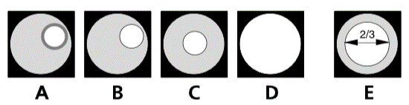
Figure 4: Diaphragm control for Kohler

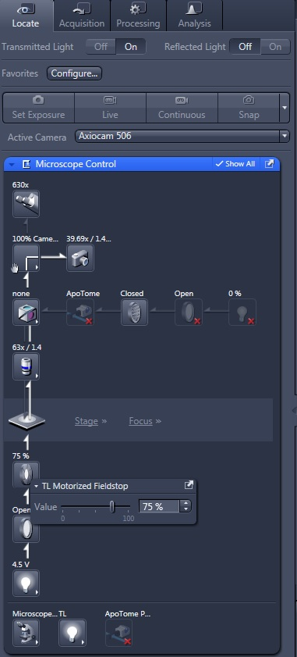
Figure 5: TL Motorized Fieldstop

  - Setting the Shading Correction:
    - Open the Acquisition tab in the software (A in Figure 6).
    - Click on the c01 (Brightfield Channel). It will select the Brightfield mode and highlight it.
    - Pull the beam splitter out to the right so that all of the light is directed to the camera.
    - Click on the Live button (B in Figure 6) and focus on the specimen.

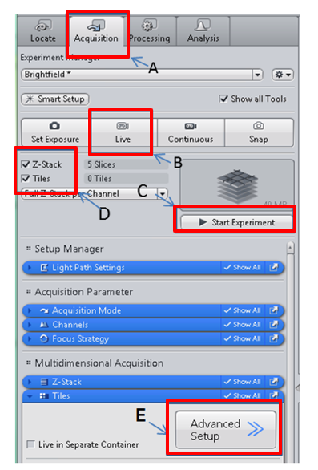
Figure 6: Image Acquisition Setup

    - Navigate to a clear area of the slide without visible debris or defects.
    - Adjust the lamp intensity using the TFT display until evenly illuminated.
    - Open the Channels drop-down menu.
    - Uncheck Shading Correction (A in Figure 7).
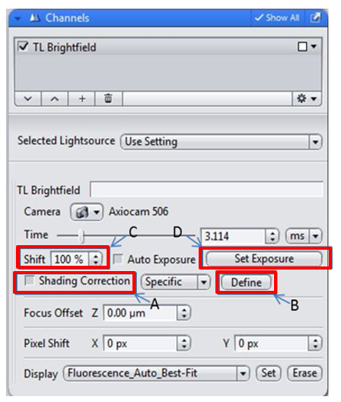
Figure 7: Shading Correction
    - Turn on the Range Indicator in the Dimension menu (A in Figure 8). Oversaturated areas will be indicated in red.
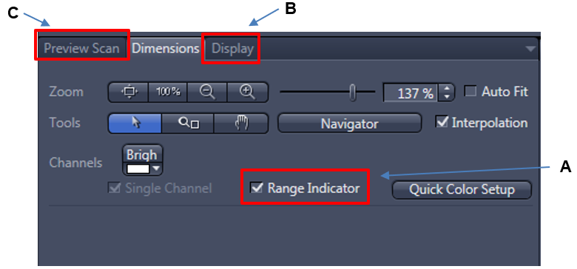
Figure 8: Range Indicator

    - Open the histogram in the Display menu (B in Figure 8).
    - Select Set Exposure, and check that the full dynamic range of the histogram is centered around intensity value of ~11,000. If the exposure time is less than 15 ms, decrease the light intensity manually and click Set Exposure again. Repeat this process until the exposure time is at least 15 ms, which will create stability in the light source and a flat field illumination within a field of view.
    - Click Define to capture and apply the shading correction (B in Figure 7). The box for Shading Correction should now be checked.
    - Click on the c04 (DAPI Channel). It will select the DAPI mode and highlight it.
    - Clean the Chroma slide and place it on the stage next to the specimen slide.
    - Click on the Live button (B in Figure 6) and focus on the specimen.
    - Navigate to a clear area of the Chroma slide without visible debris or defects.
    - Adjust LED lamp intensity to ~2% (B in Figure 9), and repeat steps 8.3.6-8.3.12.
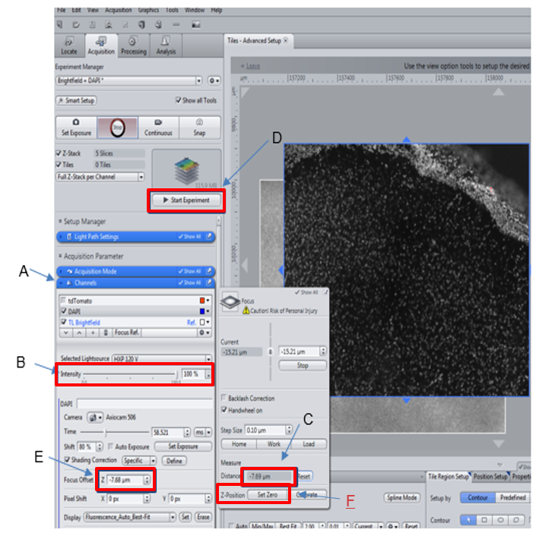
Figure 9: Channels Tab & Focus Offset Box
  - Setting Exposure Time:
    - Click on the c01 (Brightfield Channel). It will select the Brightfield mode and highlight it.
    - Focus on the specimen.
    - Pull the beam splitter all the way to the right to direct all of the light to the camera.
    - Select Live.
    - Open the Channels drop-down menu.
    - Set Shift to 100% to maximize the dynamic range (C in Figure 7).
    - Locate a stained cell in the tissue.
    - Use the joystick to navigate to a location on the slide that is just outside of the field of view of the cell but where tissue is still visible.
    - Select Set Exposure (D in Figure 7). Make sure that the exposure time is greater than 20 ms. If it is less than 20 ms, decrease the lamp intensity manually and click Set Exposure again. Repeat this procedure until you are able to obtain a value of 20-50 ms.
    - Click on the c04 (DAPI Channel). It will select the DAPI mode and highlight it.
    - Focus on the specimen.
    - Make sure that the LED intensity is turned all the way up to 100% (B in Figure 9).
    - Use the joystick to navigate to a location on the slide that is just outside of the field of view of the cell but where tissue is still visible.
    - Select Set Exposure (D in Figure 7). For human and macaque tissue, use this auto-exposure time during scan acquisition. For mouse tissue, use half of the auto-exposure time during scan acquisition.

  - Defining the Scan Area:
    - Click on the c01 (Brightfield Channel). It will select the Brightfield mode and highlight it.
    - Locate and focus on the cell.
    - Under the Tiles menu, select Advanced Setup (E in Figure 6).
    - Click the Snap button or F2 to capture a snapshot of this area.
    - In the Tiles drop-down menu, select Stake (A in Figure 10). This will create a tile region by the placement of at least two markers defined by the user.
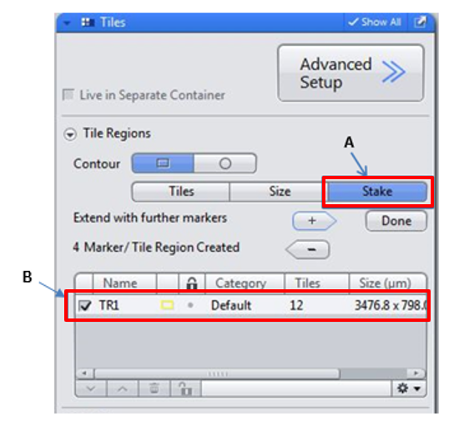
Figure 10: Tiles Drop Down Menu

    - Navigate to the region within the area of interest and add a marker. Continue to navigate around the edges of the tissue adding markers until the tile region covers the entire area of interest for scanning. Select Done.
    - Confirm that the region has been saved by deselecting and selecting the tile region in the Tiles drop-down menu (B in Figure 10).
    - Select Preview Scan in the dialogue box at the bottom right of the live window (C in Figure 8).
    - Once the preview scan has been completed, check the image for overall quality. The image should be free of any tiling artifacts (tessellation). If necessary, adjust the shading correction, image intensity (exposure time), focal plane, and bounding box to optimize the final image output.
  - Adding Support Points to DAPI acquisition
    - Click on the c04 (DAPI Channel). It will select the DAPI mode and highlight it.
    - Focus on the cells around the cell body. Then select the Set Zero button in the Focus Dialogue Box (F in Figure 9). This will reset the z-offset to zero so that the distance between focal planes in different channels can be measured.
    - Under the Focus Strategy pull-down menu, select Local Focus Surface (Figure 11). In the Focus Surface section, select Fixed Z-Position in the drop-down menu.
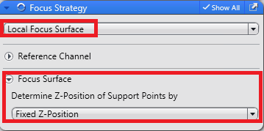
Figure 11: Focus Strategy selections for using Support Points
    - Select the tile region created under the Tiles menu (B in Figure 10).
    - Start live view and navigate with the joystick to the area of interest. Adjust the focus until layer 4-5 of mouse and human tissue is in focus (Figure 12).

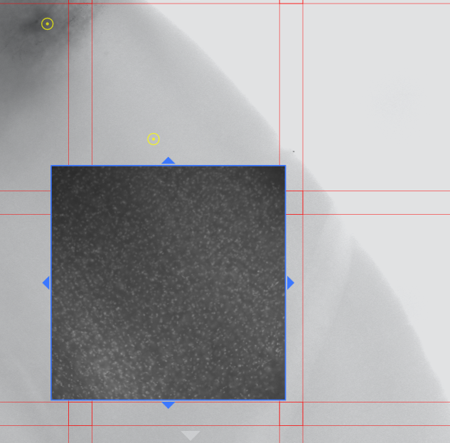
Figure 12: Support point placement around an area of interest

    - Under the Support Points tab, select Add Support Point at Current Stage and Focus Position (Figure 13). A yellow focus point will appear in the center of the field of view.

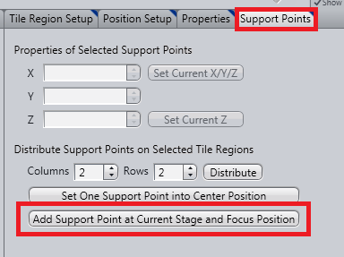
Figure 13: Adding Support Points. Dialogue populates only when Tile Region is selected.
    - Navigate to a different region of interest and continue to add support points (1 support point per tile) until 6-8 focus points are populated on the tile region.
    - In the Tiles menu under Focus Surface, select 1: Tilted Plane (at least 4 support points) in the Interpolation Degree drop-down menu (Figure 14).
    - Click on the c01 (Brightfield Channel). It will select the Brightfield mode and highlight it.
    - Locate the cell and adjust the focus knob until it appears to be in focus.
    - In the Focus Dialogue Box, measure the distance (C Figure 9) and input this value into the focus offset field (E Figure 9).
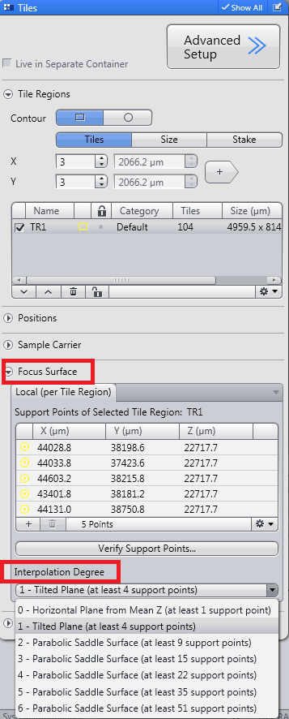
Figure 14: Tile menu; Support Points listed for tile region and Interpolation Degree.
  - Starting the Scan:
    - In the Channels drop-down menu (A in Figure 9), select both the DAPI and Brightfield channels, ensuring that each have a checkmark.
    - Ensure that the tile region is selected by checking the box in the Tiles drop down menu (B in Figure 10).
    - Click Start Experiment (D in Figure 9). A new window will appear when the scan is finished.
    - Once the scan has been completed, check the image for overall quality. The image should be free of any tiling artifacts (tessellation) and all areas of interest should appear in focus. If necessary. adjust the image intensity (exposure time), focal plane, and bounding box to optimize the final image output.
- Batch Image Export
  - The Batch Method coverts batches of images into various file types.
  - Navigate to the Processing tab.
  - Select the Batch Tab.
  - Expand the Batch Method menu, and select the Image Export method (See Figure 15).
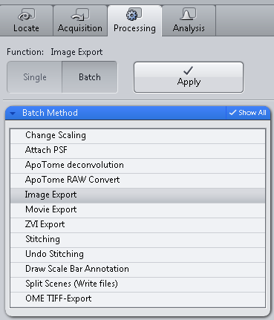
Figure 15: Image Export

    - Drag the files to be exported from their current folder to the Batch Processing area on the right side of the screen (Figure 16).

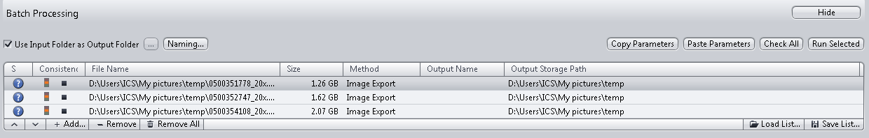
Figure 16: Batch Processing

    - On the left side of the screen, under Parameters, expand the menu (Figure 17).
      - Change the File type to Tiff Format (64Bit) (Big Tiff).
      - Select BigTIFF and Convert to 8 Bit check boxes and deselect the rest of the options.
      - In the Compression drop down, select None.
      - The Resize slider should be adjusted to 100%.
      - Deselect the checkbox next to Original Data.
      - Select Apply Display Curve and Channel Color, Burn-in Graphics, and Individual Channels Image.
      - Select Use channel names, Create Folder, and Generate xml file.
      - Select the radio button Use Full Set of Dimensions.
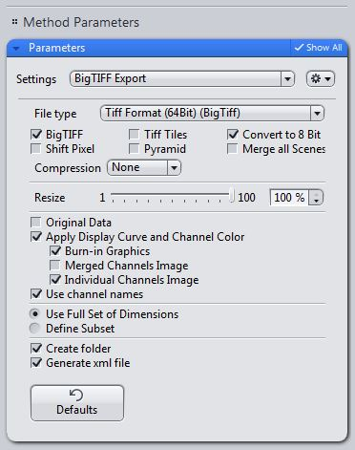
Figure 17: Method Parametes
    - To apply these settings to all files, select Copy Parameters in the Batch Processing area.
    - Highlight all of the files by clicking on the first one, holding down the “Shift” button on the keyboard and then selecting the remaining files using the mouse.
    - Click Paste Parameters and then Check All.
    - Verify that the naming convention is correct by clicking on Naming (Figure 18).

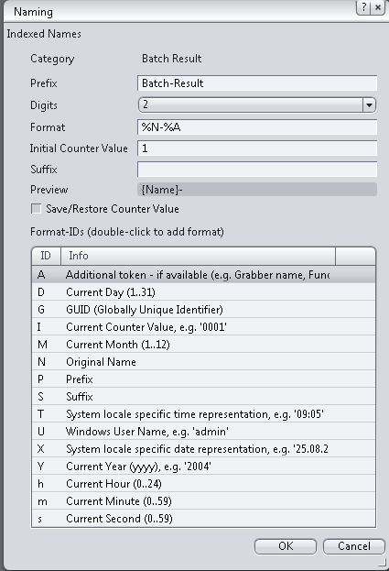
Figure 18: Naming Convention

  - Select the Use Input Folder as Output Folder check box.
  - Click Apply.
  - When the files are done converting there should be a checkmark next to each file in the Batch Processing area. Additionally, a new folder should appear for each file that has been processed. The new folder contains the contents of the converted images.

- Appendix:
  - Light Path Settings
    - Light path settings should by default be set correctly in the Brightfield + FLc01-c02-c03-c04 Template under Experiment Manager in the Acquisition Tab, (Figures 19 a-d).
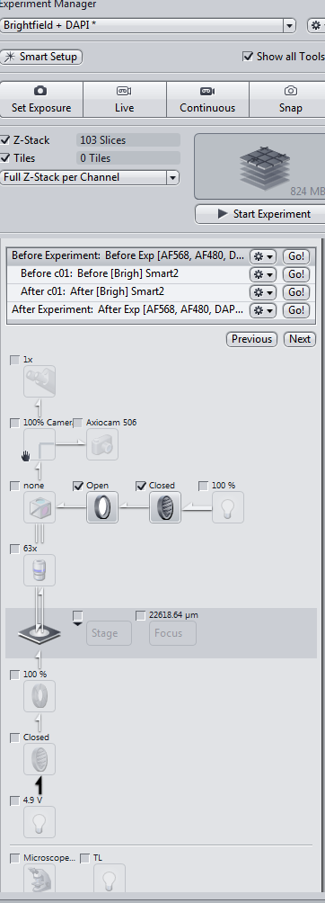 | 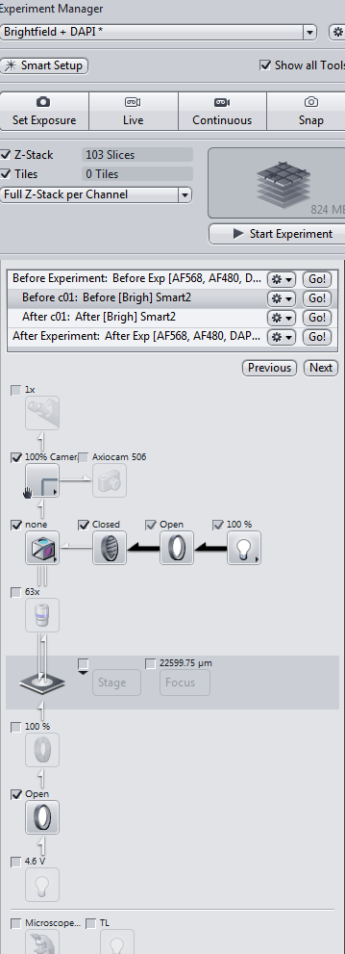
Figure 19a. BF Before Experiemnt | Figure 19b. BF Before c01
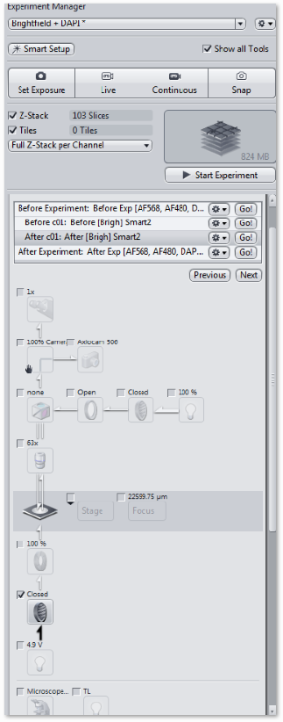 | 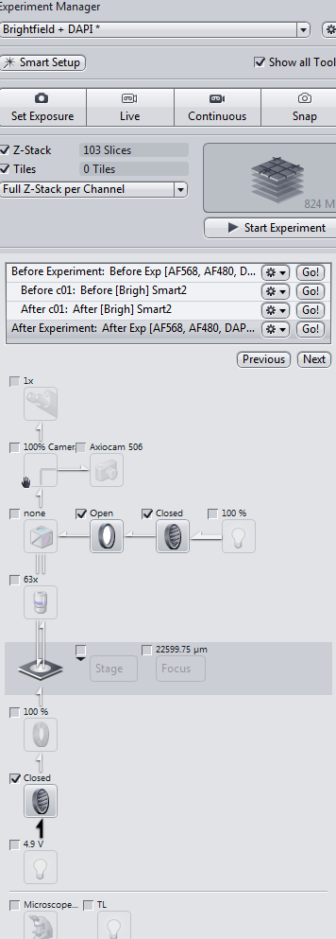
Figure 19c. BF After c01 | Figure 19d. BF After Experiment

  - Proper Alignment of the Camera
    - Locate the stage micrometer slide (slide with an embedded ruler) and place it on the stage of the microscope.
    - Under the “Locate” menu, select “Live.”
    - Under “Graphics” select “Grid” (Figure 20).
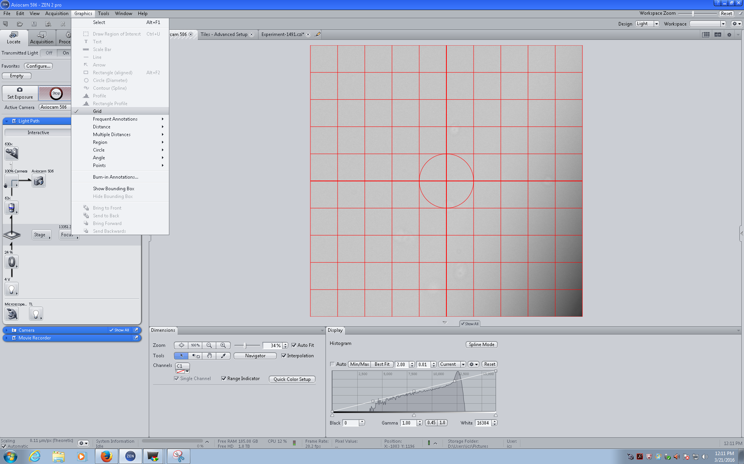
Figure 20: Graphics Menu

    - A grid should appear on the screen (Figure 21).
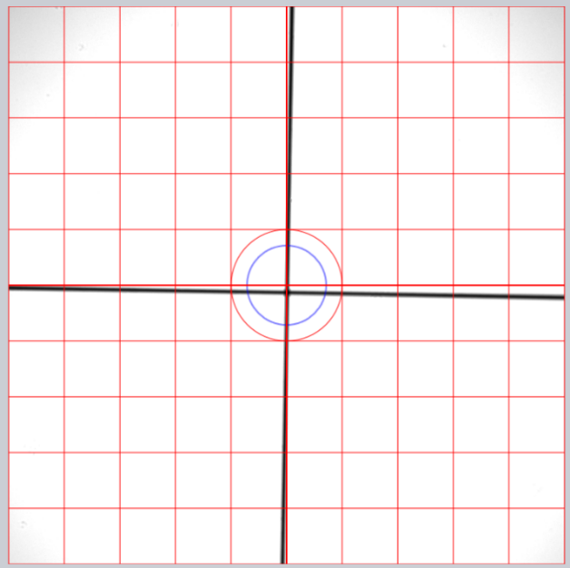 | 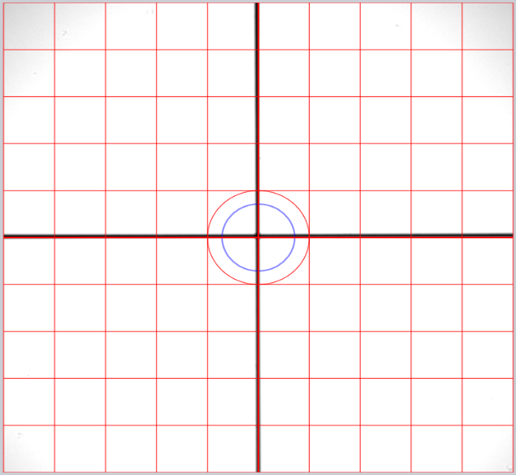
Figure 21: Alignment Grid showing unaligned (left) and aligned (right) ruler and grid

    - Navigate to the slide and locate the ruler on the slide. Both axes on the ruler should align with the grid. Make sure the slide is properly secured and positioned within the slide holder. If the ruler and grid don’t align, the camera will need to be adjusted.
    - Carefully twist the holding ring between the c-mount of the camera and microscope port hole (show picture). Rotate the camera until the ruler of the stage micrometer aligns with the grid.
    - Once aligned, carefully tighten the ring back in place without moving the camera (continue observing the live image as you tighten the ring in place.
    - The camera is now aligned.

  - Workflow flowchart; processes captured in this SOP are indicated in yellow.
