Task 2 — Git Workflow Practice

Student Name
Project Name
GitHub Repository
Submission Date

1. Git Clone
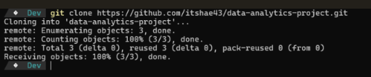

2. Git Add
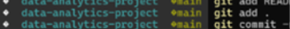

3. Git Commit
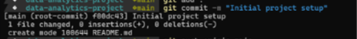

4. Git Push
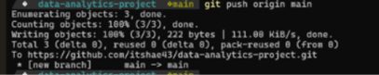

5. Git Pull
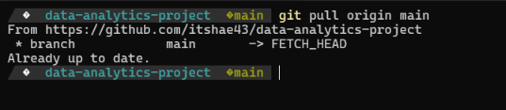

6. Three Meaningful Commits
