Task 3 — Dataset Selection & Data Preparation

3.1 Dataset Selection
Dataset Name: Sample Superstore
Domain: Sales / E-commerce
File: Sample_Superstore.xlsx

3.2 Data Inspection
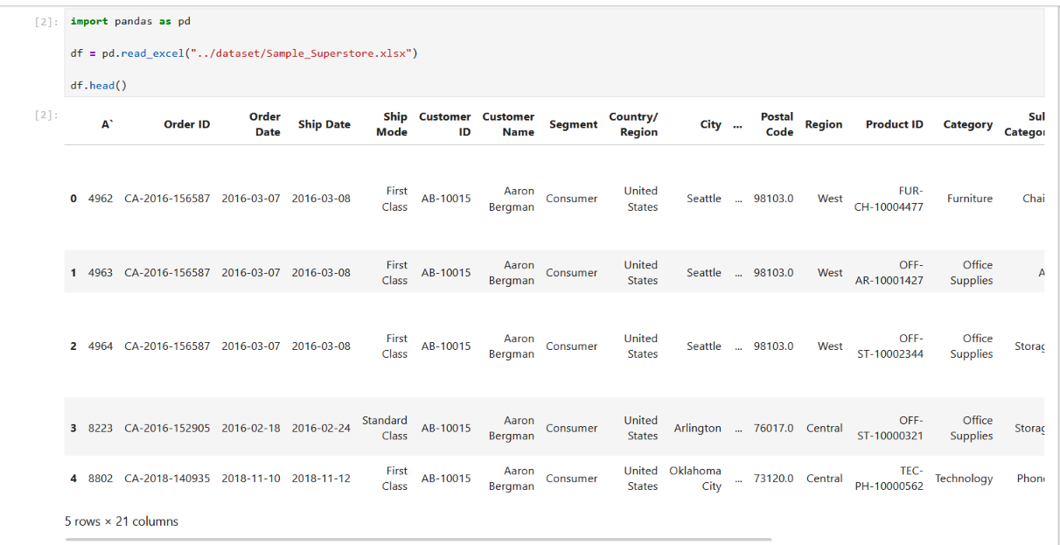

3.3 Columns & Data Types
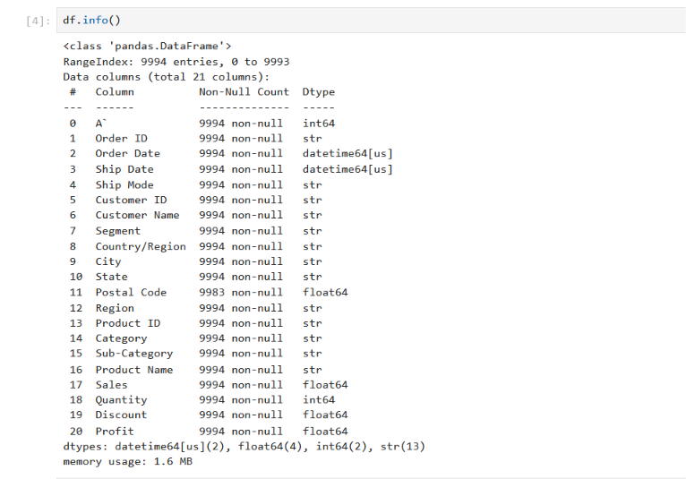

3.4 Missing Values & Duplicates
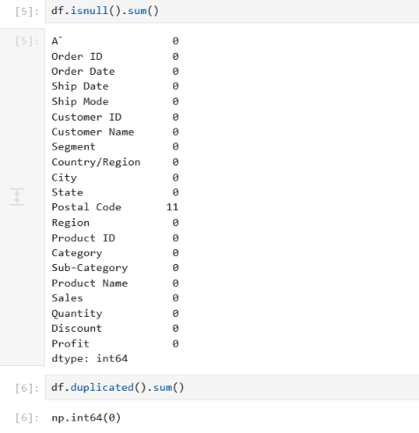

3.5 Handling of Missing Values
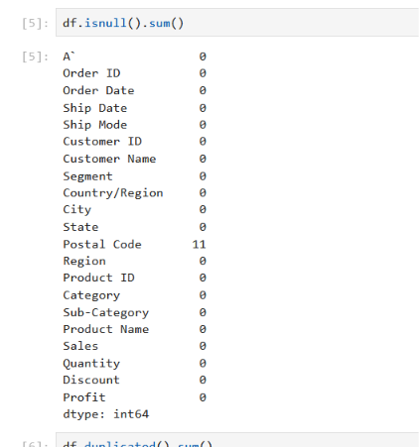

3.6 Duplicate Records


3.7 Final Dataset Preparation
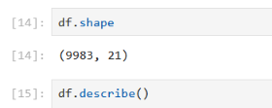

3.8 Final Dataset Summary
Item | Result
Initial Records | 9,994
Final Records | 9,983
Columns | 21
Missing Values After Cleaning | 0
Duplicate Records | 0

