Task 4 — Exploratory Data Analysis (EDA)

4.1 Descriptive Statistics
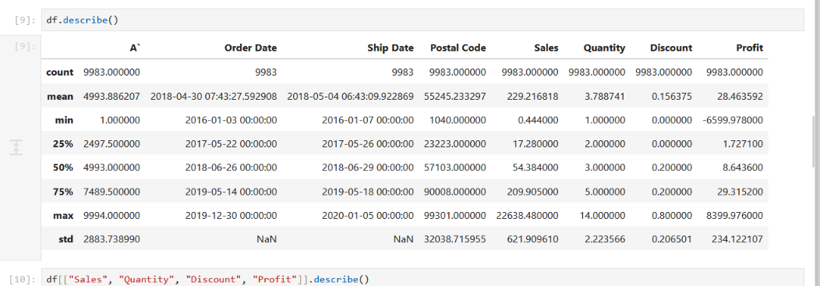

4.2 Data Inspection
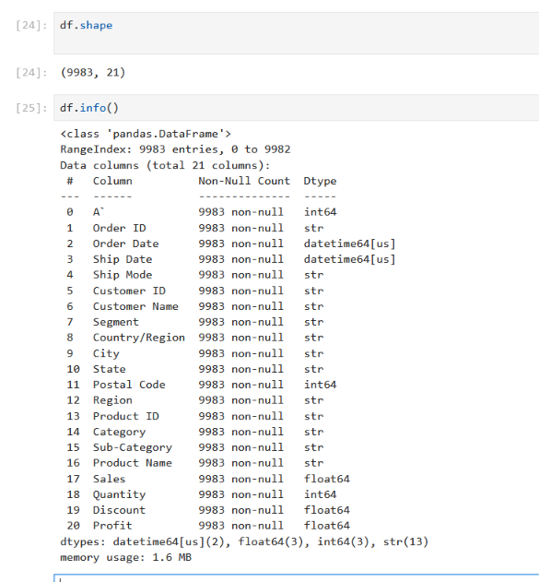

4.3 Data Cleaning
The dataset was cleaned and prepared during Task 3 before performing EDA.

4.4 Missing-Value Handling
Missing values were handled during Task 3. The final cleaned dataset contains no missing values.

4.5 Category Analysis
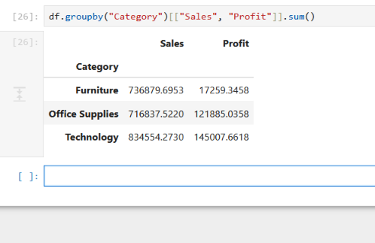

4.6 Correlation Analysis
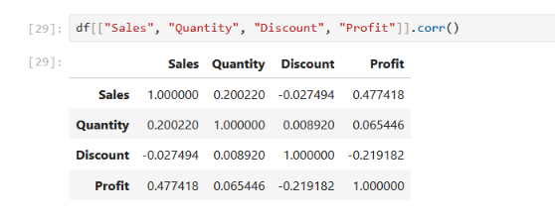

4.7 Correlation Heatmap
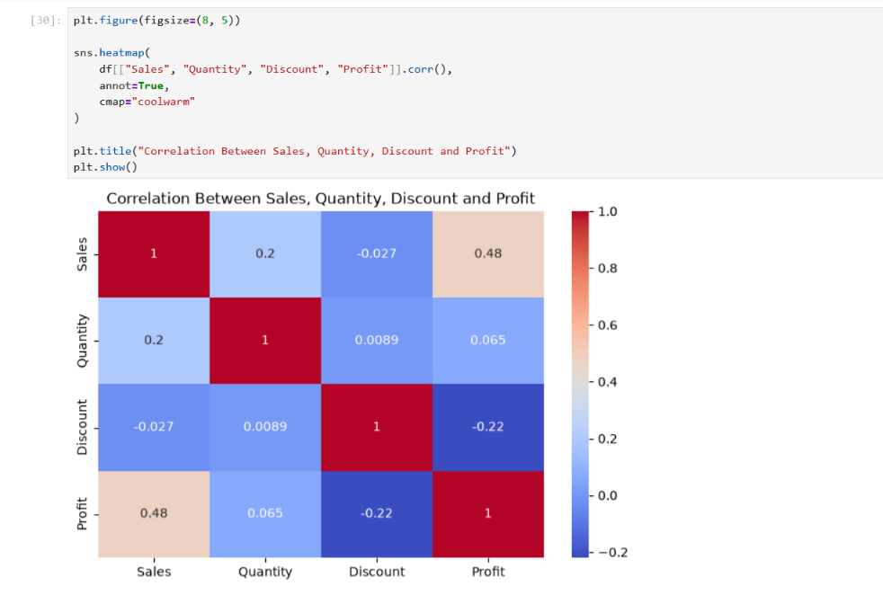

4.8 Outlier Analysis
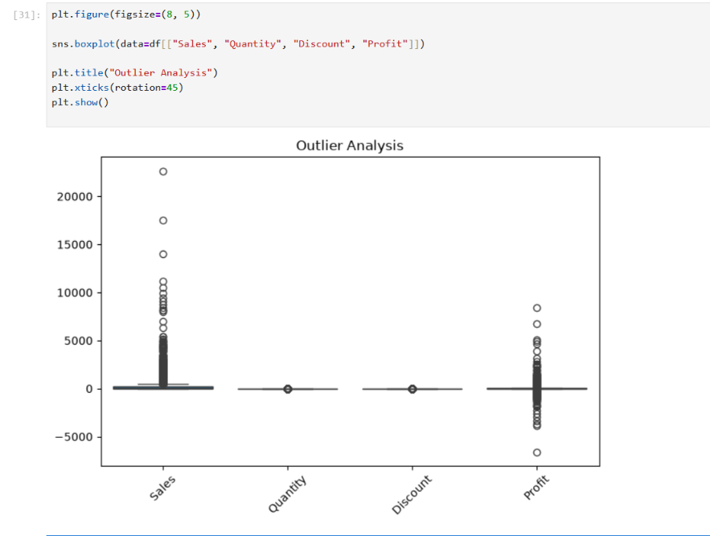

4.9 Important Patterns and Trends
- Technology has the highest sales and profit among the three categories.
- Office Supplies generates lower sales than Technology but shows a strong profit contribution.
- Furniture has the lowest profit among the three categories.
- Sales and Profit show a moderate positive correlation (approximately 0.48).
- Discount and Profit show a negative correlation (approximately -0.22), indicating that higher discounts are generally associated with lower profit.

4.10 EDA Findings
- The cleaned dataset contains 9,983 records and 21 columns.
- Technology is the strongest-performing category based on both total sales and total profit.
- Sales has the strongest positive relationship with Profit among the analyzed numerical variables.
- Discount has a negative relationship with Profit and should therefore be monitored.
- Sales and Profit contain noticeable outliers, which represent unusually large or negative transaction values and should be considered during business analysis.

