Task 5 — Data Visualization
Sample Superstore Sales Dataset

5.1 Sales by Category
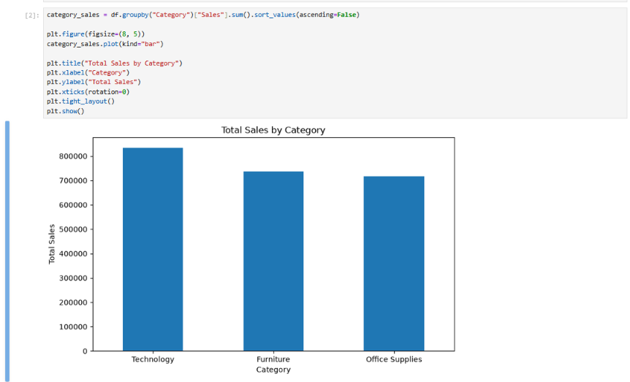

5.2 Profit by Category
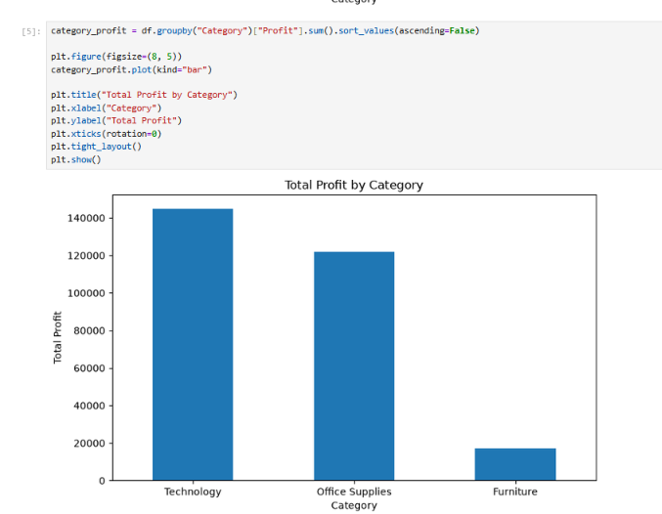

5.3 Sales by Region
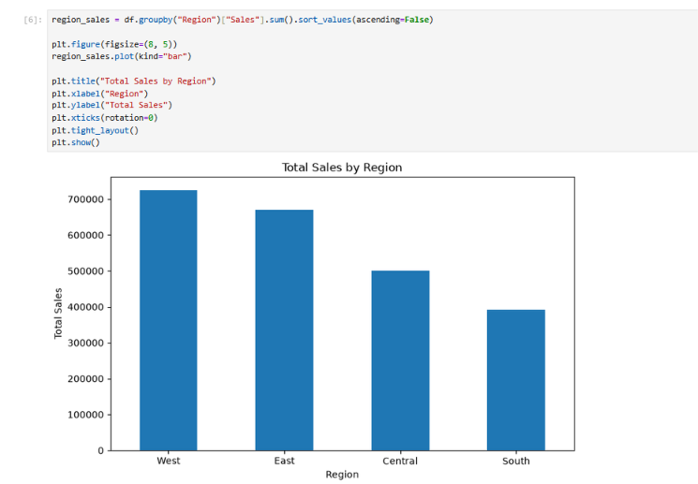

5.4 Sales vs Profit
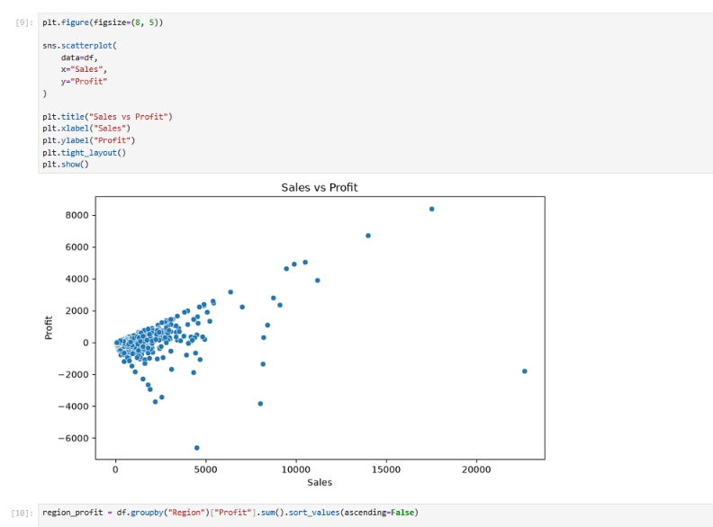

5.5 Profit by Region
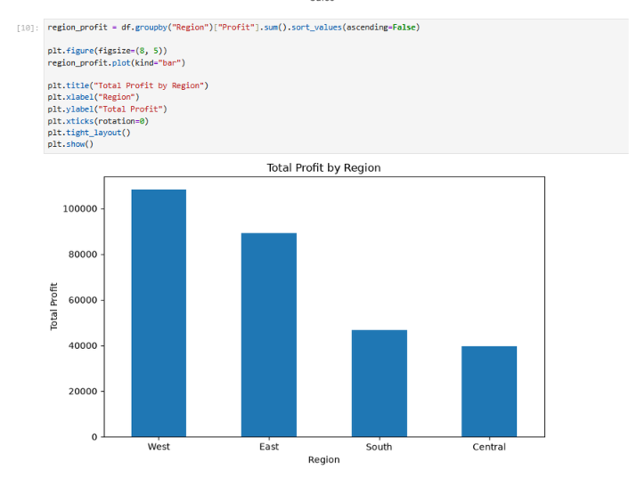

5.6 Sales by Customer Segment
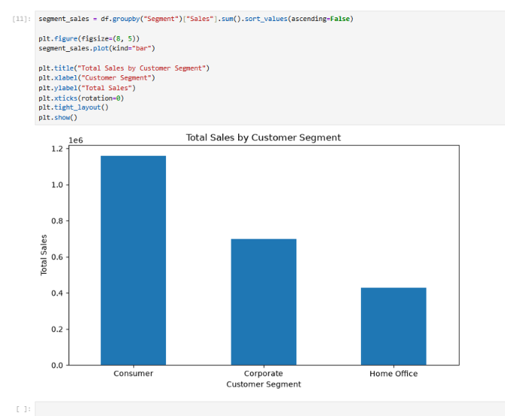

5.7 Monthly Sales Trend
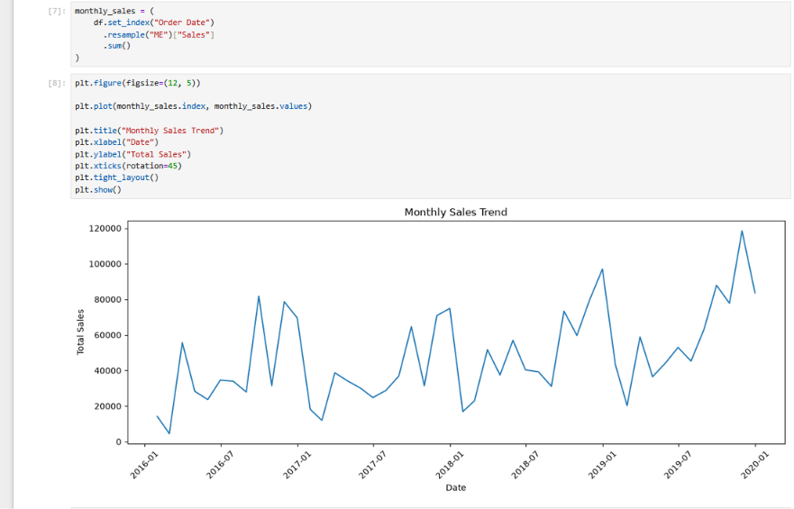

5.8 Visualization Summary
The visualizations present sales and profit comparisons across categories, regions, and customer segments, along with the monthly sales trend and the relationship between sales and profit.

5.9 Key Observations
- Technology has the highest total sales among the three product categories.
- Technology also generates the highest total profit, while Furniture has the lowest profit.
- The West region records the highest sales, followed by East, Central, and South.
- The monthly sales trend shows noticeable fluctuations with several high-sales periods.
- The Sales vs Profit scatter plot shows a generally positive relationship, with some noticeable outliers.
- The Consumer segment contributes the highest sales compared with Corporate and Home Office.

5.10 Conclusion
The visualizations make the major sales and profit patterns easier to understand and provide a clear basis for further business analysis and dashboard development.

