Task 6 — Power BI Dashboard
Superstore Sales & Profit Dashboard

6.1 Dashboard Title
Superstore Sales & Profit Dashboard

6.2 KPI Cards
The dashboard includes Total Sales, Total Profit, and Total Quantity KPI cards.
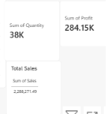

6.3 Dashboard Visualizations
The dashboard contains sales and profit analysis by category and region, a monthly sales trend, and sales distribution by customer segment.
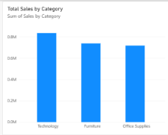

6.4 Interactive Filters
Interactive slicers are provided for Category, Region, and Segment.
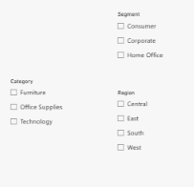

6.5 Key Dashboard Metrics
- Total Sales: 2.29M
- Total Profit: 284.15K
- Total Quantity: 38K

6.6 Dashboard Overview
The Power BI dashboard provides an interactive overview of sales, profit, quantity, categories, regions, customer segments, and monthly sales trends.

6.7 Conclusion
The dashboard presents the major business metrics and patterns from the Superstore dataset in an interactive and easy-to-understand format.

