Task 7 — Business Insights & Recommendations

7.1 Business Insights

Insight 1 — Category Performance
Technology is the highest-performing product category by total sales.

Insight 2 — Profitability by Category
Technology generates the highest total profit, while Furniture contributes the lowest profit.

Insight 3 — Regional Performance
The West region generates the highest sales, while the South region has the lowest sales among the four regions.

Insight 4 — Customer Segment Performance
Consumer customers contribute the largest share of total sales, followed by Corporate and Home Office.

Insight 5 — Sales and Profit Relationship
Sales and profit have a moderate positive relationship, with a correlation of approximately 0.48. This indicates that higher sales generally tend to be associated with higher profit.

Insight 6 — Discount and Profit Relationship
Discount and profit have a negative correlation of approximately -0.22, suggesting that higher discounts can negatively affect profitability.

Insight 7 — Sales Trend
Monthly sales fluctuate considerably over time, with several periods showing significant sales peaks.

Power BI Dashboard
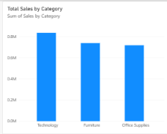

Correlation Analysis
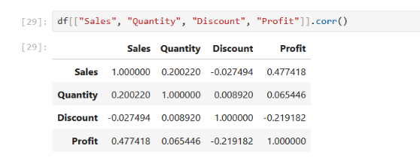

Monthly Sales Trend
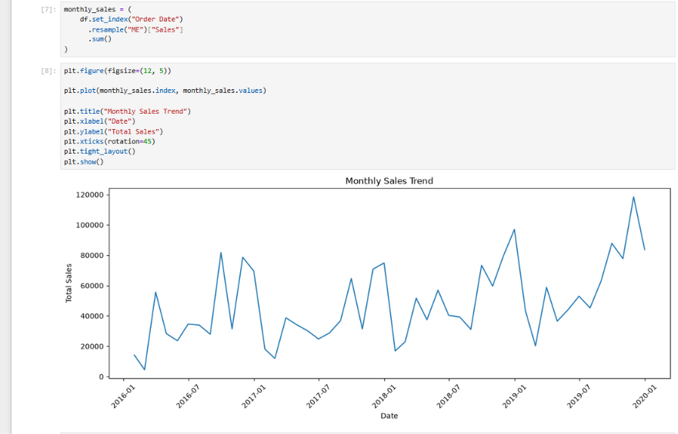

7.2 Business Recommendations

Recommendation 1 — Focus on Technology
Continue investing in the Technology category because it generates the highest sales and profit.

Recommendation 2 — Improve Furniture Profitability
Review the Furniture category to identify opportunities related to pricing, product mix, costs, and discount levels.

Recommendation 3 — Review Discount Strategy
Control discount levels carefully because the analysis shows a negative relationship between discount and profit.

Recommendation 4 — Improve South Region Performance
Investigate the lower sales performance in the South region and use targeted marketing, product, and customer strategies to improve sales.

7.3 Conclusion
The analysis and Power BI dashboard highlight important differences in category, regional, and customer-segment performance. Technology and the Consumer segment are major contributors to sales, while Furniture and the South region require further attention. The findings can help the business improve profitability, optimize discounts, and focus resources on stronger growth opportunities.

