20CYS312 -PPL -Lab Exercise 7 – Programming with RUST

Name: Kiruthik Pranav P V
Roll No: CH.EN.U4CYS22026
Date:21/02/25
Github Link:https://github.com/kpsan12/Haskell-Programming/tree/main/lab7

------------------------------------------------------------------------------------------------------------------------

Task 1: Data Types and Variables

Qn1.Deckare variables of the following types : integer,floating point,boolean and character.Print the value of each variable.

Objective:
To declare variables of the following types : integer,floating point,boolean and character and to print the value of each variable.

Program Code:

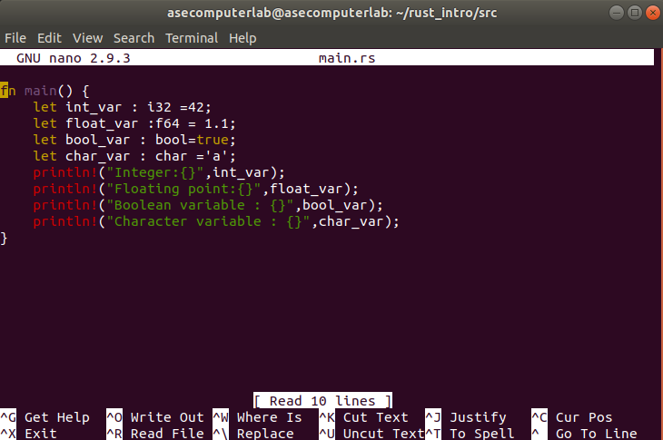
Explanation of the Code:
- Declares variables of integer (i32), floating-point (f64), boolean (bool), and character (char) types.
- Prints their value using Println!

Input/Output Example /Output Screenshot:
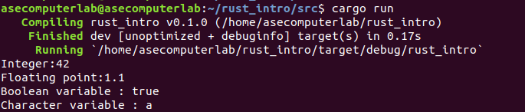

Conclusion:

- Successfully learnt how to declare variables and print them

Task 2: Simple Arithmetic Operations

Qn2.Declare two integer variables and perform the following operations:
  - Addition
  - Subtraction
  - Multiplication
  - Division
  - Modulo
Qn3.Print the Result of each operation

Objective:
- To declare two integer variables and perform arithmetic operations and print the result of each

Program Code:

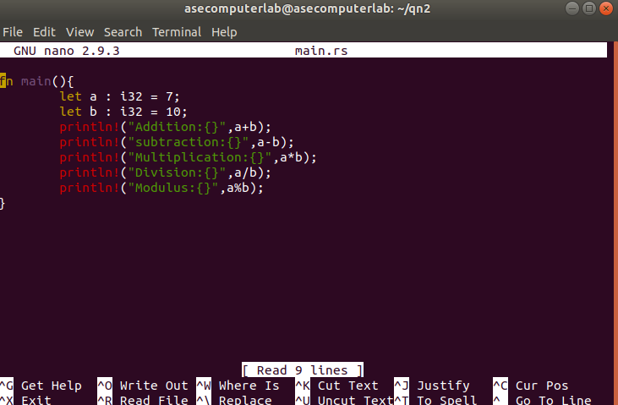

Explanation of the Code:
- Declared two variables of int and assigned values
- Printed the value of arithmetic operations

Output Screenshots:

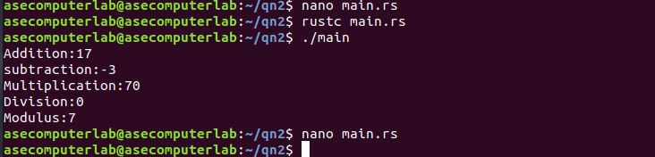
Conclusion:
- Successfully learnt how to do arithmetic operations and the ways to print them

Task 3: If-Else Decision Making

Qn1.Write a program that:
- Takes a number as input.
- Checks whether the number is positive, negative, or zero using an if-else statement.
- Print a message based on the result.

Objective:
- To check if a number is positive or negative or zero

Program Code:

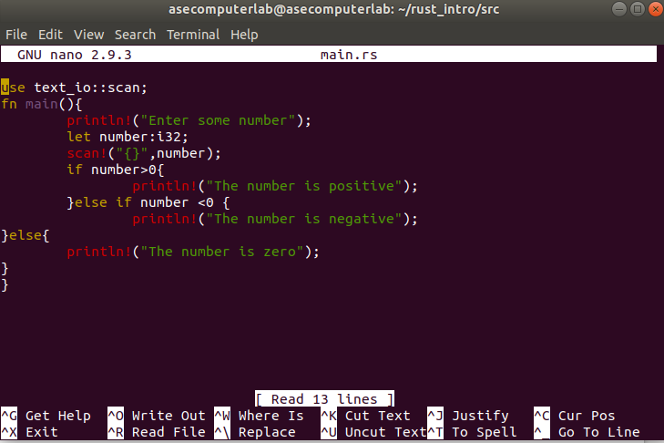

Explanation of the Code:
- First we are getting an input
- We are checking if the number is postivie and negativce or zero and printing it accordingly

Input/Output Examples:
INPUT: 1 OUTPUT: The number is positive
INPUT:-1 OUTPUT:The number is negative
INPUT:0 OUTPUT:The number is zero

Output Screenshots:
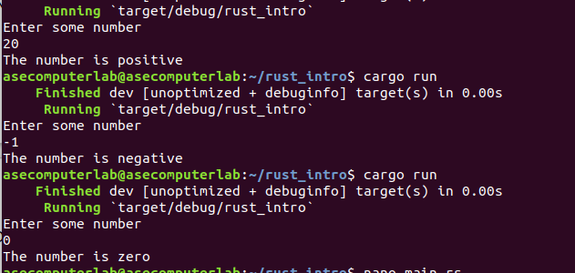

Task 4: Checking for Even or Odd

Qn1.Write a program that:
- Takes an integer as input.
- Uses an if-else statement to check if the number is even or odd.
- Print "Even" if the number is even and "Odd" if the number is odd.

Objective of the Code:
- To get a number as input and check if it it even or odd and print accordingly

Program Code:

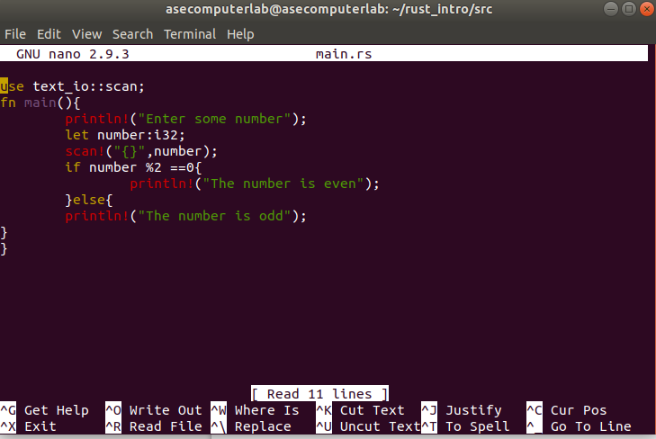

Explanation of the Code:
- Got input from user
- checked if it is odd or even using modulus functions
- Printed Accordingly

Input/Output Examples:
Input: 2 Output:The number is Even
Input:1 Output:The number is Odd

Output Screenshots:
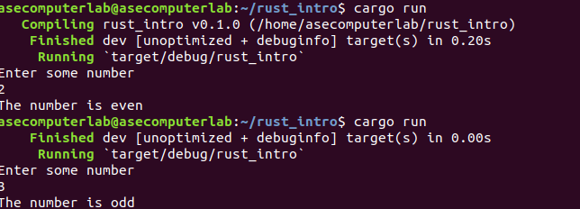

Conclusion:
- Implemented odd or even checker

Task 5: Using a Loop to Print Numbers

Qn1.Write a program that uses a for loop to print the even numbers from the range 1 to 20.

Objective
- To Write a program that uses a for loop to print the even numbers from the range 1 to 20.

Program Code:
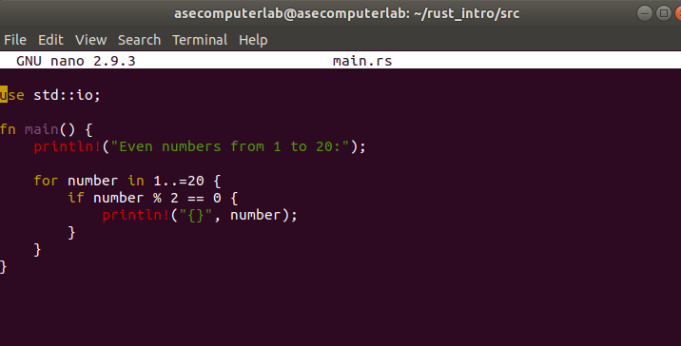
Explanation of the Code:
- Used even checking
- Printed numbers which are even using loop

Input/Output Examples / Output Screenshots:

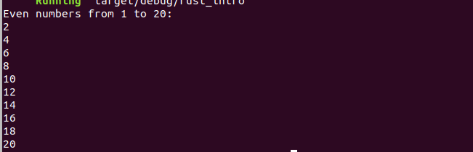

Conclusion:
- Implemented a for loop to print even numbers

Task 6: While Loop Example
Qn1.Write a program that uses a while loop to print odd numbers from the range 1 to 20.

Objective of the Code:
- To Write a program that uses a while loop to print odd numbers from the range 1 to 20.
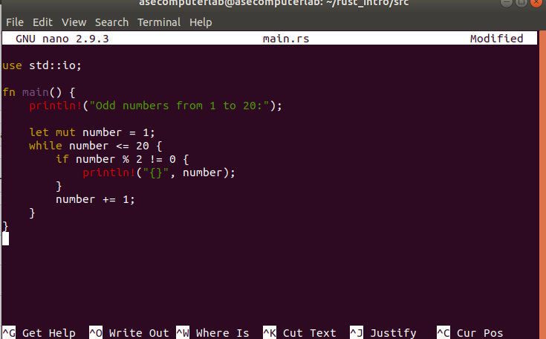
Program Code:
Explanation of the Code:
- Created a number which is mutable using the let mut number=1;
- Used a while loop for numbers upto 20
- Printing the odd numbers alone

Input/Output Examples /Screenshots
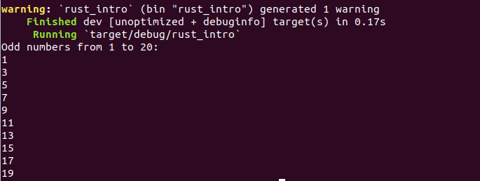

Conclusion:
- In a while loop printed all odd numbers upto 20

Task 7: Using a For Loop with a Range
Qn1.Write a program that uses a for loop to print the numbers from 10 to 1 in reverse order (10, 9, 8, ..., 1).

Objective of the Code:
- To write a program that uses a for loop to print the numbers from 10 to 1 in reverse order

Program Code:
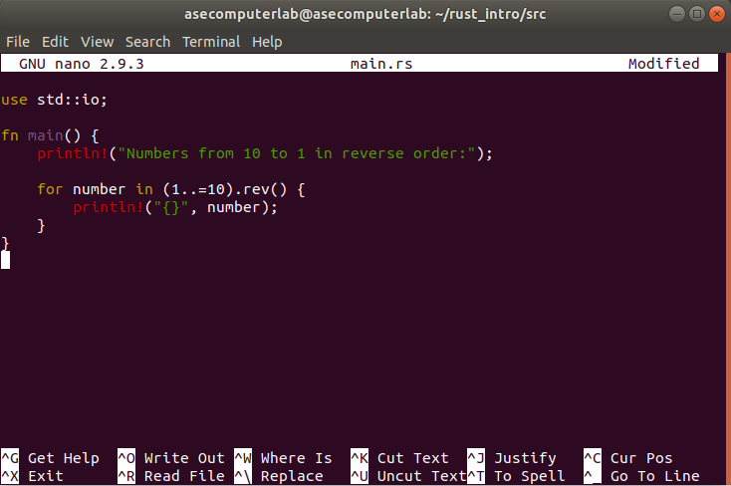

Explanation of the Code:
- Created a foor loop for numbers from 1 to 10 and used the function rev() to reverse it
- So printed the values from 10 to 1

Input/Output Examples/Screenshots:
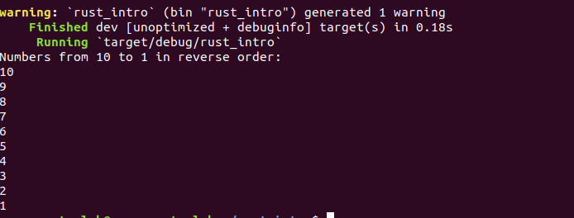
Conclusion:
- Succesfully printed the values of 10 to 1 in reverse order using for loop

