

**Biology**

**RS:1599**

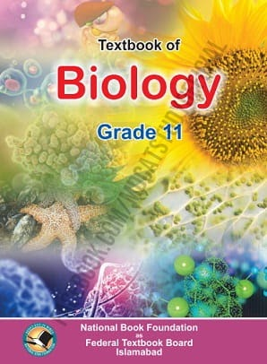

**Course Overview**

* **Diversity of Living Organisms**
* **Structural Organisation in Plants and Animals**
* **Cell: Structure and Function**
* **Plant Physiology**
* **Human Physiology.**