

**Botany**

**RS:1599**

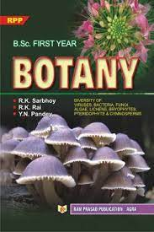

**Course Overview**

* The Living World.
* Plant Kingdom.
* Families of Angiosperms.
* Transport in Plants.
* Photosynthesis in Higher Plants.
* Plant Growth and Development