

**Chemistry**

**RS:1599**

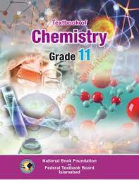

**Course Overview**

1. acids and bases
2. atomic structure
3. the periodic table
4. chemical bonds
5. chemical reactions