

**Commerce**

**RS:1000**

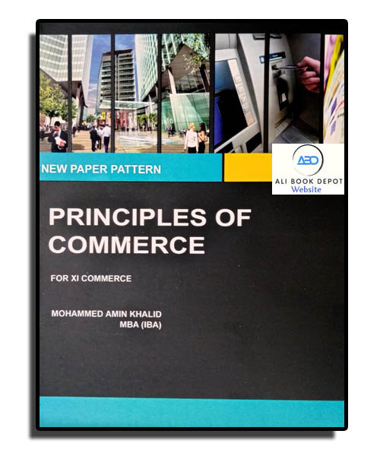

**Course Overview**

* Identify the different types of accounts
* Understand the different types of transactions
* Analyze the different financial statements
* Learn about the different accounting principles and concepts