

**Economics**

**RS:1000**

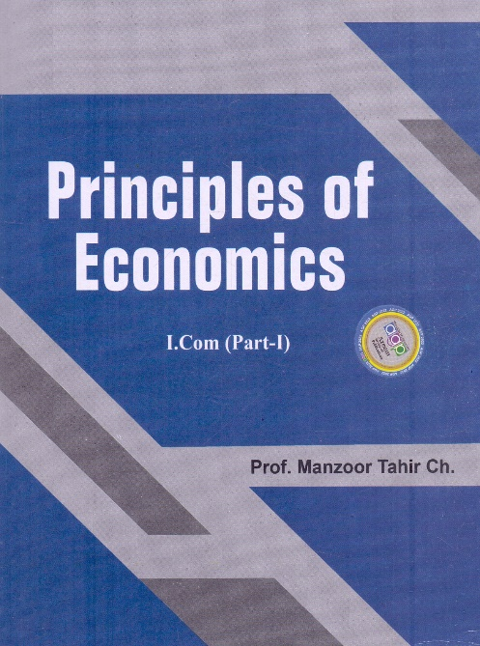

**Course Overview**

* Identify the different economic systems
* Understand the different economic theories
* Analyze the different economic policies
* Learn about the different economic tools and techniques