

**English**

**RS:1599**

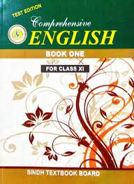

**Course Overview**

Ch 1. The Dying Sun

Ch 2. Using the Scientific Method

Ch 3. Why Boys Fail in College

Ch 4. End of Term

Ch 5. On Destroying Books