

**Mathematics**

**RS:1599**

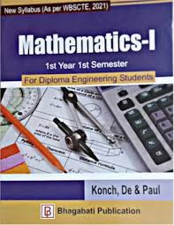

**Course Overview**

1.Quadratic Equations ·

2.Theory of Quadratic Equations ·

3.Variations ·

4.Partial Fractions ·

5.Sets and Functions ·

6.Basic Statistics