

**Zoology**

**RS:1599**

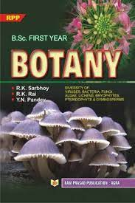

**Course Overview**

1)Classification of Animal Chordates.

2) Animal Tissues.

3)Cell cycle.

4)Molecules of Cell.

5)Respiratory System.