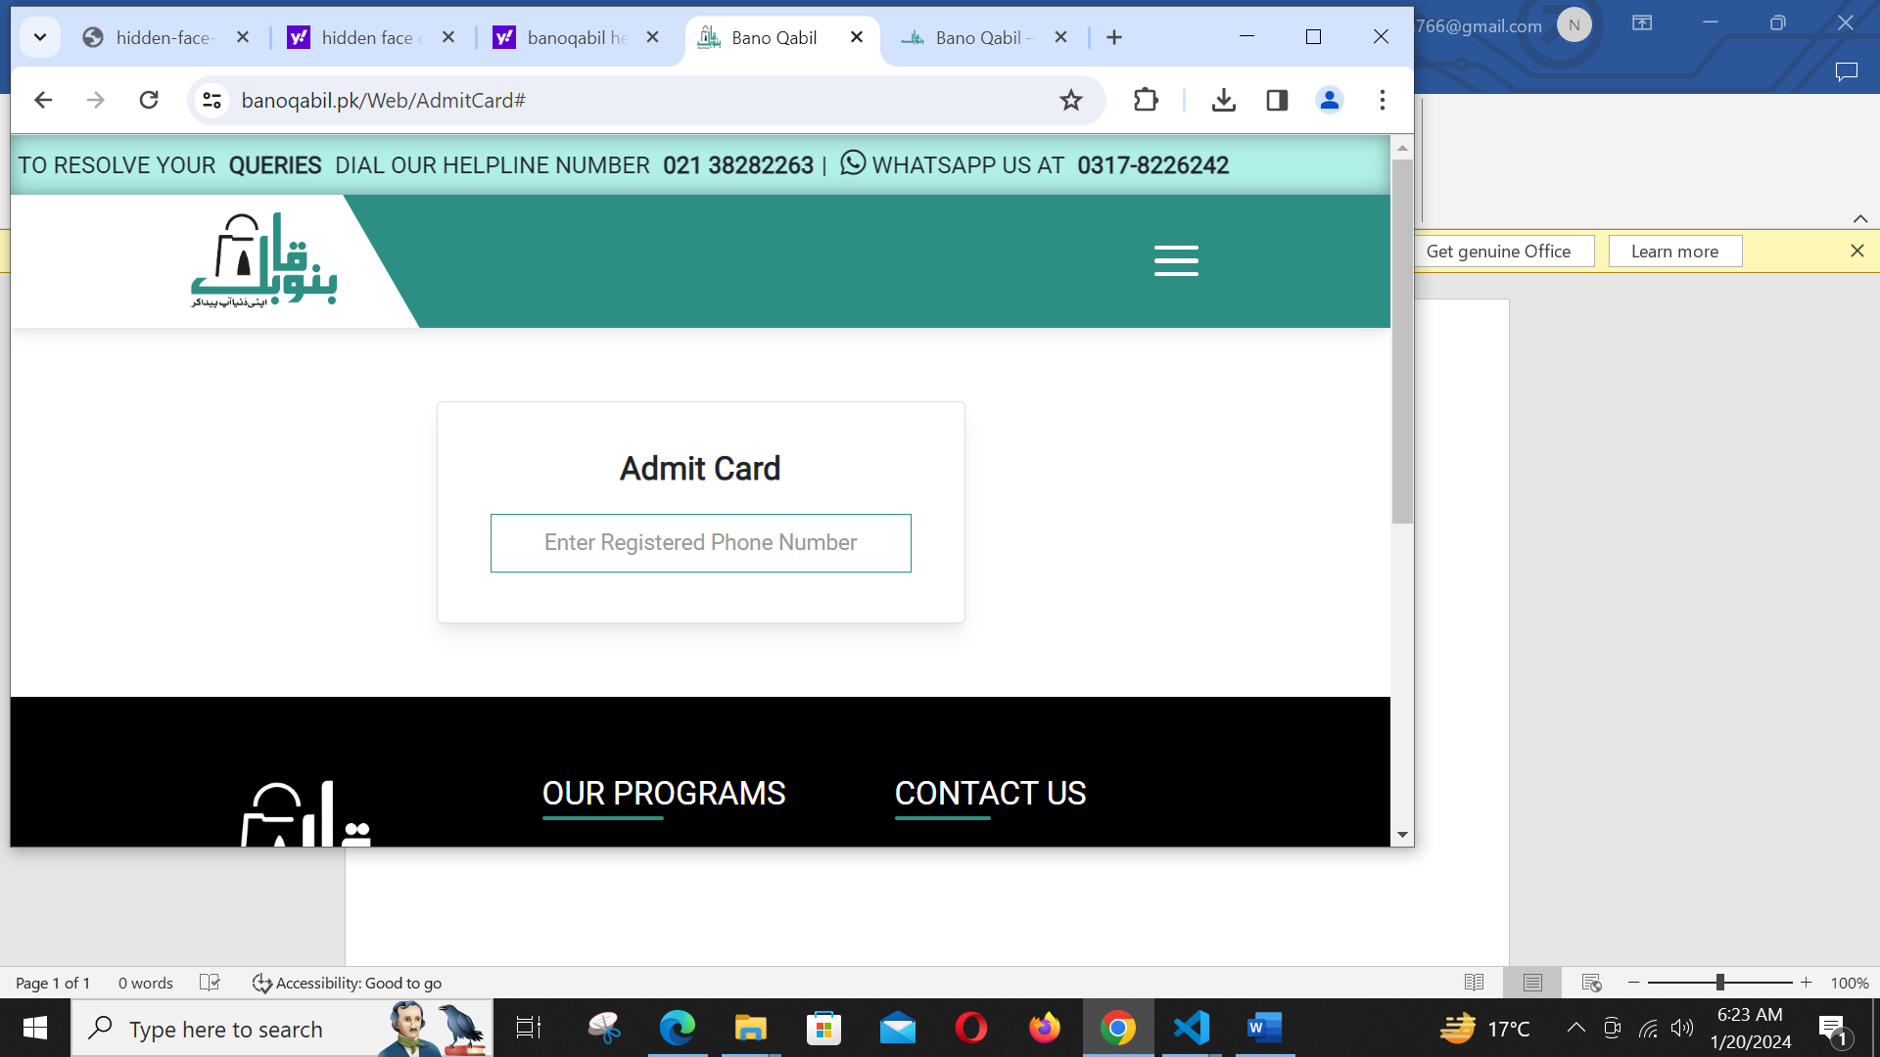**INFORMATION:**

|  |
| --- |
| Name: HIBA SULEMAN |
| Student id: WDI-F-13261 |
| Name: MISBAH |
| Student id: WDI-F-75863 |
| Teacher name: MISS SUMBUL SALEEM |
| Batch code#1603 |
| Campus: Anjuman complex sakhi hasan |
| IT course: Web development 1 |

**HM CATERING WEBSITE:**

**TABLE OF CONTENTS:**

The Online Catering Management System web application is developed for prince caterers. The project is to reduce the paperwork of the staff. The concerned people can order the item in a website. The main objective of this project is to develop a web application which supports all aspects of the delivery process through online. This system is a web application which display food menu information and allow customers to place their orders online for delivering. This system not only improves customer’s experience but also eases the workload on the staff. All Customer details, products, operators, order details and sales orders can be stored in the Food gallery website.

1. **LIST OF FIGURES:**
2. Home section
3. About section
4. Menu section
5. Contact section
6. **INTRODUCTION:**

**Order**: In this Customer can select The items That he wants to order and can set the quantities according to his needs. Admin and operator also can order food if the customer ask him to order. so that admin can order online.

**discount:** Admin can update discount for the item. discount may be flat discount(in rs.) or percentage.

**Tax:** This module to update tax info.

**Order report:** Here customer can see his order report.

**CONCLUSION:**

At last to conclude, I have developed a simple and basic personal portfolio website using HTML5 and CSS using Vs.code which I would continue to maintain in future too.

This system will show the time by which the order will be delivered to the customer.

**REVIEW:**

Thank you **bano Qabil** for all that you do for us, and thank you miss **sumbul** for making our learning experience such a positive one. Your hard work and dedication are greatly appreciated by all of us.