## ENGR 326 Formal Lab Report 3 – This assignment is worth 200 pts (100 pts for technical merit and 100 pts for the written quality of your report.

## Your Lab 3 report is due on Canvas by Tuesday Nov 13, 2018 at 5 pm. Print copies must also be submitted to Maia's and David's boxes in the ERE office by 5 pm Tuesday.

A municipality would like to excavate a gravel pit that intersects a small aquifer. For the project to succeed, the aquifer needs to be dewatered by a well or wells. Your firm has been hired to build a numerical model of the system and evaluate the placement and pumping rates for wells. Geologists have identified the boundary conditions for the system as an impermeable boundary on the east, constant head on the north and south controlled by the water levels in two rivers and a constant head on the west control by a reservoir (Figure 1). For the operation to be successful, the head at the gravel pit needs to be reduced by 4 meters.

Base Case Analysis

Determine the steady-state groundwater head in the aquifer by assuming that all nodes in the model have an initial head of 55 meters. Approximate the groundwater hydraulics of this aquifer using the confined flow equations and assuming a hydraulic conductivity of 10 m/day.

Results from this analysis:

1. Determine the steady state heads throughout the aquifer. Your program should output a nicely formatted table of the heads at each node (put this in your report appendix). Use these values to make a 3D plot showing the groundwater heads at all nodes.
2. Investigate the sensitivity of the model convergence to the SOR factor.
3. Perform sensitivity analysis on the hydraulic conductivity by changing it ± 20% and ± 50%.

Well Analysis

Using the aquifer parameters from the Base Case Analysis, add six to eight wells to your model to dewater the gravel pit. The wells cannot be located inside the gravel pit. Identify well flow rates that just meet the needed 4 meter head decrease within the gravel pit – you do not want to waste energy and pay for extra pumping. Use a transmissivity of 600 m2/day (calculated assuming a hydraulic conductivity of 10 m/day and an aquifer saturation thickness of 60 m).

Results from this analysis are:

1. Determine the steady state heads throughout the aquifer with the wells in place and pumping at a steady rate. Your program should output a nicely formatted table of the heads at each node (put this in your report appendix). Use these values to make a 3D plot showing the groundwater heads at all nodes.
2. Perform sensitivity analysis on the transmissivity by changing it ± 20% and ± 50%.

Your report Results & Discussion section should compare the results from the two different simulations.

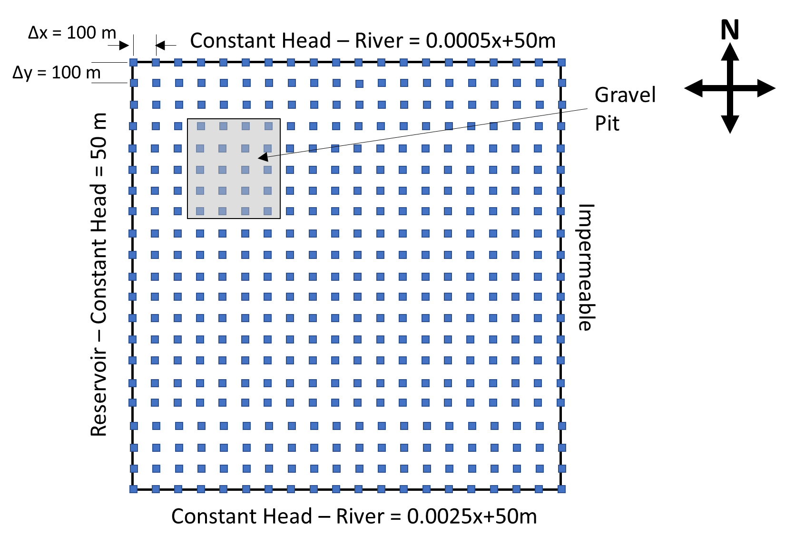

Figure 1. Plan view of aquifer with gravel pit (inspired by an example from Anderson, Woessner & Hunt, 2015, *Applied Groundwater Modeling*)