**HANGMAN GAME**

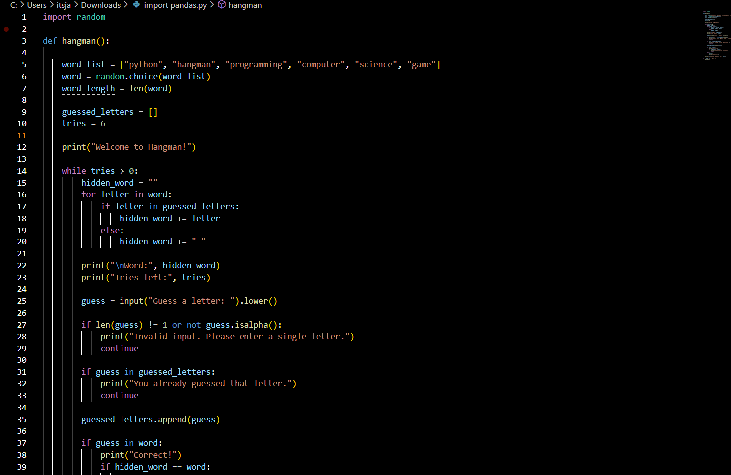



**STUDENT GRADE TRACKER**



