FOOD ORDERING WEBSITE

Submitted by
-Pratyush Sharma
-Rishab Modi
-Rohit Jain

SUBMITTED TO
- Mr. Ajay Kumar

Index

Topics

INTRODUCTION

SYSTEM REQUIREMENT SPECIFICATIONS

DATA FLOW DIAGRAMS

ENTITY RELATIONSHIP DIAGRAM

TECHNOLOGY USED

SOFTWARE AND HARDWARE REQUIREMENTS

Introduction
“Food Ordering System” is a web-based project, which is made for remote food ordering or ordering through Internet. As the technology is, being advanced the way of life is changing accordance. Now a day’s we can place the order for anything from our home. There is no need to go the shop of the things we want. The order can be placed online through Internet. The payment, the confirmation of purchasing; we can do everything we want. Now we can think that how the days have been changed with time. People had to stand in rows to wait there terms to buy a particular thing from a popular shop. Nevertheless, what is happening now a day’s; we can extremely surprise that those things can be available on the doorstep in few hours.
People had to suffer the rush of the market when they went for shopping. They used to think hundred times to buy anything having the sufficient money for shopping. The problem was the rush; the quarrel at the time of buying the things. Nevertheless, the advancement of technology brought the new way for food ordering. The way of ordering was completely changed with the coming of Internet Technology. People have to fill a simple form on the internet to place their order on any popular website or restaurant for the food they want to order. Now they can place their order from the home.
This project entitled “Food Ordering Website” is an implementation of the above description. It means, it implements the E-ordering or in other word ordering through Internet. It lets the user to place their order online for any food item.

SYSTEM REQUIREMENTS AND SPECIFICATIONS

Purpose

- Today the internet and its boom have created a new economic scenario that not only stresses on the classical concept of the “product” but also on the modern concept of “service”. It is this level of service that dictates whether a commercial venture will succeed or not in the market. To provide a high accessibility of service we will design the food ordering website, so that potential customers need not go to a physical shop to buy food. They just need to online to complete their order.

- Most current systems have a physical foundation that is the root cause to quite a number of problems. By maintaining multiple store fronts, itself being an expensive proposition, store prices are forced to rise. Thus, by using our product, our clients’ competitors are at a disadvantage because their costs are significantly higher than our costs, allowing our clients to sell the same books at a lower price. As people become more accustomed to using the internet, they view ordering products and services online as a time-saving and cost-saving experience, which is the very essence of our online store.

Scope of the project
Initial functional requirements will be
- This site is gives all the information about the e-food ordering to provide better service for the customer.
- It provides the facility to the customers who want to shop on-line due to lack of time.
- It provides facility to the customer to payment by the cash and cheque and DD also.
- It is providing the full details about the item and related information about the product like cost, ingredients used etc.
- With the help of it, we can save the time and money also.
- It provides the remote food ordering by the cash, or DD, or Debit card also.
- It provides better security and good delivery service to the customer.

Initial non-functional requirements will be

- 24 X 7 availability
- Better component design to get better performance at peak time
- Flexible service based architecture will be highly desirable for future extension
- Advertisement space where it will effectively catch the customer’s attention and as a source of revenue.

Data Flow Diagrams

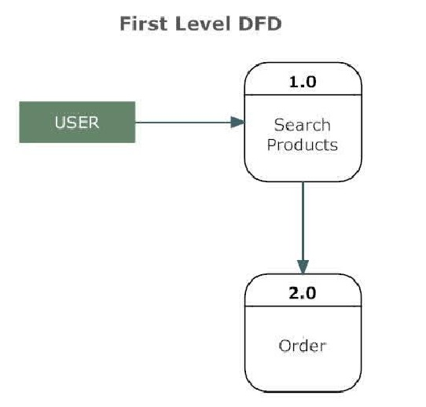

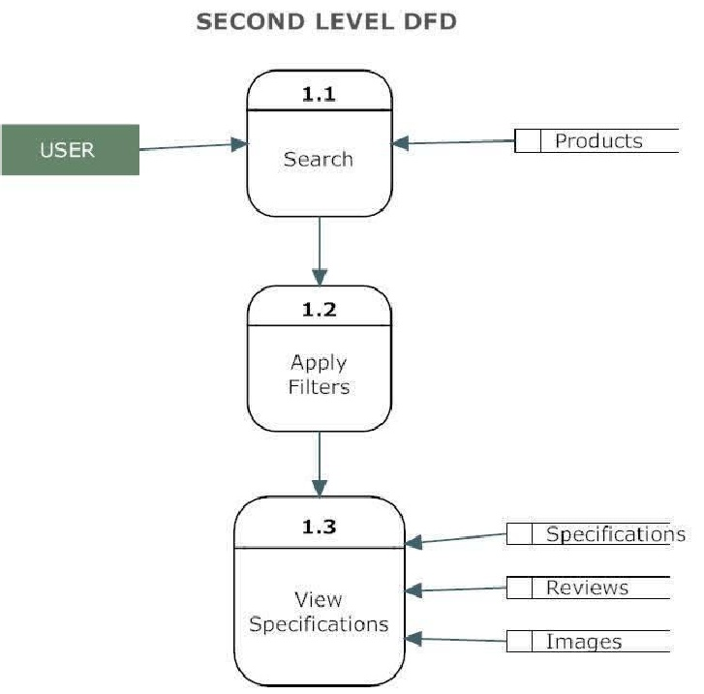

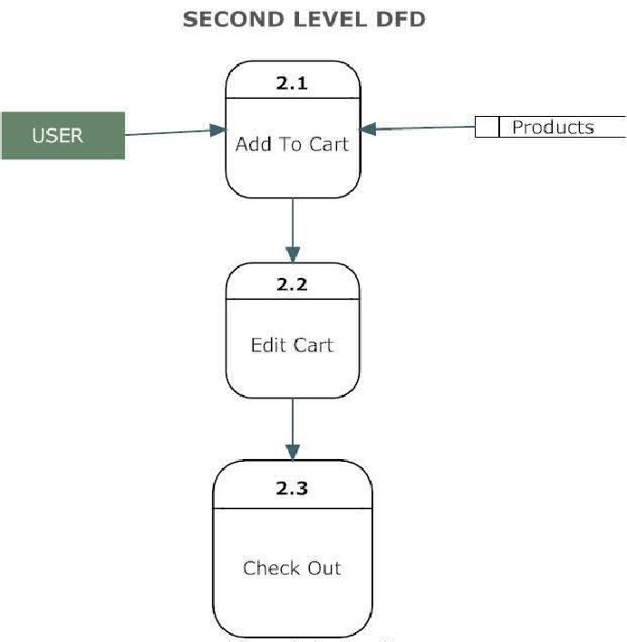

ER-DIAGRAM

ER Diagram
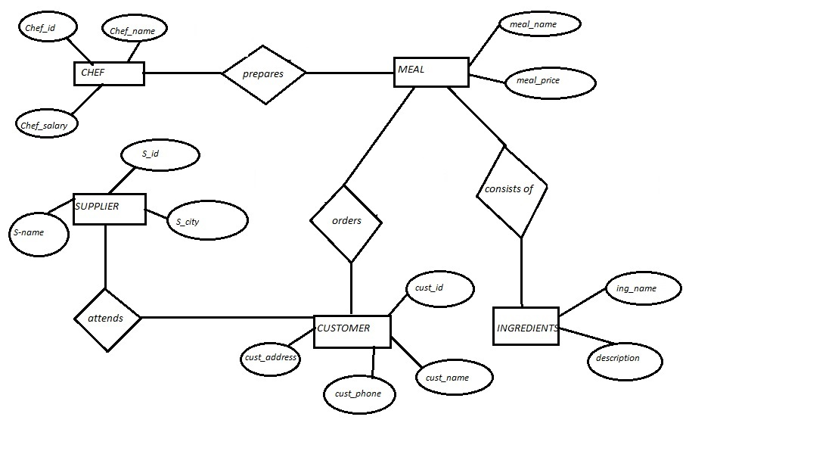

Hardware & Software Requirements
Hardware Requirement:-
Processor : Pentium Processor ISA 32 Family
Secondary Storage : 20 GB HDD
Memory : 1 GB RAM
Network Adapter : Ethernet Adapter
Modem : 128kbps Data
Others : 17" Color Monitor, Display Devices, Keyboard, Mouse.
Software Requirement:-
Platform : Windows
Operating System : Windows 8, Windows 10
Front-End Tool : HTML, CSS, AJAX, JQUERY, BOOTSTRAP
Back- End Tool : SQL Server
Scripting Tool : Java script
Server : Internet Information Server

