Predicting Next-Session Strength From Personal Training Logs:
A Single-Athlete Case Study

Javokhir Abduraxmonov
Tashkent, Uzbekistan

Abstract
I examined whether a lifter's training history can predict next-session strength more accurately than the naive rule that the next session will equal the last. Using 22 months of self-logged resistance training data from one recreational lifter (2,645 sets), I calculated the estimated one-repetition maximum (e1RM) of the best set in each session and evaluated 244 walk-forward predictions across eight exercises. The naive baseline had a mean absolute error (MAE) of 3.76 kg, or 5.4% of the lifted load. Ridge regression with six training-load, frequency, and recovery predictors was less accurate on all eight exercises (MAE = 4.14 kg; Wilcoxon signed-rank test, p < .001), as was a random forest (MAE = 4.25 kg). In a feature ablation, no single predictor improved on a model that used no predictors at all. The result held when only sets of 10 or fewer repetitions were used, when the Brzycki equation replaced the Epley equation, and when Apple Watch sleep data were added for the final 11 months. These findings suggest that, with the kind of data a typical training application records, the most recent session is a better guide to the next one than models built on training history, and that the variables most likely to explain session-to-session variation, such as effort and readiness, are not captured in standard training logs.
Keywords: resistance training, one-repetition maximum, performance prediction, walk-forward validation, single-subject design
Predicting Next-Session Strength From Personal Training Logs:
A Single-Athlete Case Study
Resistance training is usually planned one session at a time. A lifter who completed eight repetitions with a given load in the previous session will typically attempt the same load again or add a small increment, and coaches often prescribe loads as percentages of a one-repetition maximum (1RM), the heaviest load that can be lifted once (Greig et al., 2023). Mobile training applications now allow recreational lifters to record every set they perform, so that many lifters hold detailed histories of their loads, repetitions, and training dates. This raises the question of whether such a history contains enough information to forecast performance in the next session more accurately than the simple assumption that the next session will resemble the last.

Previous Research
Most research on predicting strength concerns the estimation of 1RM from a single submaximal effort rather than the forecasting of future performance. A common approach is to record the number of repetitions completed with a submaximal load and convert it into an estimated 1RM with a regression equation (Greig et al., 2023). Two of the best known equations are those of Epley (1985) and Brzycki (1993). Brzycki based his equation on the observation that the relationship between repetitions to fatigue and the percentage of maximum load is close to linear, and noted that it becomes less accurate when more than about 10 repetitions are performed. He also cautioned that inherited characteristics, such as muscle fiber type, cause individuals to differ in how many repetitions they can complete at a given percentage of their maximum.
More recently, attention has turned to load–velocity relationships, which estimate 1RM from the speed at which a bar is moved at several submaximal loads. Greig et al. (2023) reviewed 137 such models from 26 studies and analyzed data from 434 participants in 20 of them. They found moderate predictive validity, with a standard error of estimate of about 9.8% of the measured 1RM, and a tendency for predictions to overestimate it by about 4.5 kg. They found no evidence that more complex models were more accurate and recommended direct assessment of 1RM wherever possible, while noting that load–velocity estimates may still be useful for monitoring trends across a training cycle.
Machine-learning methods have also been applied to resistance training, although mostly to questions within a single session. Baek et al. (2025), for example, used force–time data from an isokinetic robotic bench press to predict ratings of perceived exertion in 32 young men who each performed seven sets at a standardized load. A random forest performed best, with more than 93% of its predictions falling within one point of the rating reported by the participant. At a larger scale, Xia et al. (2026) proposed a deep reinforcement learning system that prescribes training loads from heart rate variability, sleep quality, perceived exertion, and other physiological measures, and reported performance improvements averaging 12.3% relative to traditional periodization across several sports. The authors acknowledge, however, that Hawthorne and placebo effects cannot be ruled out in their design and that the sensors required cost several thousand dollars per athlete, and I therefore treat these results with caution.
None of these studies addresses the situation of an individual lifter who wants to know what to expect in the next session. The 1RM equations and load–velocity methods estimate current capacity from a test performed on the day, Baek et al. (2025) studied fatigue within a session, and the system described by Xia et al. (2026) depends on physiological monitoring that is not available to most recreational lifters. Whether a lifter's own training log can forecast the next session, and whether it can do so better than the most recent session alone, is not examined in these studies.

The Present Study
This paper examines that question using my own training records. The research question is whether the estimated 1RM (e1RM) in the next session of my most frequently trained exercises can be predicted more accurately than by the rule “same as last session” using information on training load, training frequency, and recovery. I expected recent training volume and session frequency to carry some predictive information, since accumulated training should precede gains in strength, at least until fatigue offsets it.
Three limitations were apparent before any model was estimated. First, the data come from a single athlete, so the results describe one person rather than lifters in general. Second, self-logged data are noisy, and many session-to-session changes are smaller than the smallest available increase in load. Third, the gap between two sessions is ambiguous, since a long gap may reflect planned rest, after which performance may improve, or illness or travel, after which it may decline. Each of these limitations proved relevant to the results.
The paper proceeds as follows. The Method section describes the data, the cleaning steps, the performance measure, and the walk-forward design used to evaluate every model. The Results section reports the naive baselines and compares them with ridge regression, a feature ablation, a random forest, two robustness checks, and a model that adds sleep data. The Discussion considers why none of the models outperformed the baseline, relates the findings to previous research, and describes the main limitations and possible extensions. The final section concludes.

Method

Data Source
The data consist of my complete training log from the LiftOff mobile application between July 26, 2024, and May 28, 2026. The log contains 2,645 rows, each describing one set, with the date and time of the workout, the exercise, the load, and the number of repetitions. I entered loads in kilograms, but the application exports them in pounds, so all loads were converted back to kilograms before analysis, and all results are reported in kilograms. Sleep data recorded by an Apple Watch from June 2025 were used in one additional analysis.

Data Cleaning
Two logging errors were found and removed. On January 31, 2025, two sets of the incline dumbbell bench press were recorded with a load of 3 kg, whereas the sessions immediately before and after reached e1RM values of about 38 to 40 kg. On July 22, 2025, 12 sets of four exercises were recorded with zero load and zero repetitions; valid sets from the same session were kept. In total, 14 sets were removed. The errors were removed from the raw log and all derived tables were then rebuilt, rather than deleting the affected rows from the final data, because an erroneous session also enters neighboring rows: as the target of the preceding session, as the previous score of the following session, and in rolling averages. After cleaning, and after the processing pipeline dropped four empty rows, the data contained 2,627 sets, 1,182 exercise sessions, and 847 sessions with a known next-session outcome. On the pipeline's original single train–test split, cleaning reduced the error of its baseline from 6.45 kg to 6.31 kg.

Performance Measure and Prediction Target
For each set, I estimated 1RM with the Epley (1985) equation, e1RM = load × (1 + repetitions / 30). The performance score of an exercise in a session is the e1RM of its best set, the set with the highest e1RM, referred to here as the top set. Each row of the modeling data describes one session of one exercise, and the prediction target is the performance score in the next session of the same exercise. All predictors describe the current session or earlier sessions only, so that no information from the predicted session is used.

Exercise Selection
I modeled the exercises with at least 30 sessions before February 1, 2026. Eight exercises met this criterion (Table 1), giving 324 rows. A session enters the modeling data only once three earlier sessions of the same exercise exist, so that the rolling predictors described below can be calculated.
Table 1
Exercises Included in the Analysis
Exercise | Sessions before February 1, 2026 | Sessions in analysis
Lying leg curl | 47 | 47
Dumbbell lateral raise | 46 | 50
Lat pulldown | 39 | 43
Cable lateral raise | 38 | 40
Incline dumbbell bench press | 38 | 40
Machine reverse fly | 34 | 34
Squat | 34 | 38
Tricep rope pushdown | 30 | 32
Total | 306 | 324
Note. Counts include only sessions with at least three earlier sessions of the same exercise and a known next session.

Evaluation Design
Every method was evaluated with walk-forward validation, a form of time-series cross-validation in which each forecast uses only information available before the period being forecast (Hyndman & Athanasopoulos, 2021). For each exercise, a model was trained on the rows for all earlier sessions and used to predict the next session; the window then moved forward by one session and the model was trained again. Predictions began once 10 sessions of history were available, which produced 244 predictions across the eight exercises, and every method was scored on the same 244 sessions. Accuracy is reported as the mean absolute error (MAE) in kilograms and as a percentage of the actual e1RM. Differences between methods were tested with the Wilcoxon signed-rank test (Wilcoxon, 1945) on the paired absolute errors of each session.

Baselines
Two naive methods served as benchmarks. The first, referred to as the last-value baseline, predicts that the next performance score will equal the current one; this is the naive forecast commonly used as a benchmark in forecasting (Hyndman & Athanasopoulos, 2021). The second predicts the mean of the three most recent scores, including the current session. While constructing the baselines, I found that the variable the processing pipeline labeled as the previous score referred to the session before the current one, which had made the pipeline's original baseline appear less accurate than it is. The baselines reported here use the score of the current session.

Models

Ridge Regression
The main model was ridge regression (Hoerl & Kennard, 1970), a linear regression in which a penalty on the size of the coefficients limits the influence of any one predictor and reduces overfitting. A separate model was estimated for each exercise and refitted at every step of the walk-forward procedure. Rather than predicting the next e1RM directly, the model predicts the change from the current session to the next and adds this change to the current score. If the predictors contain no information, the penalty shrinks their coefficients toward zero and the model predicts the average past change, which is close to the last-value baseline. Predictors were standardized, and the strength of the penalty was selected by cross-validation, both using the training rows only. The models were implemented in Python with scikit-learn (Pedregosa et al., 2011).

Predictors
Six predictors were used, all of which are known by the end of the current session: the number of days since the previous session of the exercise; the difference between the current score and the mean of the three preceding scores; the standard deviation of the three preceding scores; the total volume of the session, calculated as the sum of load multiplied by repetitions across sets; the number of earlier sessions of the exercise; and the largest number of repetitions in any set of the session.

Random Forest
To test whether a nonlinear model would perform better, I also estimated a random forest (Breiman, 2001), the method that performed best in Baek et al. (2025), with the same predictors, the same change-based target, and the same walk-forward procedure. Each forest contained 200 trees, with at least five observations in each leaf to limit overfitting to individual sessions.

Additional Analyses
In a feature ablation, the ridge model was re-estimated with each predictor removed in turn and with each predictor used alone, and a model without predictors, which adds the average past change to the current score, was estimated for reference. Two robustness checks rebuilt the data so that only sets of 10 or fewer repetitions contributed to the performance score, the range in which Brzycki (1993) considered his equation reliable, first with the Epley equation and then with the Brzycki equation, 1RM = load / (1.0278 − 0.0278 × repetitions).
Sleep data from the Apple Watch, available from June 23, 2025, were used to construct two further predictors: the hours of sleep in the night before the predicted session and the mean over the three preceding nights. Records from a second sleep application, which duplicated the same nights, and earlier phone records, which measured time in bed rather than sleep, were excluded. Nights with less than 2 hours of recorded sleep were treated as missing, which left 396 nights with a mean of 6.93 hours. Because sleep before a session is known only on the morning of that session, these predictions correspond to a forecast made on the day of training, and all methods in this analysis were evaluated only on the sessions for which sleep data were available.

Results

Descriptive Statistics
Session-to-session changes in performance were mostly small. In 27.5% of the 324 sessions, the next score was identical to the current one, and 58.0% of changes were smaller than 2.5 kg, a common minimum load increment. Larger changes did occur, however, and often in both directions within a few weeks. Figure 1 illustrates this pattern for the lat pulldown, where stretches with an unchanged score are interrupted by sharp drops and recoveries.
Figure 1
Estimated One-Repetition Maximum per Session for the Lat Pulldown
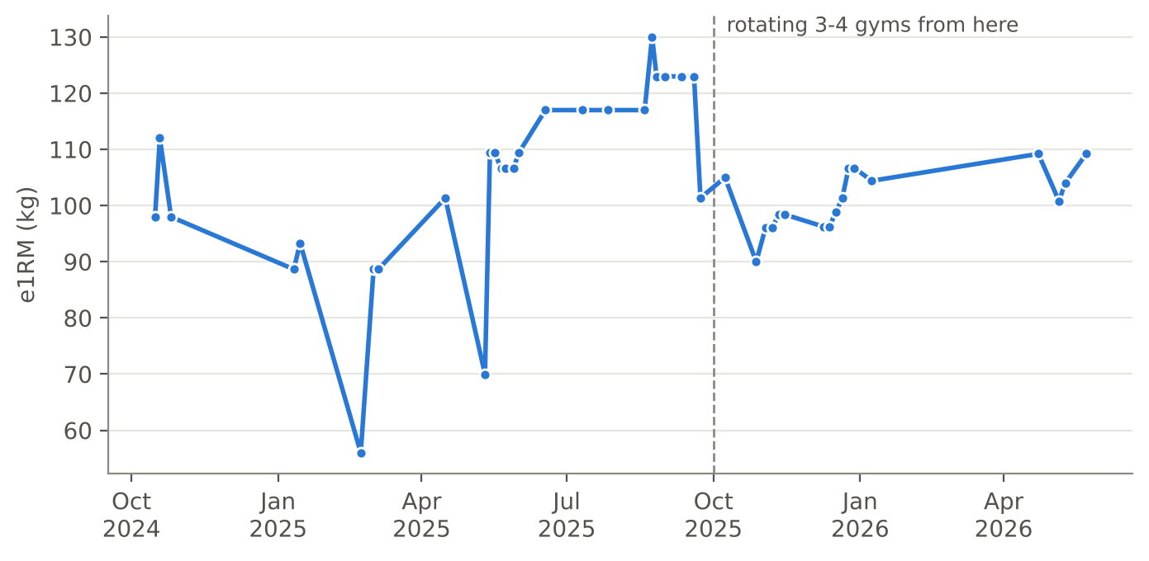
Note. The dashed line marks October 2025, after which training took place at three to four different gyms per month.

Baseline Performance
Table 2 reports the walk-forward errors of all methods. The last-value baseline had an MAE of 3.76 kg across the 244 predictions, equivalent to 5.4% of the actual e1RM, and was more accurate than the three-session mean on every exercise (MAE = 5.03 kg). The mean lagged behind the current level of performance because it included older and weaker sessions; it predicted too low in 62.3% of cases, with a median error of −1.15 kg. Errors were smallest for the two lateral raises, which are performed with light loads, and largest for the lying leg curl, the machine reverse fly, and the squat. The last-value baseline is therefore the benchmark for the models that follow.
Table 2
Walk-Forward Mean Absolute Error by Exercise and Method
Exercise | n | Last value | Three-session mean | Ridge regression | Random forest
Cable lateral raise | 30 | 1.52 | 2.14 | 1.84 | 1.74
Dumbbell lateral raise | 40 | 1.70 | 2.17 | 2.10 | 1.89
Incline dumbbell bench press | 30 | 3.16 | 3.33 | 3.35 | 3.67
Lat pulldown | 33 | 3.65 | 5.21 | 3.93 | 4.82
Lying leg curl | 37 | 5.79 | 8.78 | 6.25 | 6.14
Machine reverse fly | 24 | 6.01 | 6.52 | 6.67 | 6.67
Squat | 28 | 5.64 | 8.17 | 6.32 | 6.59
Tricep rope pushdown | 22 | 3.28 | 4.29 | 3.32 | 3.10
All exercises | 244 | 3.76 | 5.03 | 4.14 | 4.25
Note. Values are mean absolute errors in kilograms; lower values indicate more accurate predictions. n = number of predictions.

Ridge Regression
Ridge regression was less accurate than the baseline on all eight exercises (Table 2). Its overall MAE was 4.14 kg, 0.38 kg higher than that of the baseline, and the difference was statistically significant (p < .001). Ridge regression was closer to the actual value than the baseline in only 38.5% of sessions. The gap was smallest for the tricep rope pushdown (0.03 kg) and largest for the squat (0.68 kg). Figure 2 compares predicted and actual values for both methods. Both sets of predictions lie close to the line of perfect prediction, which reflects the strong persistence of performance from one session to the next, but the ridge predictions are more widely scattered. Figure 3 shows the errors by exercise.
Figure 2
Predicted Versus Actual Next-Session e1RM for the Last-Value Baseline and Ridge Regression
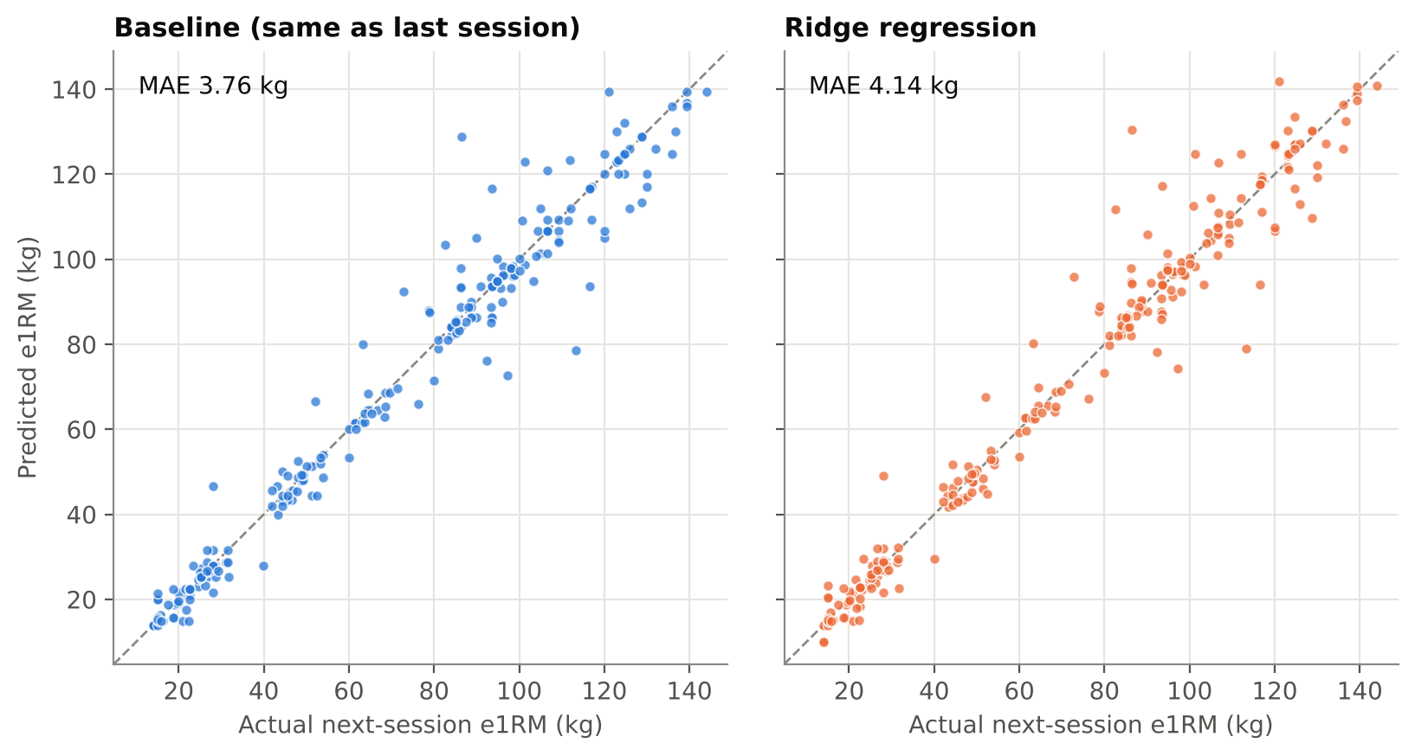
Note. Each point is one of 244 walk-forward predictions. The dashed line indicates perfect prediction. MAE = mean absolute error.

Figure 3
Mean Absolute Error by Exercise for the Last-Value Baseline and Ridge Regression
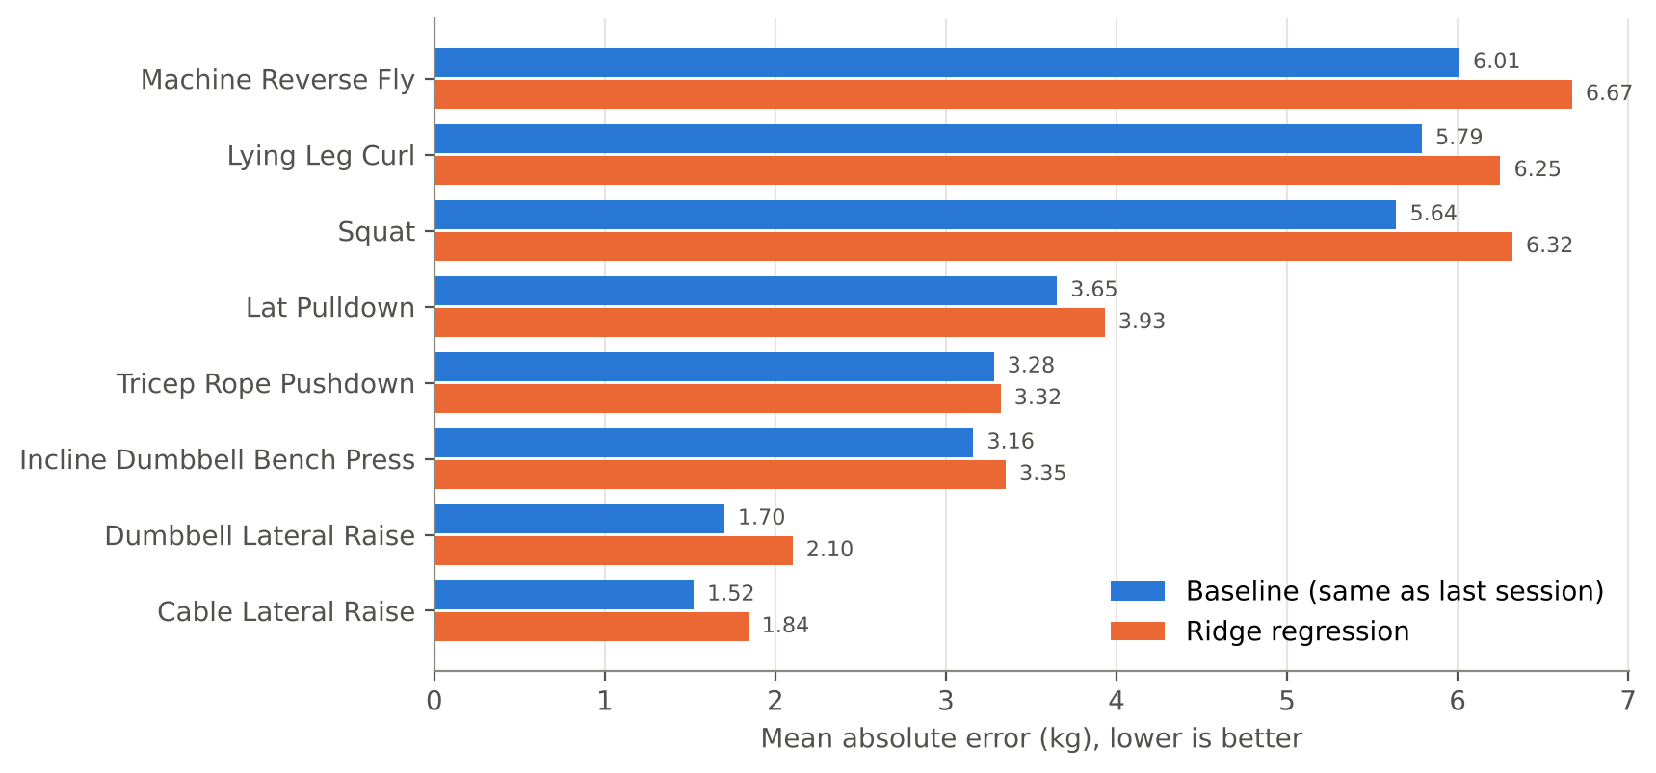
Note. Lower values indicate more accurate predictions.

Feature Ablation
The feature ablation (Figure 4) suggests that none of the predictors carried useful information. The model without predictors, which adds the average past change to the current score, had an MAE of 3.97 kg and was itself less accurate than the baseline, which indicates that the gradual upward trend in my performance was too small and irregular to improve predictions. Every model with a single predictor was less accurate again, with MAEs between 3.99 and 4.21 kg. Removing individual predictors from the full model usually increased its error, which might suggest that they contributed to it. Because the full model (MAE = 4.14 kg) was already less accurate than the model without predictors, however, the predictors appear only to have offset part of one another's noise. The exception was the number of days since the previous session, whose removal reduced the error slightly, from 4.14 to 4.12 kg. This is consistent with the ambiguity of training gaps noted earlier, since a long gap may follow either planned rest or illness and the predictor cannot distinguish between the two. The changes produced by removing individual predictors were small, between 0.01 and 0.13 kg, and do not support a ranking.
Figure 4
Mean Absolute Error of Ridge Models in the Feature Ablation
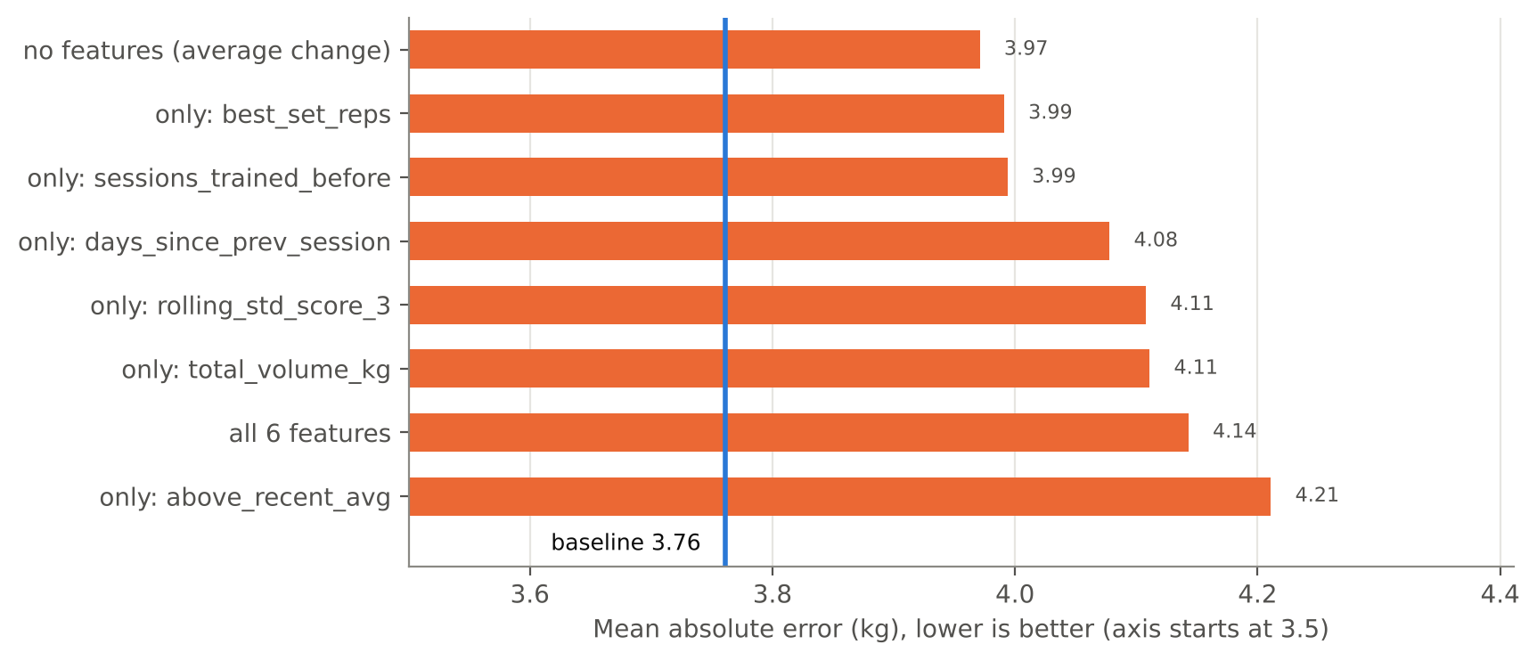
Note. The vertical line marks the last-value baseline (3.76 kg). The horizontal axis begins at 3.5 kg.

Random Forest
The random forest was less accurate than ridge regression, with an overall MAE of 4.25 kg (Table 2). It was more accurate than the baseline on one exercise, the tricep rope pushdown (3.10 vs. 3.28 kg), but this difference was based on 22 predictions and was not statistically significant (p = .59). A nonlinear model therefore did not improve on the linear one.

Robustness Checks
The main result held in both robustness checks (Table 3). Rebuilding the data with the original definitions reproduced the main comparison, with a ridge MAE of 4.15 kg instead of 4.14 kg because of small differences in the rounding of loads. When only sets of 10 or fewer repetitions counted toward the performance score, the baseline remained more accurate and the margin widened. This restriction removed a large part of the data, because four of the eight exercises were performed for more than 10 repetitions in most sets, including 86.4% of sets of the dumbbell lateral raise, and the number of predictions fell from 244 to 115. Replacing the Epley equation with the Brzycki equation changed the results very little.
Table 3
Robustness Checks
Data | n | Last value | Ridge regression | p
Reference rebuild, all sets (Epley) | 244 | 3.76 | 4.15 | < .001
Sets of 10 or fewer repetitions (Epley) | 115 | 5.44 | 7.26 | .001
Sets of 10 or fewer repetitions (Brzycki) | 115 | 5.58 | 7.56 | < .001
Note. Values are mean absolute errors in kilograms. p values are from Wilcoxon signed-rank tests on the paired absolute errors of the two methods. n = number of predictions.

Sleep
Adding sleep did not improve the predictions (Table 4). For the 82 predictions with sleep data, the baseline had an MAE of 3.70 kg. A ridge model using only the two sleep predictors had an MAE of 4.37 kg, and adding them to the six training predictors increased the error from 4.64 to 4.91 kg, a difference that was not statistically significant (p = .64). The correlation between sleep in the night before a session and the change in performance in that session was close to zero (r = −.07). The analysis covers only about 11 months and 82 predictions with short training histories, so it shows that no effect of sleep was detected rather than that sleep is unrelated to performance.
Table 4
Walk-Forward Mean Absolute Error for Sessions With Sleep Data
Method | MAE (kg)
Last-value baseline | 3.70
Ridge regression, sleep predictors only | 4.37
Ridge regression, six training predictors | 4.64
Ridge regression, six training predictors and sleep | 4.91
Note. n = 82 predictions. MAE = mean absolute error.

Discussion
Across 244 walk-forward predictions, none of the methods I tested forecast next-session e1RM more accurately than the assumption that the next session would equal the last. This was true of a linear and a nonlinear model, of each predictor on its own, of two 1RM equations, of a restricted range of repetitions, and of a model that included sleep. The hypothesis that recent training volume and frequency would improve prediction was therefore not supported.
Several features of the data help to explain this result. The most important is the persistence of performance from one session to the next. Because more than a quarter of sessions repeated the previous score exactly, the baseline made no error on these sessions, whereas any model that predicts a nonzero change incurs an error on each of them. Even the gradual upward trend in my performance, when added to the current score, made predictions worse. When performance did change, the changes were often large and went in both directions, and the ablation suggests that none of the recorded predictors anticipated them.
The amount of data for each exercise was also small. The models were trained on between 10 and 49 earlier sessions, which leaves considerable room for fitting chance patterns despite the penalty in ridge regression. More fundamentally, the factors most likely to drive session-to-session variation were not recorded. These include the effort exerted in each set, readiness on the day, the load I chose to attempt, and differences between machines. The top-set e1RM partly reflects a decision about what to attempt rather than capacity alone, and no model of training history can anticipate such decisions. Sleep was the only factor of this kind that could be tested, and it did not improve the predictions.

Comparison With Previous Research
The baseline error is modest compared with the errors reported for other methods of estimating strength. Expressed relative to the lifted load, the baseline error of 5.4% is smaller than the standard error of estimate of about 9.8% reported by Greig et al. (2023) for load–velocity prediction of 1RM. The two figures are not directly comparable, since Greig et al. assessed the estimation of a measured 1RM rather than the forecasting of a future session and used a different error statistic. The comparison nonetheless suggests that, for a lifter who trains regularly, the most recent session is already a fairly precise guide to the next. The contrast with Baek et al. (2025) is also informative. Their models predicted perceived exertion within a session from detailed force measurements, whereas the present study had only loads and repetitions recorded between sessions. The difference in results is consistent with the idea that predictive accuracy in this setting depends more on the information available than on the choice of algorithm.

Limitations
The study has several limitations. It is based on a single athlete, so the results describe my own training and cannot be generalized to other lifters. The number of predictions per exercise was small, between 22 and 40, which makes the results for individual exercises fragile. The data were self-reported; two errors were found and removed, and others may remain. Effort, for example measured as a rating of perceived exertion, and body weight were not recorded, and sleep data covered only the final 11 months. From October 2025 I trained at several gyms, and the same exercise performed on different machines may produce different loads. The robustness checks restricted to 10 or fewer repetitions removed much of the data, particularly for the lateral raises.

Future Research
Several extensions follow from these limitations. Recording the perceived effort of each set would provide the variable most likely to explain day-to-day variation. Sessions that appear anomalous could be identified by a fixed and reproducible rule rather than by inspection, which would allow their contribution to prediction error to be measured. The analysis could also be repeated with data from a second athlete, which would make it possible to test whether a model trained on one person's history transfers to another.

Conclusion
Personal training logs are now easy to collect, and it is natural to expect that they contain enough information to forecast a lifter's next session. This study found little evidence that they do. Over 22 months of data and 244 walk-forward predictions, the rule that the next session will equal the last (MAE = 3.76 kg) was more accurate than ridge regression, a random forest, every individual predictor, and a model that included sleep, and the result did not depend on the choice of 1RM equation or repetition range. For an individual lifter with the kind of data a training application records, the most recent session appears to be the best available guide to the next. Improving on it is likely to require different data, such as measures of effort and readiness, rather than more complex models.

References
Baek, J.-Y., Kwon, J.-H., Khan, H., & Lee, M.-C. (2025). Machine learning-driven muscle fatigue estimation in resistance training with assistive robotics. Sensors, 25(21), Article 6588. https://doi.org/10.3390/s25216588
Breiman, L. (2001). Random forests. Machine Learning, 45(1), 5–32. https://doi.org/10.1023/A:1010933404324
Brzycki, M. (1993). Strength testing—Predicting a one-rep max from reps-to-fatigue. Journal of Physical Education, Recreation & Dance, 64(1), 88–90. https://doi.org/10.1080/07303084.1993.10606684
Epley, B. (1985). Poundage chart. In Boyd Epley workout (p. 86). Body Enterprises.
Greig, L., Aspe, R. R., Hall, A., Comfort, P., Cooper, K., & Swinton, P. A. (2023). The predictive validity of individualised load–velocity relationships for predicting 1RM: A systematic review and individual participant data meta-analysis. Sports Medicine, 53(9), 1693–1708. https://doi.org/10.1007/s40279-023-01854-9
Hoerl, A. E., & Kennard, R. W. (1970). Ridge regression: Biased estimation for nonorthogonal problems. Technometrics, 12(1), 55–67. https://doi.org/10.2307/1267351
Hyndman, R. J., & Athanasopoulos, G. (2021). Forecasting: Principles and practice (3rd ed.). OTexts. https://otexts.com/fpp3/
Pedregosa, F., Varoquaux, G., Gramfort, A., Michel, V., Thirion, B., Grisel, O., Blondel, M., Prettenhofer, P., Weiss, R., Dubourg, V., Vanderplas, J., Passos, A., Cournapeau, D., Brucher, M., Perrot, M., & Duchesnay, É. (2011). Scikit-learn: Machine learning in Python. Journal of Machine Learning Research, 12, 2825–2830. https://jmlr.org/papers/v12/pedregosa11a.html
Wilcoxon, F. (1945). Individual comparisons by ranking methods. Biometrics Bulletin, 1(6), 80–83. https://doi.org/10.2307/3001968
Xia, X., Chen, Q., & Wang, Z. (2026). Deep reinforcement learning-driven personalized training load control algorithm for competitive sports performance optimization. Scientific Reports, 16, Article 845. https://doi.org/10.1038/s41598-025-30453-z

