**Statement of Work**

Project: Currency Converter

Group: Da Boiz: Patrick Agri, Jack Belmont, Sebastian Nevarez, Thuc Nguyen, Thomas Shea

**Jack Belmont:**

Jack Belmont was the project lead, who came up with the idea for our app. Did a lot of research on API use within java. He took on the role of reaching out to TA’s and to the professor to ask questions regarding application struggles. Although Jack reached to get help on the API call, the TA asked could not figure it out, and the professor suggested hard coding the conversions due to the lack of time remaining for solving this issue. In the end, the API call did not end up working and it was Jack who made the final call to use hardcoded conversions and forgo use of the API. Jack also helped with problem solving in the back end java coding, and generated ideas for how how to clean up the front end user interface.

**Patrick Agri:**

Patrick Agri took on the task of being the GUI designer and worked primarily on linking XML files within the app. It is almost exclusively Pat’s work on the front end of the application. He was able to devise a way to effectively navigate through various pages of the application, and was able to learn to use the interface builder in Android Studio very effectively.

For a long portion of the coding process the team was struggling to get Android Studio to work properly. Pat played a major role in figuring out how to work Android Studio on all of our devices and taught everyone how to do work with the software.

**Thuc Nguyen:**

Thuc Nguyen worked as the Processing Designer. He coded the functions that are able to do all of the mathematical conversions and processing necessary for the application to run properly. It was Thuc who manipulated data in the back end code for Thomas Shea to later link with the front end code. Thuc helped Jack Belmont research API calls.

Thuc also played a major role in helping Patrick Agri determine how to get the Android Studio software to function properly on all team member’s computers.

**Thomas Shea:**

Thomas Shea took on the role of the interface designer. Thomas took the functions and processing elements created by Thuc and linked them with the GUI developed by Patrick. Along with linking the processing code to the GUI, Thomas helped Sebastian Nevarez with creating the documentation for the application.

Over the course of the project the group had struggles with pushing and pulling the Android Studio files to/from GitHub. It was Thomas who researched the GitHub system for the app and organized/managed the upload process. Thomas taught the group how to use GitHub efficiently.

**Sebastian Nevarez:**

Sebastian Nevarez worked as the documentation manager. Sebastian completed paperwork and on the application design process and documented the group’s activities. The statement of work was written out by Sebastian Nevarez and was then reviewed by all members and signed accordingly. Sebastian filmed, edited, and uploaded the project video.

Along with completing documentation, Sebastian took time to help Thomas research the group’s GitHub problem.

Signatures:

Member I.D. BU Username Signature

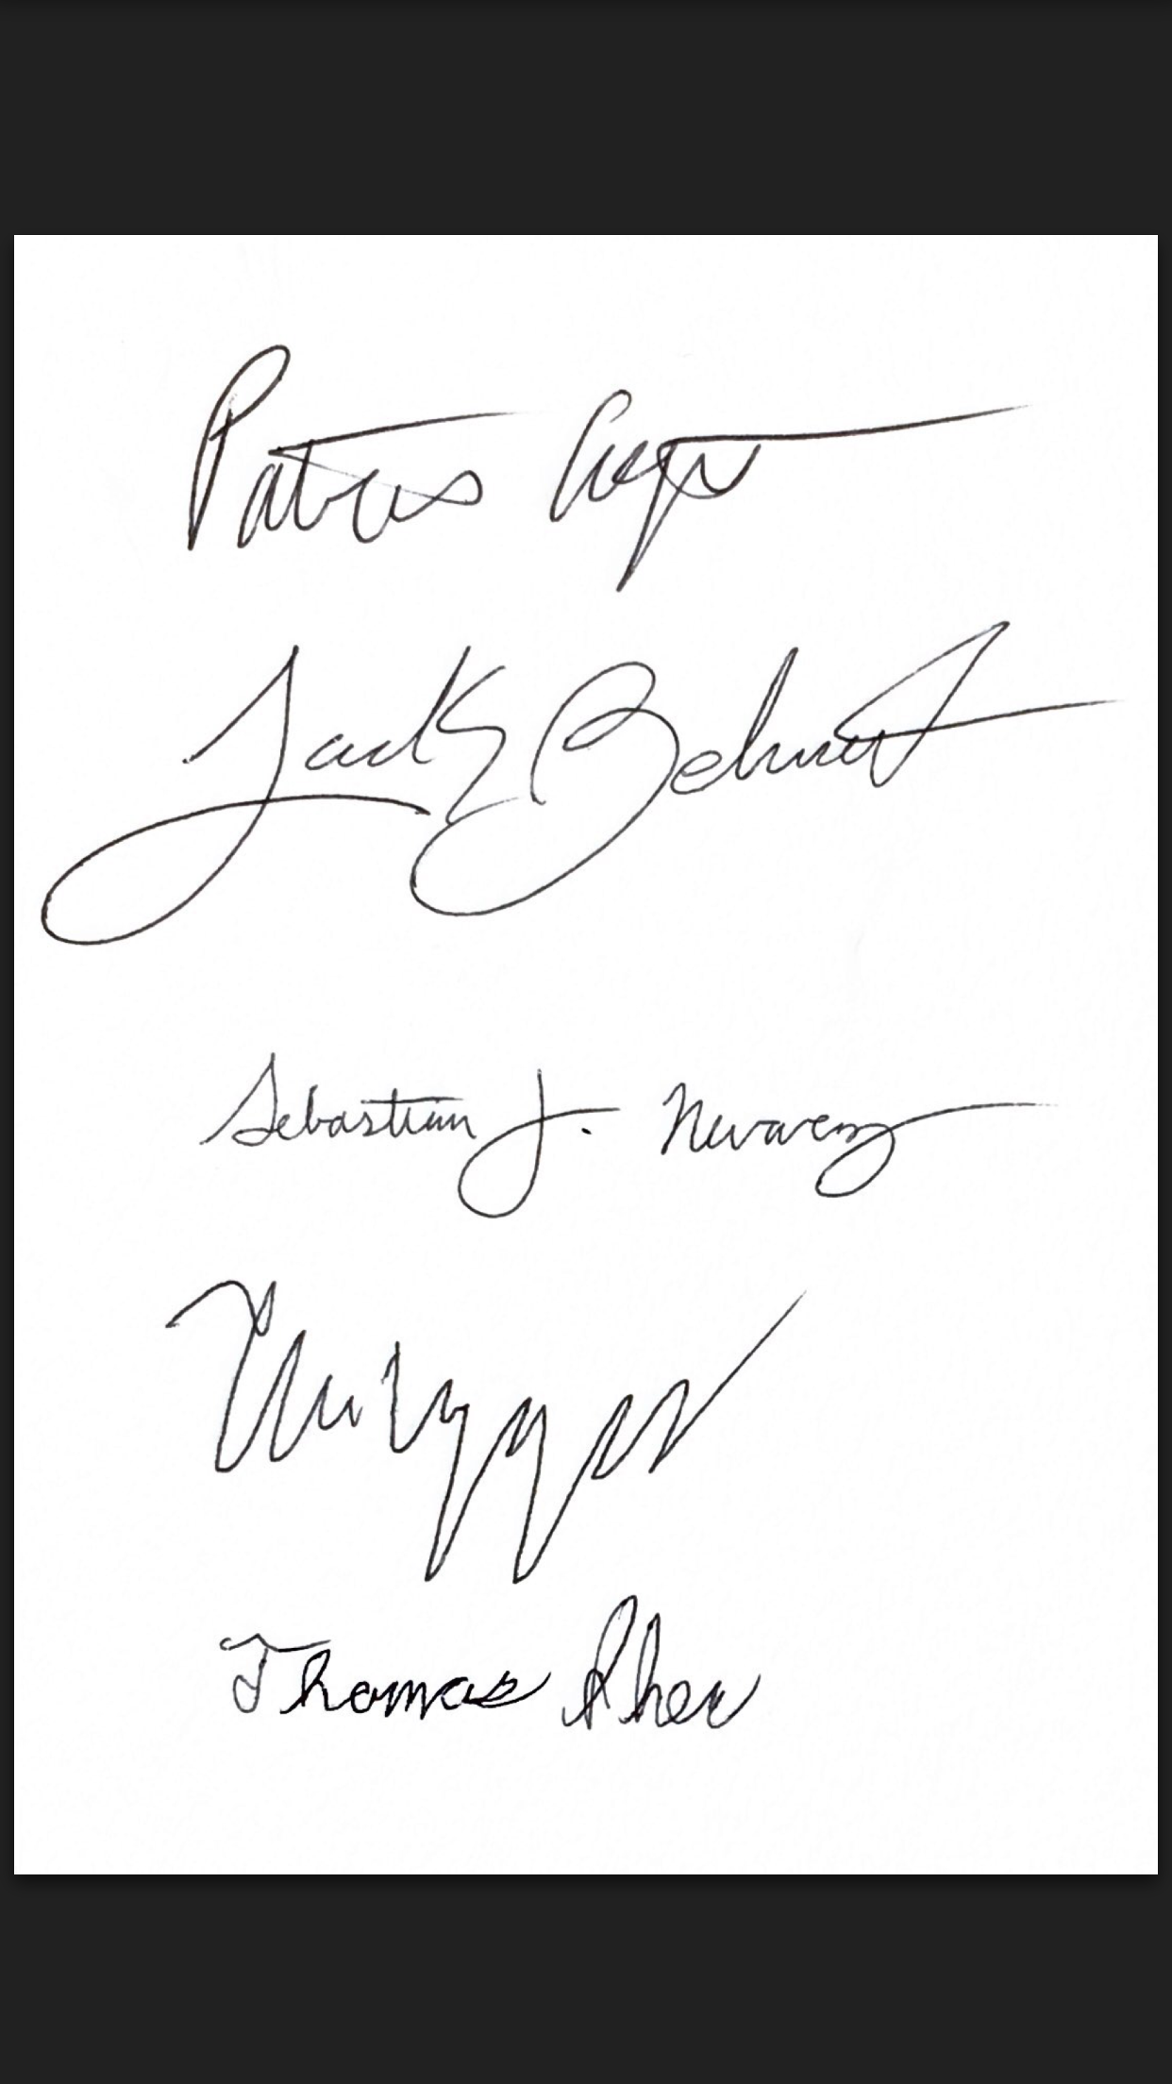

Patrick Agri U82261533 agrip

Jack Belmont U62454414 jbelmont

Sebastian Nevarez U05088946 snevarez

Thuc Nguyen U53329170 thuchngu

Thomas Shea U32281301 tpshea