**Coding Challenge**

**Specification**

After starting the app, the user is presented with a timetable of one of our stations with departures and arrivals of the buses.

**Acceptance Criteria**

* The timetable items should at least contain line number & direction, departure (or arrival) time and brief route.
* Timetable items should be grouped into sections by departure (or arrival) date.
* There should be some way to switch between departures and arrivals.

**Example of how the screen could look like:**

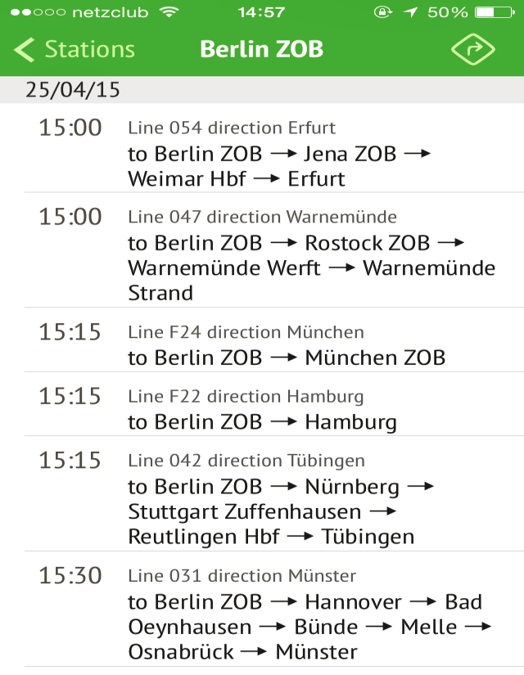

**API details**

Host: **http://api.mobile.staging.mfb.io**

Station timetable resource path: **/mobile/v1/network/station/{station_id}/timetable**

Station id: **1 (Berlin ZOB)** or **10 (Munich ZOB)**

**Authentication**

To authenticate against our API one has to add a header to the HTTP request.

Header name is **X-Api-Authentication** and value is **intervIEW_TOK3n**.

To verify that our API is working properly, use the following command:

curl -H "X-API-Authentication: intervIEW_TOK3n" http://api.mobile.staging.mfb.io/mobile/v1/network/station/1/timetable

If it doesn't work for you, please let us know ASAP.

**Response example**

You are interested in the **timetable** object and its **arrivals** & **departures** fields. Here you may see a mapping between data you have to display in the app and departure (or arrival) JSON object field names:

* line number: **line_code**
* direction: **direction**
* departure (or arrival) time: **datetime**
* brief route: **through_the_stations**
* route details: **route** array

Please note that all timestamps are accompanied by timezone of the station.

{

"timetable": {

"arrivals": [{

"through_the_stations": "Hamelin \u2192 Hanover \u2192 Peine \u2192 Berlin central bus station",

"datetime": {

"timestamp": 1461056400,

"tz": "GMT+02:00"

},

"line_direction": "Bus route 131 direction Berlin central bus station",

"route": [{

"id": 1244,

"name": "Hamelin",

"address": "Bahnhofsplatz",

"full_address": "Bahnhofsplatz, 31785 Hameln, Germany",

"coordinates": {

"latitude": 52.101429,

"longitude": 9.373824

}

}, {

"id": 64,

"name": "Hanover",

"address": "Rundestra\u00dfe 12",

"full_address": "Rundestra\u00dfe 12, 30161 Hannover, Germany",

"coordinates": {

"latitude": 52.378922,

"longitude": 9.740987

}

}, {

"id": 5958,

"name": "Peine",

"address": "Braunschweiger Stra\u00dfe",

"full_address": "Braunschweiger Stra\u00dfe, 31224 Peine, Germany”,

"coordinates": {

"latitude": 52.318714,

"longitude": 10.232146

}

}, {

"id": 1,

"name": "Berlin central bus station",

"address": "Masurenallee 4-6",

"full_address": "Masurenallee 4-6, 14057 Berlin ZOB, Germany",

"coordinates": {

"latitude": 52.507171,

"longitude": 13.279399

}

}],

"line_code": "L131",

"direction": "Berlin central bus station",

"delay_status": "on_time",

"delay": {

"timestamp": 1461056400,

"tz": "GMT+02:00"

},

"station_ride_message": "On time."

}],

"departures": [{

"through_the_stations": "Berlin central bus station \u2192 M\u00fcnchberg \u2192 Himmelkron \u2192 Munich central bus station \u2192 Friedrichshafen central station \u2192 Meersburg \u2192 Constance Allmannsdorf \u2192 Constance D\u00f6beleplatz \u2192 Zurich",

"datetime": {

"timestamp": 1461056400,

"tz": "GMT+02:00"

},

"line_direction": "Bus route 006 direction Z\u00fcrich",

"route": [{

"id": 1,

"name": "Berlin central bus station",

"address": "Masurenallee 4-6",

"full_address": "Masurenallee 4-6, 14057 Berlin ZOB, Germany",

"coordinates": {

"latitude": 52.507171,

"longitude": 13.279399

}

}, {

"id": 43,

"name": "M\u00fcnchberg",

"address": "August-Horch-Stra\u00dfe 12",

"full_address": "August-Horch-Stra\u00dfe 12, 95213 M\u00fcnchberg, Germany",

"coordinates": {

"latitude": 50.20334,

"longitude": 11.777464

}

}, {

"id": 1714,

"name": "Himmelkron",

"address": "Hofer Stra\u00dfe 2",

"full_address": "Hofer Stra\u00dfe 2, 95502 Himmelkron, Germany",

"coordinates": {

"latitude": 50.05418,

"longitude": 11.62229

}

}, {

"id": 10,

"name": "Munich central bus station",

"address": "Arnulfstra\u00dfe 21",

"full_address": "Arnulfstra\u00dfe 21, 80335 M\u00fcnchen, Germany",

"coordinates": {

"latitude": 48.14248,

"longitude": 11.55001

}

}, {

"id": 9,

"name": "Friedrichshafen central station",

"address": "Bahnhofplatz",

"full_address": "Bahnhofplatz, 88045 Friedrichshafen, Germany",

"coordinates": {

"latitude": 47.652758,

"longitude": 9.473237

}

}, {

"id": 5,

"name": "Meersburg",

"address": "Stettener Stra\u00dfe",

"full_address": "Stettener Stra\u00dfe, 88709 Meersburg, Germany",

"coordinates": {

"latitude": 47.695249,

"longitude": 9.271471

}

}, {

"id": 4,

"name": "Constance Allmannsdorf",

"address": "Mainaustra\u00dfe 154",

"full_address": "Mainaustra\u00dfe 154, 78464 Konstanz, Germany",

"coordinates": {

"latitude": 47.682148,

"longitude": 9.202582

}

}, {

"id": 3,

"name": "Constance D\u00f6beleplatz",

"address": "D\u00f6beleplatz",

"full_address": "D\u00f6beleplatz, 78462 Konstanz, Germany",

"coordinates": {

"latitude": 47.658161,

"longitude": 9.169118

}

}, {

"id": 2,

"name": "Zurich",

"address": "Limmatstrasse 5",

"full_address": "Limmatstrasse 5, 8005 Z\u00fcrich, Switzerland",

"coordinates": {

"latitude": 47.380855,

"longitude": 8.537436

}

}],

"line_code": "L006",

"direction": "Z\u00fcrich"

}],

"message": ""

}

}