剑雅10 Test 3-Section 2
Listen and answer questions 11-20

Questions 11 and 12
Choose TWO correct answers.
11 - 12 Which TWO things does Alice say about the Dolphin Conservation Trust?

A.Children make up most of the membership.
B.It's the country's largest conservation organisation.
C.It helps finance campaigns for changes in fishing practices.
D.It employs several dolphin experts full-time.
E.Volunteers help in various ways.

Question 13-15
Choose the correct answer.

13
Why is Alice so pleased the Trust has won the Charity Commission award?

A.It has brought in extra money.

B.It made the work of the trust better known.

C.It has attracted more members.

14
Alice says oil exploration causes problems to dolphins because of

A.noise.

B.oil leaks.

C.movement of ships.

15
Alice became interested in dolphins when

A.she saw one swimming near her home.

B.she heard a speaker at her school.

C.she read a book about them.

Questions 16-20
Which dolphin does Alice make each of the following comments about?
Choose the correct answer and move it into the gap.

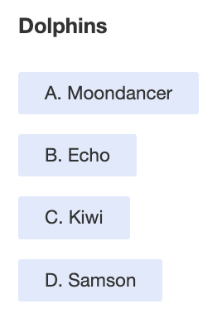
Comments

16 It has not been seen this year.
17 It is photographed more than the others.
18 It is always very energetic.
19 It is the newest one in the scheme.
20 It has an unusual shape.

