14-3-2
Questions 11 and 12
Choose TWO correct answers.
11 - 12Which TWO activities that volunteers do are mentioned?
窗体顶端
A.decorating
B.cleaning
C.delivering meals
D.shopping
E.childcare
窗体底端

Questions 13 and 14
13 - 14Which TWO ways that volunteers can benefit from volunteering are mentioned?
- learning how to be a part of a team
- having a sense of purpose
- realizing how lucky they are
- improved ability at time management
- boosting their employment prospects

Questions 15-20
What has each of the following volunteers helped someone to do?
Choose the correct answer and move it into the gap.
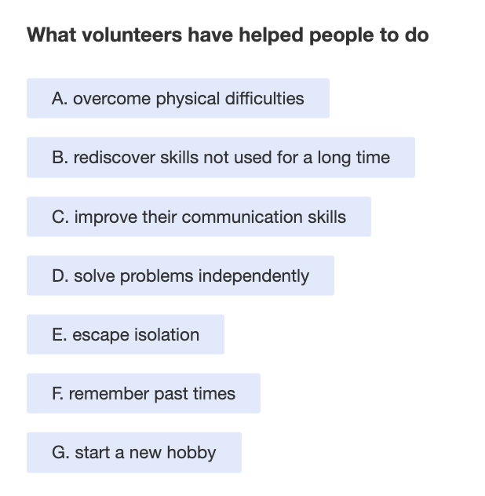
Volunteers
15 Habib
16 Consuela
17 Minh
18 Tanya
19 Alexei
20 Juba

