**TOWARDS INTELLIGENT GESTURE-DRIVEN EDUCATION: ENABLING ENHANCED LEARNING EXPERIENCES**

**A PROJECT REPORT**

***Submitted by***

**CHRIST JOE**

**RAMANARAYAN A V**

**FAWAZ HUSSAIN R**

***in partial fulfillment for the award of the degree***

***of***

**BACHELOR OF ENGINEERING**

**IN**

**COMPUTER SCIENCE AND ENGINEERING**



**MADRAS INSTITUTE OF TECHNOLOGY CAMPUS**

**ANNA UNIVERSITY:: CHENNAI 600044**

**MAY 2024**

**ANNA UNIVERSITY : CHENNAI 600044**

**BONAFIDE CERTIFICATE**

Certified that this project report **“Towards Intelligent Gesture-Driven Education: Enabling Enhanced Learning Experiences”** is the bonafide work of **“Christ Joe (2020503006), Ramanarayan A V (2020503025) and Fawaz Hussain (2020503038)”** who carried out the project work under my supervision.

**SIGNATURE SIGNATURE**

Dr. Ponsy R K Sathia Bhama Dr. P Jayashree

**SUPERVISOR HEAD OF THE DEPARTMENT**

Associate Professor Professor

Department of Computer Technology Department of Computer Technology

Anna University, MIT Campus Anna University, MIT Campus

Chromepet, Chennai-600044 Chromepet,Chennai-600044

**ABSTRACT**

In response to the evolving landscape of education towards Education 4.0, this project introduces an innovative interactive educational platform grounded in Human-Computer Interaction (HCI) principles like gesture control and speech-to-text technology. The EduGest application utilizes hand gesture-based interactions facilitated by users' web cameras to enhance engagement and learning experiences, particularly focusing on young children. Leveraging a Hand Gesture Recognition (HGR) model trained with a Random Forest Classifier achieving 98% accuracy, users can intuitively control system interactions through a set of gestures, fostering increased engagement. Key components of the platform include gamification elements integrated with assignments to track and incentivize student progress. To evaluate the effectiveness of EduGest, participant feedback regarding learning experiences before and after integrating gesture-based interactions was gathered. Results indicate significant improvements in engagement and learning outcomes, highlighting the potential of HCI-driven educational approaches in addressing contemporary challenges in the educational landscape.

**ACKNOWLEDGEMENT**

We are highly indebted to our respected Dean, **Dr. K RAVICHANDRAN**, and our respected Head of the Department **Dr. P. JAYASHREE** for providing sufficient facilities that contributed to the success of the project.

Undertaking this project has helped us learn a lot, and we would like to express our sincere gratitude towards our supervisor **Dr. PONSY R K SATHIA BHAMA** whose kind guidance and proper directions helped shape this project perfectly. The timely feedback from the supervisor was very instrumental in successful completion of the project work carried out.

We acknowledge the efforts and feedback of the panel members **Dr. S. CHITHRA**, **Dr. V P JAYACHITRA,** and **Dr. KOTTILINGAM K** in reviewing our work, providing constant valuable comments, and encouraging us to view the different aspects of the project in successful implementation of the project.

We thank all the teaching and non-teaching members of the Department of Computer Technology, MIT, Anna University, whose appreciable help, either directly or indirectly helped in the smooth completion of the Final Year Project in a limited time frame and made the demanding time efficient.

**CHRIST JOE (2020503006)**

**RAMANARAYAN A V (2020503025)**

**FAWAZ HUSSAIN R (2020503038)**

**TABLE OF CONTENTS**

|  |  |  |
| --- | --- | --- |
| **CHAPTER NO.** | **TITLE** | **PAGE NO.** |
|  | **ABSTRACT** | **iii** |
|  | **ACKNOWLEDGEMENT** | **iv** |
|  | **LIST OF TABLES** | **ix** |
|  | **LIST OF FIGURES** | **x** |
|  | **LIST OF ABBREVIATIONS** | **xi** |
| **1** | **INTRODUCTION** | **1** |
|  | 1.1 OVERVIEW | 1 |
|  | 1.2 HUMAN-COMPUTER INTERACTION | 2 |
|  | 1.3 GAMIFICATION | 3 |
|  | 1.4 OBJECTIVES | 4 |
|  | 1.5 PROBLEM STATEMENT | 4 |
|  | 1.6 ORGANIZATION OF THESIS | 5 |
| **2** | **LITERATURE SURVEY** | **6** |
|  | 2.1 INTRODUCTION | 6 |
|  | 2.2 HAND GESTURE RECOGNITION | 6 |
|  | 2.3 GAMIFICATION IN EDUCATION | 7 |
|  | 2.4 SUMMARY | 8 |
| **3** | **EDUGEST APPLICATION** | **10** |
|  | 3.1 INTRODUCTION | 10 |
|  | 3.2 PROPOSED WORKFLOW | 10 |
|  | 3.3 TOOLS USED | 12 |
|  | 3.3.1 React Frontend Development | 12 |
|  | 3.3.2 Python Flask Backend ,,,,,,,,,,,,,,,,,,,,,Development | 12 |
|  | 3.3.3 MySQL | 12 |
|  | 3.4 ARCHITECTURE DIAGRAM OF ,,,,,,,,,,,EDUGEST | 13 |
|  | 3.5 SUMMARY | 15 |
| **4** | **IMPLEMENTATION AND ALGORITHM** | **16** |
|  | 4.1 INTRODUCTION | 16 |
|  | 4.2 SPATIAL REPRESENTATION AND ,,,,,,,,,,,NORMALIZATION | 16 |
|  | 4.3 ALGORITHM | 17 |
|  | 4.3.1 Hand Landmark Detection | 19 |
|  | 4.3.2 Landmark List Initialization | 19 |
|  | 4.3.3 Landmark Preprocessing | 20 |
|  | 4.3.4 Gesture Prediction | 20 |
|  | 4.3.5 Output | 21 |
|  | 4.4 SUMMARY | 22 |
| **5** | **RESULTS AND INFERENCES** | **23** |
|  | 5.1 INTRODUCTION | 23 |
|  | 5.2 HAND GESTURE RECOGNITION | 23 |
|  | 5.3 GAMIFICATION MODEL | 25 |
|  | 5.4 INFERENCES | 27 |
|  | 5.5 SUMMARY | 29 |
| **6** | **PERFORMANCE ANALYSIS** | **30** |
|  | 6.1 INTRODUCTION | 30 |
|  | 6.2 GESTURE RECOGNITION  ,,,,,,,,,,,PERFORMANCE | 30 |
|  | 6.3 GAMIFIED LEARNING EXPERIENCE | 32 |
|  | 6.4 SUMMARY | 35 |
| **7** | **CONCLUSION AND FUTURE WORK** | **36** |
|  | 7.1 CONCLUSION | 36 |
|  | 7.2 FUTURE WORK | 37 |
|  | **REFERENCES** | **38** |

**LIST OF TABLES**

|  |  |  |
| --- | --- | --- |
| **TABLE NO.** | **TITLE** | **PAGE NO.** |
| 6.1 | Hand Gesture Recognition Model Accuracy for each gesture | 31 |
| 6.2 | Conventional vs Gamified learning evaluation metrics | 33 |

**LIST OF FIGURES**

|  |  |  |
| --- | --- | --- |
| **FIGURE NO** | **TITLE** | **PAGE NO** |
| 3.1 | Entity-Relation (ER) diagram of Tables in Database | 13 |
| 3.2 | System Architecture Diagram | 13 |
| 5.1 | Cursor pointer action | 23 |
| 5.2 | Left click action | 24 |
| 5.3 | Right click action | 24 |
| 5.4 | Scroll up | 25 |
| 5.5 | Scroll down | 25 |
| 5.6 | Double click | 25 |
| 5.7 | Home page | 26 |
| 5.8 | Course content page | 26 |
| 6.1 | Confusion Matrix of the HGR model | 31 |
| 6.2 | Comparison of Conventional and Gamified Learning metrics | 34 |

**LIST OF ABBREVIATIONS**

|  |  |
| --- | --- |
| HCI | HUMAN-COMPUTER INTERACTION |
| HGR | HAND GESTURE RECOGNITION |
| UI | USER INTERACTION |

**CHAPTER 1**

**INTRODUCTION**

**1.1 OVERVIEW**

In the digital age, the fusion of technology and education has become imperative to meet the evolving needs of learners worldwide [16]. Introduction of Human-Computer Interaction (HCI) into education has proven to show promising outcomes among students in various fields [3]. This introduction sets the stage for a transformative journey into the realms of cultural education, especially the fields which require active participation of the students. Though traditional methods and modes of education have been able to provide many benefits, there aren't many proven methods to ensure the student engagement with the educational materials [8]. With the evolution of technology, the education domain has also been improved and is moving towards education 4.0, with the involvement of various latest trends like Artificial Intelligence (AI), Internet of Things (IoT), Human-Computer Interaction (HCI) etc. for providing more accessible and engaging learning experience for students [16].

Human-Computer Interaction (HCI) bridges the gap between humans and technology by focusing on the design and evaluation of interactive systems. HCI principles are employed to create user interfaces that are intuitive, user-friendly, and cater to diverse learning styles. One exciting application of HCI in education is gesture recognition technology. This technology allows users to interact with computers through hand or body movements, eliminating the need for traditional input methods like keyboards or mice.

In the educational field, gesture recognition can revolutionize learning by creating a more engaging and interactive experience. This not only fosters a more dynamic learning environment but can also improve accessibility for students with physical limitations. By incorporating HCI and gesture recognition, educators can create a more captivating and inclusive learning experience for the digital generation. Using this concept, the proposed EduGest platform aims to use hand gesture-based navigation to teach students about Tamil Heritage, Culture, and its impact on technology. The choice of course is to help students gain knowledge on their traditional roots and history, by incorporating a more enjoyable method learning, which helps revolutionize learning using technology.

One particularly promising avenue within HCI is the integration of gamification components into educational platforms. Gamification involves the application of game-design elements and principles in non-game contexts, such as education, to enhance motivation, engagement, and learning outcomes. By incorporating gamified elements such as activities, rewards, and progress tracking, educational platforms can effectively captivate students' interest and encourage active participation in the learning process. The main aim is to satisfy the criteria of engagement, motivation, progression and retention, which are considered to be the benchmark standards for an effective learning platform.

**1.2 HUMAN-COMPUTER INTERACTION**

HCI is an interdisciplinary field that investigates the design, evaluation, and implementation of interactive computer systems for human use. It has proven to be a promising domain to establish creative methods to improve interaction between people and machines [2]. Human gestures like the gestures made by the face, hand and the body can give various information about the activities performed, or even be used to perform any action as a response to the recognized gesture. This methodology can be used in areas including and not limited to robotics. This ideology can also be implemented in the education domain to enhance the learning experience. Being able to use one's gestures to interact with a platform not only gives an engaging feel to the user but also helps increase attention and focus on the activity.

**1.3 GAMIFICATION**

Gamification is the method of including game elements in a learning environment to engage students more in the educational content [12]. This method proves to improve student engagement to learning and increases their competitiveness. More importantly, retaining student attention and focus on the platform, especially in cases where the platform requires student engagement for a long stretch of time, has been a primary criterion. With the help of hand gestures, students can feel more immersed in the learning experience and give a fun competitive twist with the gamification of the educational content [10]. There exist several examples of gamification that prove to have improved student's overall performance [12]. Incorporating leaderboards, points and progression to the educational content helps bring a sense of competitiveness among students to learn and progress more. With this idea in mind, the proposed system aims to create an educational platform with a hand gesture interaction friendly UI for learning Tamil heritage, culture, and its influence in various technologies that are used today. Gamification of heritage and culture helps spread knowledge about the history and background of a country to young learners in a fun way [10].

**1.4 OBJECTIVES**

* An efficient hand gesture recognition Random Forest Classifier model capable of detecting a user's hand and recognizing the gesture made by the user live from the standard set of gestures defined.
* A gesture-based interaction with the system to perform basic functions to help users interact with the various components of the educational platform.
* A hand gesture friendly UI with the Tamil heritage and culture content gamified to elevate user engagement.

**1.5 PROBLEM STATEMENT**

In the context of Education 4.0, which emphasizes the integration of technology to enhance learning experiences, there is a growing recognition of the importance of Human-Computer Interaction (HCI) and gamification in fostering student engagement and learning outcomes. However, existing educational platforms often lack intuitive interfaces and fail to fully leverage the potential of gamified elements to motivate and empower learners. This gap highlights the need for innovative solutions that effectively integrate HCI principles and gamification techniques to optimize the educational experience. By harnessing the power of HCI, an intuitive user interface that facilitate seamless interaction between students and educational content can be developed, thereby promoting active learning and knowledge retention. Additionally, through gamification strategies such as rewards, challenges, and progress tracking, a dynamic and immersive learning environment that motivates students and enhances their overall educational experience can be created. This project endeavors to explore the intersection of HCI and gamification in Education 4.0, with the goal of revolutionizing the way students engage with and benefit from digital learning platforms.

**1.6 ORGANIZATION OF THESIS**

Chapter 1 of this thesis provides an overview of the project domain and a description of the main concepts involved in developing the application, the objectives of this project and the problem statement. Chapter 2 gives an elaborate literature survey of the various studies and reviews conducted in these domains to help give a broad idea on existing technologies and solutions that can help us derive a better or different approach to a common problem. This chapter also contains the inferences from all these studies. Chapter 3 outlines the proposed workflow of the application along with the system architecture diagram. The technologies used to build the application are also explained in this chapter. Chapter 4 discusses the equations, algorithm and the various steps involved in the working of the model for recognizing hand gestures. Chapter 5 illustrates the results and visual representation of the final developed web application along with the explanation of all the features. Chapter 6 is the performance analysis of the different components in the application. Finally, Chapter 7 gives the conclusion of the completed application and the prospects of the findings of this work.

**CHAPTER 2**

**LITERATURE SURVEY**

**2.1 INTRODUCTION**

The growth of use cases of technology in education 4.0 has been studied in various aspects to help the industry understand how it can be used to enhance learning as well as teaching abilities in schools. Multiple reviews conducted in this domain has demonstrated the different positive aspects and the areas that can be further improved using technology while also introducing gamification principles in it. This chapter delves in the literature survey done using a set of research involving technology and gamification to improve the field of education.

**2.2 HAND GESTURE RECOGNITION**

The idea to navigate and interact or manipulate a virtual environment using gestures has become a common trend especially in the educational domain. It is quite evident in the work presented by Shaykhah Aldosari et al. in [17], where the authors propose the use of a leap motion controller that can recognize hand gestures which in turn will be used to learn molecular visualizations in chemistry experiments virtually. The mode of recognizing hand gestures can be various forms like using sensors in gloves, cameras for taking hand images or even cameras or webcams for recognizing gestures in live mode through videos. In [15], the authors propose a simple Convolution Neural Network (CNN) model for HGR in images from the Cambridge Hand Gesture dataset. [19] illustrates how the authors created a database of 3D photo-realistic synthetic skeleton hand poses which help with training better models for hand detection and gesture recognition. Hand gestures can be very helpful for people with disabilities as a mode of communication. The authors in [5] propose a HGR model for people with speech impairment which can help them communicate through the British Sign Language. Furthermore, HGR can also be used for enhancing the simple tasks of HCI for interacting with systems. [11] systematically illustrates the various modes of Human-Machine Interaction using different HGR methods to interact with machines like computers, robots etc.

**2.3 GAMIFICATION IN EDUCATION**

Gamification is the method of including game elements in a learning environment to engage students more in the educational content [12]. This method proves to improve student engagement to learning and increases their competitiveness. More importantly, retaining student attention and focus on the platform, especially in cases where the platform requires student engagement for a long stretch of time, has been of focus. [8] provides a machine learning approach to assessing student engagement in classroom instruction using their head pose, body gesture, eye movement etc. Apart from detecting whether students are attentive to the learning process, the focus needs to be on finding ways to make the learning more attention grabbing and engaging for students. There are plenty of ways the educational content could be gamified, especially social content like heritage, a country's history, culture etc. The authors in [13] conducted a study in how gamification in historical education helped students study history due to the effective organization of the study material and engaging gamified approach to learning. Another study in [10] shows how the gamification of educational material for cultural heritage through Augmented Reality (AR) and Virtual Reality (VR) has proven to provide better results in disseminating knowledge to students. Teaching students using these technologies is not just a fun learning experience, but also helps students physically engage in the learning process.

The proposed learning application is a web-based platform incorporating various gamified elements. Thomas Bohné *et al*. [18] explore the impact of gamification in web-based virtual training environments for an industrial task. The study measured various aspects of learning, including how long it took participants to complete the task, the number of mistakes they made, their motivation, self-efficacy (confidence in their abilities), and satisfaction with the training system. The efficiency of these gamified elements in education platforms and its effects are furthermore elaborated by Allan Tori *et al.* [1]. Their systematic review of Game Design in Health Education shows the most used game elements were ‘Tasks’, ‘Score’ and ‘Level Progression’. These three elements seem to have helped for users maintain their motivation while still being able to perceive their performance

**2.4 SUMMARY**

From the various studies and reviews conducted in this literature survey, it is evident that the incorporation of a technology like Human-Computer Interaction into education, further improving education 4.0 sector, proves improvement in student learning performance and engagement with the platform. Furthermore, incorporating gamified elements like ‘Progress’, ‘Tasks’ and ‘Leaderboard’ help the students maintain motivation and develop a competitive learning environment.

Based on this literature survey, it can be inferred that hand tracking systems using the Mediapipe framework by Google is a useful tool for trying out various tasks based on hand gestures. Using this foundation, the hand gesture recognition model has been developed, capable of recognizing various gestures, which are then uniquely mapped to actions on the learning web application for interactions like basic mouse clicks, scrolls etc., providing a more intuitive and engaging experience for students with online education. Moreover, it is quite evident from the various reviews conducted that including gamification in the platform by making students attend simple tasks or activities at the end of each course while gaining scores/points helps them keep track of their progress and gain a competitive nature to climb up the leaderboard, which helps many students learn better. Taking ‘Tamil Culture and Heritage’ as the main topic of interest for this application is an initiative to help spread the knowledge of Tamil culture and its impact and influence in science and technology. The use of gesture recognition along with gamification can prove to be a unique and helpful experience in learning similar concepts.

**CHAPTER 3**

**EDUGEST APPLICATION**

**3.1 INTRODUCTION**

Development of the EduGest application requires a set of tools and software to work collaboratively to function in the desired manner. This chapter illustrates the software used to build the webpage and integrate the hand gesture recognition model in it. Furthermore, the architecture diagram of the proposed system is included that illustrates the workflow of the system.

**3.2 PROPOSED WORKFLOW**

The architecture of the system consists of two major components, the HCI interface responsible for recognizing the hand gestures and performing respective actions and the gamified learning platform which is developed using a React Environment consisting of HTML/CSS/JavaScript for the frontend and Python Flask and MySQL for the backend. The learning platform contains various topics in Tamil's heritage, culture, and its influence in defining modern technology. Gamification of this topic can really help spread the importance of knowing one's heritage and history [7][14]. The system is composed of the following modules:

i. Hand Gesture Recognition Model

The HGR (Hand Gesture Recognition) model revolutionizes user interaction by offering 8 distinct gestures, 6 of which facilitate platform interaction like 'Left Click', 'Right Click', 'Pointer', 'Double Click', 'Scroll Up', and 'Scroll Down'. These gestures emulate traditional mouse and keyboard actions, empowering users to navigate and execute commands seamlessly. By enabling intuitive interaction, the HGR model enhances student engagement with the platform, fostering deeper focus and active participation. This advanced level of interactivity not only optimizes user experience but also simplifies workflow, catering to diverse student preferences and ultimately enhancing their productivity and learning outcomes. Furthermore, the intention of bringing in hand gesture navigation to replace traditional mouse was to improve student interaction with learning platforms. Conventional learning applications lack proper methods to keep track of student engagement. This comes as a massive setback to a vast majority of online learning platforms. But with the EduGest application, this problem is overcome by making the primary mode of navigation as hand gesture control, which proves to always improve student engagement with the platform and also giving them a more enjoyable experience in learning.

ii. Gamified Learning Platform

Gamification has shown various benefits in learning, especially in a virtual setting where students tend to lose focus in the process [4][9]. Including features like a reward system where students earn points for completing tasks, a leaderboard that tracks progress of students, interactive assignments and activities significantly help with the gamification process [6]. The proposed educational platform includes various gesture friendly features for learning Tamil heritage, culture, and technology with the mentioned gamification features like leaderboards and points achieved as students’ progress through different learning content. This approach helps students stay attentive to the platform and have a better experience in learning with a competitive nature. To make the platform more engaging and helpful for students, a chat-like language translation interface has been introduced where students can translate English sentences to Tamil text.

**3.3 TOOLS USED**

**3.3.1 React Frontend Development**

React is a JavaScript library for building user interfaces or UI components. React library was used to build the frontend of the learning platform which included various features like course content, map-based history learning, assignments, and a speech to text translator which helps us to learn Tamil. Users would interact on the frontend using gestures and the requests made are handled by using APIs which are managed at the backend using python flask.

**3.3.2 Python Flask Backend Development**

Flask is a micro web framework written in python used for web development. Flask was used in this project to handle HTTP requests, gesture recognition, routing pages and integrating with the frontend for dynamic data updating and content delivery.

**3.3.3 MySQL**

MySQL is a relational database management system which is used for storing and managing data like student information (login/registration details), topics, assignments, assignments completed by each student and the leaderboard details. Figure 3.1 shows the Entity-Relation (ER) diagram of the tables in the database used. The educational platform requires the user to have the live feed taken from the webcam with their hand visible for controlling the UI features. The trained model will be used to recognize the gesture live.

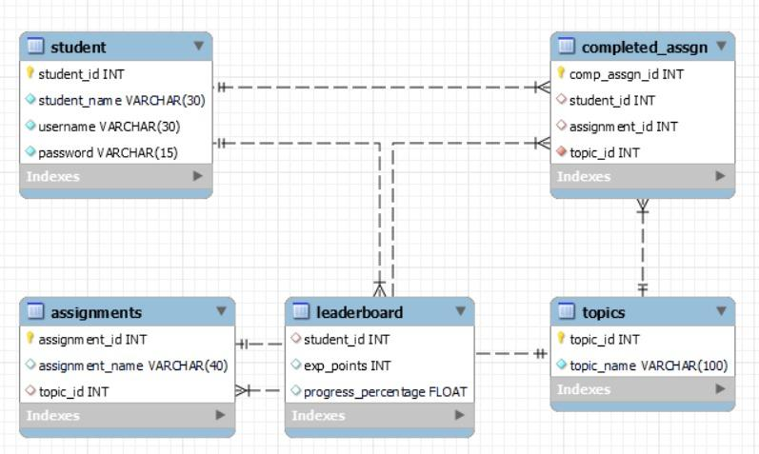

**Figure 3.1** Entity-Relation (ER) diagram of Tables in Database

**3.4 ARCHITECTURE DIAGRAM OF EDUGEST**

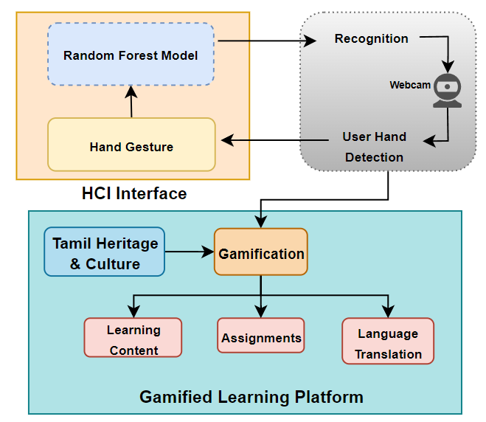

**Figure 3.2** System Architecture Diagram

The system architecture of EduGest involves several stages. The process begins with real-time video streaming, which captures frames of the user’s hand. While the frames are captured, they are simultaneously processed to recognize the signs made. The signs made in real-time are mapped to each of those 6 signs and a particular action is performed on the system.

To map these to the gesture, the model renders the hand and identifies the palm of the hand and further places reference points on the rendered hand. The detected landmarks in the hand are utilized to control the cursor and perform mouse actions. The recognized gestures’ output is then performed on screen, which enables the user to have a hands-free experience.

The user can navigate through the website and attend all the assignments with the help of gestures, which helps the user to be completely immersed in the course that they are completing. While the user completes the course content and the assignments that are arranged, they gain points which are updated in the leaderboard and on everyone’s progress bar which insinuates a feeling of competitiveness among the users.

Further, the user can delve into the depths of Tamil and its heritage using the map feature. This feature includes the various eras in Tamil history and the significant events that took place during that era. Another feature included is the chat-like English-To-Tamil language translation, which helps students understand the language even more. By speaking out the English sentence the student wishes to translate, the text is translated to its corresponding Tamil text and sent as a reply to the student.

**3.5 SUMMARY**

Software like React and Python Flask along with MySQL for the schema design were implemented for building the EduGest application. The principles of gamification were incorporated in the application to improve the learning process. Moreover, incorporation of hand gesture navigation makes this a novel approach to helping students learn important topics. Finally, the architecture flow of EduGest illustrates how the various components of the system come together to improve the learning environment using the HGR model.

**CHAPTER 4**

**IMPLEMENTATION AND ALGORITHM**

**4.1 INTRODUCTION**

This chapter analyses the underlying implementation of the HGR model to understand how the model can read the live hand gestures of the user, along with the tool and method used to train the model. The algorithm flow of the training process is also depicted in this chapter with the equations used to help achieve the goal.

**4.2 SPATIAL REPRESENTATION AND NORMALIZATION**

The Heart Gesture Recognition (HGR) system hinges on the meticulous depiction of hand gestures, ensuring precise interpretation and smooth interaction with the user interface. At its core lies the meticulous representation of hand gestures, which enables accurate interpretation and seamless interaction with the user interface. The process initiates with the computation of relative coordinates, which precisely measure the spatial deviation of each landmark point from a predefined reference point. Now, let's delve deeper into the underlying equations:

RelativeCoord(xi) = xi − x1 **(4.1)** RelativeCoord(yi) = yi − y1 **(4.2)**

In equation 4.1 and 4.2, xi and yi denote the spatial coordinates of a particular landmark point on the hand, while x1 and y1 represent the coordinates of a reference point, typically the first detected landmark. By subtracting the coordinates of the reference point from those of the target landmark, the relative displacement along the x and y axes are obtained. This process effectively normalizes the coordinates with respect to a common origin, facilitating consistent gesture representation across different hand positions and sizes. While relative coordinates provide valuable insights into the spatial distribution of hand landmarks, they may vary significantly in magnitude due to differences in hand size and positioning. To address this issue and ensure uniformity in gesture representation, a normalization process is employed.

These equations compute the spatial deviation of each landmark point from a reference point (*x1,y1*), forming the basis for gesture representation. In these equations, the relative coordinates RelativeCoord(*xi*) and RelativeCoord(*yi*) are divided by their respective maximum absolute values. This normalization technique scales the coordinates to a range between -1 and 1, Regardless of the magnitude of the original values. By standardizing the spatial values, the normalization process enhances the robustness and generalizability of the hand gesture recognition model, enabling it to effectively discern gestures across diverse hand sizes and configurations.

**4.3 ALGORITHM**

The HGR system's computational framework uses previously processed landmark coordinates to precisely forecast hand motions. This method describes a set of consecutive operations, each of which is essential to precise gesture identification and smooth user interface operation. Using the principles of the random forest model, the HGR model can make accurate classification of the gestures.

Let's investigate the successive phases that the algorithm outlines in more detail:

|  |
| --- |
| **Algorithm 4.1 Hand Gesture Recognition** |
| **Input:** Image containing a hand, Random Forest Model  **Output:** Detected hand gesture |
| 1: Detect hand landmarks using MediaPipe Hands  2: Initialize empty list landmark list  3: **for** each detected landmark **do**  4: Extract landmark coordinates *(xi , yi)*  5: Append *(xi , yi)* to landmark list  6: **end for**  7: Preprocess landmark list:  8: *x1, y1* ← Coordinates of first landmark  9: **for** each landmark point *(xi , yi)* in landmark list **do**  10: Compute relative coordinates: *∆xi = xi − x1, ∆yi = yi − y1*  11: Normalize relative coordinates: ,  12: Replace *(xi , yi)* with *(x′i , y′i)* in landmark list  13: **end for**  14: Predicted Hand Gesture = *RandomForestModel.predict(x′i , y′i)*  15: **return** Predicted hand gesture |

**4.3.1 Hand Landmark Detection**

In the initial phase of the algorithmic framework, the MediaPipe Hands library is employed to meticulously detect hand landmarks. This powerful tool set utilizes advanced computer vision techniques to accurately identify key points on the user's hand, including fingertips, knuckles, and palm centers. Through its sophisticated algorithms and neural network architectures, MediaPipe Hands provides essential spatial data that serves as the foundation for gesture recognition. This precise landmark detection process ensures the reliability and adaptability of the HGR model, enabling seamless interaction with the user interface by capturing the intricate nuances of hand movements and poses.

**4.3.2 Landmark List Initialization**

After hand landmarks are successfully detected with the MediaPipe Hands module, the proposed algorithm initializes a meticulously built list to capture and store the spatial coordinates of these landmarks in an organized manner. This clean list, which has never been used before, is the starting point for any further preparation and analysis. Through adding the exact spatial coordinates of every landmark that has been identified to this list, an extensive spatial data store that is essential for the correct interpretation and identification of hand motions is created.

This computational approach relies on this selection of hand landmarks to enable smooth preprocessing and thorough analysis of spatial data. This initial data structure serves as a basis for further stages of the algorithm and provides critical spatial insights that are necessary for accurate gesture prediction.

**4.3.3 Landmark Preprocessing**

Now that the landmark list has been carefully filled out, an important preprocessing step is carried out, in which the raw spatial data is refined through several complex steps to get it ready for the gesture prediction processes that follow. This critical phase includes a thorough journey through well-crafted preprocessing methods meant to improve the caliber and comprehensibility of the spatial data.

Every landmark list element is carefully examined during this lengthy preparation procedure to improve its geographical coordinates and guarantee accuracy and consistency throughout the dataset. This painstaking curation procedure is essential for reducing any possible discrepancies or mistakes that can occur when identifying landmarks. In addition, advanced methods are utilized to improve the stability of the spatial data by tackling elements like noise or occlusions that could hinder precise gesture identification. These painstaking preparation steps smooth and prepare the spatial data, which in turn guarantees the correctness and dependability of the computational framework and lays the groundwork for complex gesture prediction procedures.

**4.3.4 Gesture Prediction**

After landmark coordinates have been meticulously preprocessed, the algorithm moves on to its main function, which is gesture prediction. Using a precisely calibrated Random Forest classifier model that was trained on the preprocessed data, the system can anticipate hand motions with an unprecedented level of accuracy. With the help of this prediction model, which captures the complex links between hand landmark spatial configurations and gesture semantics, user movements may be accurately interpreted in real time.

Through the identification of minute patterns in the preprocessed geographical data, the model guarantees smooth operation with the user interface, improving user interaction and enabling easy navigation. The algorithm enhances the entire user experience and facilitates smooth human-computer interaction by interpreting user motions and predicting their intents through its advanced predictive capabilities.

**4.3.5 Output**

Finally, the model is trained using the preprocessed landmark list stored as coordinates in a Comma-Separated Values (CSV) file. The model is saved as a ‘joblib’ file and loaded in the backend of the application. The user is expected to have the webcam always running while using the application to help read the hand landmark coordinates. These coordinates are then sent as input to the loaded model in the backend. Based on the input read, the respective hand gesture is recognized, and the necessary action is performed.

To perform these actions, a python package called PyAutoGUI is used. Using this tool helps to manipulate the systems UI environment according to different use cases. In the case of the EduGest application, the manipulating factor is the hand gestures. Hence, as the model recognizes each gesture made by the user, the output is mapped to different functions of PyAutoGUI that are responsible for simulating the functions of a mouse. This workflow takes place dynamically from the start of the application till the end, with the necessity that the user has their webcam always running.

**4.4 SUMMARY**

The analyses of the HGR model implementation along with the algorithm that explains the model’s training process have been illustrated in this chapter. The algorithm processes the coordinates of the hand landmark points and has accurately detected and predicted the corresponding hand gesture. This output serves as a reliable foundation for user interface commands, facilitating smooth interaction between users and the system. The equations used to read and calculate the coordinates read by MeadiaPipe help gather the relative points of the hand live and detect the gesture. Training the HGR model using Random Forest proved to give the highest accuracy in predicting the right class of hand gestures.

**CHAPTER 5**

**RESULTS AND INFERENCES**

**5.1 INTRODUCTION**

This chapter illustrates the results and implementation of the HGR model with images explaining the different gestures and how the MediaPipe tool reads the hand landmark coordinates during live capture through the user’s webcam. The implementation of gamification and its components in the EduGest application is explained further.

**5.2 HAND GESTURE RECOGNITION**

The “virtual mouse system” incorporates intuitive hand gestures that allow users to control the mouse cursor without the need for physical devices. Eight unique gestures have been created and mapped with certain actions, with 6 of them being accessible.

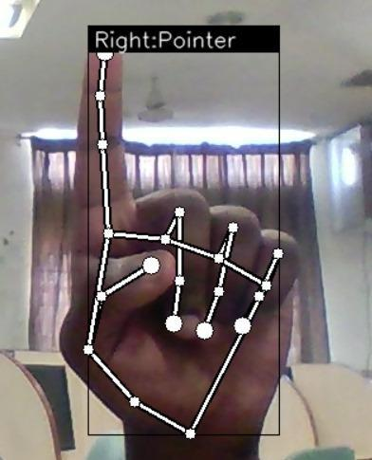

**Figure 5.1** Cursor Pointer Action

The index fingertip is used to move the cursor on the screen, and a rectangle is created as shown in figure 5.1 to ensure that all corners of the screen can be reached.

After reducing the frame and obtaining the region range, it is necessary to interpolate the range to fit the screen size accurately. This interpolation process ensures that the virtual mouse system can accurately translate the user's hand movements into corresponding cursor movements on the screen. Once the interpolation is complete, users can perform various mouse actions using specific hand gestures. Left clicking is performed when the index finger is bent down, as shown in figure 5.2. And Right-clicking is performed when the Middle-finger is bent down, as shown in figure 5.3 To initiate a double-click action, the user must only display their index and middle fingers and close other fingers, as shown in figure 5.6.

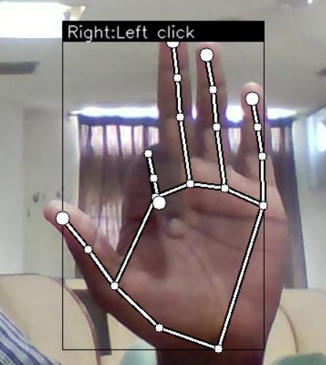 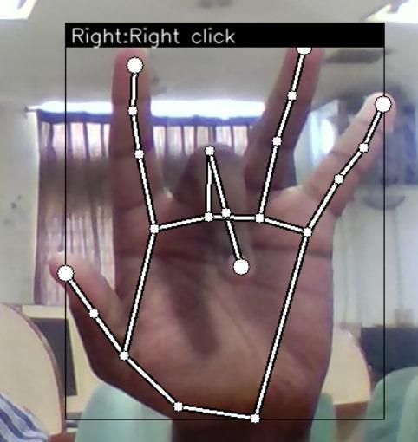

**Figure 5.2** Left click Action **Figure 5.3** Right click Action

One of the essential functionalities provided by the virtual mouse system is scrolling, which allows users to navigate through the content of a window or document. To enable scrolling up, the system utilizes a thumbs up gesture, as illustrated in figure 5.4 and for scrolling down, the thumbs down gesture is utilized as shown in figure 5.5.

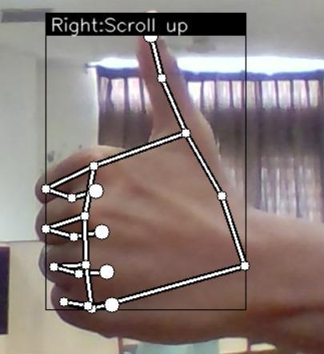 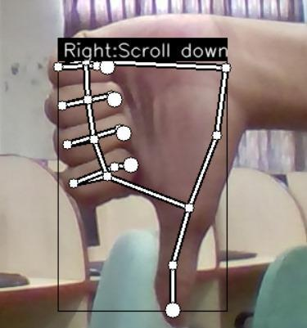 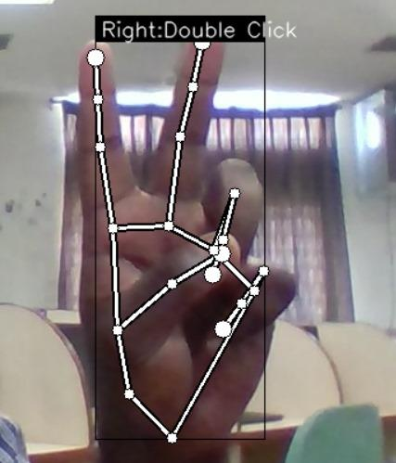

**Figure 5.4** Scroll Up **Figure 5.5** Scroll Down **Figure 5.6** Double Click

**5.3 GAMIFICATION MODEL**

The gamification model in the EduGest application is implemented using different components like awarding points over completion of tasks, leaderboard, progression tracking, interactive map, and speech-to-text chat-based language translation interface. These features combined elevate the learning experience compared to the conventional method of learning.

Figure 5.7 and figure 5.8 portray where the students can learn a certain topic. The students are presented with a description of the topic and information regarding each subsection. Students are also provided with assignments which are used to evaluate the progression made by them. After completion of the course video and the assignments, the student is awarded with the points that each assignment is valued for. The horizontal bar depicted in figure 5.7 shows how the progress of the students are updated dynamically as the student advances through the course. This helps the student be motivated, since the progress made by each student is reflected on the leaderboard as the total score. On completion of a course and its assignment, students are awarded with certain points, which are reflected here.

Additionally, to incorporate more interactive features, the EduGest application includes an interactive map and speech-to-text chat-based language translation interface. The map helps understand the history of Tamil better. The language translation component helps students learn the language better through speaking. The spoken English phrase is converted to text and then converted to its equivalent Tamil text. This whole feature is presented in a chat-like interface to give the user a sensation of student-tutor communication.

**Figure 5.7** Home Page

**Figure 5.8** Course Content Page

At the backend, any requests made by the user at the frontend are managed here using API routing in flask. This improves the efficiency with which the results are displayed on the page and ensures a dynamic workflow of data between the user and the application. Any data manipulation done is stored with the help of MySQL as the database. The content for learning about Tamil Heritage and Technology are derived from the database. As students progress through the course and complete the assignments for each topic, the achieved points or marks are recorded and stored in the database as individual student details. This information is used to present the overall student performance, current progress, and pending tasks. These gamified elements hence prove that they don’t only serve as mode of learning for students, but also help tutors keep track of multiple students and their progression with the course. This concept can further be expanded to help make EduGest more dynamic and interactive with educators too, by providing educators with facilities to update or add more content, expand the are of course material, improve the testing facilities, provide practice materials etc.

**5.4 INFERENCES**

The implementation of the EduGest application helps understand the importance of UI components when developing a new mode of navigation. As with the case of mouse, users have the independence to be able to move the mouse around to be able to access the different areas of the application. When it comes to navigating using hand gestures, there lies an importance in analyzing the extent of accessibility of the different UI components and the rate at which they can be accessed for different users. To accommodate these concerns, EduGest was carefully crafted to cater to the accessibility for each UI component using the gestures alone. Each button, selection box, text, media player etc. must be placed in such a way that it does not pose the user any hinderance in accessing or navigating through the platform with ease. In case of EduGest, hand gesture navigation being the focus, the UI elements were facilitated in such a way that the interactive components need to be big enough for the user to be able to accurately access them or manipulate them. With more platforms emerging with different modes of platform navigation, the importance of studying UI facilities for each of the modes has become a necessity when trying to build the best platform.

Apart from the UI aspect, the different gestures that were created and fed for training to the HGR model need to be understandable and practically usable by all users. For this task, each gesture created was done to simulate similar actions performed on the mouse. For example, the traditional way of performing the left click on a mouse is by using the index finger. Similarly, the middle finger is used to perform right click. Keeping these actions as reference, the gestures to simulate these actions by the HGR model follow a similar action to help the user not feel foreign to navigate through the EduGest application.

The conventional idea of performing gesture recognition is using deep neural network models that read image or video files and learn the orientation of the desired region of interest and provide an output. These models though provide an accurate and strong results, their drawbacks come from the heavy computational requirements to run these models in platforms that run on the internet. Expecting users to have the capabilities to run these models locally can be a challenging task. The HGR model stands as a strong competitor in this aspect. The lightweight characteristic of HGR is due to its simple classification principles derived from training it with the random forest classifier. As the present application requires only recognition from a set of 6 gestures, it makes the computational requirements for the model low, making it easy to run on platforms on the internet.

**5.5 SUMMARY**

The implementation of the HGR model has shown its ability to detect the 6 hand gestures that mimic the functions of a mouse. This feature is then used in the EduGest application to help students enhance their learning experience. To further improve the experience, the gamification model implemented is explored, which depicts the various gamified components of the application. The inclusion of the hand gesture navigation and gamification are what prove the EduGest platform to be practical approach to elevating the positive experiences of education 4.0.

**CHAPTER 6**

**PERFORMANCE ANALYSIS**

**6.1 INTRODUCTION**

In this chapter, the HGR model’s performance is analyzed for the different gestures to understand the model’s capability to run in real time. EduGest’s gamified components are also analyzed using a standard set of evaluation metrics. These metrics are used to compare the experience of students between conventional learning and gamified learning methods.

**6.2 GESTURE RECOGNITION PERFORMANCE**

The proposed system includes a Hand Gesture Recognition (HGR) model capable of recognizing 8 gestures, each assigned to a unique set of commands for interacting with the UI such as ‘left click’, ‘right click’, ‘scroll up’, ‘scroll down’ etc. HGR models are trained using datasets with a standard set of gestures depending on the application like sign language recognition, machine control etc. But for this purpose, no standard dataset was used to train the model. Instead, a custom set of hand landmark points denoting the skeletal structure of the hand was used. To map the model to perform the actions corresponding to the gestures mentioned above, we sequentially mapped each gesture to the particular action with the help of PyAutoGUI, a python library which helps in controlling Python scripts to automate interactions with the mouse and keyboard to other applications.

**Table 6.1** Hand Gesture Recognition Model Accuracy for each gesture

|  |  |  |
| --- | --- | --- |
| S.No. | Task | Accuracy (in %) |
| 1 | Left Click | 98 |
| 2 | Right Click | 98 |
| 3 | Double Click | 99 |
| 4 | Scroll Up | 100 |
| 5 | Scroll Down | 100 |
| 6 | Pointer | 100 |

Inferring from the exceptional performance of the HGR model from table 6.1, it can be concluded that the need for a deep neural network model for this task would be unnecessary, especially considering this model needs to be able to quickly compute the user gesture and perform the necessary task dynamically in real-time.

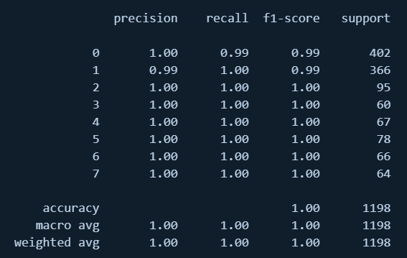

**Figure 6.1** Confusion Matrix of the HGR model

Figure 6.1 illustrates the confusion matrix generated by the HGR model, which shows the performance in terms of accuracy, precision, recall and f1-score for all the gestures. The concise set of gestures used has been a major help with the performance of the model. Increasing the class size would however not be of much issue for the required use cases as the underlying random forest classifier can accommodate a large set of classes and provide accurate classifications.

**6.3 GAMIFIED LEARNING EXPERIENCE**

To investigate whether the platform had a positive impact on student's learning rate, the amount of work done by students after completing each assignment was measured. The gamification factor here is the effort a student is willing to put after completion of a single assignment. A survey asking about the students’ experience with the conventional method of learning and with the gamified method of learning was taken. This evaluation was done using a set of metrics which are crucial to making any educational platform successful in terms of knowledge transfer as well as student satisfaction. The main metric of evaluation focused in the proposed EduGest application is interactiveness, which is achieved through the implementation of the hand gesture navigation. The other specified metrics are standard to evaluating any educational platform, which can help further develop existing methods in education 4.0 for students, further improving education 4.0. Table 6.2 depicts the set of major evaluation metrics used to evaluate the application along with their description. These metrics are standard for evaluating EduGest alone. Hence, more metrics can be added further depending upon the novel innovation of knowledge transfer to that application.

**Table 6.2** Conventional vs Gamified learning evaluation metrics

|  |  |  |
| --- | --- | --- |
| S.No | Evaluation  Metrics | Description |
| 1 | Engagement | Level of student involvement and interest in the learning process |
| 2 | Retention | Ability of students to remember and apply learned concepts over time |
| 3 | Progression | Measurement of students' advancement and achievement of learning goals |
| 4 | Motivation | Degree to which students are encouraged to participate and learn |

The result of the survey as shown in figure 6.2 serves as proof of how a gamified approach to learning can pose various advantages in the specified aspects. Compared to the conventional approach, users find the gamified approach to be more engaging with features like interactive map and speech-to-text chat-like translation interface. Moreover, the hand gesture interaction makes students engage with the platform more, improving their focus with the application. Fundamental to the success of gamified learning is its inherent capacity to motivate students. Inclusion of gamification components like points, leaderboard and progress tracking motivates the students to learn better and complete the course. Furthermore, as EduGest implements a ‘Hands On’ learning, retention of the content is not a challenging task, especially with the interactive features of the application. Other similar evaluation metrics could be used to bring in more improvements in such platforms. For example, adaptability can be studied to understand how the platform is able to adapt content with respect to its users and the content being delivered.

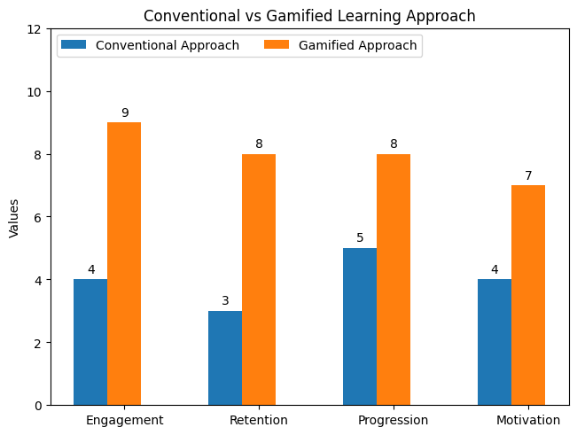

**Figure 6.2** Comparison of Conventional and Gamified Learning metrics

Though the data derived shows the success of the proposed knowledge transfer model elaborated by the EduGest application, this only applies to the presented content in the platform. The metric values may vary depending on the type of course, delivery style and other factors. However, EduGest emphasizes more on the method of content delivery, in this case, using hand gestures. Existing studies have proven the vast benefits of including technologies like HCI, Virtual Reality, Augmented Reality etc. Therefore, these metrics suit the current interest of improving education 4.0 using technology. Adding on more evaluation metrics would help customize educational platforms for more personalized necessities.

**6.4 SUMMARY**

The obtained results of the HGR model depict the excelling performance of being able to recognize the set of hand gestures. More gestures can also be added depending on the use cases of the platform and navigation requirements. The overall success of the gamification of EduGest can also be viewed through the survey using the evaluation metrics. This stands as a testimony to gamification having more benefits compared to the conventional method of learning. However, this evaluation wouldn’t be possible without the applications from conventional learning methods that help in understanding the areas that currently can be improved. These strategies could also be implemented in most traditional education, either with the inclusion of technology or gamification.

**CHAPTER 7**

**CONCLUSION AND FUTURE WORK**

**7.1 CONCLUSION**

The development of this platform will provide proof for how gamification has various benefits in multiple fields of education and how it successfully enables knowledge transfer in a more student-engaged manner. It will also provide strong evidence for gamification's potential to revolutionize education across disciplines. By fostering a fun and engaging environment, it demonstrably improves knowledge retention. The hand gesture interactive education platform represents a novel approach to teaching Tamil heritage and culture while leveraging technology and gamification to enhance student engagement and learning outcomes also it serves as a powerful testament to successfully leverage technology and gamification to make learning Tamil heritage and culture a truly immersive experience. During testing, it was found that the hand recognition model was performing exceptionally well, with high success rates and minimal errors. The model’s ability to interpret user inputs and provide seamless dynamic interaction proves the student's ease of usage in real-time. Furthermore, the students found the language translation model and map as an interesting feature of the learning website, especially those interested in the history of Tamil, who found the map feature to be very reliable. Overall, the hand-free experience, with its exceptional efficiency and accuracy, represents a significant leap in education 4.0. The exceptional performance of the hand recognition model and student satisfaction highlight the platform's potential for widespread adoption in Education 4.0, paving the way for more interactive and engaging learning experiences.

**7.2 FUTURE WORK**

The system could be further optimized in the gamification area by incorporating machine learning models that will dynamically provide assignments, personalize the learning journey, and tailor difficulty. By doing so, we can better evaluate a student’s progress and award them accordingly. This would allow for more granular assessment and a more rewarding experience. The system could also be developed in the virtual reality domain to have a more immersive learning and cultural experience. Furthermore, we can include various other learning courses, such as Data Structures and Algorithms, Operating Systems, or any subject related to this matter. To improve the accuracy of the hand gestures, we can bring the field of IoT into the system. This can help people with disabilities experience learning with ease. This would solidify the platform's position as a versatile and leading-edge tool for Education 4.0.

**REFERENCES**

* 1. A. A. Tori, R. Tori and F. d. L. d. S. Nunes (2022) "Serious Game Design in Health Education: A Systematic Review," in IEEE Transactions on Learning Technologies, vol. 15, no. 6, pp. 827-846, doi: 10.1109/TLT.2022.3200583.
  2. A. Carfì and F. Mastrogiovanni (2023) "Gesture-Based Human–Machine Interaction: Taxonomy, Problem Definition, and Analysis," in IEEE Transactions on Cybernetics, vol. 53, no. 1, pp. 497-513, doi: 10.1109/TCYB.2021.3129119.
  3. A. de Souza Vieira, M. Ribeiro Filho and C. de Salles Soares Neto (2021) "Production and Evaluation of an Educational Process for Human–Computer Interaction (HCI) Courses," in IEEE Transactions on Education, vol. 64, no. 2, pp. 172-179, doi: 10.1109/TE.2020.3024936.
  4. A. H. Nabizadeh, D. Gonçalves, S. Gama and J. Jorge (2022) "Early Prediction of Students’ Final Grades in a Gamified Course," in IEEE Transactions on Learning Technologies, vol. 15, no. 3, pp. 311-325, doi: 10.1109/TLT.2022.3170494.
  5. Chang, Victor & Eniola, Rahman & Golightly, Lewis & Xu, Qianwen. (2023). An Exploration into Human–Computer Interaction: Hand Gesture Recognition Management in a Challenging Environment. SN Computer Science. 4. 10.1007/s42979-023-01751-y.
  6. É. Lavoué, B. Monterrat, M. Desmarais and S. George (2019) "Adaptive Gamification for Learning Environments," in IEEE Transactions on Learning Technologies, vol. 12, no. 1, pp. 16-28, doi: 10.1109/TLT.2018.2823710.
  7. Eslam Nofal, Georgia Panagiotidou, Rabee M. Reffat, Hendrik Hameeuw, Vanessa Boschloos, and Andrew Vande Moere. (2020) “Situated Tangible Gamification of Heritage for Supporting Collaborative Learning of Young Museum Visitors. J. Comput. Cult. Herit.” 13, 1, Article 3, 24 pages. doi: 10.1145/3350427
  8. Goldberg, P., Sümer, Ö., Stürmer, K. et al. (2021) “Attentive or Not? Toward a Machine Learning Approach to Assessing Students’ Visible Engagement in Classroom Instruction. Educ Psychol Rev 33, 27–49, doi:10.1007/s10648-019-09514-z
  9. K. -Y. Fung, L. -H. Lee, P. Hui and S. Song (2024) "Can Underprivileged Children Learn Effectively at Home? A Six-Month Study of Game-Based Traditional Chinese Learning During the Pandemic Lockdown," in IEEE Transactions on Learning Technologies, vol. 17, pp. 294-309, doi: 10.1109/TLT.2023.3255882.
  10. Khan, Imran & Melro, Ana & Amaro, Ana Carla & Oliveira, Lidia. (2021). “Role of Gamification in Cultural Heritage Dissemination: A Systematic Review” 10.1007/978-981-16-2377-6_37.
  11. L. Guo, Z. Lu and L. Yao (2021) "Human-Machine Interaction Sensing Technology Based on Hand Gesture Recognition: A Review," in IEEE Transactions on Human-Machine Systems, vol. 51, no. 4, pp. 300-309, doi: 10.1109/THMS.2021.3086003.
  12. Manzano-León A, Camacho-Lazarraga P, Guerrero MA, Guerrero-Puerta L, Aguilar-Parra JM, Trigueros R, Alias A. (2021) “Between Level Up and Game Over: A Systematic Literature Review of Gamification in Education.” Sustainability. 13(4):2247, doi: 10.3390/su13042247
  13. Moseikina, M., Toktamysov, S., & Danshina, S. (2022). “Modern Technologies and Gamification in Historical Education.” Simulation & Gaming, 53(2), 135-156. doi: 10.1177/10468781221075965
  14. Nikolova, Alexandra & Georgiev, Vladimir. (2022). “A Comparative Analysis of Tools for Presenting Cultural-historic Resources in Education”. TEM Journal. 11. 1180-1184. 10.18421/TEM113-24.
  15. Sagayam, Martin & Andrushia, A. & Ghosh, Ahona & Deperlioglu, Omer & Sagayam, Martin & Elngar, Ahmed. (2021). “Recognition of Hand Gesture Image Using Deep Convolutional Neural Network.” International Journal of Image and Graphics. 12. 2140008. 10.1142/S0219467821400088.
  16. S. Martin, E. Lopez-Martin, A. Moreno-Pulido, R. Meier and M. Castro (2021) "The Future of Educational Technologies for Engineering Education," in IEEE Transactions on Learning Technologies, vol. 14, no. 5, pp. 613-623, doi: 10.1109/TLT.2021.3120771.
  17. S. S. Aldosari, B. Ghita, and D. Marocco (2022) “A Gesture-Based Educational System that Integrates Simulation and Molecular Visualization to Teach Chemistry”, Int. J. Emerg. Technol. Learn., vol. 17, no. 04, pp. pp. 194–211.
  18. T. Bohné, I. Heine, F. Mueller, P. -D. J. Zuercher and V. M. Eger (2023) "Gamification Intensity in Web-Based Virtual Training Environments and Its Effect on Learning," in IEEE Transactions on Learning Technologies, vol. 16, no. 5, pp. 603-618, doi: 10.1109/TLT.2022.3208936.
  19. X. Deng et al. (2021) "Hand Pose Understanding With Large-Scale Photo-Realistic Rendering Dataset," in IEEE Transactions on Image Processing, vol. 30, pp. 4275-4290, doi: 10.1109/TIP.2021.3070439