**Service : ok**

* File uploaded while creating a service, but the file is not found.
* The end date can be given before the start date.

**Supplier :**

* Preaddress has two times repetition. One is previous address another one is permanent address. In case the previous address is the same as the permanent address, a tick button can be provided to copy the previous address and provide it to the permanent address field.
* Test email can be provided without @gmail.com format
* In mobile/NID/E-TIN field, letters can also be given
* The end date can be given before the start date.

**General Entry :**

* When a general entry is created, the text field makes error is the text character is long. A character limit or a message can be given.
* The end date can be given before the start date. [–NotFOUND]

**Fund Collection > Create Fund :**While creating fund, the collection date has to be after the tentative date given for collecting fund.

**Expenses / Receive/ Advance :**

Print button needs to be fixed.

**Agenda :**

* File does not get added.
* Error while inviting other admins to discussion.

**Resolution/Status :**

* Due date can be given before start date.
* Letters can be given in “Point no” field.
* Error while creating resolution status (error while saving or printing a resolution status as well)

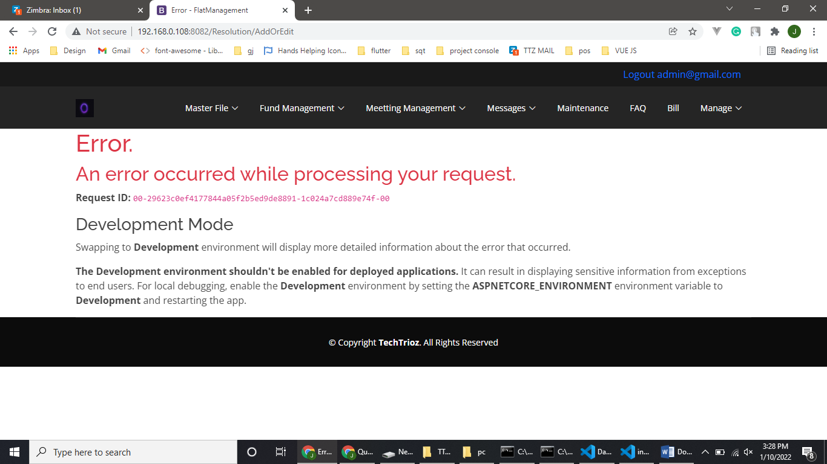

**SMS/Messaging :**

No SMS sent through the “SMS” button.