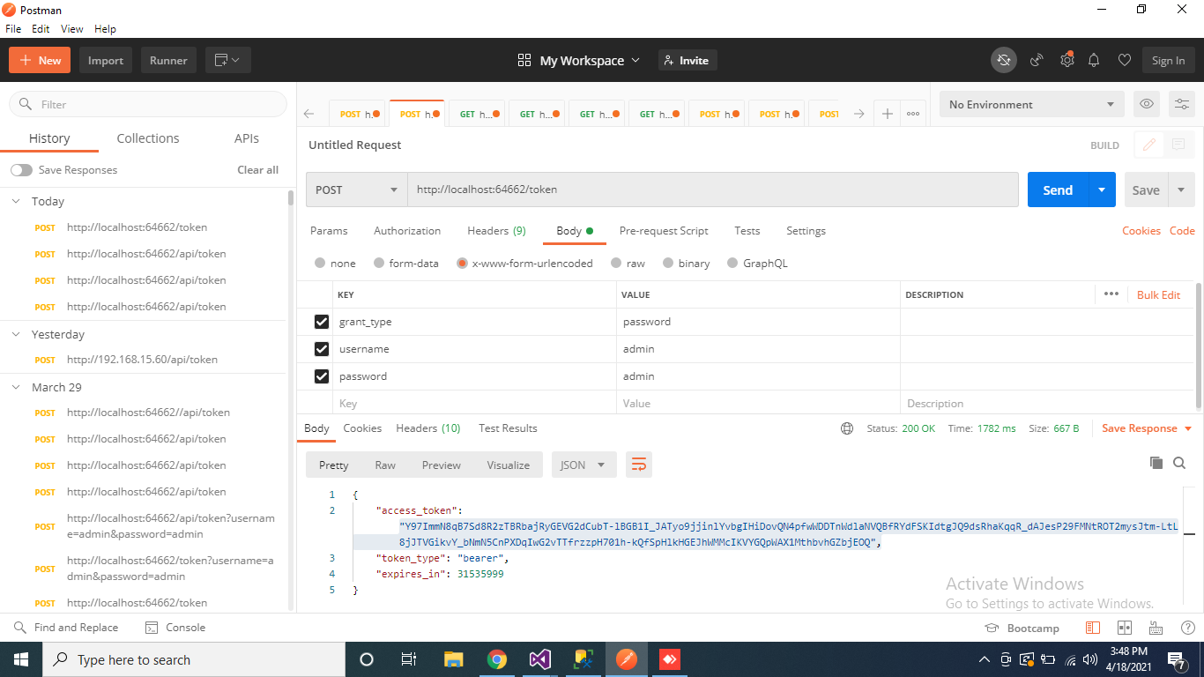

<http://localhost:64662/api/attendance/ResetPassword>

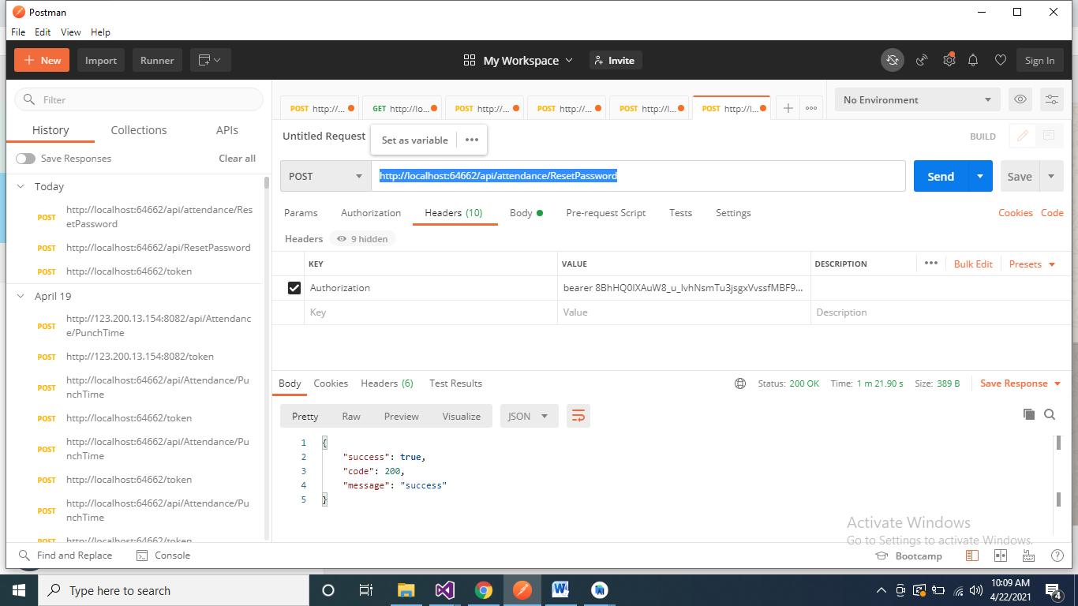

Authorization and in value field bearer token value

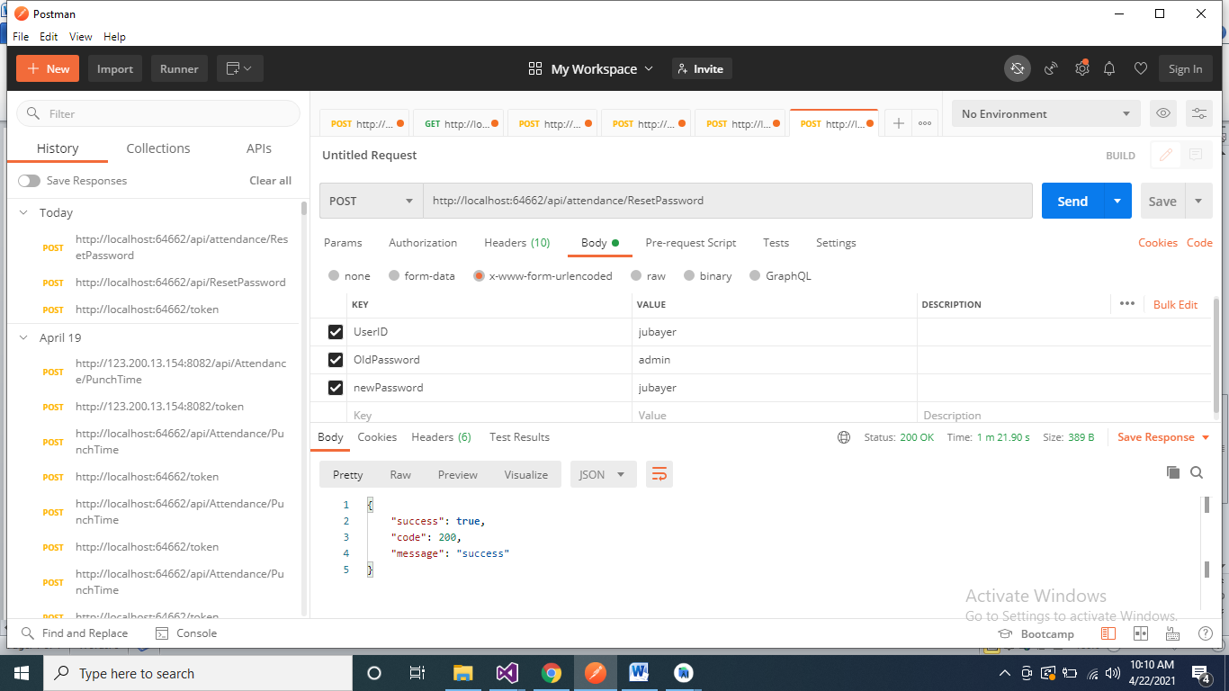

In body section select x-www-form-urlencoded

Then give parameters