MethodMark: An AI-Powered Mathematics Assessment Platform
Toh Jun Sheng
Yoheshvaran
Yash Rayapaty
Denzyl Chua De Han
Harsha Saraf
Gautham Krishna Manoj

Team 2
College of Computing and Data Science, Nanyang Technological University
Submitted to
Ajith Santhisenan
Project Advisor / Sponsor, College of Computing and Data Science, Nanyang Technological University
3 September 2026

Table of Contents
Table of Contents 2
Executive Summary 3
Statement of Problem 4
Objectives 5
Technical Approach 5
Customer Needs 5
Target Specifications 6
Technology Consideration 6
System Architecture/Platform 7
Project Management 8
Deliverables 9
Budget 10
Communication and Coordination with Sponsor 10
Special Topics 10
Team Qualifications 11
References 11
Appendix A: Résumés of Team Members 12

Executive Summary
MethodMark is a web-based AI-assisted mathematics assessment system for secondary mathematics tutors. It is designed to reduce the time tutors spend preparing practice papers, marking handwritten solutions, and tracking student progress. Tutors can generate syllabus-aligned practice papers together with solutions and marking rubrics. Students can then access the practice papers through a link and upload photographs of their handwritten solutions without creating an account.
The system will use AI to analyse each submission, mark the student's working based on the approved rubric, and generate concise feedback. Tutors will review and approve all marks and feedback before the results are released to students. These results will also be used to generate analytics such as submission status, class performance, common mistakes, and individual learning gaps.
Project development will cover requirements analysis, system design, implementation, testing, and refinement of the main features, including practice paper generation, AI-assisted marking, and performance analytics. MethodMark will focus only on secondary-level mathematics. The final deliverables will include a working prototype, source code, test documentation, technical documentation, and user guides.

Statement of Problem
Tutors often spend a significant amount of time preparing practice papers for students and marking their work. Online quiz platforms work well for questions with fixed answers, such as multiple-choice questions and numerical responses. However, mathematics questions often require students to show their reasoning and working steps. Even when the final answer is incorrect, students may still receive partial marks for using the correct method. For this reason, students often complete mathematics questions on paper, where they can clearly show their calculations and workings. When submitting their work online, students usually have to upload photographs of their handwritten solutions. Tutors must then go through these images individually to review and mark the students' work. They may also need to interpret unclear handwriting or low-quality images, making the marking process more time-consuming.
Singapore's secondary mathematics curriculum emphasises not only correct answers, but also mathematical concepts, skills, processes, metacognition, and attitudes [1]. Research on formative assessment shows that information about student learning can support learning when it is used as feedback to adjust teaching and learning activities [2]. Therefore, an effective mathematics assessment system should evaluate students' methods, apply the tutor's marking rubric, provide concise explanations of errors, and identify common learning difficulties to guide future lessons.
Beyond marking individual submissions, tutors also need to understand and track how students improve over time. This requires them to review multiple questions and assessments to identify repeated mistakes or areas of weakness. If these results are stored manually or across different files, it can be difficult and time-consuming to monitor each student's progress. Therefore, there is a need for an efficient assessment system that reduces manual effort and repetitive administrative work while helping tutors monitor student progress. Artificial Intelligence (AI) can assist with generating practice papers and marking students' work, while data analytics can help identify learning gaps and recurring mistakes over time. Together, these components can make the assessment process more efficient and provide tutors with a clearer understanding of each student's performance.

Objectives
This document proposes the design of MethodMark, an AI-assisted mathematics assessment system for tutors. The system has four main design objectives:
(1) Generate syllabus aligned mathematics practice papers with marking rubrics that separate method marks from accuracy marks.
(2) Allow students to submit photographs of handwritten solutions through a shared link without creating an account.
(3) Use AI to mark submissions according to predefined rubrics, generate concise feedback, and require tutor approval before results are released.
(4) Provide analytics on submission status, class performance, common mistakes, and individual learning gaps.
The first objective is to reduce the time tutors spend preparing practice papers. MethodMark will generate questions based on selected syllabus topics and create the marking rubric at the same time. The rubric will define the expected method, intermediate steps, and final answer so that method marks can still be awarded when the final answer is incorrect.
The second objective is to make submission simple and convenient for students. Students can access the practice paper through a shared link and upload photographs of their handwritten solutions. No student account is required. This also reduces the need for tutors to manually collect handwritten submissions.
The third objective is to reduce the time tutors spend marking while keeping them in control of the final grade. The AI will mark each question using the predefined rubric and generate brief feedback. Unclear or low-confidence cases will be flagged for review, and results will only be released after tutor approval.
The fourth objective is to turn approved grades into useful analytics and insights. Tutors can view submission status, class performance, common mistakes, and individual learning gaps. This allows tutors to monitor students' progress and provide personalised feedback.
MethodMark is scoped to secondary-level mathematics because its marking approach focuses on mathematical workings, method marks, and accuracy marks. Other subjects, education levels, learning management system integration, parent accounts, payment features, native mobile applications, and offline use are outside the project scope. The system will also include appropriate controls for data privacy, data storage, and data retention.

Technical Approach
MethodMark will be developed by first identifying the needs of mathematics tutors and students, then translating these needs into clear system specifications. The required technologies will then be considered, followed by the proposed system architecture and platform. This approach ensures that the proposed solution is aligned with user needs and the project objectives.

Customer Needs
The primary customers of MethodMark are mathematics tutors who create practice papers, collect student submissions, mark handwritten solutions, and monitor student progress. Their main needs are to reduce the time spent preparing practice materials and marking student work. Students also need a simple way to access practice papers and submit their handwritten solutions without creating an account.
These needs were identified through interviews, surveys, and feedback from tutors and students. The team's personal tutoring experience also helped identify the pain points and challenges in preparing practice materials, collecting student submissions, and marking student work.

Target Specifications
Based on the identified customer needs, MethodMark will include several key system specifications. AI-generated mathematics questions and marking rubrics will help reduce the time tutors spend preparing practice papers. Students will be able to access practice papers and submit photographs of handwritten solutions through a unique link without creating an account, making the submission process simple and convenient.
The system will use AI to evaluate student workings according to predefined marking rubrics and generate concise feedback, reducing the tutor's manual marking effort. Tutors will review and approve the results before they are released to ensure that they remain in control of the final marks. Approved results will also be used to track submission status, class performance, common mistakes, and individual learning gaps, allowing tutors to monitor student progress more effectively.

Technology Consideration
MethodMark will be developed as a web application using React for the frontend and FastAPI for the backend. Supabase will provide a PostgreSQL database for storing system data and a storage bucket for uploaded handwritten solutions. A large language model will be used to generate mathematics questions, marking rubrics, and concise feedback, while a vision-language model will analyse handwritten solutions and assist with marking. Git and GitHub will be used for version control and source-code management, while Vite will support frontend development and build processes. Table 1 lists the technologies used in the development of MethodMark.
Table 1: Technology Stack for MethodMark
Layer | Technology | Purpose
Frontend | React | Build the tutor dashboard and student assignment interface
Backend | FastAPI | Handle application logic, API requests, submissions, and AI integration
Database | Supabase PostgreSQL | Store users, assignments, questions, rubrics, marks, and analytics data
Storage | Supabase Storage | Store uploaded images of handwritten student solutions
AI Services | Large Language Model (LLM) | Generate questions, marking rubrics, and concise feedback
AI Services | Vision-Language Model (VLM) | Analyse handwritten mathematical solutions and assist with rubric-based marking
Development Tool | Git / GitHub | Version control and source-code management
Development Tool | Vite | Provides the frontend development server and build tooling for the React application

System Architecture/Platform
The proposed architecture, shown in Figure 1, is organised into four layers: Users, Frontend, Backend/Application, and Data & AI services, so that the AI grading logic and the analytics logic can each be developed, tested, and iterated on independently of the interfaces built on top of them. This separation follows directly from the two user groups identified earlier: tutors need control over rubrics and final grades, while students need a lightweight, account-free way to submit work, and neither need should be entangled with how the AI pipeline itself is implemented.
At the frontend layer, a single React web application serves two purpose-built views: a Tutor Dashboard for creating assignments and rubrics, and a Student Assignment Interface for submitting handwritten work via a shared link, consistent with the "no student account required" objective. A separate Analytics Dashboard gives tutors access to longitudinal performance data once it has been processed.
The backend/application layer is fronted by a single FastAPI service that orchestrates three pipelines: the Practice Paper Generation Pipeline (creates questions and rubrics), the Grading Pipeline (scores submissions against the rubric), and Analytics Processing (aggregates approved scores into trends). Critically, every grade produced by the Grading Pipeline passes through a Tutor Review step before it reaches a student or feeds into analytics — this is where the human-in-the-loop requirement from the Objectives section is enforced architecturally, rather than left as a policy to be followed.
The data & AI services layer separates persistence from intelligence. Supabase PostgreSQL and Supabase Storage hold rubrics, submissions, scores, and history; a vision-language model (VLM) reads the uploaded photographs of handwritten solutions and converts them into a form the grading logic can evaluate; and a large language model (LLM) both generates questions/rubrics and produces the rubric-aligned score and feedback during grading. Keeping the VLM and LLM as distinct services (rather than one model doing both handwriting interpretation and grading judgment) makes it possible to swap or recalibrate either one without touching the other.
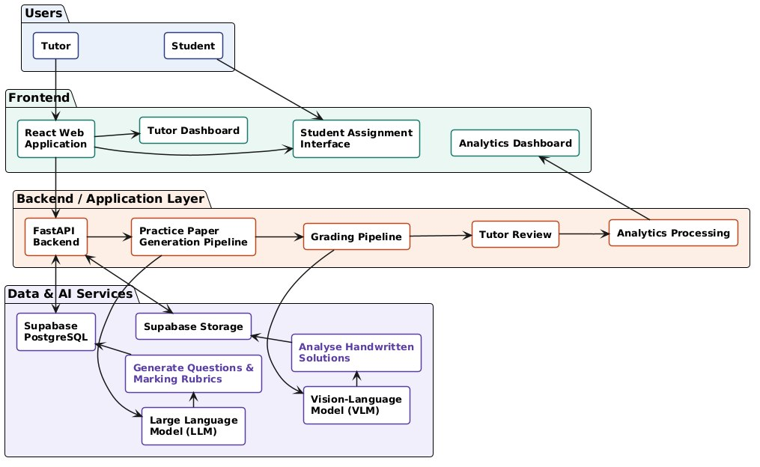
Figure 1: Proposed System Architecture

Project Management
MethodMark will be developed from 21 August 2026 to 29 October 2026, following the schedule shown in Figure 2. Development will progress from requirements and quality planning to prototyping, implementation, configuration management, testing, and final presentation. Some activities will overlap to allow the prototype to be refined throughout the project.
Tasks will be assigned according to each team member's project role. GitHub will be used for source-code and documentation management, while the backlog and meeting minutes will be updated throughout each laboratory session.
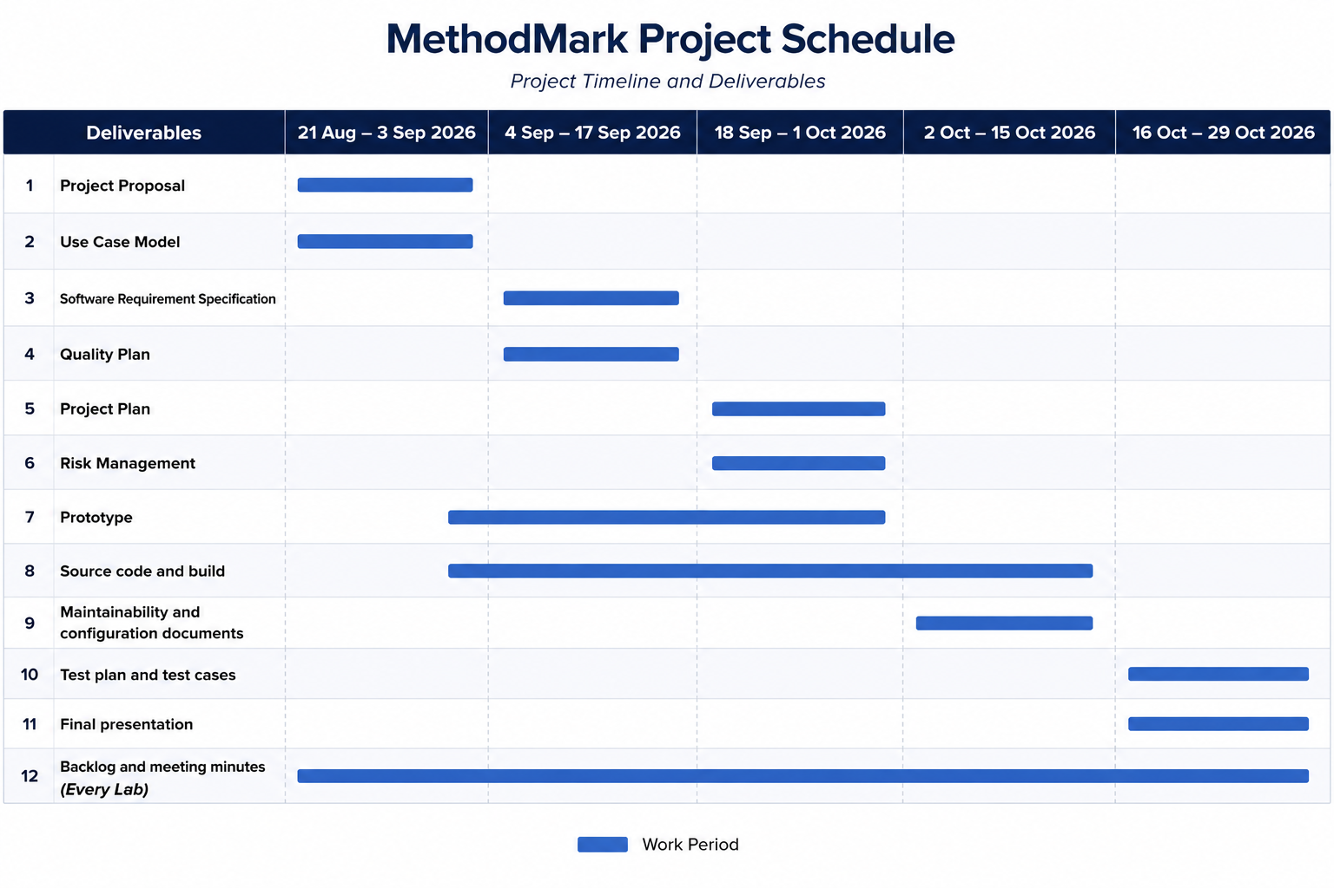
Figure 2: Gantt chart for the project. The solid bars indicate the portions of the tasks that we have accomplished.

Deliverables
Table 2: Project Deliverables
Deliverable | Description | Expected Completion
Project Proposal | This document | 3 Sep 2026
Use Case Model | Use case diagram and a written description of each use case | 3 Sep 2026
Software Requirement Specification | Functional and non-functional requirements, each verifiable and traceable | 17 Sep 2026
Quality Plan | Quality model, review procedure, entry and exit criteria, defect classification | 17 Sep 2026
Project Plan | Define work breakdown, project scheduling and resource allocation | 1 Oct 2026
Risk Management | Identifies possible risks during the project development and strategies to manage risks | 1 Oct 2026
Prototype | Working system with front end and back end, demonstrated live | 1 Oct 2026
Source Code and Build | Code, database schema, seed data, CI pipeline, README and API documentation | 15 Oct 2026
Maintainability and Configuration Documents | Design report on maintainability, configuration, change and release plans | 15 Oct 2026
Test Plan and Test Cases | Test procedures with inputs, steps and expected results; coverage report | 29 Oct 2026
Final Presentation | Slides covering the project, each laboratory, achievements and issues | 29 Oct 2026
Backlog and Meeting Minutes | One backlog and at least two sets of minutes per laboratory, with Trello captures | Every Lab

Budget
The estimated simulated budget for MethodMark is S$46,000. The majority of the budget is allocated to project manpower and development laptops, while the remaining costs cover AI API credits, application hosting, database services, office rental and transportation. These resources are expected to support the development, testing and deployment of the proposed system.
Table 3: Requested Items and Funds for Initial Design
Item | Supplier | Quantity | Unit Price | Total
Project manager | — | 1 | $10,000.00 | $10,000.00
Project team members | — | 5 | $3,000.00 | $15,000.00
Development laptop | Apple | 6 | $1,000.00 | $6,000.00
AI API credits | OpenAI | 1 | $2,000.00 | $2,000.00
Application hosting | Vercel | 1 | $2,000.00 | $2,000.00
Database | Supabase | 1 | $5,000.00 | $5,000.00
Office rental | NTU | 1 | $6,000.00 | $6,000.00
 |  |  | TOTAL | $46,000.00

Communication and Coordination with Sponsor
The project manager will be the main contact for the course sponsor throughout the development of MethodMark. Progress updates will be provided every two weeks through email or online meetings, depending on the type of discussion required. The team will be responsible for preparing progress updates, raising issues, and presenting completed work, while the sponsor will provide feedback, clarification, and approval when required.
Project updates will include the current development progress, completed tasks, upcoming work, and any issues that require attention. Routine updates will be provided for information, while matters involving changes to requirements, project scope, or major design decisions will require a response or approval from the sponsor. Additional meetings may be arranged when further clarification or discussion is needed.

Special Topics
MethodMark may involve confidential information, including student submissions, assessment results, and project-related data provided by the sponsor. Such information will only be used for project development and evaluation and will be stored securely with access limited to authorised team members. Confidential information will not be shared with external parties without approval.
No equipment is expected to be loaned by the sponsor for this project. If any equipment or materials are provided during the project, the team will be responsible for their proper use, safekeeping, and return upon project completion.

Team Qualifications
The qualifications and relevant experience of each team member are summarised in Table 4, with one-page résumés provided in Appendix A.
Table 4: Team Members' Qualifications
Name | Role | Experience
Yash Rayapaty | Project Manager | Experience in project planning, task coordination, progress tracking, and managing overall project delivery.
Toh Jun Sheng | Lead Developer | Strong background in software development and system design, with responsibility for technical decisions, integration, and technical delivery.
Yoheshvaran | Front-end Developer | Skilled in web application development and user interface design, including frontend implementation, documentation, and testing.
Yash Rayapaty, Harsha Saraf | Back-end Developer | Knowledgeable in server-side development, APIs, application logic, and database programming, with involvement in documentation and testing.
Denzyl Chua De Han | QA Manager | Familiar with software quality assurance, test planning, and ensuring that development processes meet project requirements.
Harsha Saraf | QA Engineer | Capable of preparing test cases, conducting functional and integration testing, identifying defects, and documenting test results.
Gautham Krishna Manoj | Release Engineer / Manager | Proficient in version control, software integration, build management, and preparing product or prototype releases for delivery.

References
[1] Ministry of Education Singapore. Mathematics Syllabuses: Secondary One to Four, Express Course and Normal (Academic) Course. Curriculum Planning and Development Division, 2023.
[2] Black, P., and Wiliam, D. Assessment and Classroom Learning. Assessment in Education: Principles, Policy & Practice, 5(1), 7–74, 1998. https://doi.org/10.1080/0969595980050102

Appendix A: Résumés of Team Members
The following pages present one-page résumés of the team members for this project.

