1. Red-Black Tree is a self-balancing Binary Search Tree have every node has a color either red or black which.
- Root of tree is always black.
- There are no two adjacent red nodes
- Every path from a node (including root) to any of its descendant NULL node has the same number of black nodes.
2.

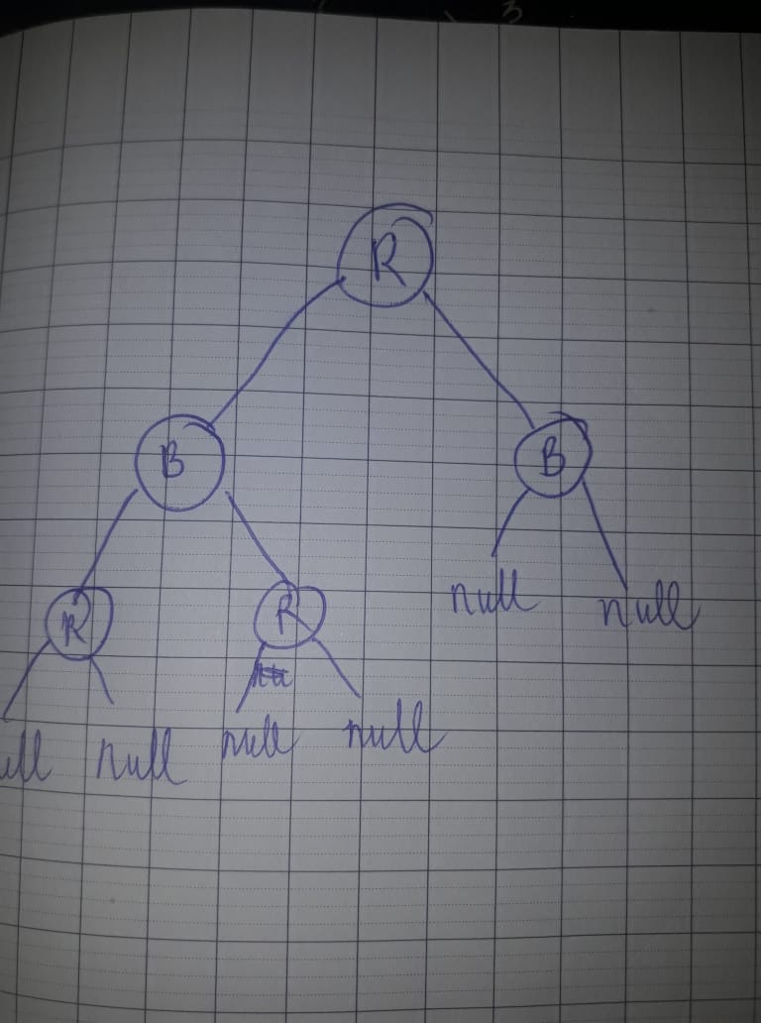
Root is red

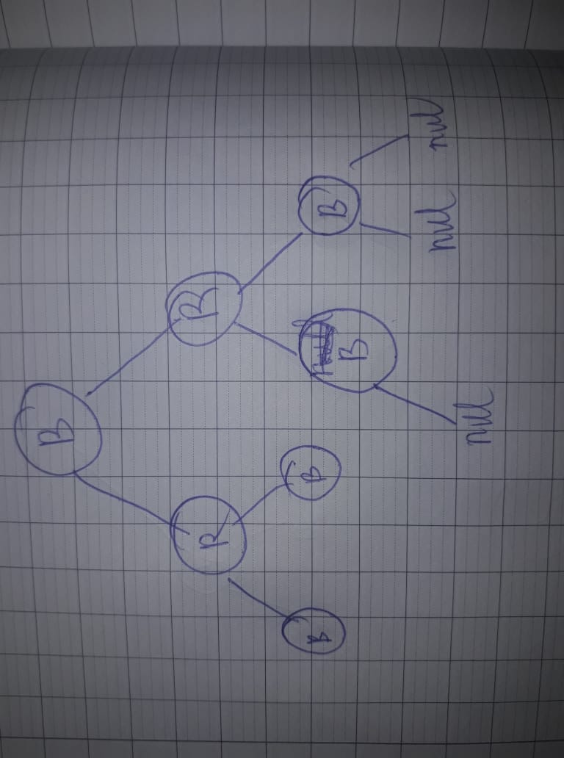

have paths do not end by a NULL

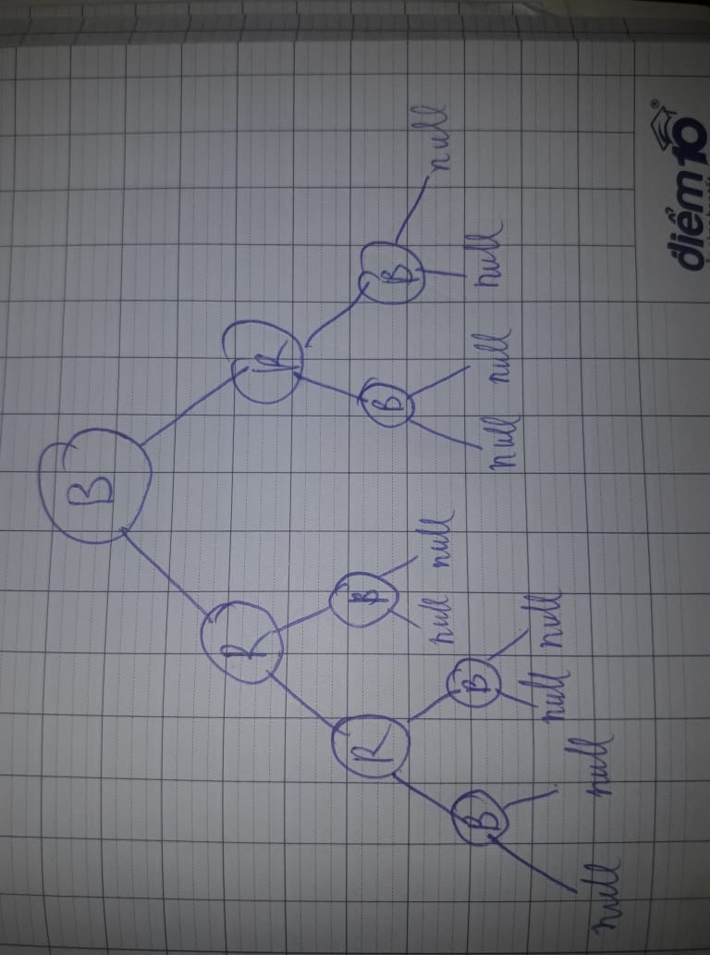

two red nodes are adjecting

3.

case 1: no because paths from root to null nodes are not having same black node
case 2: yes
case 3: no with same reason like case 1
case 4: no because having two red adjacent
case 5: yes

4.
BH[7]=2; BH[2]=0; BH[18]=1; BH[10]=0;
BH[22]=0; BH[8]=0; BH[11]=0; BH[26]=0;

5.
yes because it dont violate any thing in defination.

