1.

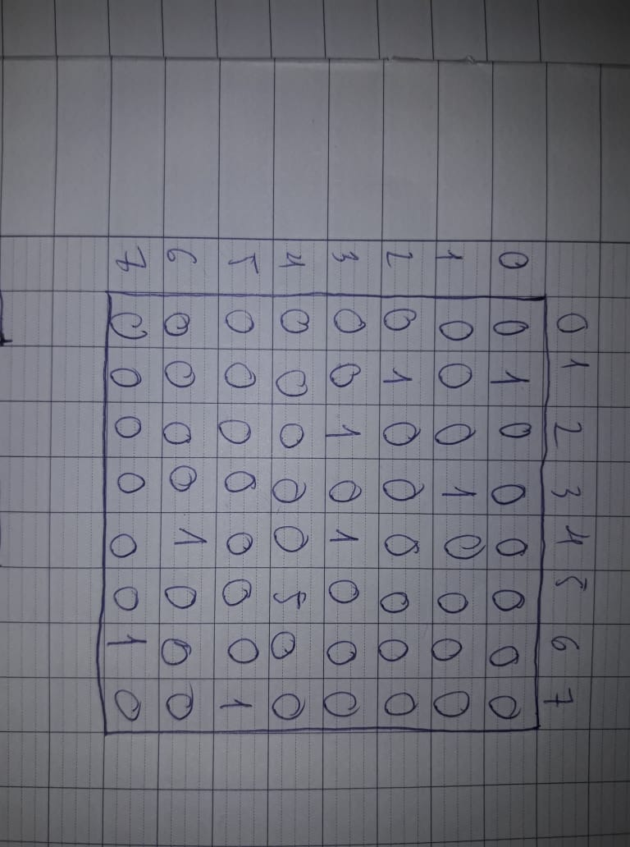
a.

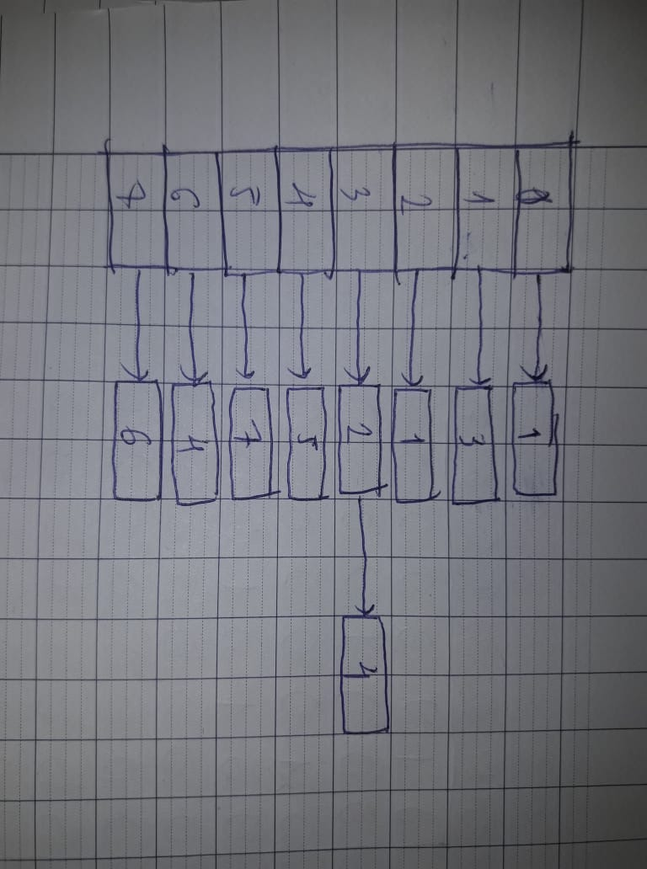
b.

2.
To compute for the Out-degree of every vertex, O(E+V) with E is number of edges, V is number of vertices.
To compute for the In-Degree of every vertex, O(E+V) with E is number of edges, V is number of vertices.
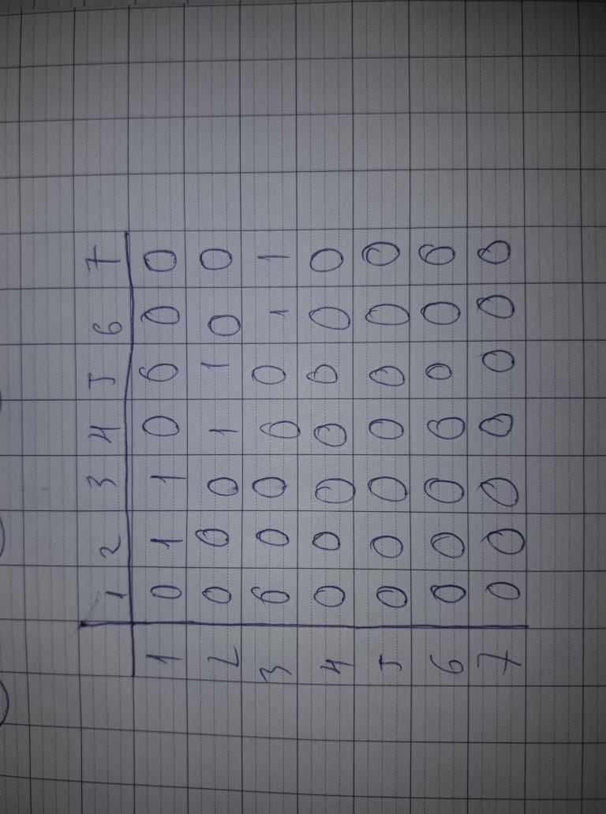
3.

4.
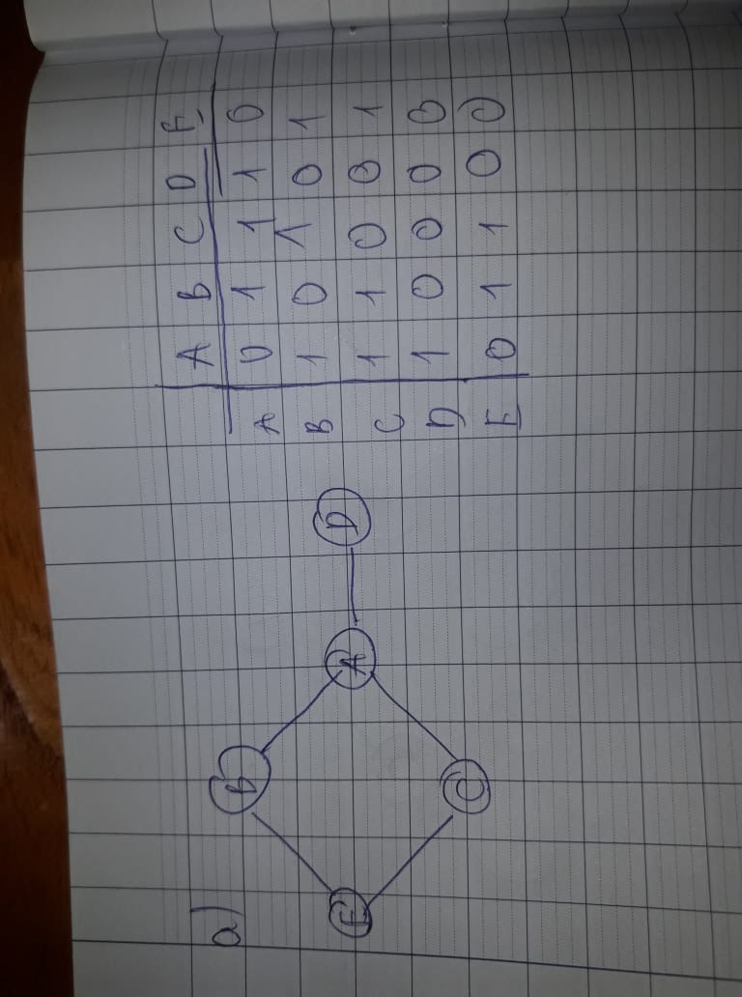
a.

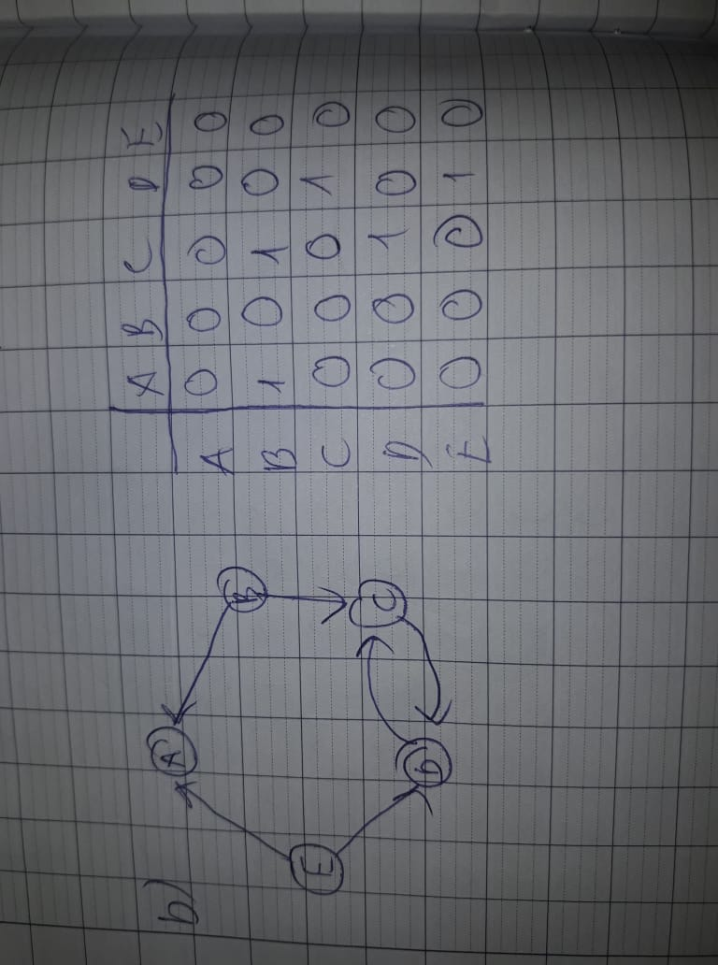
b.

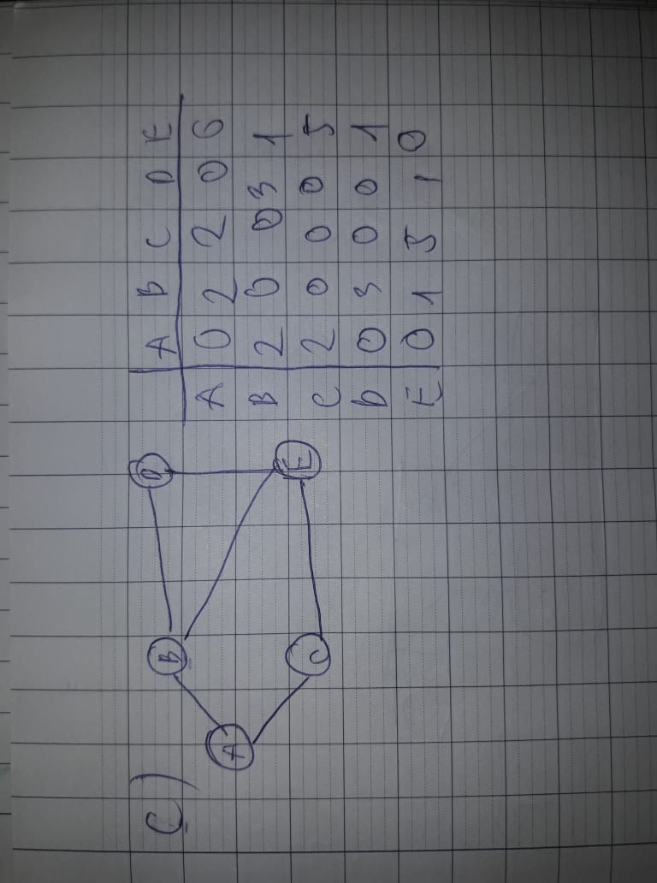
c.

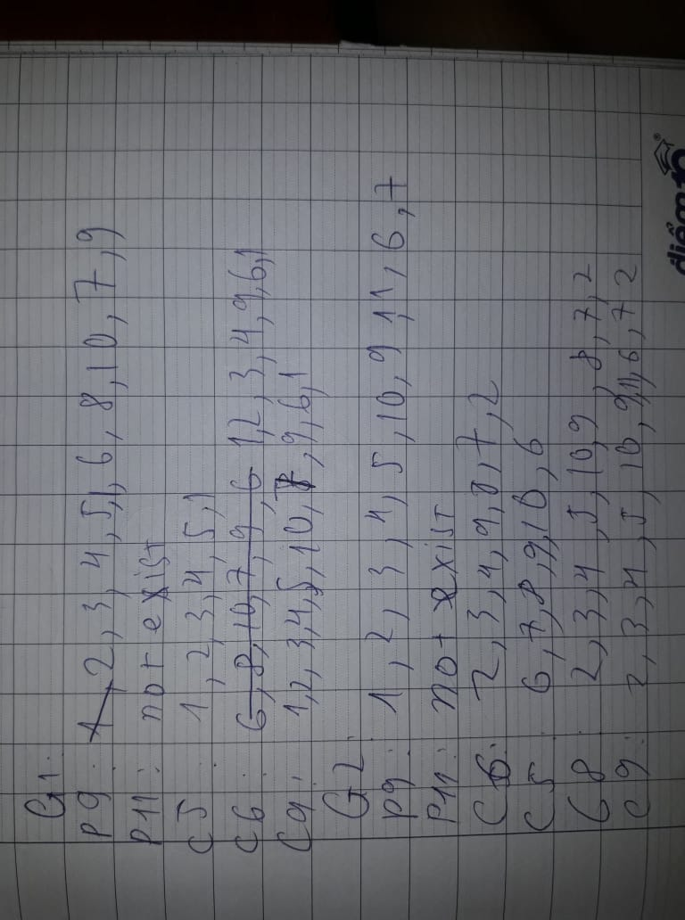
5.

6.
1) There are 2 connected component
- abdefgij
- ch
2) There are 3 connected component
- abdeghmj
- cfki
- l
7. Graph 4
8. Graph 3,4,5
9.
- 7
- 5

