1.
0 7 1
0 4 5
1 4 5
1 2 5
2 5 3
2 6 6
3 6 2
3 10 4
10 13 4
12 13 1
13 16 1
9 10 5
12 15 6
14 15 1
11 14 2
8 11 6
13 17 7

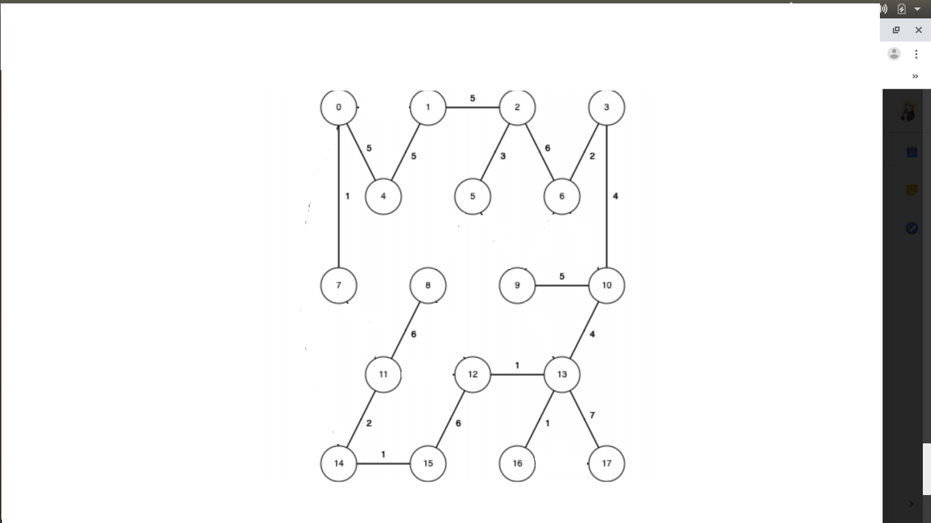

4.
no. because it will be trapped in a negative loop which can not have shortest path.
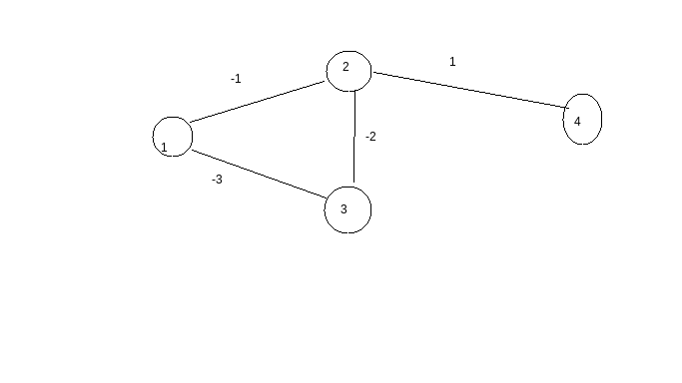

2.

0 4 5
0 7 1
1 2 5
1 4 5
2 5 3
2 6 6
3 6 2
3 10 4
8 11 6
9 10 5
10 13 4
11 14 2
12 13 1
12 15 6
13 16 1
13 17 7
14 15 1

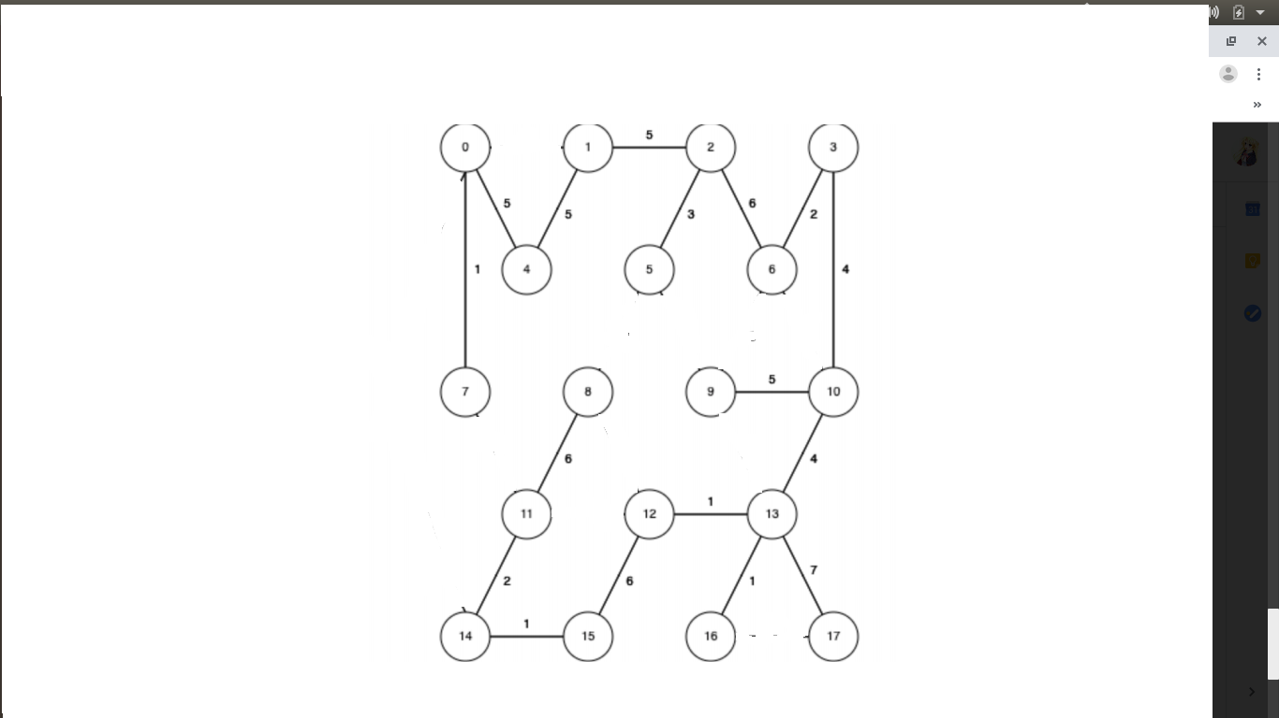
3.

to 1= 6
0→1

to 2=11
0→1→2

to 3=19
0→1→2→6→3

to 4=5
0→4

to 5=14
0→1→2→5

to 6=17
0→1→2→6

to 7=1
0→7

to 8=16
0→7→11→8

to 9=21
0→1→2→5→9

to 10=21
0→14→15→12→13→10

to 11=10
0→7→11

to 12=16
0→14→15→12

to 13=17
0→14→15→12→13

to 14=9
0→14

to 15=10
0→14→15

to 16=18
0→14→15→12→13→16

to 17=24
0→14→15→12→13→17

