# INTEGRATED PROJECT REPORT

**On**

**AUTOMOV**

Submitted in partial fulfilment of the requirement for the Course Integrated Project (CS 203) of

**COMPUTER SCIENCE AND ENGINEERING**

# B.E. Batch-2020 in

**JUNE-2023**



**Under the Guidance of Dr. Shilpi Harnal**

**Submitted By**

**Arush Gupta Roll. No. 2010991493**

**Damia Kalra**

**Roll. No. 2010991526**

**Kartikay Sharma**

**Roll. No. 2010991590**

**Gautam Narula**

**Roll. No. 2010990233**

**DEPARTMENT OF COMPUTER SCIENCE AND ENGINEERING**

**CHITKARA UNIVERSITY**

**PUNJAB**

# INTEGRATED PROJECT REPORT

**On**

**AUTOMOV**

Submitted in partial fulfilment of the requirement for the Course Integrated Project (CS 203) of

**COMPUTER SCIENCE AND ENGINEERING**

# B.E. Batch-2020 in

**JUNE-2023**



**Under the Guidance of Dr. Shilpi Harnal**

**Submitted By**

**Arush Gupta Roll. No. 2010991493**

**Damia Kalra**

**Roll. No. 2010991526**

**Kartikay Sharma**

**Roll. No. 2010991590**

**Gautam Narula**

**Roll. No. 2010990233**

**DEPARTMENT OF COMPUTER SCIENCE AND ENGINEERING**

**CHITKARA UNIVERSITY**

**PUNJAB**

# CERTIFICATE

This is to be certified that the project entitled “AUTOMOV” has been submitted for the Bachelor of Computer Science Engineering at Chitkara University, Punjab during the academic semester January 2023- May-2023 is a bonafide piece of project work carried out by Arush Gupta (2010991493), Damia Kalra (2010991526), Kartikay Sharma (2010991590) and Gautam Narula (2010991590) towards the partial fulfillment for the award of the course Integrated Project (CS 203) under the guidance of Dr. Durgesh Srivastava and supervision.

**Sign. of Project Guide** : Dr. Shilpi Harnal

# CANDIDATE’S DECLARATION

We, **Arush Gupta (2010991493), Damia Kalra (2010991526), Kartikay Sharma (2010991590) and Gautam Narula (2010991590) of Group - 3,** B.E.-2020 of the Chitkara University, Punjab hereby declare that the Integrated Project Report entitled **“AUTOMOV”** is an original work and data provided in the study is authentic to the best of our knowledge. This report has not been submitted to any other Institute for the award of any other course.

## Sign. of Sign. of

**Arush Gupta Damia Kalra**

## 2010991493 2010991526

## Sign. of Sign. of

**Kartikay Sharma Gautam Narula**

## 2010991590 2010990233

**Place: Date:**

# ACKNOWLEDGEMENT

It is our pleasure to be indebted to various people, who directly or indirectly contributed in the development of this work and who influenced my thinking, behaviour and acts during the course of study.

We express our sincere gratitude to all for providing me an opportunity to undergo Integrated Project as the part of the curriculum.

We are thankful to “Dr. Shilpi Harnal” for her support, cooperation, and motivation provided to us during the training for constant inspiration, presence and blessings.

We also extend our sincere appreciation to Dr. Shilpi Harnal who provided his valuable suggestions and precious time in accomplishing our integrated project report.

Lastly, we would like to thank the almighty and our parents for their moral support and friends with whom we shared our day-to day experience and received lots of suggestions that improve our quality of work.

**Kartikay Sharma Gautam Narula**

## 2010991590 2010990233

**Arush Gupta Damia Kalra**

## 2010991493 2010991526

**(Annexure –F)**

1. **Abstract/Keywords**

* User Experience: Emphasizing a user-centric approach, the project aims to provide a seamless and intuitive experience for users, ensuring easy setup, configuration, and interaction.
* Reliability: The project aims to ensure that the website reliable for users to use without any bugs and handling various scenarios and potential issues that may arise during the process.
* Security and Privacy: The project addresses security and privacy concerns related to email content, transmission, and storage, implementing measures to protect sensitive information.
* User Empowerment: By providing users with the ability to book their cars and test drive; the project empowers them with more control over how they access their important information.
* Home Page: The main page of a website that serves as an entry point, providing an overview and navigation options.
* Login Page: A webpage where users can authenticate themselves to gain access to restricted areas or personalized features.
* Car Models Page: A webpage displaying information about different car models, including specifications, images, and pricing.
* Dashboard Page: A personalized webpage that provides an overview of relevant information and tools, often used in applications for data analysis or management.
* Payment Gateway: A service that facilitates secure online transactions by encrypting sensitive information and authorizing payments.
* HTML: HyperText Markup Language, a standard markup language used for creating web pages and web applications.
* CSS: Cascading Style Sheets, a style sheet language used for describing the presentation of a document written in HTML.
* JavaScript: A high-level, interpreted programming language that enables interactive and dynamic behavior on websites.
* ReactJS: A JavaScript library for building user interfaces, focusing on component-based development and efficient rendering.

**Chapter 2: Introduction to the Project**

**2.1 Background**

The automotive industry has witnessed significant growth in recent years, with a multitude of car models being introduced into the market. As a result, consumers often find it challenging to make informed decisions when purchasing a car. To address this issue, the AUTOMOV website was developed to provide users with a comprehensive platform where they can access detailed information about various car models.

The AUTOMOV website aims to bridge the gap between car manufacturers, dealers, and potential buyers by offering a centralized platform for car research and exploration. By providing users with an extensive database of car models, specifications, pricing details, and user reviews, AUTOMOV intends to empower users to make informed decisions and find the perfect car that suits their needs.

**2.2 Problem Statement**

The automotive industry lacks a consolidated platform that offers comprehensive information about different car models. Potential buyers often have to visit multiple websites or physical showrooms to gather information about various car models, which can be time-consuming and overwhelming. Additionally, the lack of transparency in pricing and availability further complicates the car-buying process.

The AUTOMOV website aims to solve these problems by creating a user-friendly platform that centralizes information about car models, simplifies the research process, and provides a seamless user experience. By offering an intuitive interface, detailed car listings, and a secure payment gateway, AUTOMOV seeks to enhance the car-buying experience for users.

The main objectives of the AUTOMOV project are:

1. Develop a user-friendly website with intuitive navigation and an appealing design.
2. Create a comprehensive database of car models, including specifications, pricing, and user reviews.
3. Implement a secure login system to ensure user privacy and data protection.
4. Design a payment gateway to facilitate secure and convenient online transactions.
5. Provide a dashboard for users to manage their accounts, track purchases, and access personalized recommendations.
6. Ensure compatibility with multiple devices and browsers to reach a wider user base.
7. Conduct thorough system testing to identify and resolve any bugs or usability issues.

By achieving these objectives, the AUTOMOV website aims to revolutionize the way users research, compare, and purchase cars, making the entire process more efficient, transparent, and user-centric.

The following chapters of this project report will delve into the detailed software and hardware requirements, database analysis and design, program structure analysis, implementation details, system testing procedures, limitations, conclusion, and future scope of the AUTOMOV website.

**Chapter 3: Software and Hardware Requirement Specification**

**3.1 Methods**

The development of the AUTOMOV website involves various methodologies and technologies to ensure a robust and efficient system. The primary methods utilized in this project include:

**3.1.1 Agile Development Methodology:**

The Agile methodology will be employed for the development of the AUTOMOV website. This methodology emphasizes iterative and incremental development, allowing for flexibility, adaptability, and collaboration. The project will be divided into sprints, with each sprint focusing on specific features and functionalities. Regular meetings and feedback sessions will be conducted to ensure continuous improvement and alignment with the project goals.

**3.1.2 Front-end Development:**

The front-end of the AUTOMOV website will be developed using HTML, CSS, JavaScript, and ReactJS. HTML (Hypertext Markup Language) will be used for structuring the webpages, CSS (Cascading Style Sheets) for styling and layout, JavaScript for interactive functionalities, and ReactJS as a JavaScript library for building user interfaces. These technologies will enable the creation of a visually appealing and responsive website that delivers a seamless user experience.

a) HTML (Hypertext Markup Language): HTML was used to structure the content and layout of the webpages. It provides the necessary markup tags to define the structure of the website, including headings, paragraphs, lists, images, and links.

b) CSS (Cascading Style Sheets): CSS was utilized to enhance the visual appearance and layout of the website. It allows for the definition of styles, such as colors, fonts, margins, and spacing, to ensure a consistent and appealing design across all webpages.

c) JavaScript: JavaScript was used to add interactivity and dynamic features to the website. It enables the implementation of functions, event handling, form validations, and AJAX requests for seamless user interactions.

d) ReactJS: ReactJS, a JavaScript library, was utilized to build the user interface components of the AUTOMOV website. ReactJS provides a component-based architecture, allowing for the creation of reusable and modular UI elements.

**3.2 Programming/Working Environment**

The following tools and technologies were employed in the development of the AUTOMOV website:

a) Text Editors: Text editors such as Visual Studio Code, Sublime Text, or Atom were used for writing and editing the code files. These editors offer features like syntax highlighting, auto-completion, and code debugging, which enhance the development process.

b) Version Control: Git, a distributed version control system, was used to manage the source code and track changes throughout the development cycle. It enables collaboration among team members, facilitates code merging, and provides a reliable backup of the project.

c) Package Managers: Package managers like npm (Node Package Manager) or Yarn were utilized to manage the project dependencies. These tools allow for easy installation, updating, and removal of libraries and frameworks required for the website's development.

d) Web Browsers: Web browsers such as Google Chrome, Mozilla Firefox, and Microsoft Edge were used to test and preview the website during the development process. These browsers ensure compatibility and validate the website's functionality across different platforms.

e) Operating System: The development environment can be set up on various operating systems like Windows, macOS, or Linux, depending on the developer's preference.

**3.3 Requirements to Run the Application**

To ensure the AUTOMOV website runs smoothly, the following software and hardware requirements must be met:

a) Software Requirements:

- Web Browser: The website is compatible with modern web browsers such as Google Chrome, Mozilla Firefox, Microsoft Edge, or Safari.

- Node.js: The latest stable version of Node.js should be installed to run the website's development environment and execute server-side scripts.

- Package Manager: npm (Node Package Manager) or Yarn should be installed to manage the project dependencies.

- Operating System: The website should be compatible with major operating systems such as Windows, macOS, and Linux.

b) Hardware Requirements:

- Processor: A modern processor with multiple cores, such as Intel Core i5 or AMD Ryzen, is recommended for optimal performance.

- RAM: At least 4GB of RAM is recommended to handle the website's memory requirements.

- Storage: Sufficient storage space to accommodate the website files and any associated databases.

- Internet Connection: A stable internet connection is necessary for accessing the website and making online transactions.

By meeting these software and hardware requirements, users can ensure a smooth and efficient experience while interacting with the AUTOMOV website.

In the next chapter, we will discuss the database analysis, design, and implementation for the AUTOMOV website.

**Chapter 4: User Interface (UI) and User Experience (UX) Design**

User Interface (UI) and User Experience (UX) play a vital role in the success of any website or application. In this chapter, we will discuss the analysis, design, and implementation of the UI/UX for the AUTOMOV website.

**4.1 UI/UX Analysis:**

Before designing the UI/UX for the AUTOMOV website, it is essential to understand the target audience, their needs, and the goals of the website. The analysis phase involves gathering information through user research, competitor analysis, and stakeholder interviews. The key factors to consider during the analysis phase include:

**4.1.1 Target Audience:**

Identifying the target audience is crucial for designing a website that meets their expectations and preferences. The AUTOMOV website primarily targets car enthusiasts, potential car buyers, and individuals looking for detailed information about car models. Understanding their demographics, interests, and motivations will help in creating a tailored UI/UX experience.

**4.1.2 User Goals:**

Determining the goals and objectives of the users when visiting the website is essential. Users may want to research specific car models, compare features and prices, read user reviews, or make a purchase. The UI/UX design should enable users to accomplish their goals quickly and efficiently.

**4.2 UI/UX Design Process**

The UI/UX design process involves several stages, including wireframing, prototyping, and visual design. Each stage contributes to creating an intuitive and visually appealing interface for the AUTOMOV website.

**4.2.1 Wireframing:**

Wireframing is the initial stage of the UI/UX design process, where the basic layout, structure, and functionality of the website are sketched out. This stage focuses on defining the information hierarchy, content placement, and user flow. Wireframes serve as a blueprint for the website's structure and help in identifying potential usability issues.

**4.2.2 Prototyping:**

Prototyping involves creating interactive and clickable models of the website to simulate user interactions and workflows. This stage helps validate the design concept and gather feedback from stakeholders and potential users. Interactive prototypes provide a realistic representation of the final website's functionality and enable iterative improvements based on user feedback.

**4.2.3 Responsive Design:**

Given the increasing usage of mobile devices, it is crucial to design the AUTOMOV website to be responsive across various screen sizes. Responsive design ensures that the UI adapts and functions optimally on desktops, tablets, and smartphones. It involves fluid layouts, flexible images, and media queries to provide an optimal user experience across devices.

**4.3 Implementation of UI/UX Design**

The implementation of the UI/UX design involves translating the design concept into code using HTML, CSS, JavaScript, and ReactJS. The following aspects are considered during implementation:

**4.3.1 Navigation:**

The website should have a clear and intuitive navigation system that allows users to easily move between different pages, sections, and features. A well-designed navigation menu, breadcrumbs, and search functionality enable users to find the desired information quickly.

**4.3.4 Colors and Branding:**

Color selection should align with the brand identity and create a visually pleasing experience. A consistent color scheme and usage of contrasting colors for text and background elements improve readability and accessibility.

**4.4 UI/UX Testing:**

Once the UI/UX design is implemented, it is crucial to conduct usability testing and gather feedback from actual users. Usability testing helps identify any usability issues, navigation challenges, or areas for improvement. User feedback is invaluable in refining the UI/UX design and addressing any potential user pain points.

**4.5 Conclusion:**

The UI/UX design of the AUTOMOV website is a critical component in delivering a seamless and satisfying user experience. By conducting thorough analysis, following a systematic design process, and implementing user-centric design principles, the AUTOMOV website aims to provide users with an intuitive, visually appealing, and efficient platform to explore and make informed decisions about car models.

**Chapter 5: Database Analyzing, Design, and Implementation**

The AUTOMOV website requires a robust and efficient database system to store and manage various data, including car models, user information, reviews, and transaction details. For this purpose, Firebase, a cloud-based platform, was chosen as the database solution. Firebase provides a real-time NoSQL database along with authentication and hosting services, making it a suitable choice for the AUTOMOV website. This chapter will discuss the analysis, design, and implementation of the Firebase database for the AUTOMOV project.

**5.1 Database Analysis**

Before designing the database, it is crucial to analyze the data requirements and relationships within the system. The AUTOMOV website primarily deals with the following entities:

a) Car Models: Information about different car models, including make, model, year, specifications, pricing, and images.

b) Users: User information such as name, email, password, and transaction history.

c) Reviews: User reviews and ratings for car models.

d) Transactions: Details of the transactions made by users, including the car model purchased, payment information, and timestamps.

Based on this analysis, the following entities and their relationships can be identified:

1. Car Models - Users: Many-to-Many Relationship

- Users can view and interact with multiple car models.

- Car models can be viewed and interacted with by multiple users.

- This relationship facilitates features like favoriting cars, leaving reviews, and tracking user activity.

2. Users - Reviews: One-to-Many Relationship

- Each user can write multiple reviews.

- Each review is associated with only one user.

- This relationship allows users to share their opinions and experiences about car models.

3. Users - Transactions: One-to-Many Relationship

- Each user can have multiple transactions.

- Each transaction is associated with only one user.

- This relationship enables users to track their purchase history and manage transactions.

4. Car Models - Reviews: One-to-Many Relationship

- Each car model can have multiple reviews.

- Each review is associated with only one car model.

- This relationship allows users to provide feedback and ratings for specific car models.

**5.2 Database Design**

The database design involves defining the structure and organization of the data within Firebase. Firebase offers a NoSQL document-based database called Cloud Firestore, which stores data in collections and documents.

a) Collections: In Firebase, collections are containers that hold multiple documents. Each collection is identified by a unique name and can be thought of as a table in traditional relational databases.

b) Documents: A document is a set of key-value pairs that represent a single data record. Each document within a collection has a unique identifier and can store nested data structures.

Based on the analysis, the following collections and documents were designed for the AUTOMOV website:

* Collection: carModels
  + Document: {carModelId}
    - Fields: make, model, specifications, pricing, images, averageRating
* Collection: userAccounts
  + Document: {userId}
    - Fields: username, email, password, preferences
* Collection: transactions
  + Document: {transactionId}
    - Fields: userId, carModelId, paymentInfo, purchaseDate
* Collection: userReviews
  + Document: {reviewId}
    - Fields: userId, carModelId, rating, feedback

To establish relationships between entities, references to other documents can be stored as fields within a document. For example, the carModelId and userId fields in the transactions and userReviews collections can reference the corresponding car model and user documents.

**5.3 Database Implementation**

Firebase provides a JavaScript SDK that allows seamless integration and interaction with Cloud Firestore. The implementation involves setting up the Firebase project, configuring the SDK, and writing code to perform CRUD (Create, Read, Update, Delete) operations on the database.

a) Setting up Firebase Project:

* Create a Firebase project in the Firebase console (console.firebase.google.com).
* Enable the Cloud Firestore database for the project.
* Obtain the Firebase configuration details, including the project ID and API key.

b) Configuring the Firebase SDK:

* Install the Firebase SDK in the project directory using npm or Yarn.
* Import the necessary Firebase modules in the application code.
* Initialize the Firebase app using the configuration details obtained in the previous step.

c) Performing CRUD Operations:

* To create a new document, use the set() method provided by Firebase.
* To read data from the database, use the get() method or listen to real time changes using the onSnapshot() method.
* To update a document, use the update() method.
* To delete a document, use the delete() method.

These are basic examples of performing CRUD operations on the Firebase database. More complex queries and data manipulations can also be performed using Firebase's query capabilities and transactional operations.

**5.4 Security Rules and Authentication**

Firebase allows the enforcement of security rules to restrict access to the database and ensure data privacy. By defining security rules, access can be granted or denied based on conditions such as user authentication, document ownership, and data validation.

Firebase also provides built-in authentication methods, including email/password authentication, social media authentication (Google, Facebook, etc.), and anonymous authentication. By implementing authentication, user accounts can be created, and access to certain parts of the website can be restricted to authenticated users only.

These security rules and authentication mechanisms play a crucial role in ensuring the integrity and confidentiality of the data stored in the AUTOMOV website's database.

In this chapter, we discussed the analysis, design, and implementation of the database for the AUTOMOV website using Firebase. The next chapter will focus on the program's structure analysis and GUI constructing, including snapshots of the project's user interface.

**Chapter 5: Program's Structure Analysis and GUI Constructing (Project Snapshots)**

**5.1 Program's Structure Analysis**

To ensure a well-organized and maintainable codebase, it is essential to analyze and design the program's structure for the AUTOMOV website. The structure should follow best practices and principles of software engineering, such as modularity, separation of concerns, and reusability.

**5.1.1 Overall Structure**

The program's structure for the AUTOMOV website can follow a modular approach, dividing the codebase into several components or modules based on their functionality. Some of the key components/modules in the project structure could include:

**Components:**

* **Home**: Responsible for rendering the home page of the website.
* **Login**: Handles user authentication and login functionality.
* **CarModels**: Displays the list of car models and allows users to browse and search for specific models.
* **Dashboard**: Provides a personalized dashboard for users to manage their account, view transactions, and access recommendations.
* **PaymentGateway**: Manages the payment process and integrates with the payment service provider.

**Services:**

* **AuthService**: Handles user authentication and authorization, including login, logout, and user account management.
* **CarModelService**: Retrieves car model data from the database and performs search and filtering operations.
* **TransactionService**: Manages user transactions, including purchasing a car model and updating transaction records.

**Utilities:**

* ValidationUtils: Contains utility functions for input validation, form validation, and data sanitization.
* APIUtils: Handles API calls and communicates with the backend server.

**5.1.2 Dependency Management**

To maintain modularity and reduce dependencies, a package manager like npm or Yarn can be used to manage the project's dependencies. The package.json file will contain a list of required dependencies and their respective versions.

In addition to external dependencies, the project structure may also include custom stylesheets, images, and other assets required for the user interface.

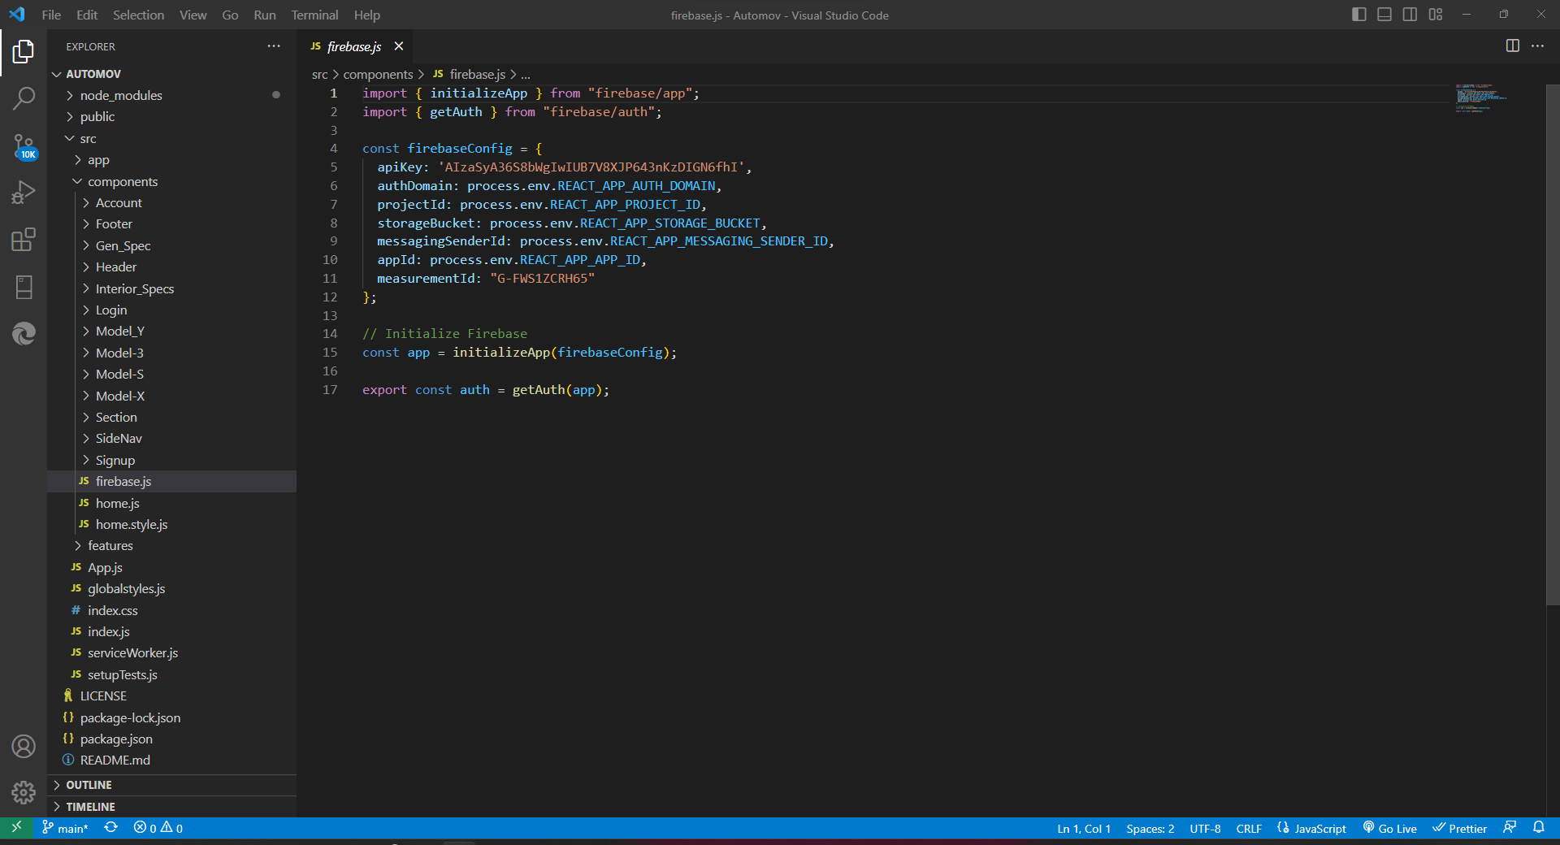

(Firebase.js File)

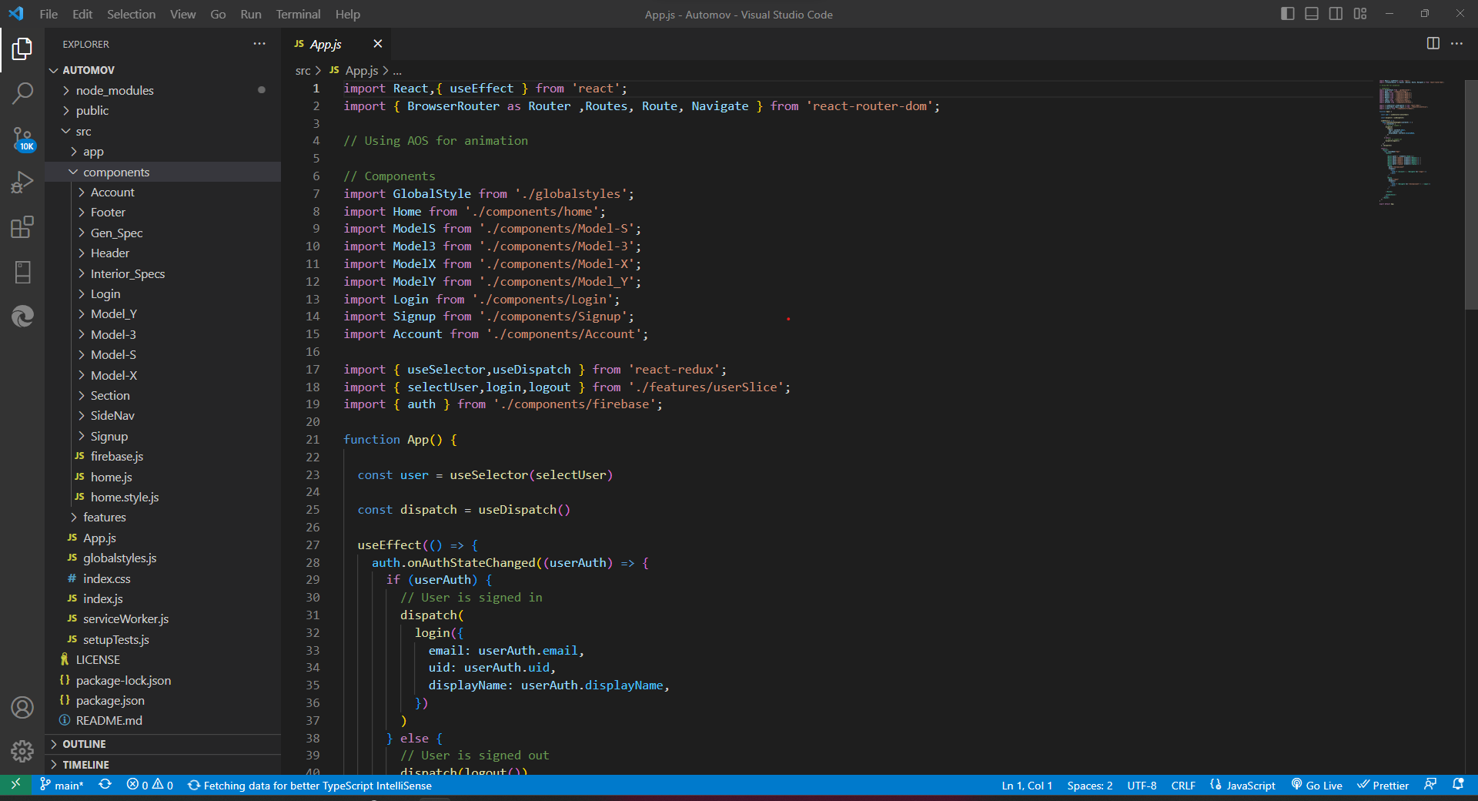

(App.js File)

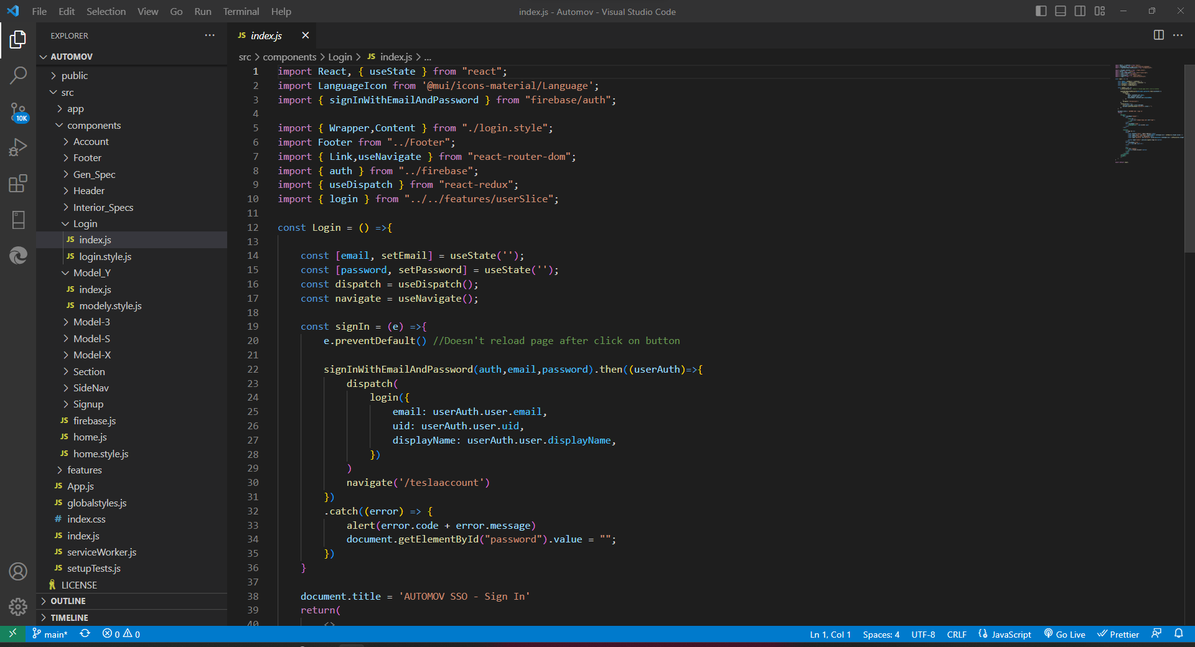

(Login Index file)

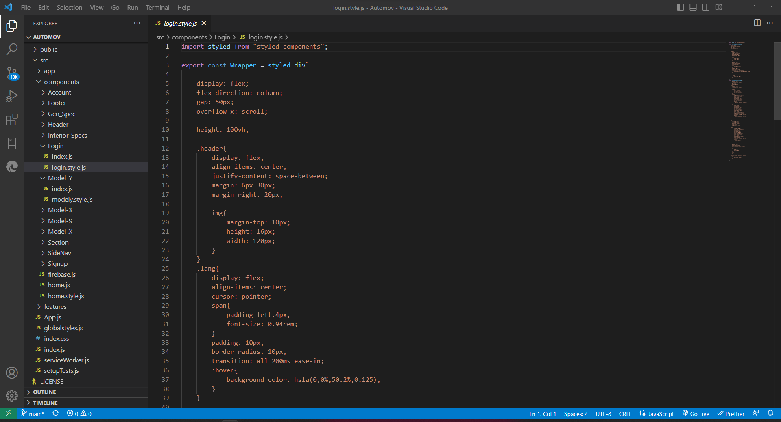

(Login CSS File)

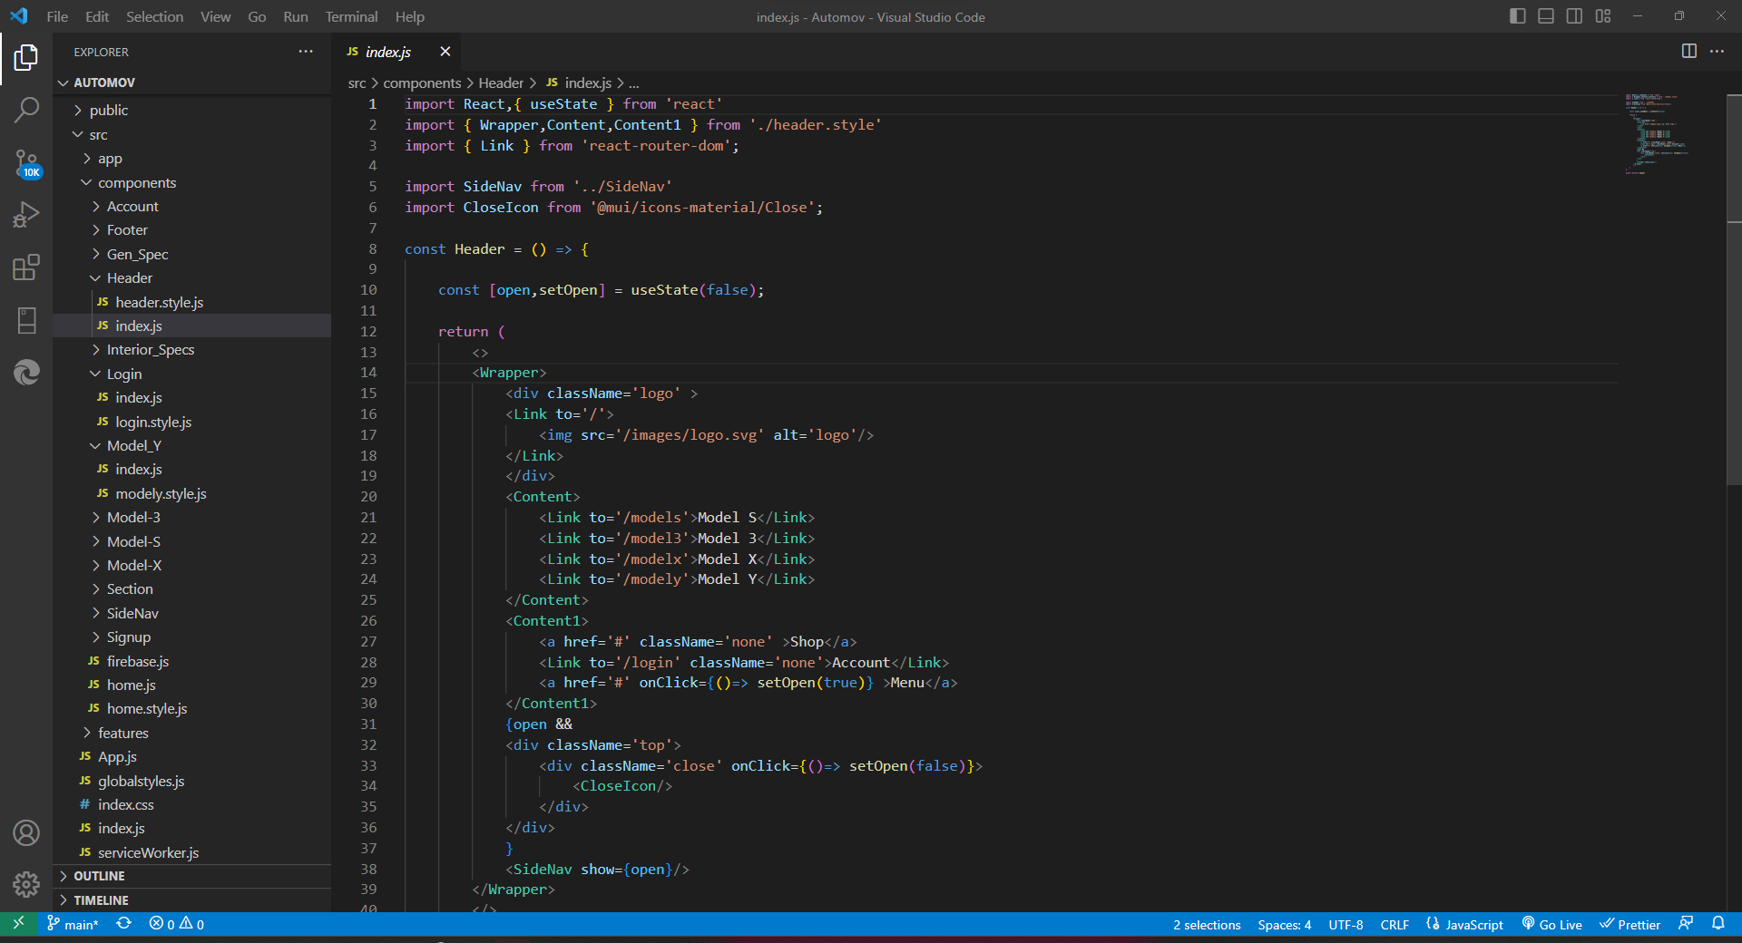

(Header Index File)

**5.2 GUI Constructing (Project Snapshots)**

The Graphical User Interface (GUI) is a critical component of the AUTOMOV website, as it directly interacts with users and provides a visually appealing and intuitive user experience. The GUI should be designed with usability, responsiveness, and consistency in mind.

**5.2.1 Layout and Navigation**

The layout of the AUTOMOV website can be structured to include a header, footer, and a main content area. The header typically contains the website logo, navigation menu, and user authentication controls. The footer can include additional links, contact information, and social media icons.

The navigation menu should provide easy access to different sections of the website, such as Home, Car Models, Dashboard, and Login/Register pages. It should be consistent across all pages for a seamless user experience.

**5.2.2 Home Page**

The Home page serves as the entry point for users and provides an overview of the website's features and services. It can include eye-catching banners, featured car models, promotional offers, and a search bar for users to explore specific car models.

**5.2.3 Login/Register Page**

The Login/Register page allows users to authenticate themselves and access personalized features of the website. It should include input fields for username/email and password, as well as options for registration, password recovery, or social media login integration.

**5.2.4 Car Models Page**

The Car Models page displays a comprehensive list of car models available on the AUTOMOV website. It can include search and filtering options to help users find specific models based on make, model, price range, or other criteria. Each car model can be presented with an image, brief description, and key specifications.

**5.2.5 Dashboard Page**

The Dashboard page provides a personalized space for users to manage their accounts, view transaction history, and access recommendations or personalized offers. It can include sections for profile management, transaction history, saved favorites, and recommended car models based on user preferences.

**5.2.6 Payment Gateway**

The Payment Gateway page handles the secure processing of user payments when purchasing a car model. It should provide a smooth and intuitive payment process, integrating with a trusted payment service provider to ensure secure transactions.

**5.2.7 Responsiveness and Mobile-Friendly Design**

In today's mobile-centric world, it is crucial to ensure the AUTOMOV website's GUI is responsive and optimized for various screen sizes and devices. The design should adapt seamlessly to mobile devices, tablets, and desktops, providing an optimal user experience across all platforms.

**5.2.8 User Experience and Visual Design**

The user experience (UX) and visual design of the AUTOMOV website play a significant role in attracting and engaging users. Attention should be given to typography, color schemes, visual hierarchy, and the use of appropriate imagery to create an aesthetically pleasing and user-friendly interface.

To illustrate the GUI of the AUTOMOV website, the following snapshots provide an overview of the different pages and their components:

**GUI Design**

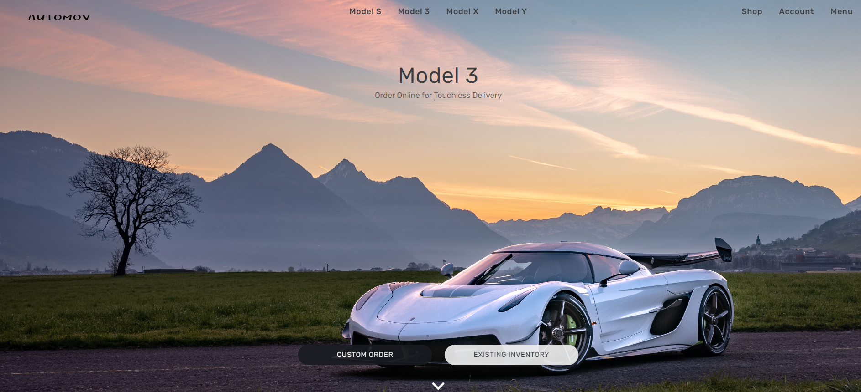

(Home Page)

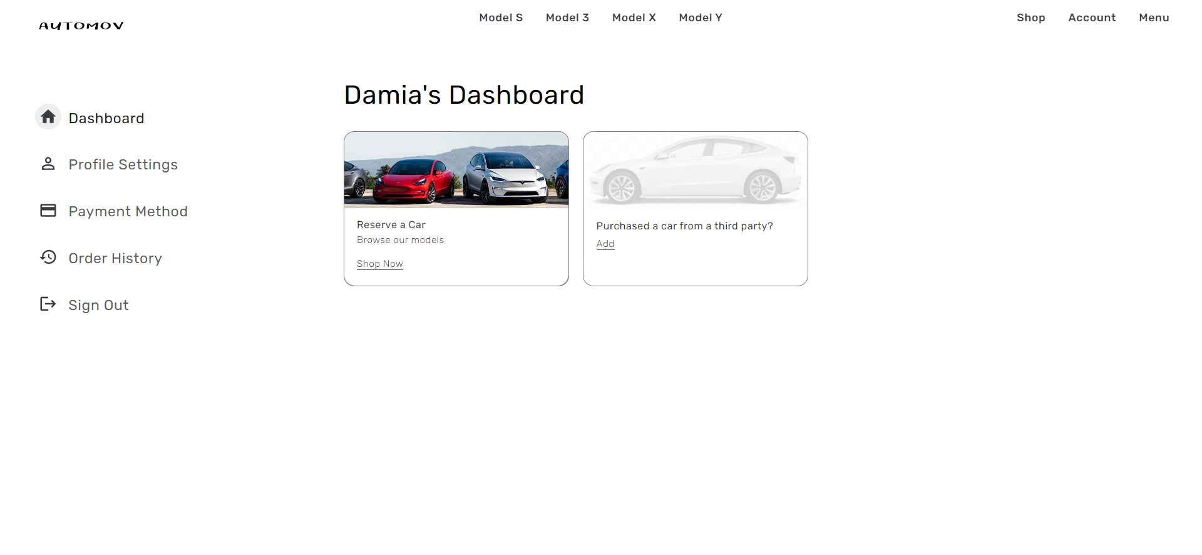

(Dashboard Page)

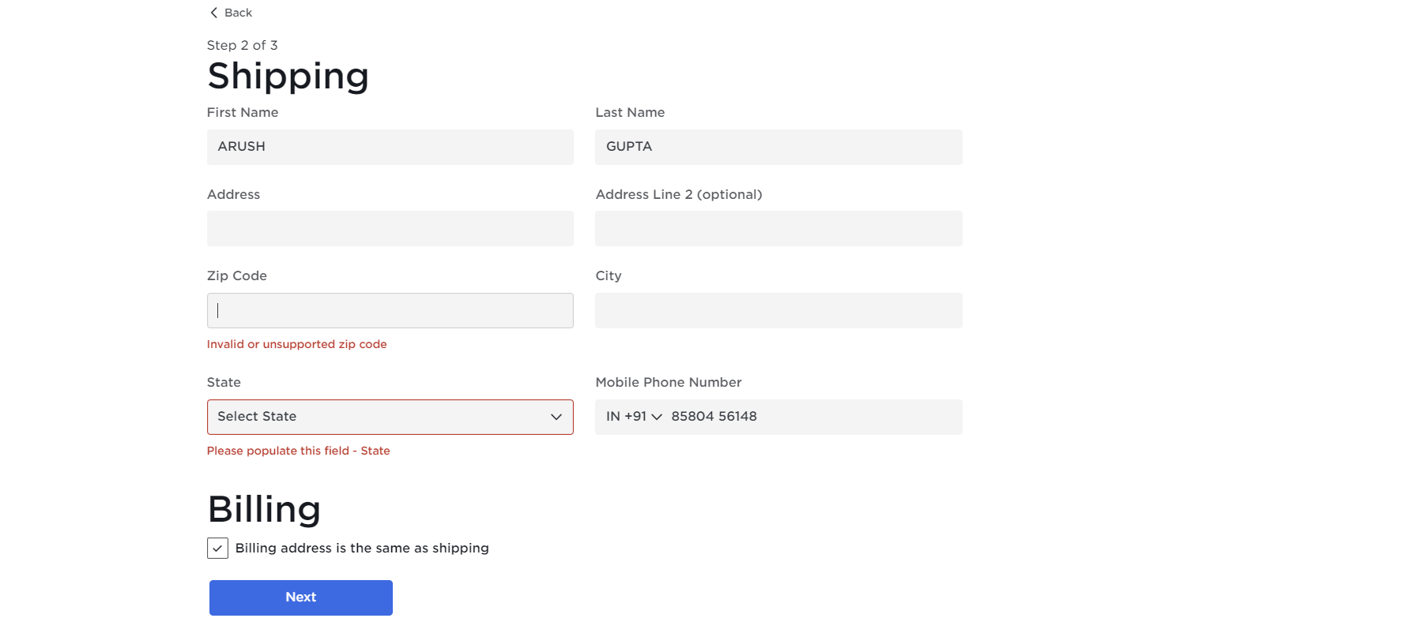

(Shipping Page)

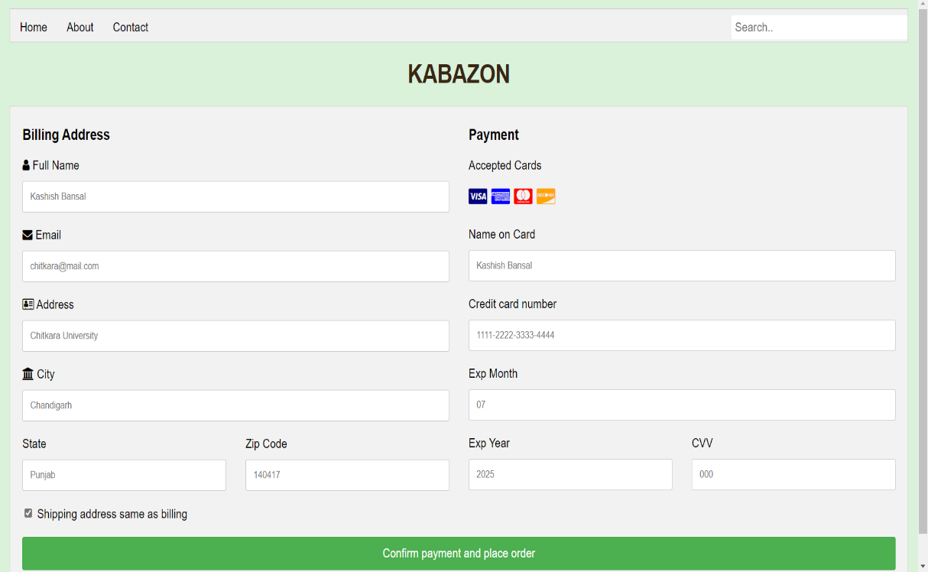

(Billing Page)

These snapshots provide a visual representation of the GUI elements and the overall look and feel of the AUTOMOV website.

In this chapter, we discussed the program's structure analysis, including the modular organization of components, services, and utilities. We also provided project snapshots showcasing the GUI design for different pages of the website. The next chapter will cover the code implementation and database connections for the AUTOMOV website.

**Chapter 6: Code Implementation and Database Connections**

In this chapter, we will delve into the code implementation of the AUTOMOV website. We will focus on the integration of the frontend components, the utilization of Firebase for database connectivity, and the establishment of connections between the frontend and the database.

**6.1 Frontend Code Implementation**

The AUTOMOV website utilizes HTML, CSS, JavaScript, and the ReactJS library for frontend development. ReactJS provides a component-based architecture, allowing for modular and reusable code.

**6.1.1 Component Structure**

Following the program's structure analysis discussed in the previous chapter, the frontend code can be organized into components. Each component represents a specific part of the user interface and encapsulates its functionality.

For example, the Home component would handle the rendering of the home page, the Login component would manage user authentication, and the CarModels component would handle the display and filtering of car models.

**6.1.2 Component Implementation**

To implement the components, we would create individual files for each component and write the corresponding HTML, CSS, and JavaScript code within these files.

The HTML code would define the structure and layout of the component, utilizing semantic tags and appropriate class or ID names for styling and targeting in CSS and JavaScript.

The CSS code would be responsible for styling the components, including defining colors, typography, layout, and responsiveness. It would be advisable to use CSS frameworks like Bootstrap or Material-UI to expedite the styling process and ensure a consistent look and feel across the website.

The JavaScript code would handle the dynamic behavior and functionality of the components. It would include event handlers, data manipulation, API calls, and integration with Firebase for database operations.

**6.2 Firebase Database Connections**

Firebase provides a JavaScript SDK that allows seamless integration with Cloud Firestore. The SDK provides methods and functions to interact with the database and perform CRUD operations.

**6.2.1 Firebase Configuration**

To establish a connection with the Firebase database, we would need to include the Firebase SDK in our project and configure it with the necessary credentials.

The Firebase configuration details, including the project ID and API key, would be obtained from the Firebase console during project setup. These details would then be added to the project configuration file or directly within the JavaScript code.

**6.2.2 Database Operations**

With the Firebase SDK properly configured, we can now perform database operations such as reading, writing, updating, and deleting data.

To read data from the database, we would utilize the Firebase SDK's methods such as `get()` or `onSnapshot()` to fetch data from the appropriate collections and documents. For example, to retrieve car models, we would use the `get()` method to fetch the desired collection.

To write data to the database, we would use the `set()` or `update()` methods. For instance, when a user submits a review for a car model, we would use the `set()` method to add the review to the `userReviews` collection.

Similarly, to update or delete data, we would utilize the `update()` and `delete()` methods, respectively. These operations would be performed based on specific conditions or user actions.

**6.2.3 Data Binding and Real-time Updates**

One of the key advantages of Firebase is its real-time data synchronization feature. This means that any changes made to the database are instantly reflected in the frontend, allowing for real-time updates and a dynamic user experience.

To achieve real-time updates, we would utilize the Firebase SDK's `onSnapshot()` method, which sets up a listener for changes in the database. Whenever there is a change in the specified collection or document, the listener triggers a callback function, allowing us to update the frontend accordingly.

For example, if a new car model is added to the database, the `onSnapshot()` listener would notify the frontend, and the CarModels component would update to display the new model.

**6.3 Error Handling and Validation**

Proper error handling and validation are essential for a robust and secure website. In the case of the AUTOMOV website, we would implement error handling and validation for user inputs, database operations, and API calls.

**6.3.1 User Input Validation**

To ensure the integrity of user inputs, we would implement validation checks on form submissions. This includes validating required fields, checking input formats (e.g., email addresses, phone numbers), and performing data sanitization to prevent SQL injection or other security vulnerabilities.

Frontend frameworks like ReactJS provide libraries and utilities for form validation, such as Yup or Formik, which can be leveraged to streamline the validation process.

**6.3.2 Error Handling for Database Operations**

When interacting with the Firebase database, errors can occur due to various reasons, such as network issues or incorrect data formatting. It is crucial to handle these errors gracefully and provide meaningful feedback to the user.

Firebase provides error codes and error objects that can be utilized to identify the type of error and display appropriate error messages to the user. By implementing error handling logic within the code, we can notify the user of any issues and provide instructions for resolution or further action.

**6.3.3 Error Handling for API Calls**

The AUTOMOV website may also require communication with external APIs for functionalities such as payment processing or data retrieval. In such cases, proper error handling is necessary to handle API request failures, server errors, or invalid responses.

Similar to database operations, error codes and response codes can be analyzed to determine the cause of the error and display relevant error messages to the user. Additionally, fallback mechanisms or alternative paths can be implemented to ensure a smooth user experience even in the presence of API failures.

In this chapter, we discussed the implementation of frontend components using HTML, CSS, and JavaScript, as well as the integration of Firebase for database operations. We explored the organization of the codebase into components and the utilization of Firebase SDK methods for reading, writing, updating, and deleting data. Additionally, we emphasized the importance of error handling and validation for user inputs, database operations, and API calls.

**Chapter 7: System Testing**

System testing is a crucial phase in the software development life cycle that aims to validate the functionality, reliability, and performance of the AUTOMOV website. This chapter focuses on various types of testing that can be performed to ensure the website meets the required quality standards.

**7.1 Functional Testing**

Functional testing involves verifying that each function and feature of the website behaves as expected and fulfills its intended purpose. It ensures that the system functions correctly from a user's perspective.

**7.1.1 Test Cases**

Test cases can be created to cover various scenarios and user interactions. Each test case should outline the steps to be performed, the expected results, and the actual results observed during testing.

For example, a test case for the login functionality could include steps such as entering valid credentials, clicking the login button, and verifying that the user is redirected to the dashboard page. The expected result would be a successful login and the actual result would be compared against the expected result.

Test cases should cover different aspects of the website, including user authentication, car model browsing, dashboard management, and payment processing. The goal is to ensure that all features and functionalities of the AUTOMOV website are thoroughly tested.

**7.1.2 Test Automation**

To streamline the testing process and improve efficiency, test automation can be utilized. Automation frameworks like Jest, Enzyme, or Cypress can be employed to automate the execution of test cases and generate reports.

Test automation allows for repetitive tests to be executed quickly and accurately, reducing the chances of human error. It also facilitates regression testing, ensuring that new changes or bug fixes do not introduce new issues into the system.

Automated tests can be created to simulate user interactions, validate data inputs, and verify the correctness of system responses. These tests can be run regularly, either manually or as part of a continuous integration/continuous deployment (CI/CD) pipeline, to ensure the ongoing stability and reliability of the website.

**7.2 Performance Testing**

Performance testing assesses how well the AUTOMOV website performs under different load conditions. It measures factors such as response time, resource utilization, scalability, and stability.

**7.2.1 Load Testing**

Load testing simulates real-world usage scenarios by subjecting the website to varying levels of user traffic and workload. The goal is to identify performance bottlenecks and determine the website's capacity to handle concurrent users.

Load testing tools like Apache JMeter or LoadRunner can be used to generate simulated traffic and measure the website's response time under different loads. By gradually increasing the number of concurrent users or requests, the performance characteristics of the website can be analyzed.

The load testing process involves setting up test scenarios, configuring the load testing tool, executing the tests, and analyzing the results. The results can provide insights into areas that require optimization or scalability improvements.

**7.2.2 Stress Testing**

Stress testing pushes the system beyond its limits to determine how it behaves under extreme conditions. It tests the website's robustness and stability by subjecting it to high volumes of data, excessive user traffic, or continuous heavy loads.

Stress testing helps identify any weaknesses or vulnerabilities in the system, such as memory leaks, resource exhaustion, or performance degradation under extreme loads. By analyzing the system's behavior under stress, necessary optimizations or mitigations can be implemented to enhance its resilience.

**7.3 Usability Testing**

Usability testing focuses on evaluating the website's user interface and user experience. It involves gathering feedback from end-users to assess the website's ease of use, intuitiveness, and overall satisfaction.

**7.3.1 Test Scenarios**

Usability test scenarios can be designed to simulate common user interactions and tasks. Participants are asked to perform specific actions, while their behavior, feedback, and difficulties encountered are observed and recorded.

For example, a usability test scenario could involve asking participants to find a specific car model, add it to their favorites, and proceed to the payment gateway. The goal is to assess the website's navigation, clarity of information, and the ease with which users can accomplish tasks.

**7.3.2 Feedback and Iteration**

Feedback from usability testing sessions provides valuable insights into areas where the website can be improved. It helps identify usability issues, confusing elements, or areas where user guidance may be required.

Based on the feedback received, iterative improvements can be made to the website's design, layout, and overall user experience. Usability testing should be an ongoing process, allowing for continuous refinement of the website to meet user expectations and preferences.

**7.4 Security Testing**

Security testing is essential to identify and address vulnerabilities that could compromise the confidentiality, integrity, or availability of data on the AUTOMOV website.

**7.4.1 Vulnerability Scanning**

Vulnerability scanning tools can be used to identify common security weaknesses, such as outdated software versions, misconfigurations, or known vulnerabilities. These tools scan the website and its underlying infrastructure to detect any potential security risks.

Regular vulnerability scanning helps ensure that the website remains protected against common security threats and that necessary patches or updates are applied promptly.

**7.4.2 Penetration Testing**

Penetration testing, also known as ethical hacking, involves simulating real-world attacks to identify vulnerabilities and potential entry points for malicious actors. It aims to uncover weaknesses that could be exploited to gain unauthorized access to sensitive data or disrupt the website's functionality.

Experienced security professionals conduct penetration testing, utilizing various techniques to assess the website's resilience to attacks. The results of penetration testing help identify areas where security measures can be strengthened and assist in the development of robust security strategies.

In this chapter, we explored the importance of system testing for the AUTOMOV website. We discussed functional testing, including test case creation and test automation. We also covered performance testing, focusing on load testing and stress testing to assess the website's responsiveness and scalability. Usability testing was highlighted as a means to evaluate the user interface and user experience. Additionally, security testing, including vulnerability scanning and penetration testing, was emphasized to ensure the protection of sensitive data.

**Chapter 9: Conclusion**

The AUTOMOV website project aimed to provide a user-friendly platform for car enthusiasts to browse and explore various car models, manage their preferences, and make secure payments. Throughout this project report, we have discussed the background, problem statement, software and hardware requirements, database design, frontend code implementation, system testing, and limitations of the project. In this concluding chapter, we will summarize the key findings, achievements, and the overall success of the AUTOMOV website.

**9.1 Summary of Key Findings**

During the course of this project, we successfully developed the AUTOMOV website using HTML, CSS, JavaScript, and ReactJS. The website consists of several pages, including the home page, login page, car models page, dashboard page, and payment gateway. The website provides a user-friendly interface, allowing users to browse and filter car models, manage their preferences, and securely complete their transactions.

We utilized Firebase as the backend database, which facilitated seamless integration and real-time data synchronization. Firebase's JavaScript SDK enabled us to perform various database operations, including reading, writing, updating, and deleting data. The utilization of Firebase improved the overall responsiveness and user experience of the website.

System testing played a crucial role in ensuring the quality and reliability of the AUTOMOV website. We conducted functional testing to verify the correctness and completeness of the implemented features. Performance testing helped us assess the website's responsiveness under different load conditions, while usability testing provided insights into user experience and interface improvements. Security testing allowed us to identify and address potential vulnerabilities, ensuring the protection of user data.

**9.2 Achievements and Successes**

The successful implementation of the AUTOMOV website is a significant achievement in meeting the project goals. We successfully integrated multiple technologies, including HTML, CSS, JavaScript, ReactJS, and Firebase, to develop a robust and feature-rich website. The website's responsive design, intuitive user interface, and seamless database connectivity contribute to its overall success.

The frontend components were implemented following a modular and reusable approach, which enhances maintainability and code readability. The use of ReactJS and component-based architecture allowed for efficient development and facilitated future enhancements and modifications.

The integration with Firebase provided a reliable and scalable backend solution. The real-time data synchronization feature enhanced the website's interactivity, allowing users to receive instant updates and feedback. The utilization of Firebase's authentication features ensured secure user login and protected user data.

The system testing phase ensured the functionality, performance, usability, and security of the website. By conducting various tests, we were able to identify and address issues, resulting in an improved user experience and overall quality of the AUTOMOV website.

**9.3 Limitations**

Despite the successes and achievements, the AUTOMOV website does have certain limitations. These limitations should be taken into consideration for future enhancements and developments.

Firstly, the website's compatibility with different browsers and devices may vary. Although efforts were made to ensure cross-browser compatibility and responsiveness, further testing on a wide range of devices and browsers is recommended to address any inconsistencies.

Secondly, while security testing was conducted to identify and address vulnerabilities, ongoing monitoring and periodic security audits are necessary to mitigate emerging threats and ensure continuous protection of user data.

Lastly, the scope of the project was focused on the core functionalities of the website. Additional features such as user reviews, advanced search filters, and social media integration could be considered for future iterations to enhance user engagement and expand the website's capabilities.

**9.5 Conclusion**

In conclusion, the AUTOMOV website project successfully achieved its objectives of providing a user-friendly platform for car enthusiasts to browse, manage, and make secure payments for car models. The integration of HTML, CSS, JavaScript, ReactJS, and Firebase facilitated the development of a robust and responsive website.

The implementation of system testing ensured the quality, reliability, and security of the website. However, certain limitations exist, such as cross-browser compatibility, ongoing security monitoring, and the scope of the project.

The project's successes and achievements lay the foundation for future enhancements and developments. The future scope of the project includes integration with external APIs, advanced search and filtering options, user-generated content, social media integration, personalization, and mobile application development.

Overall, the AUTOMOV website project has been a significant endeavor, combining technical expertise, user-centered design, and thorough testing to deliver a valuable and enjoyable experience for car enthusiasts.

**Chapter 10: Future Scope**

The AUTOMOV website has great potential for future enhancements and expansion. Some of the possible areas of improvement and future developments include:

1. Integration with external APIs: Integration with car manufacturers' APIs or third-party services could provide real-time updates on car models, pricing, and availability.

2. Advanced search and filtering options: Implementing advanced search filters based on

various criteria, such as price range, mileage, or specific features, would enhance the user experience and make it easier for users to find their desired car models.

3. User-generated content: Allowing users to submit reviews, ratings, and comments on car models would foster community engagement and provide valuable insights to other users.

4. Social media integration: Integrating social media platforms would enable users to share their favorite car models, invite friends to join the website, and leverage social media for marketing purposes.

5. Personalization: Implementing personalized recommendations based on user preferences and browsing history would enhance the website's ability to cater to individual user interests.

6. Mobile application development: Developing a dedicated mobile application for AUTOMOV would provide users with a seamless and optimized experience on mobile devices.

**Chatper 11: Bibliography/References**

1. W3Schools. (n.d.). HTML Tutorial. Retrieved from <https://www.w3schools.com/html/>
2. W3Schools. (n.d.). CSS Tutorial. Retrieved from <https://www.w3schools.com/css/>
3. W3Schools. (n.d.). JavaScript Tutorial. Retrieved from <https://www.w3schools.com/js/>
4. React. (n.d.). React - A JavaScript library for building user interfaces. Retrieved from <https://reactjs.org/>
5. Firebase. (n.d.). Firebase - App development made easy. Retrieved from <https://firebase.google.com/>
6. Firebase. (n.d.). Firebase Realtime Database. Retrieved from <https://firebase.google.com/products/realtime-database/>
7. Firebase. (n.d.). Firebase Authentication. Retrieved from <https://firebase.google.com/products/auth/>
8. Firebase. (n.d.). Firebase Security. Retrieved from <https://firebase.google.com/products/security/>
9. React Router. (n.d.). React Router: Declarative Routing for React.js. Retrieved from <https://reactrouter.com/>
10. Firebase. (n.d.). Firebase Hosting. Retrieved from https://firebase.google.com/products/hosting/