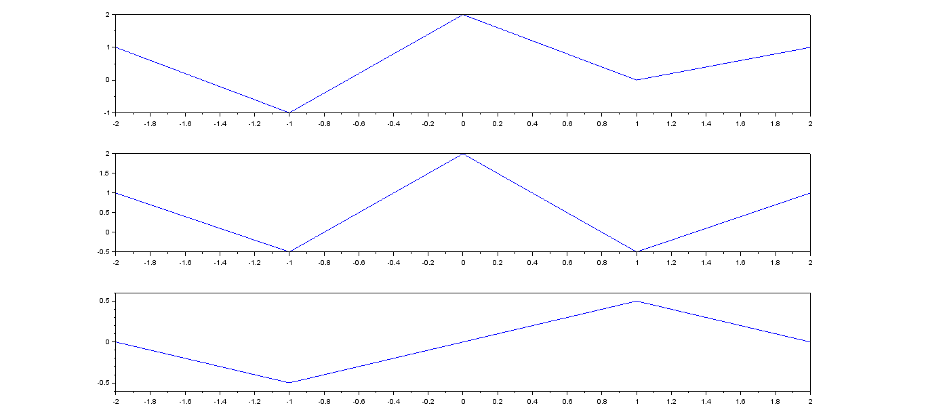

t=0:0.001:10

y=5\*exp(-5\*t)

E=integrate('(5\*exp(-5\*t))^2','t',0,2\*%pi)

disp(E,'Energy of the Signal in Joules=')

E = 2.5000000

t=0:0.001:10

y=5\*exp(-5\*t)

P=integrate('(5\*exp(-5\*t))^2','t',0,2\*%pi)/(2\*pi)

disp(P,'Power of the Signal in watts=')

P = 0.3978874