PHISINIG:
USING HOUND:
Phishing is a social engineering technique where attackers try to trick users into revealing sensitive information such as usernames, passwords, OTPs, or financial details by pretending to be a trusted entity. It commonly exploits human behavior rather than technical vulnerabilities. Phishing attacks are usually delivered through emails, messages, fake websites, or social media platforms that look legitimate and convincing.
Hound is an open-source password auditing and recovery tool used mainly in cybersecurity and penetration testing. It is designed to test the strength of passwords by performing automated attacks such as dictionary-based and brute-force attempts against password hashes. Hound supports multiple hashing algorithms and allows security analysts to evaluate how resistant a system’s credentials are to common attack techniques.
STEPS:
- git clone https://github.com/techchipnet/hound.git
- mkdir hound
- cd hound
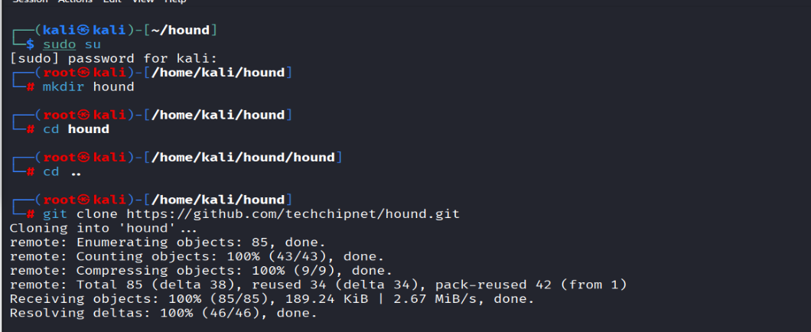4.bash hound.sh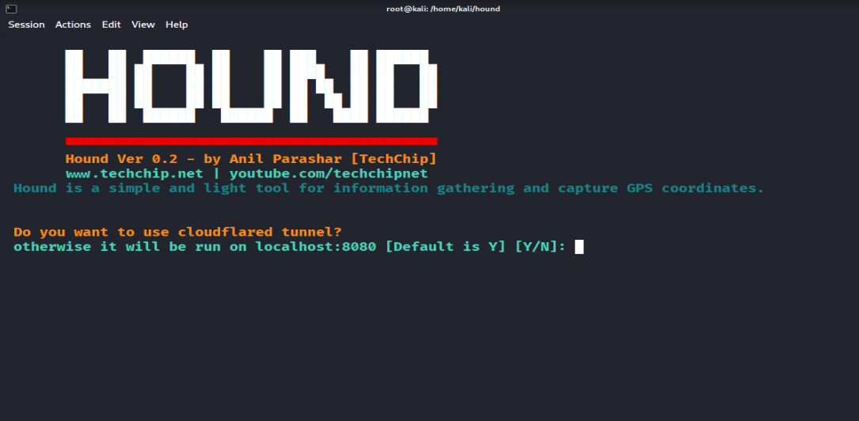
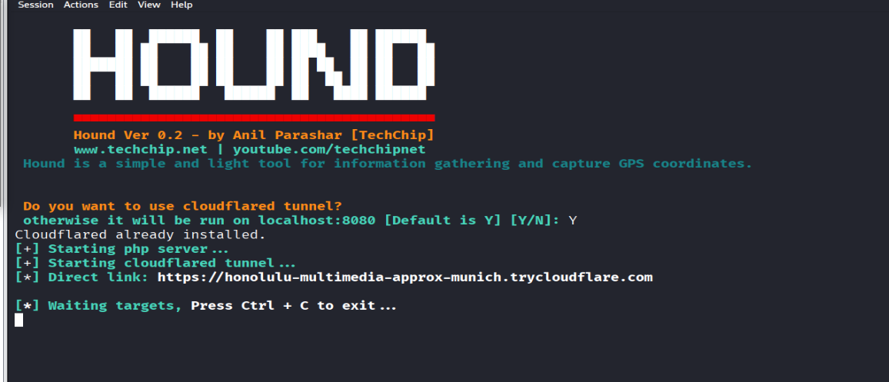
Direct link: https://honolulu-multimedia-approx-munich.trycloudflare.com
OUTPUT:
