YUVAINTERN
WEEK 2 INTERNSHIP REPORT
Advanced Data Visualization and Storytelling with Python
Student Performance: Turning Data into an Actionable Story
Intern | Keval Prashant Chaudhari
Organization | YuvaIntern
Role | Virtual Data Science with Python Apprentice Intern
Task | Week 2 – Advanced Data Visualization and Storytelling with Python
Dataset | UCI Student Performance – Mathematics

1. Introduction
Week 2 extends the Week 1 exploratory workflow by treating visualization as a communication tool rather than simply a collection of charts. The same Mathematics-course Student Performance dataset is used so the internship work remains consistent. The storytelling sequence moves from overall grade distribution to the year-long grade path, performance bands, social-behaviour group patterns, and attendance.
The objective is to communicate the main patterns to a non-technical audience using clear titles, annotations, captions and short explanations. The analysis is descriptive and does not claim that any observed factor causes a change in academic performance.

2. Dataset and Analytical Context
The UCI Student Performance dataset concerns secondary-school achievement at two Portuguese schools and contains demographic, social, school-related and academic attributes. The UCI documentation provides separate Mathematics and Portuguese files; this report uses the Mathematics file with 395 student records and 33 attributes. The final grade G3 is measured from 0 to 20. UCI also notes that G3 is strongly correlated with G1 and G2 because these are earlier-period grades from the same course.
The dataset has no missing values according to UCI. The original file contains categorical variables alongside numeric and ordinal variables, so chart selection is based on the meaning of each variable rather than treating every column as continuous.

3. Storytelling Strategy
Story stage | Question | Visualization role
1. Outcome | Where do final grades concentrate? | Establishes the baseline performance picture.
2. Progress | How does average performance move through the year? | Shows the direction and size of the average change.
3. Segments | How many students fall into broad performance bands? | Turns a distribution into an audience-friendly support view.
4. Social context | Do going-out levels map to a simple grade trend? | Tests a plausible but non-linear relationship.
5. Behaviour context | Does weekend alcohol use show a simple trend? | Shows why group comparisons need careful interpretation.
6. Attendance | What does the absence distribution look like? | Highlights the long tail and the difference between typical and extreme absence.

4. Visualization 1 – Where Final Grades Concentrate
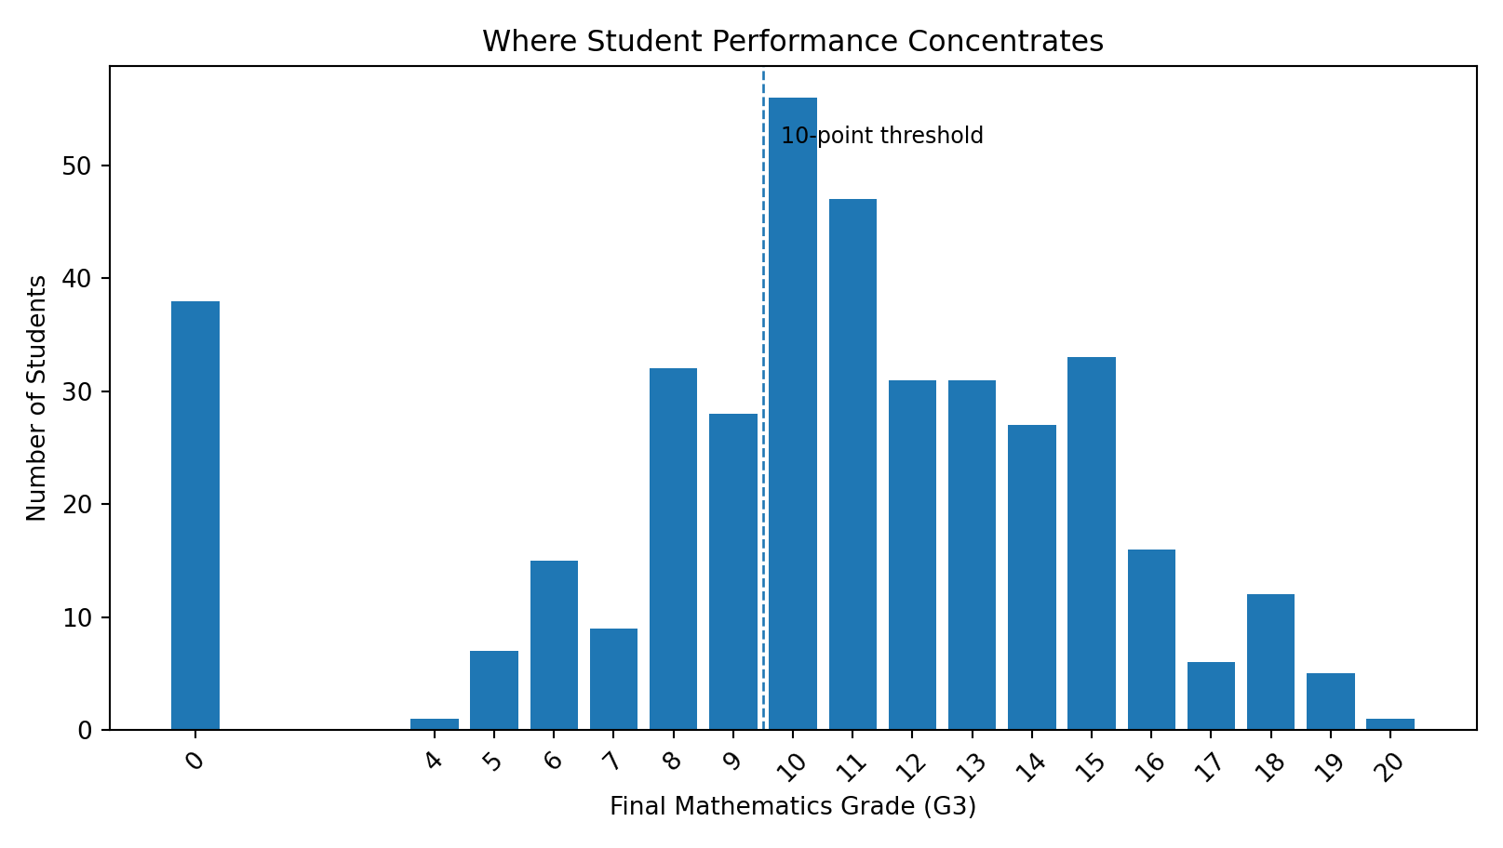
4. Visualization 1 – Where Final Grades Concentrate.

Why this chart?
A vertical bar chart is used because G3 is an integer score from 0 to 20. The chart makes concentration around the middle of the grading scale visible and highlights the 10-point threshold used later.

What the audience should see
The distribution is concentrated around grades 8–14, with grade 10 particularly frequent. A notable group has G3 = 0. Because the dataset does not document why those zeros occur, they should not automatically be treated as missing values.

Story takeaway
Performance is varied; one average grade cannot describe the whole student population.

5. Visualization 2 – The Average Grade Path
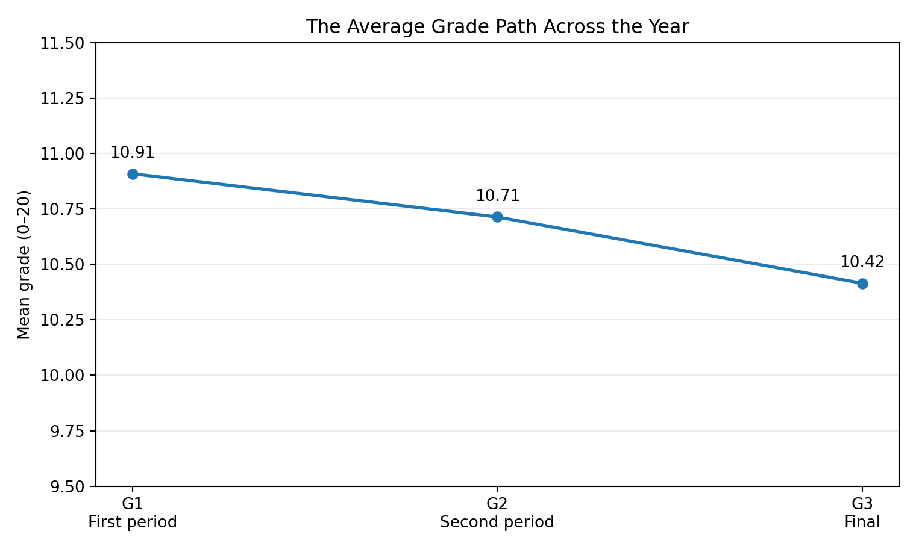
5. Visualization 2 – The Average Grade Path.

Why this chart?
A line chart communicates sequence: G1 is the first-period grade, G2 the second-period grade, and G3 the final grade. Point labels make small differences readable.

What the audience should see
The mean grade moves from 10.91 in G1 to 10.71 in G2 and 10.42 in G3. The final grade also has greater dispersion than the earlier grades.

Story takeaway
Average performance does not improve across these checkpoints, while individual outcomes remain widely spread.

6. Visualization 3 – Performance Bands
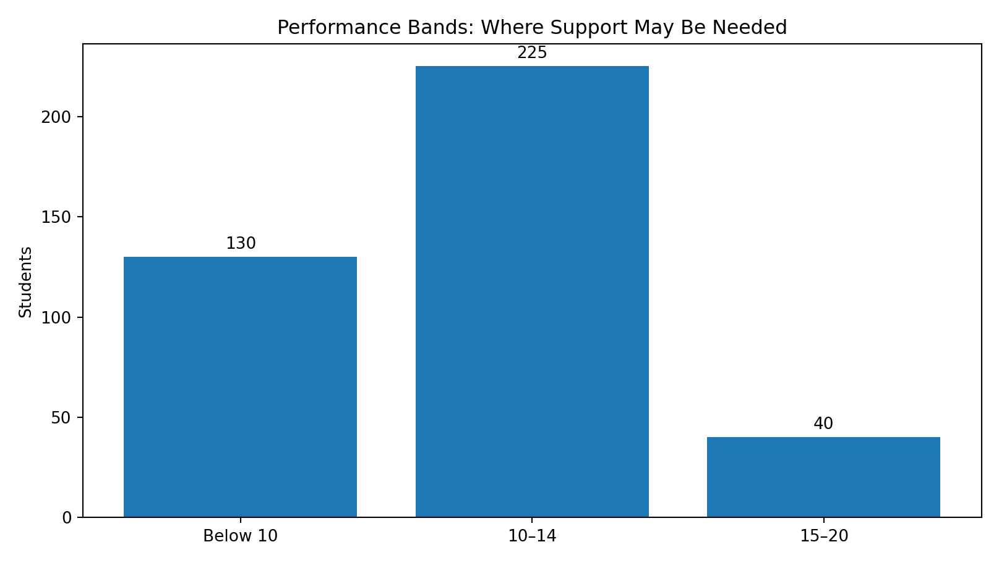
6. Visualization 3 – Performance Bands.

Why this chart?
A three-band bar chart translates the 0–20 score into broad groups: below 10, 10–14, and 15–20. This is easier for a non-technical audience to interpret than a long list of individual grade counts.

What the audience should see
There are 130 students below 10, 225 between 10 and 14, and 40 between 15 and 20. The middle band is the largest group, while the below-10 group is large enough to merit attention.

Story takeaway
A support-oriented discussion should consider the substantial lower-performing group, not only the overall mean.

7. Visualization 4 – Going Out and Academic Outcomes
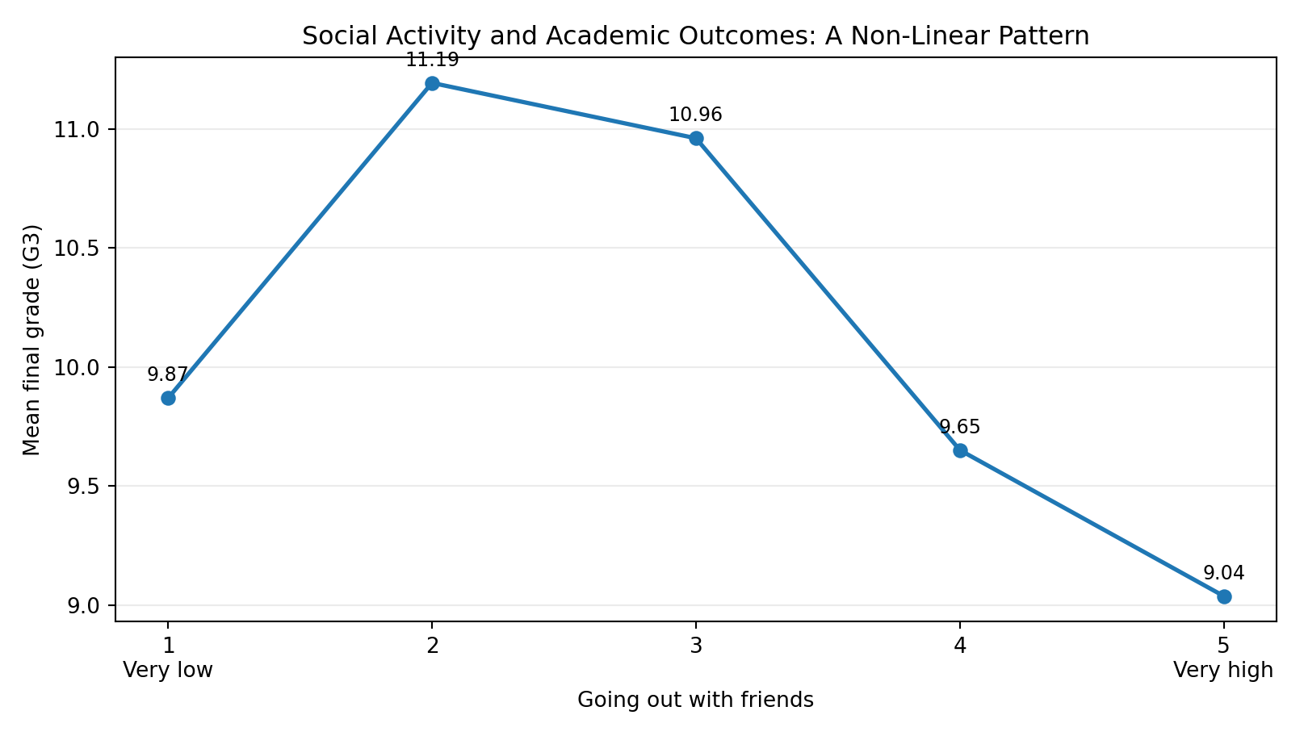
7. Visualization 4 – Going Out and Academic Outcomes.

Why this chart?
A connected point chart emphasizes the shape of group means without implying a continuous causal relationship. Labels show exact group averages.

What the audience should see
Mean G3 values are 9.87, 11.19, 10.96, 9.65 and 9.04 for going-out levels 1–5. The pattern is non-linear: the highest mean occurs at level 2 and the lowest at level 5.

Story takeaway
More social activity is not associated with a simple step-by-step increase or decrease in grades in this dataset.

8. Visualization 5 – Weekend Alcohol Consumption
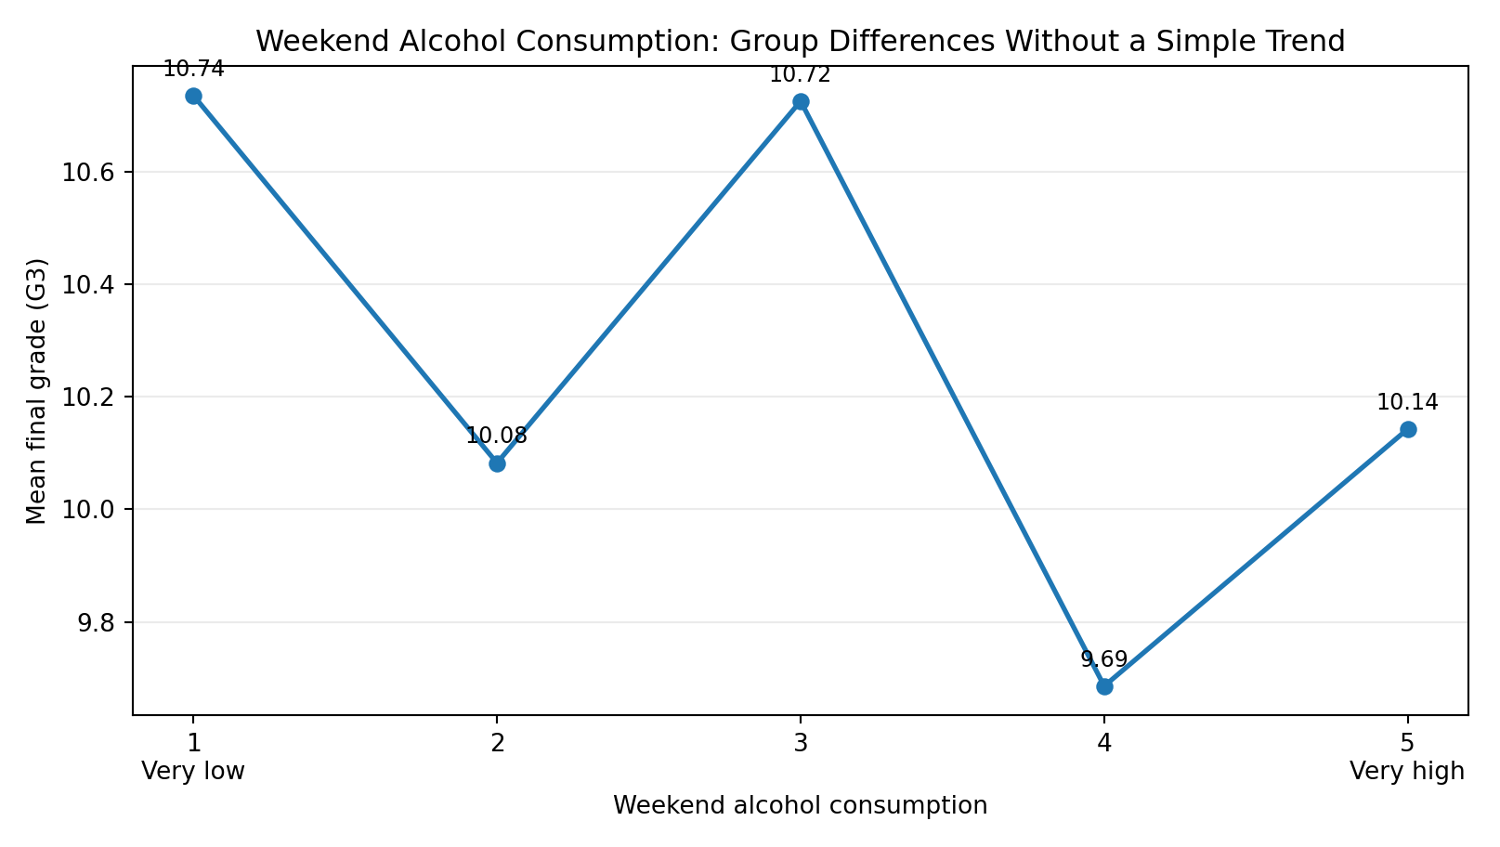
8. Visualization 5 – Weekend Alcohol Consumption.

Why this chart?
The same visual grammar is reused for weekend alcohol-consumption levels so the audience can compare the pattern with the previous chart.

What the audience should see
Mean G3 values are 10.74, 10.08, 10.73, 9.69 and 10.14 across levels 1–5. The differences are relatively modest and do not form a simple monotonic trend.

Story takeaway
Group differences exist, but they are not evidence of a causal effect.

9. Visualization 6 – Attendance: Typical Level vs Long Tail
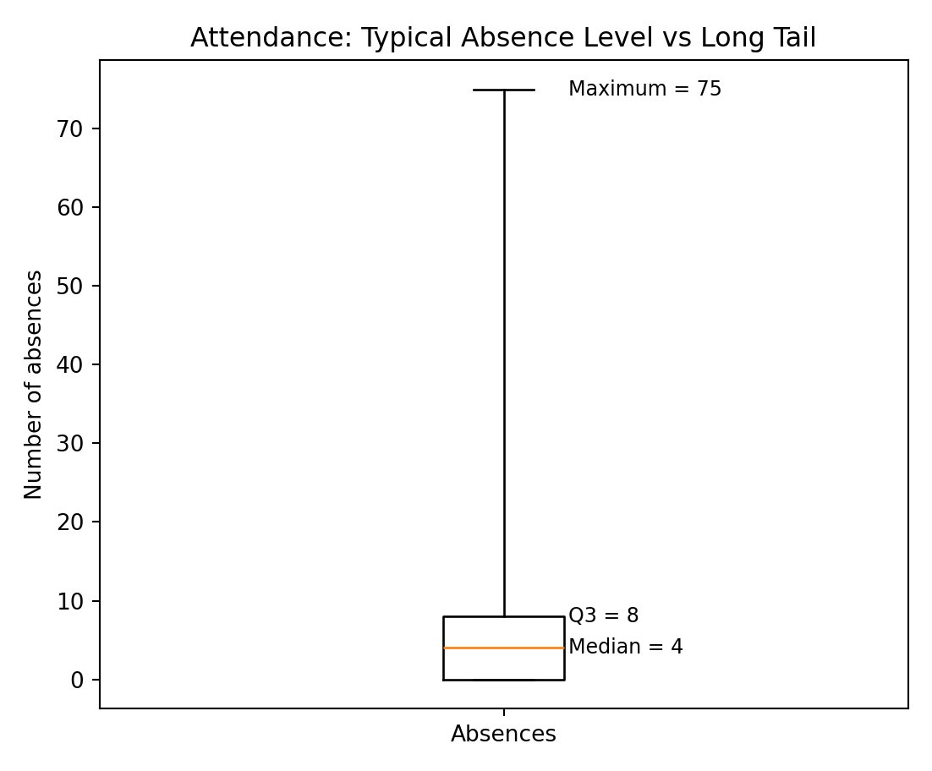
9. Visualization 6 – Attendance: Typical Level vs Long Tail.

Why this chart?
A box-and-whisker summary is appropriate for a count variable with a long tail. The five-number summary shows the middle 50% while making the extreme maximum visible.

What the audience should see
Absences have a mean of 5.71, a median of 4, Q1 of 0, Q3 of 8 and a maximum of 75. The gap between the typical range and the extreme maximum is the key story.

Story takeaway
Most students are concentrated at relatively low absence counts, but extreme cases may warrant separate attention.

10. Potential Educational / Scientific Implications
- Use multiple grade checkpoints rather than relying only on the final average when monitoring progress.
- A broad performance-band view can help communicate the size of the lower-performing group to educators and decision-makers.
- Extreme absence counts may justify targeted follow-up, but absence alone should not be treated as a complete explanation of performance.
- Social-behaviour variables show non-linear group patterns; educational decisions should avoid simplistic one-variable explanations.
- The strong relationship between G1, G2 and G3 means these grades should be distinguished from independent explanatory factors in future modeling.
- These observations are descriptive and come from two Portuguese schools; they do not establish causation or universal generalization.

11. Visualization Design Principles Used
- Titles communicate the message rather than merely naming a variable.
- Annotations expose key values so readers do not need to estimate them.
- Consistent grade language and scales improve comparison.
- Different chart forms answer different questions: distribution, sequence, segmentation, group pattern and long-tailed count.
- Captions and narrative text explain why each visualization belongs in the story.
- No causal claims are made from descriptive group comparisons.

12. Python Workflow
import pandas as pd
import matplotlib.pyplot as plt
import seaborn as sns
df = pd.read_csv("student-mat.csv", sep=";")
print(df.shape)
print(df.info())
print(df.isna().sum())
# Final grade distribution
df["G3"].value_counts().sort_index().plot(kind="bar")
plt.title("Where Student Performance Concentrates")
plt.xlabel("Final Grade (G3)")
plt.ylabel("Number of Students")
plt.show()
# Grade progression
means = df[["G1", "G2", "G3"]].mean()
means.plot(marker="o")
plt.title("The Average Grade Path Across the Year")
plt.ylabel("Mean Grade")
plt.show()
# Performance bands
df["performance_band"] = pd.cut(
df["G3"], bins=[-1, 9, 14, 20],
labels=["Below 10", "10–14", "15–20"]
)
print(df["performance_band"].value_counts().sort_index())
# Group comparisons
print(df.groupby("goout")["G3"].mean())
print(df.groupby("Walc")["G3"].mean())
# Attendance summary
print(df["absences"].describe())

13. Conclusion
The visualization sequence turns the Student Performance dataset into a coherent narrative. The story begins with the distribution of final grades, follows average performance through the year, translates the distribution into practical performance bands, and then examines social and attendance context. The central communication lesson is that no single chart or variable explains student performance.
For a non-technical audience, the useful message is that student outcomes are heterogeneous and should be interpreted using multiple indicators. Further work could add statistical testing, interactive dashboards, or carefully validated predictive models.

14. References
Cortez, P. (2008). Student Performance [Dataset]. UCI Machine Learning Repository. https://doi.org/10.24432/C5TG7T
UCI Machine Learning Repository. Student Performance dataset, Dataset ID 320. https://archive.ics.uci.edu/dataset/320/student+performance
The UCI documentation states that the dataset covers student achievement at two Portuguese schools, provides Mathematics and Portuguese files, has no missing values, and defines G1, G2 and G3 as first-, second- and final-period grades.

