YUVAINTERN
WEEK 4 INTERNSHIP REPORT
Machine Learning Model Development and Evaluation
Predicting Student Pass/Fail Outcomes with Logistic Regression
Intern | Keval Prashant Chaudhari
Organization | YuvaIntern
Role | Virtual Data Science with Python Apprentice Intern
Task | Week 4 – Machine Learning Model Development and Evaluation
Dataset | UCI Student Performance – Mathematics

1. Introduction
This project develops and evaluates a binary classification model for predicting whether a student achieves a final Mathematics grade of at least 10. The uploaded UCI Mathematics Student Performance dataset is used to build an early-warning-style model. The workflow covers target definition, feature selection, preprocessing, train/test splitting, model training, evaluation, cross-validation, error analysis and improvement recommendations.
Logistic Regression was selected because the target is binary, the method is comparatively interpretable, and it produces probability estimates that support ROC-AUC evaluation.

2. Dataset and Target
The uploaded ZIP was used as the direct data source. After extracting student.zip, the Mathematics file student-mat.csv was used. It contains 395 student records and 33 original attributes. The target is Pass when G3 ≥ 10 and Fail when G3 < 10. The resulting classes are 265 Pass and 130 Fail.
The source data contains demographic, family, school, social, study and attendance variables. The original dataset contains no missing values, but the modeling pipeline includes imputers to make the workflow robust.

3. Feature Selection and Leakage Prevention
G1, G2 and G3 are excluded from the predictors. G3 directly defines the target, while G1 and G2 are earlier grades from the same course and are strongly related to G3. Excluding these variables makes the model more suitable for an early-warning scenario and prevents near-target information from dominating the classification.
Numerical variables are median-imputed and standardized. Categorical variables are imputed with the most frequent value and one-hot encoded. These transformations are fitted within a Pipeline so that test-set information is not used during training.

4. Model Selection and Training
Logistic Regression is used as the baseline classifier. class_weight='balanced' is applied because the Pass and Fail classes are not perfectly balanced. The data is split into 80% training and 20% test observations using stratification and random_state=42.

5. Evaluation Metrics
- Accuracy measures the proportion of correct classifications.
- Precision measures how many predicted Pass cases are actually Pass.
- Recall measures how many actual Pass cases are identified.
- F1-score balances precision and recall.
- ROC-AUC evaluates probability-based discrimination across thresholds.
- The confusion matrix shows correct classifications and the two types of classification error.

6. Held-Out Test Results
Metric | Result
Accuracy | 0.595
Precision | 0.714
Recall | 0.660
F1-score | 0.686
ROC-AUC | 0.595
On the 20% unseen test set, the model achieved 0.595 accuracy and 0.595 ROC-AUC. Precision was 0.714, recall was 0.660, and F1-score was 0.686. These metrics describe this held-out split and are not a guarantee of performance on new schools or future cohorts.

7. Visualization 1 – Confusion Matrix
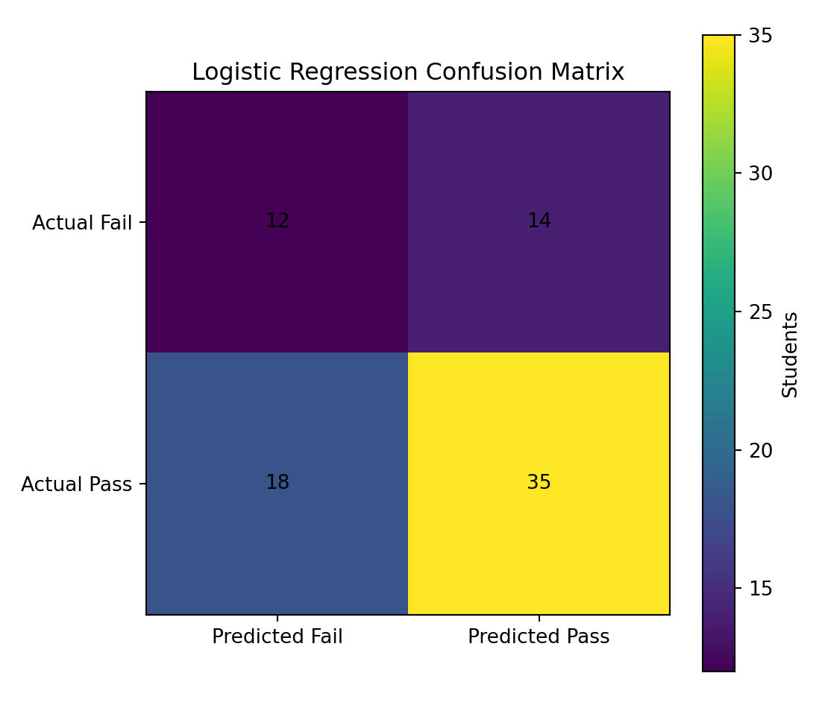
Figure 1. Confusion matrix for the held-out test set.
False negatives are important in an early-warning context because they represent students in the target class who were missed by the model.

8. Visualization 2 – ROC Curve
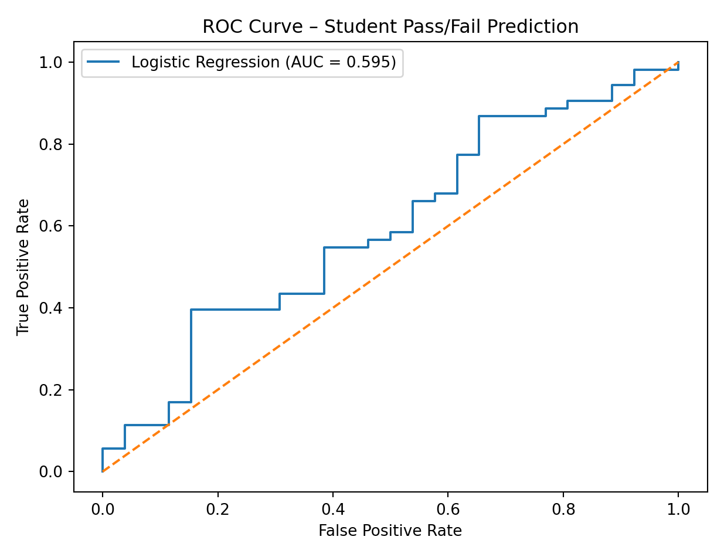
Figure 2. ROC curve and ROC-AUC.
The ROC curve shows the trade-off between true-positive and false-positive rates as the decision threshold changes. ROC-AUC summarizes ranking discrimination.

9. Visualization 3 – Model Metrics
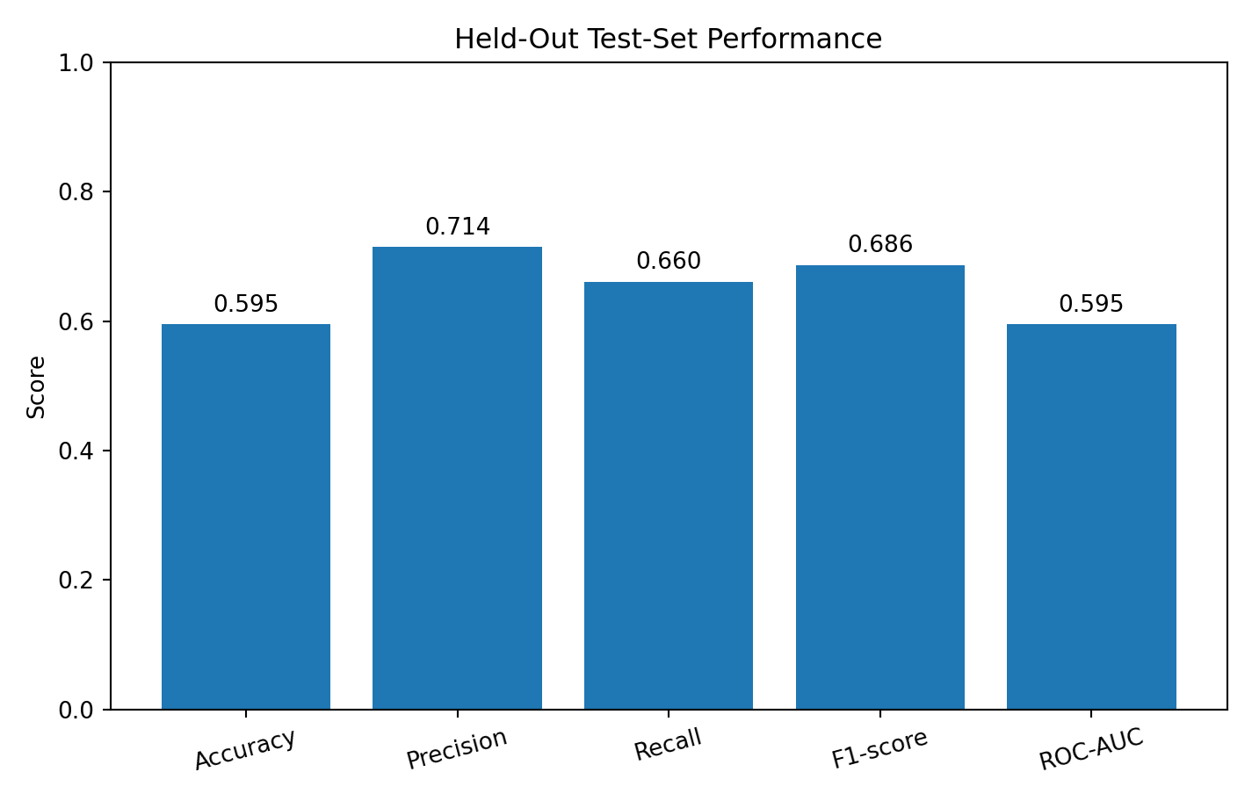
Figure 3. Test-set classification metrics.
Reporting several metrics avoids relying on accuracy alone and provides a more complete view of classification performance.

10. Visualization 4 – Cross-Validation
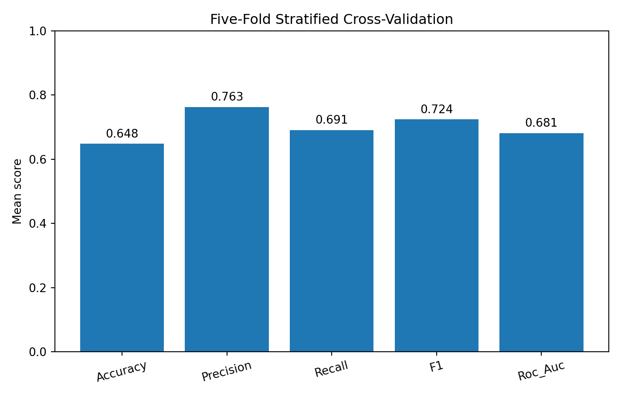
Figure 4. Mean five-fold stratified cross-validation metrics.
Five-fold stratified cross-validation checks whether the baseline performance is reasonably stable across different train/validation partitions.

11. Cross-Validation Results
Metric | Mean 5-fold score
Accuracy | 0.648
Precision | 0.763
Recall | 0.691
F1 | 0.724
Roc_Auc | 0.681

12. Visualization 5 – Target Class Distribution
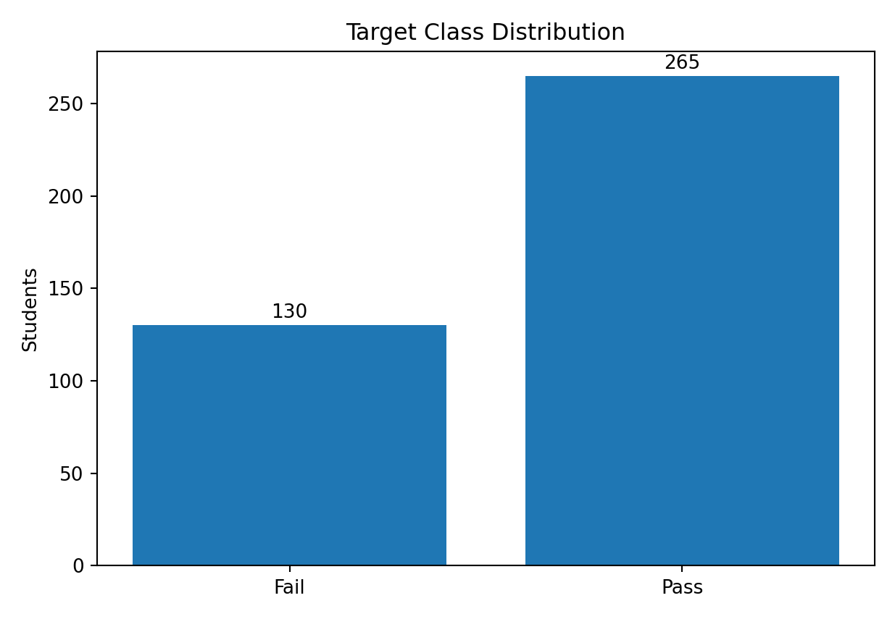
Figure 5. Pass/Fail target distribution.
The class distribution is not perfectly balanced. This supports reporting precision, recall, F1 and ROC-AUC alongside accuracy and motivates the use of balanced class weights.

13. Error Analysis and Limitations
- False negatives may be more consequential than false positives if the model is used for early intervention.
- The sample has only 395 Mathematics records, so performance estimates can vary.
- The source data comes from two Portuguese schools and may not generalize to other populations.
- The target is a thresholded version of G3, so the model predicts Pass/Fail rather than the exact final score.
- Excluding G1/G2 improves the early-warning interpretation but removes highly informative academic indicators.
- Logistic Regression may miss non-linear relationships and feature interactions.
- Survey-style variables may contain measurement or reporting bias.
- Cross-validation improves evaluation reliability but cannot eliminate external-validity or dataset-shift risks.

14. Potential Model Improvements
- Compare Decision Tree, Random Forest and Gradient Boosting models with the same leakage-safe preprocessing.
- Tune hyperparameters using stratified cross-validation.
- Evaluate alternative probability thresholds when missing at-risk students is especially costly.
- Use probability calibration if risk scores will be used for ranking.
- Investigate feature contribution using permutation importance.
- Validate on an independent external dataset before practical deployment.
- Assess fairness across relevant demographic groups before using predictions for interventions.

15. Python Code
import pandas as pd
from sklearn.model_selection import train_test_split, StratifiedKFold, cross_validate
from sklearn.compose import ColumnTransformer
from sklearn.pipeline import Pipeline
from sklearn.preprocessing import OneHotEncoder, StandardScaler
from sklearn.impute import SimpleImputer
from sklearn.linear_model import LogisticRegression
from sklearn.metrics import accuracy_score, precision_score, recall_score, f1_score, confusion_matrix, roc_auc_score
df = pd.read_csv("student-mat.csv", sep=";")
df["pass_fail"] = (df["G3"] >= 10).astype(int)
# G1/G2/G3 are intentionally excluded to avoid target leakage/near-target information.
X = df.drop(columns=["G1", "G2", "G3", "pass_fail"])
y = df["pass_fail"]
cat_cols = X.select_dtypes(include="object").columns.tolist()
num_cols = X.select_dtypes(exclude="object").columns.tolist()
preprocess = ColumnTransformer([
("num", Pipeline([
("imputer", SimpleImputer(strategy="median")),
("scaler", StandardScaler())
]), num_cols),
("cat", Pipeline([
("imputer", SimpleImputer(strategy="most_frequent")),
("onehot", OneHotEncoder(handle_unknown="ignore"))
]), cat_cols)
])
model = Pipeline([
("preprocess", preprocess),
("classifier", LogisticRegression(max_iter=2000, class_weight="balanced"))
])
X_train, X_test, y_train, y_test = train_test_split(
X, y, test_size=0.20, stratify=y, random_state=42
)
model.fit(X_train, y_train)
pred = model.predict(X_test)
prob = model.predict_proba(X_test)[:, 1]
print("Accuracy:", accuracy_score(y_test, pred))
print("Precision:", precision_score(y_test, pred))
print("Recall:", recall_score(y_test, pred))
print("F1:", f1_score(y_test, pred))
print("ROC-AUC:", roc_auc_score(y_test, prob))
print("Confusion matrix:\n", confusion_matrix(y_test, pred))
cv = StratifiedKFold(n_splits=5, shuffle=True, random_state=42)
scores = cross_validate(
model, X, y, cv=cv,
scoring=["accuracy", "precision", "recall", "f1", "roc_auc"]
)
for key, value in scores.items():
if key.startswith("test_"):
print(key, value.mean())

16. Conclusion
The Week 4 project demonstrates a complete machine-learning pipeline for student Pass/Fail classification. The uploaded Mathematics dataset was transformed into a binary target, processed with a reproducible scikit-learn pipeline, and modeled with Logistic Regression. Performance was evaluated on an unseen test set and with five-fold stratified cross-validation.
The intentional exclusion of G1 and G2 makes the model more aligned with an early-warning scenario and reduces near-target leakage. The model should be treated as a baseline for learning and experimentation rather than a production decision system. Future work should compare additional algorithms, tune thresholds, investigate feature contributions, assess fairness and validate the model externally.

17. References
UCI Machine Learning Repository. Student Performance, Dataset ID 320. https://archive.ics.uci.edu/dataset/320/student+performance
Cortez, P. (2008). Student Performance [Dataset]. UCI Machine Learning Repository. https://doi.org/10.24432/C5TG7T
Scikit-learn documentation. Classification metrics and model-selection utilities. https://scikit-learn.org/stable/

