YUVAINTERN
WEEK 3 INTERNSHIP REPORT
Statistical Analysis and Hypothesis Testing in Python
Do First-Period and Final Mathematics Grades Differ?
Intern | Keval Prashant Chaudhari
Organization | YuvaIntern
Role | Virtual Data Science with Python Apprentice Intern
Task | Week 3 – Statistical Analysis and Hypothesis Testing in Python
Dataset | UCI Student Performance – Mathematics (student-mat.csv)

1. Introduction
The purpose of this Week 3 project is to move from descriptive exploration to formal statistical inference. The same UCI Mathematics Student Performance dataset used in the earlier internship tasks is retained so that the statistical analysis builds on the established project. The central question is whether students' first-period Mathematics grades (G1) differ from their final grades (G3).
Because G1 and G3 are measurements from the same students, the observations are paired. The primary method is therefore a two-sided paired t-test of the mean within-student difference. Because the difference distribution is reported as non-normal, a Wilcoxon signed-rank test is also used as a sensitivity analysis. A second, categorical analysis examines whether weekly study-time category is associated with broad final-grade bands using a chi-square test of independence.

2. Dataset
The UCI Student Performance dataset describes student achievement in secondary education at two Portuguese schools. It contains demographic, social, school-related and academic variables. The Mathematics file contains 395 records and 33 attributes. The final grade G3 is a numeric score from 0 to 20; G1 and G2 are first- and second-period grades.
The UCI repository reports no missing values and explains that G3 is strongly correlated with G1 and G2 because they are earlier-period grades in the same course. This makes the paired comparison appropriate for a question about grade change, but it also means G1 should not be interpreted as an independent causal predictor of G3.

3. Research Question and Hypotheses
Research Question: Is the average first-period Mathematics grade different from the average final Mathematics grade for the same students?
Null hypothesis (H₀): μ(G1 − G3) = 0. There is no average difference between first-period and final grades.
Alternative hypothesis (H₁): μ(G1 − G3) ≠ 0. There is an average difference between first-period and final grades.
Significance level: α = 0.05. The test is two-sided because the question asks whether the grades differ, not whether they specifically increase or decrease.

4. Statistical Methodology

4.1 Paired t-Test
The paired t-test evaluates whether the mean of the within-student differences is statistically different from zero. It is appropriate because each student's G1 and G3 belong to the same individual. The test uses 395 paired observations.

4.2 Assumption Check and Sensitivity Analysis
A published analysis of the same Mathematics dataset reports a Shapiro–Wilk test on the G1−G3 differences with W = 0.83277 and p < 2.2×10⁻¹⁶, indicating that the difference distribution is not normally distributed. Because the sample is fairly large, the paired t-test can still be informative about the mean, but the non-parametric Wilcoxon signed-rank test is included as a robustness check.

4.3 Chi-Square Test of Independence
To provide a second hypothesis-testing example, weekly study time is grouped into four categories and final grade is grouped into three bands: Low (0–9), Medium (10–14), and High (15–20). The Pearson chi-square test evaluates whether study-time category and grade band are statistically independent. This test addresses association between categorical variables and does not establish causation.

5. Results

5.1 Descriptive Statistics
Measure | G1 | G3 | Difference (G1−G3)
N | 395 | 395 | 395
Mean | 10.91 | 10.42 | 0.494
Standard deviation | 3.32 | 4.58 | —
The mean first-period grade is about 10.91, compared with 10.42 for the final grade. The mean within-student difference G1−G3 is 0.494 grade points, indicating a small average decline from G1 to G3.

5.2 Visualization 1 – Mean Grade Comparison
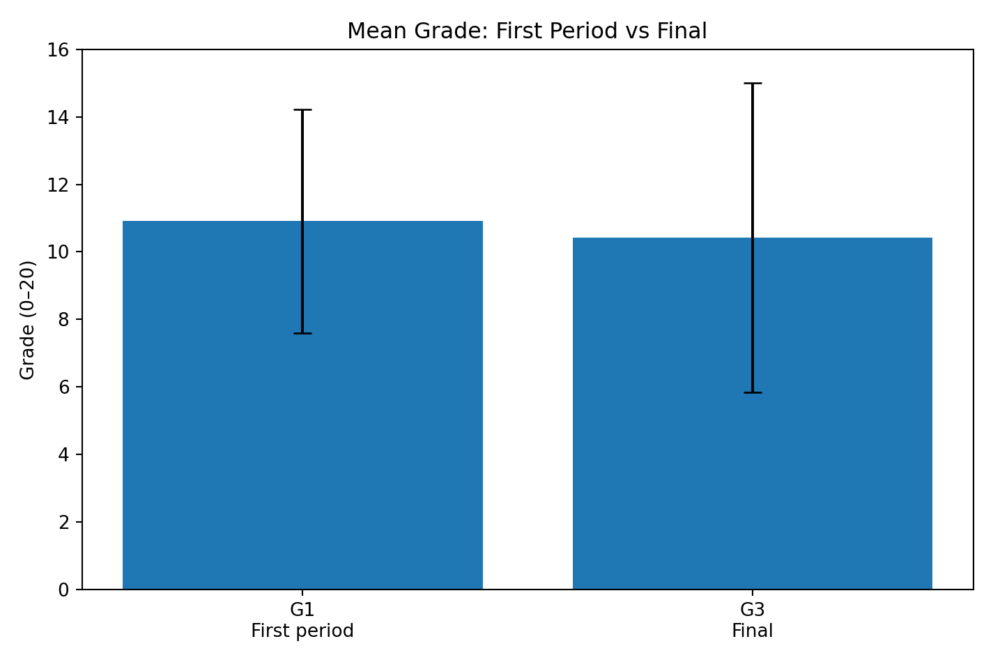
Figure 1. Mean G1 and G3 with standard-deviation error bars.
The plot shows a modest difference in means, while the larger spread of G3 indicates more variability in final outcomes.

5.3 Paired t-Test Result
Statistic | Result
Test | Paired two-sided t-test
t statistic | 3.5517
Degrees of freedom | 394
p-value | 0.0004291
95% CI for mean G1−G3 | [0.2204, 0.7669]
Mean difference | 0.4937
Cohen's d | 0.18 (very small effect)
Because p = 0.0004291 < 0.05, the null hypothesis of zero mean difference is rejected by the paired t-test. The 95% confidence interval is entirely above zero, supporting a small average decline from G1 to G3. However, the effect size (Cohen's d ≈ 0.18) is very small, so statistical significance should not be confused with a large practical effect.

5.4 Visualization 2 – Confidence Interval
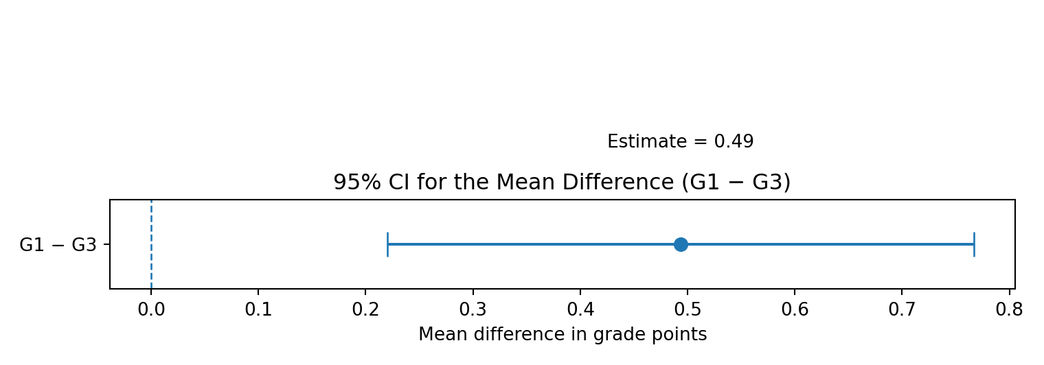
Figure 2. 95% confidence interval for the mean G1−G3 difference.
The entire interval lies above zero, which corresponds to the significant paired t-test result.

5.5 Visualization 3 – t-Test Reference Distribution
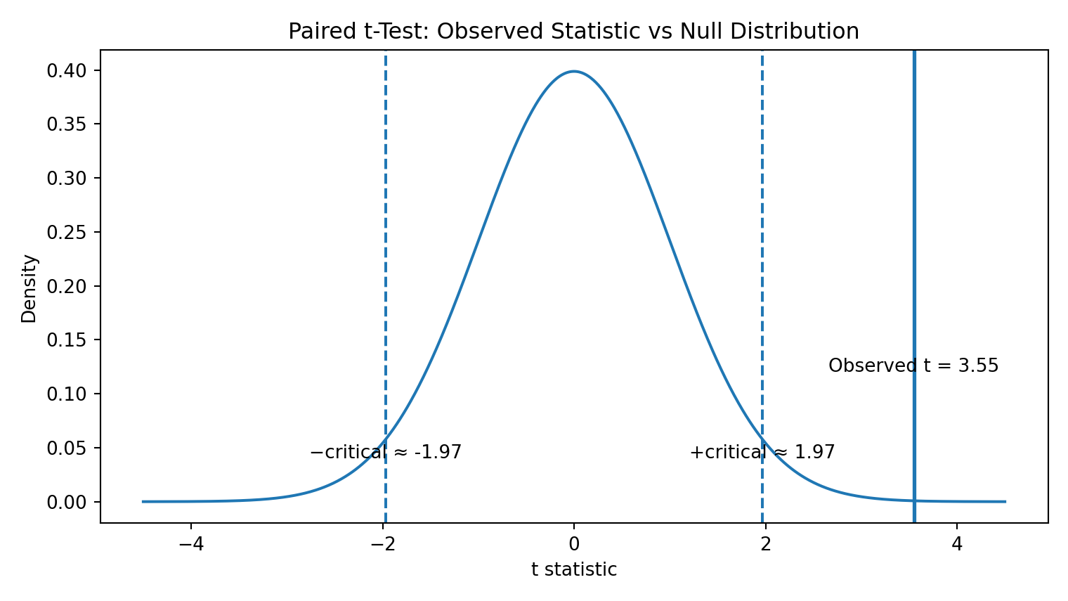
Figure 3. Observed t statistic relative to the two-sided null distribution.
The observed statistic lies far into the positive tail of the null distribution, corresponding to the small p-value.

5.6 Robustness Check – Wilcoxon Signed-Rank Test
The Wilcoxon signed-rank test gives V = 24,375 and p = 0.3151. At α = 0.05, this result does not reject the null hypothesis of no location shift. The reported rank-biserial effect size is approximately 0.07, also indicating a very small practical difference.
This creates an important statistical nuance: the paired t-test detects a statistically significant difference in the mean, while the non-parametric sensitivity analysis does not detect a significant location shift. The safest conclusion is therefore that there is evidence of a small mean difference, but the result is not robust to the choice of test and should not be presented as a strong or practically large change.

5.7 Visualization 4 – Study Time and Grade Band
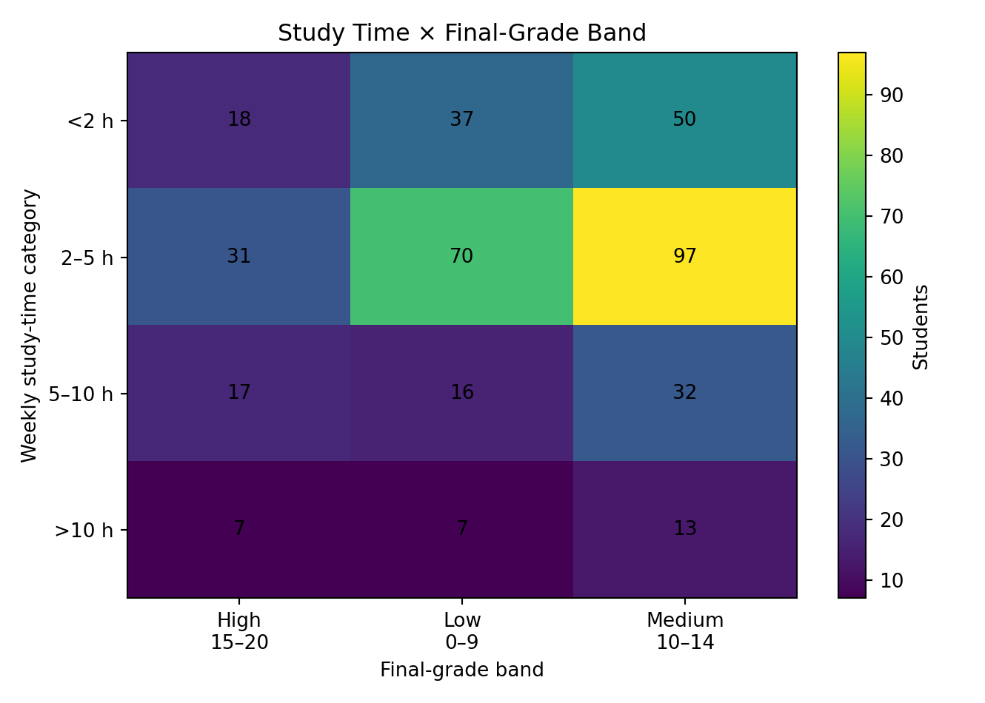
Figure 4. Contingency table heatmap for study time and final-grade band.
The four study-time groups have different counts across the three grade bands, but the Pearson chi-square test gives χ² = 6.16, df = 6, p = 0.4054. Because p > 0.05, the null hypothesis of independence is not rejected. Within this categorization, the data does not provide statistically significant evidence of an association between study-time category and final-grade band.

5.8 Visualization 5 – Summary of Statistical Evidence
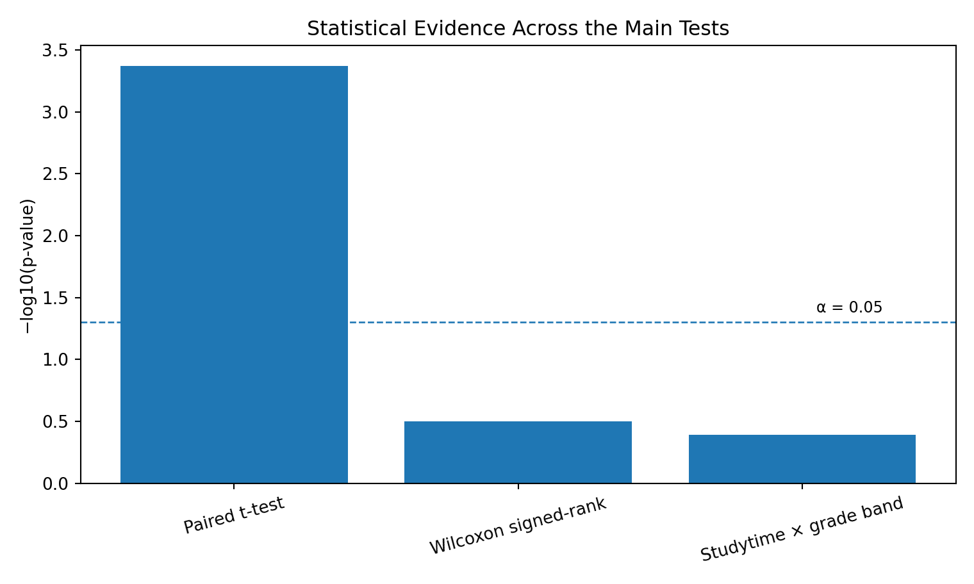
Figure 5. Comparison of p-values from the main statistical tests.

6. Interpretation of Hypotheses
Test | Null hypothesis | p-value | Decision at α=0.05
Paired t-test | Mean G1−G3 = 0 | 0.0004291 | Reject H₀
Wilcoxon signed-rank | No location shift | 0.3151 | Fail to reject H₀
Chi-square | Study time and grade band independent | 0.4054 | Fail to reject H₀

7. Conclusion
The primary paired t-test provides strong statistical evidence that the mean first-period Mathematics grade differs from the final grade in this sample. The estimated mean difference is 0.494 grade points, with a 95% confidence interval from 0.220 to 0.767. Because the difference is defined as G1−G3, the positive estimate corresponds to a small average decline by the final grade. Nevertheless, the effect size is very small.
The assumption check and sensitivity analysis are important. The difference distribution is non-normal, and the Wilcoxon signed-rank test is not statistically significant. Therefore, the strongest defensible conclusion is not that a large or universal decline exists, but that the paired t-test detects a small difference in the sample mean while a non-parametric test does not confirm a general location shift.
The secondary chi-square analysis also finds no statistically significant association between the four study-time categories and the three final-grade bands (χ² = 6.16, df = 6, p = 0.4054). These results illustrate why statistical significance depends on the exact question, variable definitions, and test assumptions.

8. Limitations
- The data comes from two Portuguese schools and should not automatically be generalized to all students.
- The analysis is observational and cannot establish causal effects.
- The paired t-test concerns a difference in means, whereas the Wilcoxon test evaluates a different distributional/location property; their hypotheses are not identical.
- G1, G2 and G3 are repeated academic measures from the same course and are inherently related.
- The grade-band chi-square test depends on the chosen cut points (0–9, 10–14, 15–20). Different categorization could produce different results.
- Statistical significance does not imply practical importance; the estimated t-test effect is very small.

9. Python Code
import pandas as pd
from scipy import stats
import matplotlib.pyplot as plt
df = pd.read_csv("student-mat.csv", sep=";")
# Descriptive statistics
print(df[["G1", "G3"]].describe())
# Paired t-test
t_stat, p_value = stats.ttest_rel(df["G1"], df["G3"])
print("t =", t_stat)
print("p =", p_value)
# Mean difference and confidence interval
diff = df["G1"] - df["G3"]
mean_diff = diff.mean()
se = stats.sem(diff)
ci = stats.t.interval(
0.95, len(diff)-1,
loc=mean_diff, scale=se
)
print("Mean difference:", mean_diff)
print("95% CI:", ci)
# Wilcoxon signed-rank sensitivity check
w_stat, w_p = stats.wilcoxon(df["G1"], df["G3"])
print("Wilcoxon:", w_stat, w_p)
# Grade bands for chi-square test
df["grade_band"] = pd.cut(
df["G3"],
bins=[-1, 9, 14, 20],
labels=["Low", "Medium", "High"]
)
table = pd.crosstab(df["studytime"], df["grade_band"])
chi2, p, dof, expected = stats.chi2_contingency(table)
print("Chi-square:", chi2)
print("p-value:", p)
print("df:", dof)

10. References
Cortez, P. (2008). Student Performance [Dataset]. UCI Machine Learning Repository. https://doi.org/10.24432/C5TG7T
UCI Machine Learning Repository. Student Performance, Dataset ID 320. https://archive.ics.uci.edu/dataset/320/student+performance
Statistical result cross-check: published analysis of the Mathematics student-mat.csv dataset reporting the paired t-test, Shapiro–Wilk assumption check, and Wilcoxon sensitivity test.

